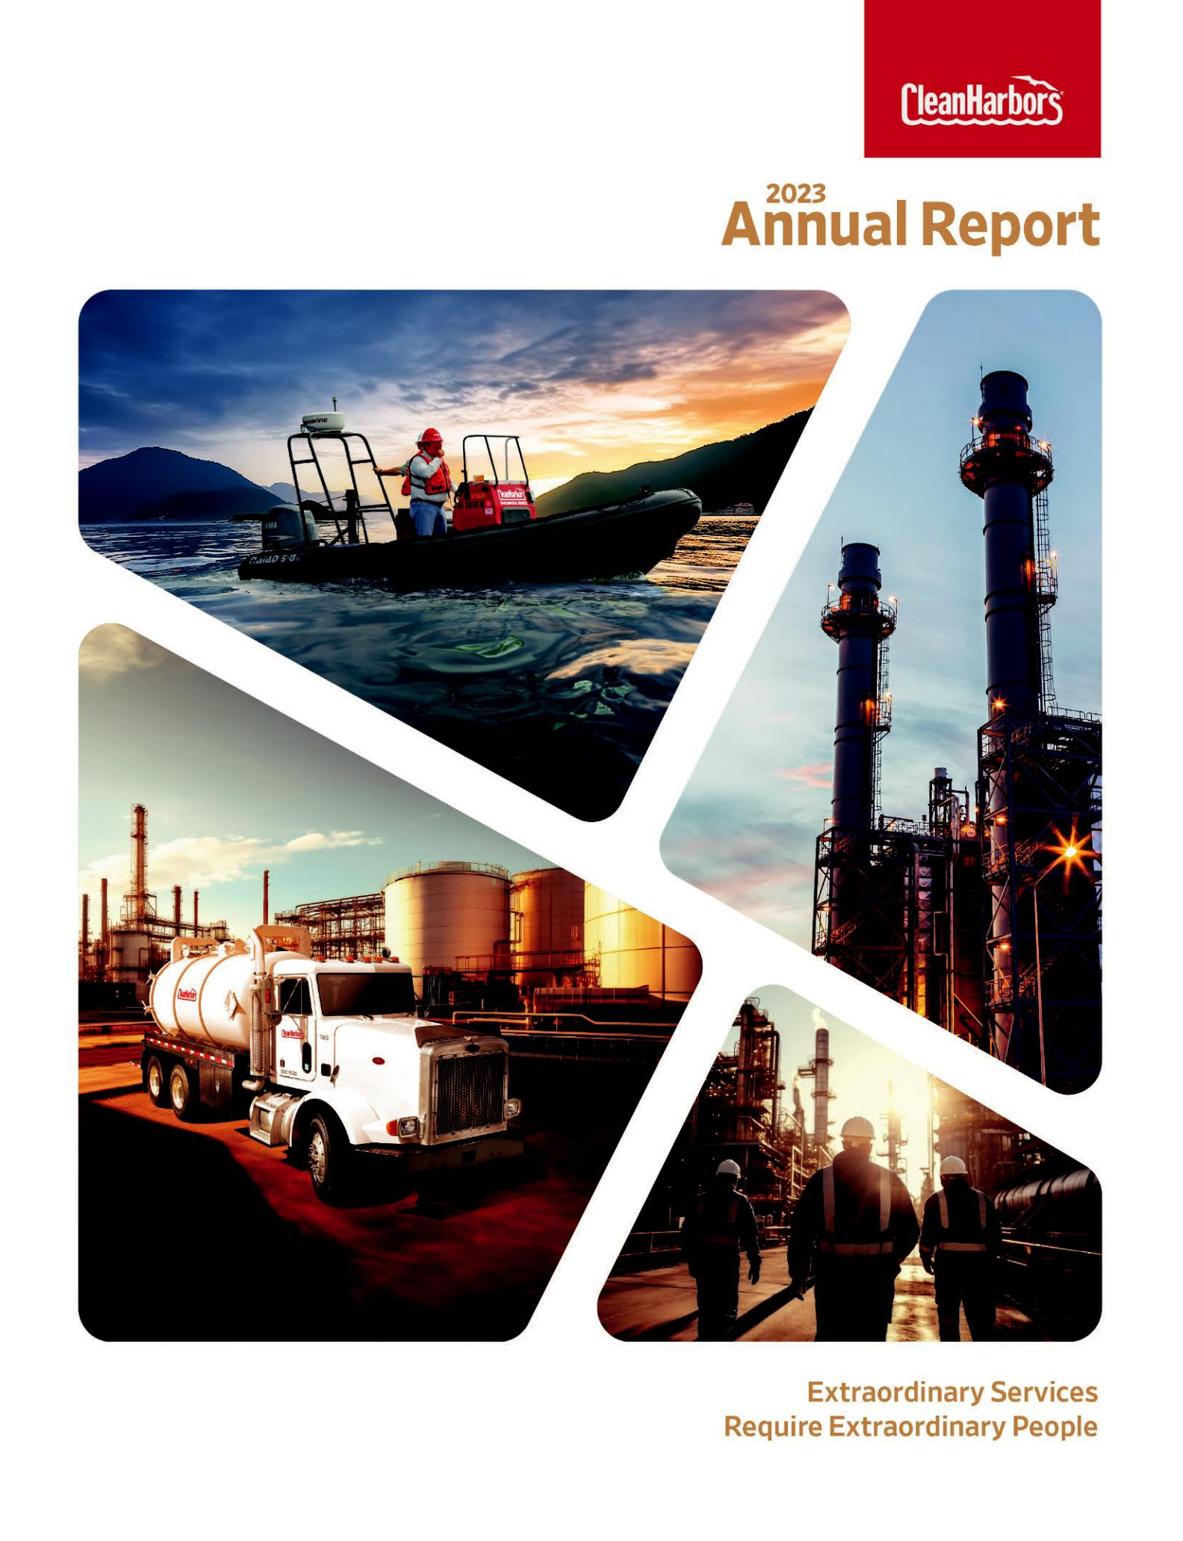

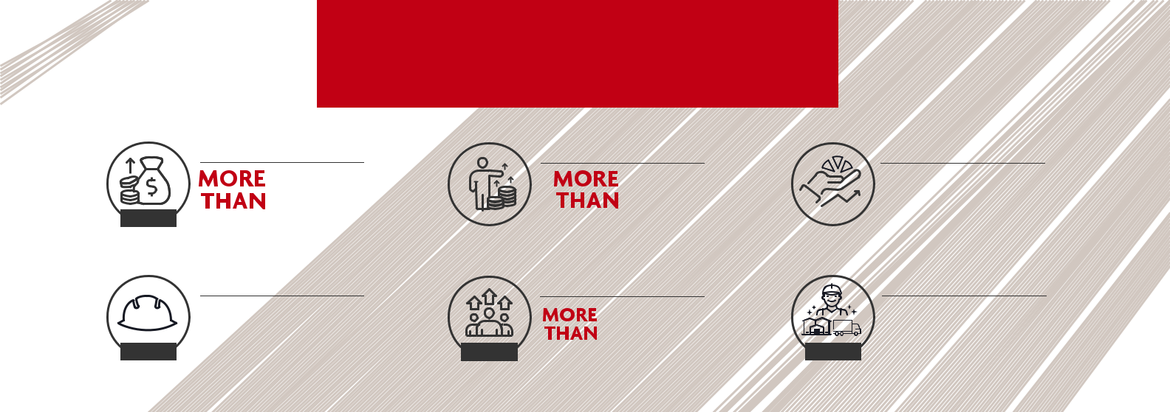
2023 BY THE NUMBERS

 | REVENUE | ADJUSTED EBITDA |  |  | RETURNS
RECORD | 5.4B | $1B | CLH | TSR:53%
 | Highest in Company History | Second Consecutive Year |  | Total Shareholder Return
 | SAFETY | PROMOTIONS |  | CAPEX INVESTMENT
 | TRIR 0.63 | 1,000 |  | $ | MORE THAN
 | LOWEST |  |  | In Plants,^{420M}Fleet&SafetyEquipment
RECORD | Best in Company History | ^{RECORD}Most in a Single Year | RECORD

STRENGTHENING OUR FOUNDATION

The milestone successes of 2022 carried Clean Harbors into 2023 with a momentum that guaranteed another remarkable year. While the year was not without its challenges, we have many things to be proud of and even more to call great achievements. None of this would have been possible without the strong foundation of our shareholders, customers, business partners and employees.

Clean Harbors is dedicated to service excellence and is determined to provide our customers with the best products and services on the market. In 2023, we recommitted ourselves to investing in our workforce with the goal of continually improving overall safety, career development pathways and quality of life for everyone. We continued to rely on the expertise and insight of our customers and our extraordinary employees at every level

to give us unique insight into how we can grow and improve.

The sustainability of our products and services is inextricably linked to the sustainability of the company. This year we implemented strategies that will ensure the expansion and development of our entire network in a realistic, sustainable way. For example, the acquisition of Thompson Industrial allowed us to add more services to our one-stop-shop business model without sacrificing quality.


2024 is sure to bring even more success within all lines of business, especially with the much-anticipated opening of our state-of-the-art incinerator facility in Kimball, Nebraska. We will continue to invest in our people who enable us to be the leader in the industry while we work toward our future successes without losing sight of our foundation.
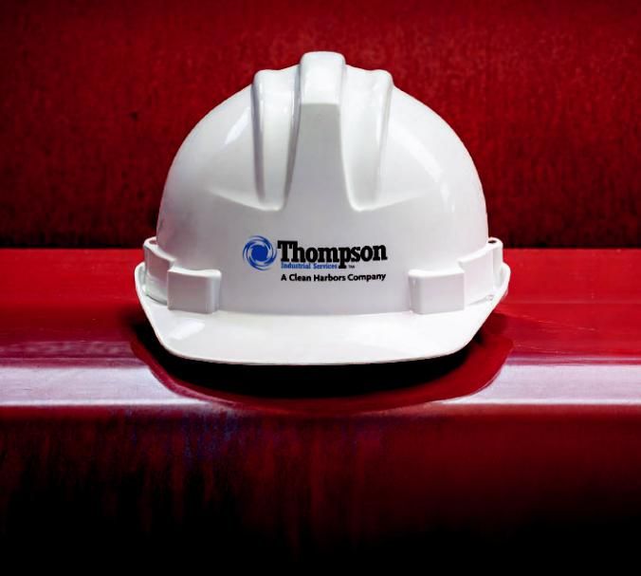

Our 2023 acquisition of Thompson Industrial expands our presence in the Southeast U.S. and strengthens our leadership position in Industrial Services.

ABOUT CLEAN HARBORS

Clean Harbors (NYSE: CLH) is North America’s leading provider of environmental and industrial services. The Company serves a diverse customer base, including a majority of Fortune 500 companies. Its customer base spans a number of industries, including chemical, manufacturing and refining, as well as numerous government agencies. These customers rely on Clean Harbors to deliver a broad range of services such as end-to-end hazardous waste management, emergency spill response, industrial cleaning and maintenance, and recycling services. Through its Safety-Kleen subsidiary, Clean Harbors also is a leading provider of parts washers and environmental services to commercial, industrial and automotive customers, as well as North America’s largest re-refiner and recycler of used oil. Founded in 1980 and based in Massachusetts, Clean Harbors operates in the United States, Canada, Mexico, Puerto Rico and India. For more information, visit www.cleanharbors.com.

CLEAN HARBORS, INC. | ANNUAL REPORT 2023

TO OUR SHAREHOLDERS

DEAR SHAREHOLDERS,

2023 was an outstanding year for Clean Harbors. We delivered record financial performance in our Environmental Services (ES) segment, notable operational accomplishments and exceptional safety results. Our performance reflected favorable market dynamics in ES as well as a combination of strategic initiatives to drive efficiencies, achieve pricing gains and capture greater volumes of high-value waste into our disposal and recycling network.

Adjusted EBITDA exceeded $1 billion in 2023, while total revenue grew by 5% to more than $5.4 billion. We expanded EBITDA margins in ES by 160 basis points through the combination of 8% revenue growth and a 16% increase in Adjusted EBITDA. Within our Safety-Kleen Sustainability Solutions (SKSS) segment, the team navigated a challenging year, as overall pricing weakened across the industry after an especially strong year in 2022.

Extending our Record Safety Performance

Most importantly in 2023, we achieved a Total Recordable Incident Rate (TRIR) of 0.63 – the best annual safety performance in our history. To achieve that result, we continued to invest in areas such as automation, enhanced safety equipment and robust reporting systems. Our continuous commitment to safety keeps our highly skilled workforce safe. A low TRIR enhances our ability to win business, protect communities, lower insurance costs, and attract and retain talented people. Safety is the foundation of everything we do.

Construction of our Kimball Incinerator

We made significant strides in 2023 on the construction of our new 70,000-ton incinerator in Kimball, Nebraska, enabling us to move up the expected opening date to later this year from early 2025. This $200 million kiln mirrors the successful design unveiled at our Arkansas facility in 2017, and will increase our network capacity by 12%. Based on conversations with customers about their plans, we added several enhancements to the facility’s design, including more direct burn bays and specialized lines. These additions will enable that site to process even more high-margin

materials and containerized waste, capacity needed in the marketplace, particularly in light of reshoring, national infrastructure investments and other industry trends.

Building Extraordinary Careers

At its core, Clean Harbors is a service business; service excellence begins and ends with our people. A critical focus has been to invest in our workforce and lower voluntary turnover. In 2023, we reduced voluntary turnover by more than 15% and are now below pre-pandemic levels. Now 23,000 strong, we employ the best team in the industry and are the go-to experts for what we do. Our success in 2023 was the direct result of our team’s dedication and countless contributions. In addition to higher wages and compensation for our people we also:

- Absorbed healthcare cost increases for all employees for the sixth straight year;

- Invested more than $420 million CapEx in our plants, fleet and safety equipment;

- Paid out more than $2 million to employees through our lucrative referral program;

- Implemented more employee touchpoints to

drive career development, particularly for first-year employees to keep them safe and engaged; and

- Promoted more than 1,000 employees – the most in a single year in our history.

We pride ourselves on the longevity of our workforce

as many have been with us for decades. Whether it’s a

new worker or a long-time team member, we offer our

employees the opportunity for an extraordinary career.

Sustainability Story Continues to Unfold

Clean Harbors made important strides in telling our sustainability story, including issuing a full report in 2021 using the Sustainability Accounting Standards Board (SASB) framework. We continued that momentum in 2023, improving our ESG ratings with a number of providers and being recognized with multiple awards, including receiving the Game Changer Award from the National Waste &
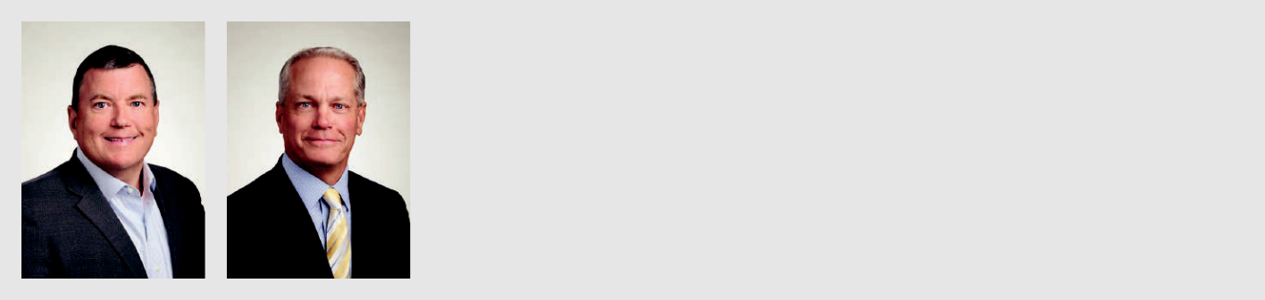

“Since our founding, the growth of Clean Harbors has always been a function of the excellent work of our extraordinary people and their commitment to safety and service excellence.”

Michael L. Battles & Eric W. Gerstenberg

Co-Chief Executive Officers
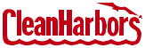


CLEAN HARBORS, INC. | ANNUAL REPORT 2023 | 1

TO OUR SHAREHOLDERS

Recycling Association (NWRA). The most notable of our recent sustainability accolades was earning a spot on the Corporate Knights’ 2024 list of the 100 Most Sustainable Corporations in the World. The recognition, which was announced at the World Economic Forum, represents the top echelon of sustainability globally. Clean Harbors was ranked 13th overall and was second among all U.S.-based companies.

Clean Harbors maintains sustainable revenue sources through our recycling and re-refining of used motor oil and solvents, along with our work in facilitating the proper destruction of ozone-depleting and hazardous substances. We lead efforts to strengthen the resiliency of the customers and communities through spill prevention and remediation, natural disaster response and relief. Additionally, we calculated that we have destroyed and/or avoided more than twice the greenhouse gas emissions we generate from our operations.

Introducing Vision 2027

During 2023, we introduced our comprehensive five-year growth plan – Vision 2027 – whereby we plan to double our size. Vision 2027 is built upon the five core elements of our growth strategy:

- Cross-Sell Our Solutions – The breadth of our service offerings allows us to provide customers with full solutions for their environmental, industrial and sustainability needs. Through our cross-selling efforts, we have created a one-stop-shop encompassing disposal, emergency response, Safety-Kleen and industrial services.

- Expand Network and Suite of Offerings – In addition to our Kimball expansion, we have a number of capital investments underway to enhance our network. We recently announced a $20 million investment at our Baltimore site to centralize some of our mid-Atlantic locations, add more recycling, and create a manufacturing facility to build roll-off containers for our operations nationwide. On the service side, we will continue to open branches in new and existing strategic markets, further capitalizing on our economies of scale.

- Pursue Acquisitions and Divestitures – We expect to remain active on the M&A front in 2024, including our recently completed acquisition of HEPACO. The pipeline of M&A candidates to support our growth objectives is robust. We remain committed to smart capital deployment with an emphasis on permitted assets or service businesses that support our existing network and footprint.

- Execute Cost, Pricing and Productivity Initiatives – We are continuing to pursue pricing strategies to more than offset any inflationary pressures and maximize returns on our scarce assets. At the same time, we are implementing other initiatives to further reduce costs, enhance productivity and increase efficiencies to improve margins.

- Foster Innovation Through Technology – We intend to keep Clean Harbors at the technology forefront of our industry, enabling us to gain a distinct competitive advantage in areas such as waste tracking, intelligent routing, logistics support, pricing, capital deployment and more. The influence of artificial intelligence, data analytics and robotic process automation will continue to support our productivity gains and margin improvement.

2024 Growth Outlook and Market Dynamics

We expect 2024 to be an incredibly dynamic year for Clean Harbors. We begin with considerable momentum in our ES segment as our facilities network and service lines remain in high demand. We expect the favorable market conditions that drove our recent success, including U.S. manufacturing and regulatory trends, to continue to support our profitable growth. Our new incinerator will be adding much-needed capacity. We see a strong pipeline of remediation and waste projects, which we expect will grow based on infrastructure spending and reshoring. We recently launched our Total PFAS Solution that will position us well in this still emerging marketplace. Within Industrial Services, we expect a record 2023 to carry over into 2024. Our Field Services business will greatly benefit from the addition of HEPACO this year.

For SKSS, our strategy will continue to center on areas we can control, including waste oil collection costs, transportation and re-refinery production. We will continue to focus on the expansion of our blended lubricants. In addition, we will move forward with our promising Group III program.

We are confident in our ability to deliver solid profitable growth in both operating segments as we work toward realizing our Vision 2027 strategy. Since our founding, the growth of Clean Harbors has always been a function of the excellent work of our extraordinary people and their commitment to safety and service excellence. On behalf of our entire management team and Board of Directors, we want to thank all of our employees for making another successful year. We also extend our sincere appreciation to our loyal shareholders, customers and partners. We look forward to sharing our progress with you throughout 2024. Stay safe and well in the year ahead.

Co-Chief Executive Officers

Clean Harbors, Inc.

March 31, 2024
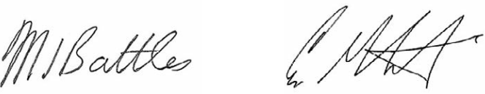

 | Michael L. Battles | Eric W. Gerstenberg
 | Co-Chief Executive Officer | Co-Chief Executive Officer
2 | CLEAN HARBORS, INC. | ANNUAL REPORT 2023

SELECTED FINANCIAL DATA

 |  | For the Years Ended December 31 ( in thousands, except per share amounts )
INCOME STATEMENT DATA
INCOME STATEMENT DATA |  | 2023 |  | 2022 |  | 2021 |  | 2020 |  | 2019
Revenues | $ | 5,409,152 | $ | 5,166,605 | $ | 3,805,566 | $ | 3,144,097 | $ | 3,412,190
Cost of revenues |  | 3,746,124 |  | 3,543,930 |  | 2,609,837 |  | 2,137,751 |  | 2,387,819
(exclusive of items shown separately below)
Selling, general and administrative expenses |  | 671,161 |  | 627,391 |  | 537,962 |  | 451,044 |  | 484,054
Accretion of environmental liabilities |  | 13,667 |  | 12,943 |  | 11,745 |  | 11,051 |  | 10,136
Depreciation and amortization |  | 365,761 |  | 347,594 |  | 298,135 |  | 292,915 |  | 300,725
Income from operations |  | 612,439 |  | 634,747 |  | 347,887 |  | 251,336 |  | 229,456
Other income (expense), net |  | 2,315 |  | 2,472 |  | (515) |  | (290) |  | 2,897
Loss on early extinguishment of debt |  | (2,880) |  | (422) |  | — |  | — |  | (6,131)
Gain (loss) on sale of businesses |  | — |  | 8,864 |  | — |  | (3,376) |  | 687
Interest expense, net of interest income |  | (108,595) |  | (107,663) |  | (77,657) |  | (73,120) |  | (78,670)
Income before provision for income taxes |  | 503,279 |  | 537,998 |  | 269,715 |  | 174,550 |  | 148,239
Provision for income taxes |  | 125,423 |  | 126,254 |  | 66,468 |  | 39,713 |  | 50,499
Net income | $ | 377,856 | $ | 411,744 | $ | 203,247 | $ | 134,837 | $ | 97,740
Earnings per share:
Basic | $ | 6.99 | $ | 7.59 | $ | 3.73 | $ | 2.43 | $ | 1.75
Diluted | $ | 6.95 | $ | 7.56 | $ | 3.71 | $ | 2.42 | $ | 1.74
CASH FLOW DATA
Net cash from operating activities | $ | 734,552 | $ | 626,214 | $ | 545,997 | $ | 430,597 | $ | 413,192
Net cash used in investing activities |  | (575,050) |  | (388,944) |  | (1,507,602) |  | (199,460) |  | (217,856)
Net cash (used in) from financing activities |  | (208,891) |  | (187,315) |  | 898,249 |  | (88,946) |  | (53,425)
OTHER FINANCIAL DATA
Adjusted EBITDA (1) | $ | 1,012,570 | $ | 1,022,128 | $ | 676,606 | $ | 573,804 | $ | 558,133
Adjusted Free Cash Flow (2) | $ | 321,902 | $ | 289,937 | $ | 326,297 | $ | 265,044 | $ | 208,523
 |  |  |  | As of December 31 ( in thousands )
BALANCE SHEET DATA
BALANCE SHEET DATA |  | 2023 |  | 2022 |  | 2021 |  | 2020 |  | 2019
Working capital | $ | 1,014,682 | $ | 1,013,667 | $ | 815,857 | $ | 889,577 | $ | 680,808
Total assets |  | 6,382,869 |  | 6,129,707 |  | 5,653,699 |  | 4,131,520 |  | 4,108,904
Long-term debt (including current portion) |  | 2,301,717 |  | 2,424,828 |  | 2,534,559 |  | 1,557,176 |  | 1,561,651
Stockholders' equity |  | 2,247,506 |  | 1,922,322 |  | 1,513,887 |  | 1,341,551 |  | 1,269,813


- See “Adjusted EBITDA” under Item 7, “Management Discussion and Analysis” on page 37 of the Annual report on Form 10-K, incorporated herein, for a reconciliation of net income to Adjusted EBITDA for 2023, 2022 and 2021. Beginning in the first quarter of 2021, we revised our calculation of reported Adjusted EBITDA to add back stock-based compensation, a non-cash item, to other charges which are added back to GAAP net income for purposes of calculating Adjusted EBITDA. Amounts above for 2019 and 2020 have been recast to provide comparative information by adding back the stock-based compensation balance per the respective period’s cash flow to the previously disclosed Adjusted EBITDA balance.

- See “Adjusted Free Cash Flow” under Item 7, “Management Discussion and Analysis” on page 40 of the Annual Report on Form 10-K, incorporated herein, for a reconciliation of net cash from operating activities to Adjusted Free Cash Flow for 2023, 2022 and 2021. Reconcilations for years prior to that can be found in the Annual Reports on Form 10-K for the respective period.

CLEAN HARBORS, INC. | ANNUAL REPORT 2023 | 3

EXECUTIVE OFFICERS & DIRECTORS

EXECUTIVE OFFICERS


ALAN S. McKIM Founder, Executive Chairman and Chief Technology Officer
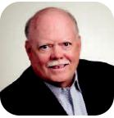

GEORGE L. CURTIS Executive Vice President, Pricing & Proposals*
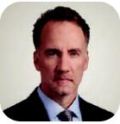

ROBERT HARRISON Executive Vice President, Health & Safety*
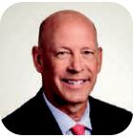

MICHAEL L. BATTLES Co-Chief Executive Officer


ERIC J. DUGAS Executive Vice President and Chief Financial Officer


ROBERT E. SPEIGHTS President, Industrial Services*

ERIC W. GERSTENBERG Co-Chief Executive Officer


SHARON M. GABRIEL Executive Vice President and Chief Information Officer*


REBECCA UNDERWOOD President, Facilities*

BRIAN P. WEBER

President, Safety-Kleen

Sustainability Solutions

DIRECTORS
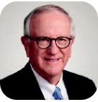

ALAN S. McKIM EDWARD G. GALANTE

Founder, Executive Lead Independent

Chairman and Chief Director

Technology Officer

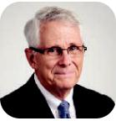

JOHN T. PRESTON ALISON QUIRK

Director Director



ANDREA ROBERTSON, LAUREN C. STATES

CPA Director

Director
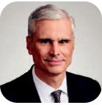
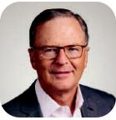

JOHN R. WELCH ROBERT WILLETT

Director Director

* officer of a wholly-owned subsidiary of the parent holding company, Clean Harbors, Inc.


KARYN POLITO Director


MARCY L. REED, CPA Director
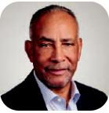

SHELLEY STEWART, JR. Director

4 CLEAN HARBORS, INC. | ANNUAL REPORT 2023

UNITED STATES

SECURITIES AND EXCHANGE COMMISSION

Washington, D.C. 20549

FORM 10-K

- ANNUAL REPORT PURSUANT TO SECTION 13 OR 15(d) OF THE SECURITIES EXCHANGE ACT OF 1934

FOR THE FISCAL YEAR ENDED DECEMBER 31, 2023

OR

- TRANSITION REPORT PURSUANT TO SECTION 13 OR 15(d) OF THE SECURITIES EXCHANGE ACT OF 1934

FOR THE TRANSITION PERIOD FROM |  | TO
 | COMMISSION FILE NUMBER 001-34223
 | CLEAN HARBORS, INC.
 | (Exact name of registrant as specified in its charter)
 | Massachusetts | 04-2997780
(State or Other Jurisdiction of Incorporation or Organization) |  | (IRS Employer Identification No.)
42 Longwater Drive Norwell MA |  | 02061-9149
(Address of Principal Executive Offices) |  | (Zip Code)

Registrant’s Telephone Number, Including area code: (781) 792-5000

Securities registered pursuant to Section 12(b) of the Securities Exchange Act of 1934:

Title of each class |  | Trading Symbol |  | Name of each exchange on which registered
Common Stock, $0.01 par value |  | CLH |  | New York Stock Exchange

Indicate by check mark if the registrant is a well-known seasoned issuer, as defined in Rule 405 of the Securities Act. Yes ý No ☐ Indicate by check mark if the registrant is not required to file reports pursuant to Section 13 or Section 15(d) of the Act. Yes ☐ No ý

Indicate by check mark whether the registrant (1) has filed all reports required to be filed by Section 13 or 15(d) of the Securities Exchange Act of 1934 during the preceding 12 months (or for such shorter period that the registrant was required to file such reports), and (2) has been subject to

such filing requirements for the past 90 days. Yes ý No ☐

Indicate by check mark whether the registrant has submitted electronically every Interactive Data File required to be submitted pursuant to

Rule 405 of Regulation S-T (§ 232.405 of this chapter) during the preceding 12 months (or for such shorter period that the registrant was required to submit such files). Yes ý No ☐

Indicate by check mark whether the registrant is a large accelerated filer, an accelerated filer, a non-accelerated filer, a smaller reporting company, or an emerging growth company. See the definitions of “large accelerated filer,” “accelerated filer,” “smaller reporting company,” and "emerging growth company" in Rule 12b-2 of the Exchange Act.

Large accelerated filer | ☒ | Accelerated filer | ☐
Non-accelerated filer | ☐ | Smaller reporting company | ☐
 |  | Emerging growth company | ☐

If an emerging growth company, indicate by check mark if the registrant has elected not to use the extended transition period for complying with any new or revised financial accounting standards provided pursuant to Section 13(a) of the Exchange Act. ☐

Indicate by check mark whether the Registrant has filed a report on and attestation to its management’s assessment of the effectiveness of its internal control over financial reporting under Section 404(b) of the Sarbanes-Oxley Act (15 U.S.C. 7262(b)) by the registered public accounting firm that prepared or issued its audit report. ☒

If securities are registered pursuant to Section 12(b) of the Act, indicate by check mark whether the financial statements of the registrant included in the filing reflect the correction of an error to previously issued financial statements. ☐

Indicate by check mark whether any of those error corrections are restatements that required a recovery analysis of incentive-based compensation received by any of the registrant's executive officers during the relevant recovery period pursuant to §240.10D-1(b). ☐

Indicate by check mark whether the registrant is a shell company (as defined in Rule 12b-2 of the Exchange Act). Yes ☐ No ý

The aggregate market value of the voting Common Stock held by non-affiliates at June 30, 2023 was approximately $8.3 billion using the New York Stock Exchange closing price for such shares on that date. For purposes of this calculation, all directors and executive officers are affiliates.)

On February 14, 2024, there were outstanding 53,940,747 shares of Common Stock, $0.01 par value.

DOCUMENTS INCORPORATED BY REFERENCE

 | Document |  | Incorporated as to
Proxy Statement for the |  |  | Part III
2024 Annual Meeting of Stockholders

CLEAN HARBORS, INC.

ANNUAL REPORT ON FORM 10-K

YEAR ENDED DECEMBER 31, 2023

TABLE OF CONTENTS

Part I

Item 1. Business

Item 1A. Risk Factors

Item 1B. Unresolved Staff Comments

Item 1C. Cybersecurity

Item 2. Properties

Item 3. Legal Proceedings

Item 4. Mine Safety Disclosures

Part II

Item 5. Market for the Registrant's Common Equity, Related Stockholder Matters and Issuer Purchases of
Equity Securities

Item 6. Reserved

Item 7. Management's Discussion and Analysis of Financial Condition and Results of Operations

Item 7A. Quantitative and Qualitative Disclosures About Market Risk

Item 8. Financial Statements and Supplementary Data

Item 9. Changes in and Disagreements with Accountants on Accounting and Financial Disclosure

Item 9A. Controls and Procedures

Item 9B. Other Information

Item 9C. Disclosure Regarding Foreign Jurisdictions that Prevent Inspections

Part III

Item 10. Directors, Executive Officers and Corporate Governance

Item 11. Executive Compensation

Item 12. Security Ownership of Certain Beneficial Owners and Management and Related Stockholder
Matters

Item 13. Certain Relationships and Related Transactions, and Director Independence

Item 14. Principal Accountant Fees and Services

Part IV

Item 15. Exhibits and Financial Statement Schedules

Item 16. Form 10-K Summary

SIGNATURES

Page

No

1

17

25

25

26

27

27

28

29

30

46

48

91

91

93

93

93

93

93

93

93

94

94

95

(This page has been left blank intentionally.)

Disclosure Regarding Forward-Looking Statements

In addition to historical information, this Annual Report on Form 10-K contains forward-looking statements, which are generally identifiable by use of the words "believes," "expects," "intends," "anticipates," "plans to," "seeks," "should," "estimates," "projects," "may," "likely" or similar expressions. Such statements may include, but are not limited to, statements about future financial and operating results, the Company's plans, objectives, expectations and intentions and other statements that are not historical facts. Forward-looking statements are neither historical facts nor assurances of future performance. Such statements are based upon the beliefs and expectations of Clean Harbors' management as of this date only and are subject to certain risks and uncertainties identified in this report under Item 1A, "Risk Factors," and Item 7, "Management's Discussion and Analysis on Financial Condition and Results of Operations." Readers are cautioned not to place undue reliance on these forward-looking statements, which reflect management's opinions only as of the date hereof. Our actual results and financial condition may differ materially from those indicated in the forward-looking statements. We undertake no obligation to revise or publicly release the results of any revision to these forward-looking statements. Readers should also carefully review the risk factors described in the other documents which we file from time to time with the Securities and Exchange Commission ("SEC"), including Clean Harbors' quarterly reports on Form 10-Q to be filed during 2024.

PART I

ITEM 1. BUSINESS

General

Clean Harbors, Inc. and its subsidiaries (collectively, "we," "Clean Harbors" or the "Company") is a leading provider of sustainable environmental and industrial services throughout North America. Everywhere industry meets the environment, we strive to provide eco-friendly services and products that protect and restore North America's natural environment. We are also the largest provider of parts cleaning and related environmental services to general manufacturing, automotive and commercial customers in North America and the largest re-refiner and recycler of used oil in North America. One of our primary goals as a company is supporting our customers in providing environmentally responsible solutions to further their sustainability goals in today's rapidly changing world.

We have two operating segments through which the Company conducts its operations: (i) the Environmental Services segment and (ii) the Safety-Kleen Sustainability Solutions segment.

- Environmental Services - Our Environmental Services business offers an array of services to customers. We safely collect, transport, treat and dispose of hazardous and non-hazardous waste through our network of over 100 waste disposal facilities including incinerators, landfills, and treatment, storage and disposal facilities ("TSDFs"). Our emergency response services leverage specialized equipment, expertise and responsiveness to support our customers. We also leverage our assets to perform a wide range of industrial maintenance and specialty industrial services, both planned and unplanned. We collect containerized waste and provide parts washer and vacuum services to small quantity generators of hazardous waste. All of these services are designed to protect the environment and address environmental related challenges through the use of innovation and the latest technologies. We provide customers with sustainable solutions that seek to recycle waste materials whenever possible.

- Safety-Kleen Sustainability Solutions - Our Safety-Kleen Sustainability Solutions ("SKSS") business offerings span the life-cycle of oil and other sustainable lubricant products. Our teams collect used oil which serves as feedstock for our eight oil re-refineries. At our facilities, we manufacture, formulate and package high quality lubricants which are returned to the marketplace, providing our customers with sustainable solutions to meet their oil and lubricant demands.

Clean Harbors, Inc. was incorporated in Massachusetts in 1980 and our principal executive offices are located in Norwell,

Massachusetts. We maintain a website at the following Internet address: http://www.cleanharbors.com. Through a link on this

website, we provide free access to our annual reports on Form 10-K, quarterly reports on Form 10-Q, current reports on

Form 8-K and amendments to those reports filed or furnished pursuant to Section 13(a) or 15(d) of the Securities Exchange Act

of 1934 as soon as reasonably practicable after electronic filing with the SEC. Our guidelines on corporate governance, the

charters for our board committees, and our code of ethics for members of the board of directors, our Co-Chief Executive

Officers and our other senior executive officers are available on our website. Should it be necessary, any waivers for such

policies will also be posted on our website. In September 2023, we published our 2023 Sustainability Supplement which

updates some of our key sustainability metrics through 2022 and is intended as a companion to our 2021 Clean Harbors'

Sustainability Report. These publications are available on our website's Sustainability page. Our website and the information

contained therein or connected thereto are not incorporated by reference into this annual report on Form 10-K.

1

Commitment to Safety

Safety is a core value throughout Clean Harbors. Employees at all levels of our Company share this belief and are committed to keeping our teams, customers and communities safe. Our Safety Starts with Me: Live It 3-6-5 mindset, is the foundation to our overall safety approach. This mindset is organized around three Safety Philosophies, six Golden Rules of Safety and each employee’s five personal reasons why they choose to be safe at work, while operating a vehicle or at home. This overall approach, along with other targeted safety programs, have enabled us to achieve continued safety improvement across our Company. For the year ended December 31, 2023, our key safety metrics of Total Recordable Incident Rate ("TRIR") and Days Away, Restricted Activity and Transfer Rate ("DART"), were 0.63 and 0.35, respectively. TRIR is a measure of total recordable injuries relative to hours worked while DART is a measure of recordable injury severity for the hours worked. This year marked another all-time best for both TRIR and DART in the Company's history, which further highlights the commitment to safety and continuous improvement across the Company.

Moving forward, we remain focused on the safety of our teams, our customers and the communities in which we work, live and drive. We will be relentless in our pursuit to improve how we work through effective partnering and collaboration, as well as innovation and technological solutions which deliver on our promise to ourselves, our customers and our neighbors. It starts with us, and we live it 3-6-5.

Compliance

We regard compliance with applicable regulations as a critical component of our overall operations and we maintain a compliance organization that is independent of the operations of the business to monitor and provide oversight throughout our organization. We strive to maintain strict professional standards in our compliance activities. Our compliance staff is responsible for the facilities' permitting and regulatory compliance, compliance training, transportation compliance and related record keeping. To ensure the effectiveness of our regulatory compliance program, our facilities operations are monitored by our compliance staff and a compliance audit staff who routinely conduct audits of our programs.

Our facilities are also frequently inspected and audited by regulatory agencies, as well as by customers. Although our facilities have been cited on occasion for regulatory violations, we believe that each of our facilities is currently in substantial compliance with applicable permit requirements.

Competitive Strengths

As noted above, Safety is our underlying core value and we believe our long standing commitment to safety is an important competitive strength of Clean Harbors. We have attained leading positions across our business lines despite facing robust competition from local, regional and national firms. We believe the following are our core competitive strengths developed over our 40+ years of operations which have and will continue to facilitate our prominent position in the marketplace:

- Leading Provider of Environmental and Industrial Services - We are a leading provider of environmental and industrial services which provide sustainable solutions that help our customers protect the environment. We own nine commercial hazardous waste incinerators, making us the largest operator of such high demand facilities in North America. In order to help meet increasing demands for disposal capabilities, we are on schedule to open our tenth incinerator in Kimball Nebraska in late 2024. We are also one of the few industrial services companies with footprints across both the U.S. and Canada. Our highly trained workforce safely responds to customer needs across a variety of service lines, including emergency response services and plant turnarounds. We provide multi-faceted, high-quality services to a broad mix of customers and our vast capabilities, valuable and unique assets, skilled workforce, safety profile and breadth of services as well as our overall size, scale and geographic footprint help us attract customers and provide them with environmentally responsible solutions.

- Integrated Network of Assets - We believe, in the aggregate, we operate the largest number of commercial hazardous waste incinerators, landfills, treatment facilities and TSDFs in North America. We also operate our significant fleet of more than 20,000 vehicles across a transportation network spanning the U.S. and Canada. Our broad service network enables us to effectively handle a hazardous waste stream from its origin through disposal while internalizing transportation to reduce costs. Our breadth of waste disposal outlets allows us to efficiently internalize a greater volume of waste in our incinerators, landfills and other disposal facilities. These assets are very difficult to duplicate and maintain because, in addition to sizable required capital investments, there are significant permitting, regulatory approvals and ongoing compliance regulations necessary in order for new commercial waste disposal sites to come on-line and remain operational. In addition, expertise gained through years of experience is paramount to safely operating such facilities. As such, these longstanding capabilities exhibited by us create a competitive advantage and provide substantial value for our network.

2

- Comprehensive Service Capabilities Complementing our Customers' Sustainability Goals - Our comprehensive service offerings and product catalog allow us to act as a full service provider of sustainable options for our customers' needs. Not only can our customers rely on Clean Harbors to be a sustainability partner, but they can minimize the number of outside vendors utilized and rely on us as a "one-stop-shop" service provider. Our breadth of service offerings creates incremental revenue growth with no single competitor offering the portfolio of services that we can provide to our customers. Our workforce is trained to fulfill a multitude of customer needs and our complementary lines of business help keep us steady in times of market uncertainty. In addition, our proprietary and integrated technology platforms utilized to deliver our services provides a competitive advantage for us and continuous investments provide incremental value to our customers' experience.

- Used Motor Oil Collection and Re-refining Capabilities - As the largest re-refiner and recycler of used oil in North America, during 2023, we collected and processed 235 million gallons of used oil and returned approximately 221 million gallons of new re-refined oil, lubricants and byproducts back into the marketplace. Our ability to collect used lubricants from customers and have the capability to then re-refine and produce high-quality, environmentally responsible recycled products sets us apart from many competitors in the space. In 2023, by collecting and then re-refining this used oil, we helped avoid the creation of approximately 1.4 million metric tons of greenhouse gas ("GHG"). The estimated GHG avoided as a result of our re-refining process in 2023 is equivalent to growing approximately 23 million trees for 10 years or taking over 318,000 passenger cars off the road for one year.

- Effective Cost Management - We have effective cost management programs in place in order to maintain or improve our overall margins in spite of inflation and other drivers of higher costs. Our significant scale allows us to lower costs through standardized compliance procedures and significant purchasing power. Leveraging our investment in technology and our ability to efficiently utilize logistics and transportation, we strive to direct waste streams to the most efficient facility. We also use internal resources to transport and process the substantial majority of all hazardous waste that we manage for our customers. Our SKSS segment results are significantly impacted by the overall market pricing associated with oil products. To reduce this commodity exposure, we manage the pricing on our used oil collection services which allows us to effectively manage the re-refinery spreads inherent in our SKSS business. Across the entire Company, our support functions are highly leverageable also driving improved operating margins.

- Large and Diversified Customer Base - Our customer portfolio ranges from small companies to Fortune 500 companies and includes public and private entities that span multiple industries and business types, including government entities. This diversification opens opportunities for cross-selling our large portfolio of services and limits our credit exposure to any single customer and potential cyclicality in any one industry. As a percentage of our 2023 revenues, the top ten industries we serviced totaled approximately 80% of revenues and included chemical (16%), general manufacturing (14%), refineries (14%), automotive (8%), base and blended oils (7%), utilities (6%), government (4%), oil and gas (4%), transportation (4%), and construction (3%).

- Stable and Recurring Revenue Base - We have long-standing relationships with our large customers, many of whom have worked with our Company for decades. We also have certain of our operations embedded in customer facilities, integrating Clean Harbors into our customers' day-to-day operations. A significant portion of our revenues are derived from previously served customers with recurring needs for our services. Due to customers' desire to audit disposal facilities prior to their qualification as approved sites and to limit the number of facilities to which their hazardous waste is shipped in order to reduce potential liability under United States and Canadian environmental laws and regulations, there can be a financial burden that accompanies switching hazardous waste disposal providers. We have been selected as an approved vendor by large and small generators of waste because, in addition to our strong safety performance, we possess comprehensive collection, recycling, treatment, transportation, disposal and hazardous waste tracking capabilities and have the expertise necessary to comply with applicable environmental laws and regulations. Those customers that have selected us as an approved vendor typically continue to use our services on a recurring basis. In our SKSS segment, used oil collections are the feed-stock into our oil product sales. Though our collection services customer base may fluctuate, we consistently collect over 220 million gallons of used oil annually with an average of 229.1 million gallons collected annually over the past three years.

- Regulatory Compliance - We continue to make capital investments in our facilities to ensure that they are in compliance with current federal, state, provincial and local regulations. We have an independent compliance group outfitted to monitor and adhere to these compliance standards. Companies relying on in-house or captive disposal methods may find the current regulatory requirements to be too capital intensive or complex, and may choose to outsource many of their hazardous waste disposal needs.

- Proven and Experienced Management Team - Our executive management team provides extensive depth of knowledge and continuity with years of experience and expertise in the environmental and industrial services industries. Alan S. McKim founded our Company in 1980 and served as the Chief Executive Officer for over 43 years

3

before Michael L. Battles and Eric W. Gerstenberg were appointed as Co-Chief Executive Officers in effective March 31, 2023. Mr. McKim continues to serve as Executive Chairman of the Board, a position he has continuously held throughout the Company's history, and also as the Company's Chief Technology Officer. Our Co-Chief Executive Officers collectively have over 40 years of experience in the environmental and industrial industries, and previously led alongside Mr. McKim for years as EVP and Chief Financial Officer and Chief Operating Officer, respectively. We believe that the separation of the Chairman and CEO roles will strengthen the overall governance of Clean Harbors. Eric J. Dugas, our former SVP and Chief Accounting Officer, succeeded Mr. Battles as our EVP and Chief Financial Officer in early 2023. Eric has been a key member of the management team since he joined the Company in 2014. Our experienced management team has the depth of knowledge of both the industry and our operations to be able to quickly pivot in times of change and identify and respond to new market risks, opportunities and demands.

Strategy

Our strategy involves leveraging our core competitive strengths to develop and maintain ongoing relationships with a diversified group of customers while continuing to grow our service lines, ensuring that we can meet our customers' changing environmental and sustainability needs. Targeted marketing opportunities allow us to expand market awareness of the breadth of our service offerings to current and future customers. We strive to be recognized as the premier supplier of a broad range of value-added environmental services based upon the breadth of those services, quality, responsiveness, customer service, information technologies, safety and cost effectiveness. Everywhere industry meets the environment, we aim to be a primary resource for our customers.

The principal elements of our business strategy are:

- Cross-Sell Our Solutions - The breadth of our service offerings allow us the opportunity to provide various services and products to meet our customers' environmental and sustainability objectives. Our significant North American footprint allows us to quickly respond to customer needs, including in emergency response situations. We can assist with remediation needs for small and large scale efforts, either planned or unplanned, by providing remediation contractors and project managers with support services including groundwater disposal, roll-off container management and many other related services. We look for opportunities to be a one-stop-shop service provider, expanding the range of services we traditionally provide to a customer. Our team is committed to identifying opportunities to cross-sell among and across our segments which we expect will continue to drive additional revenue for our Company.

- Expand Our Network and Suite of Offerings - We operate an extensive network of hazardous waste management facilities and oil re-refineries, which provides us with significant operating leverage as volumes increase. We monitor for opportunities to quickly respond to the ever-changing needs of the marketplace. We also look to the future of our customers' waste disposal needs to have the solution when the need arise. For example, the U.S. Environmental Protection Agency ("EPA") is preparing a regulatory framework for per- and poly-fluorinated alkyl substances ("PFAS"). In preparation for those expected regulations, we are creating a Total PFAS Solutions service offering for customers that capitalizes on our unique combination of permitted laboratory, transportation and disposal assets. Our Total PFAS Solution will include sampling and analytics, water filtration remediation of sites, transportation of contaminated materials and ultimately multiple disposal options within our facilities network. We also look for opportunities to expand waste handling capacity or oil processing at our facilities by modifying the terms of the existing permits, improving technology or, in certain instances, significantly expanding our facilities. Through selected permit modifications within our network of facilities, we can expand the range of treatment services offered to our customers without the significant capital investment necessary to acquire or build new waste management facilities. We also look for opportunities to grow through opening new locations in strategic geographies, expanding to new waste streams and being responsive to shifting product and service needs in the marketplace.

- Pursue Acquisitions and Divestitures - We have a history of strategic acquisitions ranging from small, "tuck-ins" to large scale operations and we continue to actively pursue selective acquisitions we believe can enhance and expand our business. Strategic acquisitions are executed to expand existing services, generate incremental revenues from existing and new customers, obtain greater market share, broaden the markets in which we operate and expand our total waste disposal or oil re-refining capacity. In order to maximize synergies, we rapidly integrate our acquisitions into our existing processes. To complement our acquisition strategy, we regularly review and evaluate our operations to determine whether we should divest certain non-core businesses and reallocate our resources to businesses that we believe better align with the long-term strategic direction of the Company.

- Execute on Cost, Pricing and Productivity Initiatives - We continually seek to increase efficiency and reduce costs through enhanced technology, process improvements and strategic expense management. We seek to identify areas in

4

our business where strategic investments in automation, process improvements and employees can serve to increase productivity, efficiency and safety compliance. We continuously focus on the operating leverage of our support functions, including expanding globally to achieve profitability and productivity benefits. We aim to price our services and products competitively, understanding the demands of our customers, inherent value of our network of assets and operations and our ability to quickly to respond to market and macroeconomic changes. We also understand the value our customers place on our products and services in a global market continuously focusing on sustainability, environmental compliance and safety.

- Foster Innovation through Technology - Technology has always been part of our core operations, influencing our strategy from increasing throughput at our facilities to automation, including artificial intelligence and robotic process automation, to enhance productivity. We aim to utilize advanced technologies in our operations while also integrating technology-based solutions for our customers to use in the management of their generated waste streams and which promote the safety, efficiency and profitability of these operations. With technology, we are able to centrally manage our transportation network, deploying, monitoring and adjusting our transportation fleet as needs change. Technology is enhancing our customer interactions through the use of our Customer Solutions Portal, our e-commerce initiatives and through tools providing customers with real-time data on the services we are providing. We anticipate that as new waste streams arise or grow in prominence, we will develop new technology and/or prove the capabilities of existing technology to respond to these waste disposal needs. We believe that making technological investments that increase the value of our services delivered to our customers pays off in a variety of ways including growth, retention, profitability and overall customer experience.

Business Overview

We operate our business in two segments: Environmental Services and SKSS. Each segment utilizes our network of specialized facilities and equipment, along with our skilled workforce, to meet the needs of our customers. Further, each has individual key performance indicators that management uses to assess results as well as certain macroeconomic trends and influences that impact the results.

Environmental Services

Our Environmental Services business offers an array of services to customers. We safely collect, transport, treat and dispose of hazardous and non-hazardous waste, including resource recovery, physical treatment, fuel blending, incineration, landfill disposal, wastewater treatment, lab chemical disposal, explosives management and CleanPack® services. Our CleanPack® services include the collection, identification, categorization, specialized packaging, transportation and disposal of laboratory chemicals and household hazardous waste. We perform a wide range of industrial maintenance and specialty industrial services and utilize specialty equipment and resources to perform services at any chosen location on a planned or emergency response basis. We also collect containerized waste and provide parts washer and vacuum services to small quantity generators of hazardous waste. All of these services are designed to protect the environment and address environmental related challenges through the use of innovation and the latest technologies. We provide customers with sustainable solutions that seek to recycle waste materials whenever possible.

The Environmental Services segment results are predicated upon the demand by our customers for our wide variety of services, waste volumes managed by delivering such services and project work for which responsible waste handling and/or disposal is required. Environmental Services results are also impacted by the demand for planned and unplanned industrial related cleaning and maintenance services at customer sites, environmental cleanup services on a scheduled or emergency basis, including response to large scale events such as major chemical spills, natural disasters, or other instances where immediate and specialized services are required. The Environmental Services segment results include our Safety-Kleen branches' core environmental service offerings such as containerized waste disposal, parts washer and vacuum services. These results are driven by the volumes of waste collected from these customers, the overall number of parts washers placed at customer sites and the demand for and frequency of other offered services. In managing the business and evaluating performance, management tracks the volumes and mix of waste handled and disposed of or recycled, generally through our incinerators, TSDFs and landfills, the utilization rates of our incinerators, equipment and workforce, including billable hours, and the number of parts washer services performed, and pricing realized by our business and peer companies as well as other key metrics. Levels of activity and ultimate performance associated with this segment can be impacted by many factors including overall U.S. GDP, U.S. industrial production, economic conditions in the chemical, manufacturing and automotive markets including efforts and economic incentives to reshore operations to the U.S., available capacity at waste disposal outlets, complex laws and regulations over waste handling and disposal, weather conditions, efficiency of our operations, technology, changing regulations, competition, market pricing of our services, costs incurred to deliver our services and the management of our related operating costs.

5

Technical Services

We provide technical services through a network of service centers from which a fleet of vehicles are dispatched to pick up customers' waste either on a predetermined schedule or on demand, and to deliver the waste to permitted facilities, which are usually Company-owned. Our service centers can also dispatch chemists to a customer location for collection of chemical and laboratory waste for disposal. InSite Service® offerings is a branded on-site/in-plant service delivery program through which we offer a full range of environmental, industrial and waste management services. This signature program is built on safety, quality, efficiency and integrity, and has been offered by Clean Harbors for more than 30 years. By leveraging Clean Harbors' expertise and capabilities, our on-site crews are dedicated to developing the safest, most cost-effective and sustainable solutions to service customers’ needs.

As an integral part of our services, we collect industrial waste from customers and transport such waste to and between our facilities for treatment or bulking for shipment to final disposal locations. Waste is typically accumulated in containers, such as 55-gallon drums, bulk storage tanks or 20-cubic-yard roll-off containers. In providing this service, we utilize a variety of specially designed and constructed tank trucks and semi-trailers as well as third-party transporters and rail.

We recycle, treat and dispose of hazardous and non-hazardous waste. Certain waste handled includes substances which are classified as "hazardous" because of their corrosive, ignitable, infectious, reactive or toxic properties and other substances subject to federal, state and provincial environmental regulation. We provide final treatment and disposal services designed to manage waste which cannot be otherwise safely and/or economically recycled or reused. The waste that we handle comes in solid, sludge, liquid and gas form.

Incineration is the preferred method for the treatment of organic hazardous waste because it effectively destroys the contaminants at high temperatures. High temperature incineration safely and efficiently eliminates organic waste such as herbicides, halogenated solvents, pesticides and pharmaceutical and refinery waste, regardless of form as gas, liquid, sludge or solid. Federal and state incineration regulations require a destruction and removal efficiency of at least 99.99% for most organic waste and our incinerators meet or exceed these requirements.

As of December 31, 2023, we had nine active incinerators operating in five incineration facilities that offer a wide range of technological capabilities to customers. In the United States, we operate one fluidized bed thermal oxidation unit for maximum destruction efficiency of hazardous waste with an estimated annual practical capacity of 58,808 tons and three solids and liquids capable incinerator facilities with a combined estimated annual practical capacity of 377,387 tons. We also operate one hazardous waste liquid injection incinerator in Canada with total annual practical capacity of 125,526 tons. We are currently constructing a second incinerator at our Kimball, Nebraska facility that will increase our permitted capacity by approximately 70,000 tons. This incinerator is modelled after our El Dorado, Arkansas facility, housing a rotary kiln incinerator with a secondary combustion chamber allowing the facility to destroy 99.9999% of what is put in leaving only inert ash and vapor as a byproduct of the operation. This new incinerator is set to open in late 2024.

Our incinerator facilities in Kimball, Nebraska; Deer Park, Texas; El Dorado, Arkansas; and Aragonite, Utah, are designed to process liquid organic waste, sludge, solids, soil and debris. Our Deer Park facility has two kilns and a rotary reactor. Our El Dorado facility specializes in the treatment of bulk and containerized hazardous liquids, solids and sludge, and has a hazardous waste incinerator which specializes in high-temperature incineration of regulated waste such as industrial and laboratory chemicals, manufacturing byproducts, fertilizers and other solid and liquid materials that would otherwise be hazardous to the environment and public health if not properly managed. Our facility in Kimball has an on-site operational landfill for the disposal of ash produced as a result of the incineration process.

Our incinerator facility in Lambton, Ontario, is a liquid injection incinerator designed primarily for the destruction of liquid organic waste. Typical waste streams include wastewater with low levels of organics and other higher concentration organic liquid waste not amenable to conventional physical or chemical waste treatment.

Landfills are primarily used for disposal of inorganic waste. In the United States and Canada, we operate seven commercial landfills, six of which are designed and permitted for disposal of hazardous waste and one which is operated for non-hazardous industrial waste disposal. Of our six commercial hazardous waste landfills, four are located in the United States and two are located in Canada. Our non-hazardous landfill is located in the United States. In addition to our seven commercial landfills, we also own and operate one non-commercial landfill that only accepts waste from our on-site incinerators, as described above.

As of December 31, 2023, the useful economic lives of our six commercial hazardous waste landfills included approximately 23.9 million cubic yards of remaining capacity. We estimate the useful economic lives of landfills to include permitted airspace and unpermitted airspace that our management believes to be probable of being permitted based on our analysis of various factors. In addition to the capacity included in the useful economic life of these landfills, there are approximately 37.5 million cubic yards of additional unpermitted airspace capacity included in the footprints of these landfills

6

that may ultimately be permitted, although there can be no assurance that this additional capacity will be permitted. As of December 31, 2023, the useful economic life of our non-hazardous industrial landfill included 3.3 million cubic yards of remaining permitted capacity. This facility is located in the United States and has been issued operating permits under Subtitle D of the Resource Conservation and Recovery Act ("RCRA"). Our non-hazardous landfill facility is permitted to accept commercial industrial waste, including waste from demolition and construction.

Another waste disposal outlet in our network of facilities are our TSDFs that collect, temporarily store, process and/or consolidate compatible waste streams for more efficient processing and transportation to final recycling, treatment or disposal destinations. These facilities hold special, hard to come by permits, such as Part B permits under the RCRA, which allow them to process, transfer and dispose of waste through various technologies including recycling, incineration, landfill and wastewater treatment depending on each location's permitted and constructed capabilities.

We operate recycling systems for the reclamation and reuse of certain waste, particularly solvent-based waste generated by industrial cleaning operations, metal finishing and other manufacturing processes. Resource recovery involves the treatment of waste using various methods, which effectively remove contaminants from the original material to restore its fitness for its intended purpose and to reduce the volume of waste requiring disposal. We also operate a recycling facility that recycles refinery waste and spent catalyst. The recycled oil and catalysts, depending on market conditions, are sold to third parties.

Our wastewater treatment facilities process hazardous and non-hazardous waste through use of physical and chemical treatment methods. Our ten wastewater treatment facilities offer or employ a range of wastewater treatment technologies. These facilities treat a broad range of liquid and semi-liquid waste containing heavy metals, organics and suspended solids.

We also provide total project management services in areas such as chemical packing, on-site waste management, remediation, compliance training and emergency spill response, while leveraging Clean Harbors' network of service centers and environmental capabilities. Our household hazardous waste collection services provide municipalities with a partner for the collection and disposal of household paints, solvents, batteries, fluorescent lamps, pesticides, cleaners and other hazardous materials.

Industrial Services

We perform industrial cleaning, maintenance and support services and specialty industrial services at refineries, chemical plants, upgraders, power generation and other utilities facilities, manufacturing facilities and other industrial customers throughout North America.

Our industrial services crews support ongoing in-plant cleaning and maintenance services on our customers' mission critical equipment and infrastructure. These services include liquid and dry vacuum services, hydro-blasting, dewatering and materials processing, leak detection and repair, tank cleaning, specialty mechanical services, vapor control, water and chemical hauling, foam cleaning, steam cleaning, ultrasonic cleaning technology and temporary housing services. We provide a variety of specialized industrial services including plant outage and turnaround services, specialty cleaning services including chemical cleaning and high and ultra-high pressure water cleaning, production services and upstream energy services.

Field and Emergency Response Services

Our crews and equipment are dispatched on a planned or emergency basis and perform services such as confined space entry for tank cleaning, site disinfecting, decontamination and disposal, large remediation projects, demolition, spill cleanup on land and water, railcar cleaning, hydro excavation, manhole/vault clean outs, product recovery and transfer, scarifying and media blasting, vacuum services and water treatment services.

We are also a leader in providing response services for environmental emergencies of any scale from man-made disasters such as oil spills and natural disasters such as hurricanes.

Safety-Kleen Environmental Core Services

Our Safety-Kleen Environmental branches' core service offerings focus on the small quantity waste generators predominately within the general manufacturing, automotive, and retail space. We provide containerized waste, parts-washer and vacuum services to a diverse range of customers including automobile repair shops, car and truck dealers, metal fabricators, machine manufacturers, fleet maintenance shops and other automotive, industrial and retail customers. We provide pickup and transportation of hazardous and non-hazardous containerized waste for recycling or disposal, primarily through the Clean Harbors' network of recycling, treatment and disposal facilities. As the largest provider of parts cleaning services in North America, we offer a complete line of specially designed parts washers to customer locations and then deliver recurring service that includes machine cleaning and maintenance and disposal and replenishment of clean solvent or aqueous fluids. Our vacuum services remove solids, residual oily water and sludge and other fluids from customers' oil/water separators, sumps and collection tanks. We also remove and collect waste fluids found at large and small industrial locations, including metal

7

fabricators, auto maintenance providers and general manufacturers.

Safety-Kleen Sustainability Solutions

Our Safety-Kleen Sustainability Solutions business offerings span the life-cycle of lubricants and other sustainable automotive products. These operations center around our eight re-refineries located in East Chicago, Indiana; Breslau, Ontario; Fallon, Nevada; Kingsland, Georgia; Newark, California; Tacoma, Washington; Wichita, Kansas; and Rollinsford, New Hampshire.

Using our nationwide fleet of trucks, tankers, rail-cars and barges, our teams collect used oil from thousands of customers which serves as feedstock for our oil re-refineries. In 2023, we collected 235 million gallons of used oil. Our state-of-the-art processes allow us to realize oil's capacity to be recycled and reused. We process the used oil into a variety of products, mostly base oils, including our KLEEN+ brand of Group II+ base oils which launched in 2022, and blended lubricating oils. Our Performance Plus® family of automotive and industrial lubricants are sold to on- and off-road corporate fleets, government entities, automotive service shops and industrial plants for hydraulic components, motors, pumps and valves. Our anti-wear hydraulic oils and lubricants provide extended operating life, protection from corrosion and abrasion and improved cleanliness. We also sell unbranded blended oils to distributors that resell them under their private label brands. These high-quality lubricants provide our customers with a sustainable solution to their oil demands.

The used oil can also be processed into recycled fuel oil, or “RFO,” which is then sold to customers such as asphalt plants, industrial plants, pulp and paper companies or into vacuum gas oil "VGO" which can be further re-refined into lubricant base oils or sold directly into the marine diesel fuel market. With 235 million gallons of used oil collected in 2023, we were able to return approximately 221 million gallons of new re-refined oil, lubricants and byproducts back into the marketplace helping our customers meet the growing demand for the use of sustainable products in their operations.

The SKSS operations also collect and either recycle or dispose of related automotive products including antifreeze and oil filters. We sell automotive and industrial products including antifreeze recycled through our collections, windshield washer fluid, degreasers, glass and floor cleaners, hand cleaners, absorbents, mats and spill kits.

SKSS segment results are impacted by our customers' demand for high-quality, environmentally responsible recycled oil products and their demand for our related service and product offerings. Segment results are impacted by market pricing, overall demand and the mix of our oil products sales. Segment results are also predicated on the demand for other SKSS product and service offerings including collection services for used oil, used oil filters and other automotive fluids. These fluid collections are used as feedstock in our oil re-refining to produce our base and blended oil products and our recycled automotive related fluid products or are integrated into the Clean Harbors' recycling and disposal network.

In operating the business and evaluating performance, management tracks the volumes and relative percentages of base and blended oil sales along with various pricing metrics associated with the commodity driven margin between product pricing and the overall costs associated with the collection of used oil. Levels of activity and ultimate performance associated with this segment can be impacted by economic conditions in the automotive services and manufacturing markets, including supply imbalances, efficiency of our operations, technology, weather conditions, changing regulations, competition and the management of our related operating costs. Costs incurred in connection with the collection of used oil and other raw materials associated with the segment’s oil related products can also be volatile and can be impacted by global events and their relative impact on commodity products and pricing. The overall market price of oil and regulations that change the possible usage of used oil or burning of used oil as a fuel, impact the premium the segment can charge for used oil collections.

Geographical Information

For the year ended December 31, 2023, we generated $4,787.9 million or 88.5% of our direct revenues in the United States and $621.3 million or 11.5% of our direct revenues in Canada. For the year ended December 31, 2022, we generated $4,493.5 million or 87.0% of our direct revenues in the United States and $673.1 million or 13.0% of our direct revenues in Canada. For additional information about the geographical areas from which our revenues are derived and in which our assets are located, see Note 3, "Revenues," and Note 20, "Segment Reporting," respectively, to our consolidated financial statements included in Item 8 of this report.

Acquisitions and Divestitures

As noted above, we execute acquisitions as an element of our business strategy to create opportunities for profitable

growth. We also monitor our operations for opportunities to reallocate resources through the divestiture of non-core businesses.

In 2023, we acquired Thompson Industrial Services, LLC ("Thompson Industrial") for an all-cash purchase price of $110.9 million, net of cash acquired. The operations of Thompson Industrial expand the Environmental Services segment's industrial service operations in the southeastern region of the United States.

8

In 2022, we acquired two privately-owned businesses for a collective purchase price of $91.5 million. The acquisitions expanded the SKSS segment's waste oil collection capabilities and re-refining business throughout the southern United States. Additionally, we sold a line of business from our non-core operations for a price of $18.8 million. The divested line of business was previously included within the Environmental Sales and Service reporting unit of the Environmental Services segment.

For additional information relating to our acquisition and divestiture activities during 2023, 2022 and 2021, see Note 4, "Business Combinations," and Note 5 "Disposition of Business," to our consolidated financial statements included in Item 8 of this report.

Protecting the Environment and Sustainability at Clean Harbors

Balancing environmental, economic and social concerns is foundational to our framework for success and is expected by our employees, customers and other stakeholders. Sustainability is not only about doing less to harm the earth or consuming fewer essential resources, it is also about doing more good and partnering with our customers to minimize their environmental impacts. Our core business is to provide industry, government and the public a wide range of sustainable solutions that protect and restore North America's natural environment and resources.

Our commitment to sustainability includes a focus on continuously improving our efforts around sustainability. We communicate our sustainability programs and progress across various channels. In September 2023, we published our 2023 Sustainability Supplement which updates some of our key metrics through 2022, both adding disclosures which align to the Global Reporting Initiative framework and additional voluntary disclosures to complement our Sustainability Accounting Standards Board disclosures. The 2023 Sustainability Supplement is intended as a companion to the 2021 Clean Harbors Sustainability Report, both of which can be found under "Sustainability" on our website.

We have requirements for periodic regulatory reporting to the EPA and other agencies that are available to the public and we continue to monitor for emerging legislation which may influence sustainability-related requirements and potential disclosures. With a focus on emerging legislation, we continue to work with our customers to support their carbon accounting requests while providing mechanisms to minimize environmental impact through the sustainable products and services we offer. We voluntarily provide data to various external sustainability reporting and assessment organizations, many of which provide subscribers and the public with their rankings or scorecards of companies based on a combination of public and private information. We utilize these formal reporting platforms to inform customers and other stakeholders of our sustainability efforts. We have been pleased to see our efforts to improve the reporting of our sustainable business practices reflected in improved scores from various rating organizations including EcoVadis, a rating agency specialized in assessing environmental performance and corporate social responsibility. We have shown improvement in the Environmental, Social and Governance ("ESG") risk assessments that the Institutional Shareholder Services Inc. ("ISS") publishes as well as continued improvement with the S&P Global ratings system. We continue to disclose as a voluntary participant to the Carbon Disclosure Project, MSCI Environmental Social and Governance Ratings and Morning Star Sustainalytics.

Clean Harbors has received recent external recognition for our sustainable customer solutions and products as well as our Company’s employee programs. Our KLEEN+ products from our SKSS business earned a spot on the list of sustainable products from the Sustainability Environmental Achievement and Leadership Awards. For a fourth consecutive year, Clean Harbors has been recognized as a top company for women in transportation by the Women in Trucking Association and in 2022 we were named a top veteran employer by Military.com. In 2023, Clean Harbors was also recognized by the National Waste and Recycling Association as a recipient of the prestigious Sustainability Partnership Game Changer Award. Most recently, in early 2024, we were named to the Corporate Knights' Global 100 Most Sustainable Corporations in the World. The recognition was announced in Davos, Switzerland during the 54th annual meeting of the World Economic Forum. Clean Harbors was ranked 13th overall, and was second among all U.S. based companies.

While we are proud of the improvements in third-party scoring and rankings and acknowledgement by outside entities, the focus of our program is on tangible improvements that positively impact the environment, our community and our employees. Our overall sustainability program expands our commitment beyond our services and products to include our operations, employees and community and focuses on the following key elements:

Comprehensive Focus on Safety

As noted above, Safety is our #1 core value and as such is foundational to our sustainability program. Safety is not just the hallmark of our Company but is also at the heart of what we provide to customers. Our programs and procedures focus on delivering services with unparalleled safety to our employees, our customers, local communities and other key stakeholders. In 2023, we achieved a TRIR of 0.63 and DART of 0.35, the best levels in Company history and continuing to exceed our 2030 TRIR goal of less than 1.0. Six of our U.S. sites have been recognized by the U.S. Occupational Safety & Health Administration’s Voluntary Protection Program ("VPP") for their effective safety management systems and low injury and

9

illness rates. To put this accomplishment in context, less than 0.1% of the eight million U.S. workplaces have earned this elite VPP recognition.

Operations/ Customer Solutions

Technologies and operational improvements have allowed Clean Harbors to develop initiatives that focus on minimizing the Company’s and our customers’ impact on the environment. As a leading provider of environmental and industrial services throughout North America, we help our customers prevent the release of chemicals and hazardous waste streams into the environment. We also recover and decontaminate pollutants that have been released. This includes the safe destruction or disposal of hazardous materials in a manner that ensures these materials are no longer a danger to the environment. As an example, to provide an efficient and safe alternative for hazardous waste disposal, Clean Harbors developed and built an incinerator at our El Dorado facility which uses world-class air emissions control technology that meets or exceeds the most stringent emissions standards under the U.S. Clean Air Act. Our new hazardous waste incinerator in Kimball, Nebraska is being built to these high standards as well and is scheduled to be operational in late 2024.

With a focus on delivering sustainable solutions to address emerging contaminants and pollutants, we concluded a comprehensive third-party study demonstrating that the Company's commercial incinerators can safely and thoroughly destroy per- and poly-fluorinated alkyl substances ("PFAS") in multiple forms. Specifically the study demonstrated that the use of high-temperature combustion destroyed greater than 99.9999% of PFAS compounds, a level that meets the strict chemical destruction standards for many of the most dangerous and difficult to destroy hazardous wastes. As the prevalence of PFAS and the necessity to mitigate future harm from these "forever chemicals" becomes more widely understood and likely demand for services to properly handle and dispose of these materials increases, we believe this capability will become a differentiating factor for us.

When providing environmental services, we are committed to the recycling, reuse and reclamation of handled waste streams whenever practical using a variety of methods more fully explained in the sections describing our general operations. Many of our branded services exemplify our commitment to sustainability and providing environmental solutions to the marketplace. Where possible, liquids such as solvents, chemicals and used oil are continuously recycled to industry standards and made into useful and sustainable products. Tolling programs provide a closed-loop process in which the customer’s spent solvents are recycled to precise specifications and returned directly to the customer. Across our facilities we implemented multiple cost-saving and recycling initiatives to enhance efficiency of our waste-handling systems. For example, our El Dorado, Arkansas, facility now has the capability to recycle and reconstitute polycarbonate containers resulting in recycling more than 400,000 plastic containers at the site in 2023.

Our Safety-Kleen OilPlus® Program is designed to help companies manage their oil related disposal and consumption needs in a more sustainable way. Environmental regulations prohibit the disposal of oil in sewers or landfills as improper disposal can lead to widespread environmental problems. To avoid the improper disposal of oil, we deploy our fleet of trucks, tankers, rail-cars and barges to collect used oil. In 2023, we gathered more than 235 million gallons of used oil in North America. This used oil is feedstock into our re-refining process which extends the life of crude oil resources. Not only does this outlet reduce the likelihood of improper oil disposal but also it decreases overall energy usage as, per the Department of Energy, it can take less energy to recycle used oil than to create new lubricating oil from virgin crude oil.

Our state of the art re-refining processes enable us to fully realize oil's remarkable capacity to be recycled, re-refined and reused. Our plants have re-refined more than 4.6 billion gallons of used oil, avoiding improper disposal of these gallons and allowing such oils to have a new life as high-quality recycled lubricants. Our Sustainability award-winning KLEEN+ family of re-refined base oil products is designed to help companies manage their oil needs in a more sustainable way with less reliance on virgin crude oil production. With the consumer and investor focus on environmental and socially responsible practices, including less reliance on foreign oil products, we expect that the use of KLEEN+ re-refined oil products will contribute to our customers' ESG efforts.

We continue to seek to improve efficiency and sustainability within our operations through continuous improvements and well-defined strategic initiatives that show the highest positive impact on the environment, the communities and the economy in which we work and live. Our assets represent one of our largest opportunities to apply environmentally sustainable business practices. Our Asset Refurbishment Program is a comprehensive effort to rebuild key vehicles to "like new" quality while reusing or recycling as much of the material as possible. Our annual goal is to replace over 200 older specialized vehicles used in our operations such as vacuum trucks, industrial air movers and waste oil trucks with state of the art refurbished or internally manufactured assets using repurposed parts whenever possible. We also have a field repair/refurbishment program for our parts washers. In 2023, we repaired or refurbished over 6,500 parts washers in the field, saving transportation to our refurbishment facility. Parts washers that required repairs or refurbishment beyond what could be accomplished in the field were returned to our refurbishment facility. We were able to recondition the majority of these machines and salvaged the components from any machines that were beyond reconditioning. These operations at our facility refurbished over 8,000 machines in 2023 and avoided disposal of approximately 400 tons of metals and plastics.

10

Environmental Commitment

One of the Company’s sustainability goals is to contribute to a cleaner environment by maximizing energy and water efficiency and conservation across our organization. Energy usage at our facilities is the focus of our Facility Energy Conservation program, which provides ongoing oversight and recommendations to our facilities to help support their electricity management efforts. We continue to evaluate and incorporate solar energy as a viable option for our facilities where possible and have built solar arrays at select sites for their ongoing energy needs. We also continuously seek to better understand the contribution of renewable energies to our collective energy consumption. We estimate that about 19% of our U.S. electricity consumption is generated by renewable energy sources, including hydroelectric, biomass, wind, solar and geothermal energy.

Clean Harbors makes fleet energy management a key focus, beginning with ongoing routing reviews by our logistics team to reduce total miles driven. We also evaluate options for reducing fuel costs including routine use of rail and barge transportation, implementation of alternative fuel vehicles and using our Kleen+ and Performance Plus® re-refined engine oils throughout our fleet.

All of these items above exemplify how we, as a company, are working to minimize our footprint on the environment; however, our environmental commitment extends beyond our internal focus to how we can help other companies minimize their environmental footprint and achieve their sustainability goals. The core of our operations is to provide our customers with environmentally responsible solutions, whether they be our commitment to environmentally conscious services and waste disposal or our re-refined oil offerings.

Supply Chain

We believe in holding ourselves to high standards for sustainability and human rights practices and have taken efforts to drive sustainable practices through rigorous supply chain oversight. We monitor for practices that are not in line with our corporate vision and work to drive change. We have established and published our Vendor Code of Business Conduct and Ethics covering treatment of workers, supply chain practices, workplace safety, environmental impact and ethical business practices.

Community Engagement

Clean Harbors prides itself on being an important member of the communities in which we operate, dedicating ourselves to assisting industry customers with safely disposing of their waste and protecting the environment for today and future generations. We understand that the success of our enterprise is intertwined with the prosperity of the communities in which we operate. Our endeavors have spanned collaborative partnerships with local organizations, active involvement in community events and the mobilization of our employees for regional volunteer efforts. One of our most significant programs is our Household Hazardous Waste collection events we hold at our facilities across the country every year. We invite community members to bring their paints, solvents, batteries, fluorescent lamps, pesticides, cleaners and other hazardous materials that otherwise might be improperly disposed of or become dangerous depending on where and how they are stored.

Our commitment and our business go hand in hand as we work to provide services and products that complement our customers' sustainability plans and hold ourselves and others accountable to environmental, social and corporate governance standards and best practices.

Competitive Markets

Due to the variety of services and products offered, the Company faces competition from companies in various industries across all lines of business. The Company's breadth of service offerings however has resulted in no one competitor directly competing with our full suite of offerings. Sources of competition vary by locality and by type of service rendered, with competition coming from national and regional industrial and automotive waste services companies and hundreds of privately-owned firms. Veolia North America, Enviri Corporation, Republic Services, Waste Management, Stericycle, Inc., GFL Environmental and the operations of Heritage-Crystal Clean, a portfolio company of J.F. Lehman & Company, are the principal national firms with which we compete. Each of these competitors is able to provide one or more of the products and services we offer.

Under federal and state environmental laws in the United States, generators of hazardous waste remain liable and responsible for the proper disposal of such waste. Although generators may hire various companies that have the proper permits and licenses, because of the generators' potential liability, they are very interested in the reputation and financial strength of the companies they use for the management of their hazardous waste. We believe that our technical proficiency, safety record, customer service oriented culture and overall reputation are important considerations to our customers in selecting and continuing to utilize our services. We also believe that the depth of our recycling, treatment and disposal capabilities, and our

11

ability to collect and transport waste materials efficiently are additional significant differentiating factors that create an advantage for us in the market for treatment and disposal services.

Competition within our Environmental Services segment varies by locality and type of service rendered. For our landfill and waste services, competitors include several major national and regional environmental services firms, as well as numerous smaller local firms. We believe the availability of skilled, technical and professional personnel, quality of performance, diversity of services, safety record, quality of assets and use of current technologies, as well as price, are the key competitive factors in this service industry. For our industrial, field, emergency response and Safety-Kleen branches' core services, competitors vary by locality and by type of service rendered, with competition coming from national and regional service providers and hundreds of privately-owned firms that offer similar services. Heritage-Crystal Clean in the United States, and CEDA, GFL Environmental Inc. and Secure Energy Services in Canada, are the principal national firms with which we compete for this work. There are also several regional and local firms with which we compete.

For our SKSS segment, competitors vary by locality and by type of services rendered, with competition coming from Heritage-Crystal Clean, along with many regional and local firms. We believe that geographic coverage, pricing and breadth of services and products, including our ability to produce high quality sustainable lubricants from the used motor oil we collect, are key competitive factors in this industry. With our Safety-Kleen Oil Plus® closed loop offering, we are competing in certain markets with other North American lubricant distributors. With our KLEEN+ base oil produced at our re-refineries, we compete against base oil produced at traditional oil refineries such as Motiva Enterprises LLC and Chevron Corporation.

We believe that we offer a more comprehensive range of services and products than our competitors in major portions of the United States and Canada.

Human Capital

As of December 31, 2023, we employed 21,021 active full-time employees, of which approximately 1,571 in the United States and 654 in Canada were represented by labor unions. In response to the needs of our business, we also employ temporary and part-time employees. As of December 31, 2023, the total of all active employees, inclusive of the temporary and part time workforce, was approximately 21,539.

Our human capital objectives focus on the health and safety of our employees, employee development and training, fair and competitive compensation and benefits and business and hiring practices that support diversity and inclusion. Key metrics that management uses to measure these objectives include TRIR, voluntary turnover rates and time to job ready, all of which are monitored at all levels of the organization. We believe that our relationship with our employees is positive and we engage with our employees through periodic employee engagement surveys, and other mechanisms, to continue the development of these relationships. As part of our commitment to employee safety and quality customer service, we have an extensive compliance program and trained environmental, health and safety staff. We continually strive to invest in our employees through training programs, including training specifically aimed at workplace safety and cybersecurity. We provide the training and licensing necessary to maintain a skilled and experienced workforce. We also provide competitive compensation and benefit programs, including matching employee contributions towards certain retirement savings plans and health savings accounts.

We are committed to fundamental human rights principles and we have a comprehensive Human Rights Policy to formalize the standards to which we hold ourselves accountable. Respect is essential to our interactions with employees, customers, shareholders and the public at large. In recognition of our Human Rights Policy and our intrinsic values of diversity and inclusion, we promote equal opportunity and respect in our workplaces. Our seven employee resource groups were developed to encourage belonging, inclusion and collaboration among our employees at Clean Harbors.

Resources

We have invested significantly in the development of proprietary technologies and also to establish and maintain an extensive knowledge of leading technologies, including the incorporation of artificial intelligence platforms and robotic process automation. We incorporate these technologies into the services we offer and provide to our customers to enhance the service and value received by our customers, reduce the time and/or increase the safety of such services. For example, our internally developed proprietary software system, Waste Information Network, electronically tracks each step taken by any particular load of waste in our business, allowing customers assurance and transparency into their waste disposal.

As of December 31, 2023, we held a total of 61 U.S. and 21 foreign issued or granted patents (which will expire between 2024 and 2042), six U.S. and six foreign pending patent applications, 90 U.S. and 61 foreign trademark registrations and seven U.S. pending trademark registrations and five foreign trademark registrations. We also license software and other intellectual property from various third-parties. We enter into confidentiality agreements with certain of our employees, consultants and corporate partners, and control access to software documentation and other proprietary information. We believe that we hold

12

adequate rights to all intellectual property used in our business and that we do not infringe upon any intellectual property rights held by other parties.

We must obtain and maintain permits and licenses for transportation and industrial needs throughout our business. We are required to obtain federal, state, provincial and local permits or approvals for each of our hazardous waste facilities. These permits and licenses are material to our business operations. Such permits are difficult to obtain and, in many instances, extensive studies, tests and public hearings are required before the approvals can be issued. Our compliance programs are paramount in maintaining these permits and licenses as well.

Management of Risks

We adhere to a program of risk management policies and practices designed to reduce potential liability, as well as to manage customers' ongoing environmental exposures. This program includes installation of risk management systems at our facilities, such as fire suppression, employee training, environmental consciousness, auditing and policy decisions restricting the types of waste handled. We evaluate all revenue opportunities and decline those that we believe involve unacceptable risks.

We dispose of waste at our incinerator, wastewater treatment and landfill facilities, or at facilities owned and operated by other firms that we have audited and approved. We apply established technologies to treatment, storage and recovery of hazardous waste. We believe our operations are conducted in a safe and prudent manner and in substantial compliance with applicable laws and regulations.

Insurance and Financial Assurance

Our insurance programs cover the potential risks associated with our multifaceted operations from two primary exposures: direct physical damage and third-party liability. We maintain a casualty insurance program which provides coverage for vehicles, employer's liability and commercial general liability in the aggregate amount of $105.0 million, $102.0 million and $102.0 million, respectively, per year, subject to retentions of $1.0 million for employers' liability in the United States, $2.0 million per occurrence for auto and commercial general liability in the United States and $2.0 million (CAD) per occurrence for employer's liability, auto and commercial general liability in Canada. We also have workers' compensation insurance with limits established by state statutes.

We have pollution liability insurance policies covering potential risks in three areas: as a contractor performing services at customer sites, as a transporter of waste and as a processor of waste at our facilities. The contractor's pollution liability insurance has limits of $30.0 million per occurrence and $30.0 million in the aggregate, covering offsite remedial activities and associated liabilities.

For sudden and accidental in-transit pollution liability, our auto liability policy provides the primary $5.0 million per occurrence of transportation pollution insurance. Our pollution liability policies provide an additional $85.0 million per occurrence and $85.0 million in the aggregate for a total of $90.0 million per occurrence and $90.0 million in the aggregate, respectively. A $2.0 million deductible per occurrence applies to this coverage in the United States and Canada.

Federal and state regulations require liability insurance coverage for all facilities that treat, store or dispose of hazardous waste. RCRA, the Toxic Substances Control Act and comparable state hazardous waste regulations typically require hazardous waste handling facilities to maintain pollution liability insurance in the amount of $1.0 million per occurrence and $2.0 million in the aggregate for sudden occurrences and $3.0 million per occurrence and $6.0 million in the aggregate for non-sudden occurrences. Our liability insurance coverage meets or exceeds all federal and state regulations.

We maintain property insurance for our physical locations valued in excess of $10.0 million covering direct physical damage. We consolidated the insurance on these locations and this policy has a $10.0 million aggregate deductible. We are self-insured for locations not specifically listed on this policy.

Our international operations are insured under locally placed insurance policies that are compulsory in a specific country. In addition, we have a global foreign liability policy that will provide excess and difference in condition coverage in international countries.

It is our practice to retain a significant portion of certain expected losses related primarily to employee benefits, workers' compensation, commercial general and vehicle liability. Provisions for losses expected under these programs are recorded based upon our estimates of the actuarially determined value of the aggregate liability for claims.

Operators of hazardous waste handling and certain other permitted facilities are required by federal, state, provincial and local regulations to provide financial assurance for closure and post-closure care of those facilities should the facilities cease operation. Closure would include the cost of removing the waste stored at a facility which ceased operating and sending the material to another facility for disposal and the cost of performing certain procedures for decontamination of the facility. We

13

have obtained all of the required financial assurance for our facilities through a combination of surety bonds and insurance from qualified insurance companies.

Government Regulations

Our business is subject to extensive and evolving federal, state, provincial and local environmental, health, safety and transportation laws and regulations. While our business has historically benefited from increased government regulation of hazardous waste transportation, storage and disposal, the environmental services industry itself is the subject of extensive and evolving regulation by federal, state, provincial and local authorities. Increasing regulations may have a negative impact on our operating costs; however, extensive environmental regulation applicable to our industry and operations is a barrier to rapid entry that benefits the Company. Additionally, the impacts of regulations on our customers further enhance the value of the disposal and environmental services we can provide.

We are required to obtain federal, state, provincial and local permits or approvals for each of our hazardous waste facilities. We have acquired all material operating permits and approvals now required for the current operation of our business and have applied for, or are in the process of applying for, all permits and approvals needed in connection with planned expansion or modifications of our operations. We continue to monitor and comply with the requirements of our permits and these regulations.

We are constantly monitoring the regulatory environment which is often influenced by leadership at the federal, state, provincial and local levels. We make a continuing effort to anticipate regulatory, political and legal developments that might affect operations, but are not always able to do so. We cannot predict the extent to which any legislation or regulation that may be enacted or enforced in the future may affect our operations.

United States Hazardous Waste Regulation

Federal Regulations. The most significant federal environmental laws affecting us are RCRA, the Comprehensive Environmental Response, Compensation and Liability Act, also known as the "Superfund Act," the Clean Air Act, the Clean Water Act and the Toxic Substances Control Act ("TSCA").

RCRA. RCRA is the principal federal statute governing hazardous waste generation, treatment, transportation, storage and disposal. Pursuant to RCRA, the EPA has established a comprehensive "cradle-to-grave" system for the management of a wide range of materials identified as hazardous waste. States that have adopted hazardous waste management programs with standards at least as stringent as those promulgated by the EPA have been delegated authority by the EPA to administer their facility permitting programs in lieu of the EPA's program.

Every facility that treats, stores or disposes of hazardous waste must obtain a RCRA permit from the EPA or an authorized state agency unless a specific exemption exists, and must comply with certain operating requirements ("Part B" permitting process). RCRA also requires that Part B permits contain provisions for required on-site study and cleanup activities, known as "corrective action," including detailed compliance schedules and provisions for assurance of financial responsibility. See Note 10, "Closure and Post-Closure Liabilities," and Note 11, "Remedial Liabilities," to our consolidated financial statements included in Item 8 of this report for a discussion of our environmental liabilities. See "Insurance and Financial Assurance" above for a discussion of our financial assurance requirements.

The Superfund Act. The Superfund Act is the primary federal statute regulating the cleanup of inactive hazardous substance sites and imposing liability for cleanup on the responsible parties. It provides for immediate EPA coordinated response and removal actions for hazardous substances released into the environment. It also authorizes the government to respond to the release or threatened release of hazardous substances or to order responsible persons to perform any necessary cleanup. The statute provides for strict and, in certain cases, joint and several liability to the parties involved in the generation, transportation and disposal of hazardous substances for the cost of these responses and for the cost of damages to natural resources. Under the statute, we may be deemed liable as a generator or transporter of a hazardous substance which is released into the environment, or as the owner or operator of a facility from which there is a release of a hazardous substance into the environment. See Note 18, "Commitments and Contingencies," to our consolidated financial statements included in Item 8 of this report for a description of the principal such proceedings in which we are now involved.

The Clean Air Act. The Clean Air Act was passed by Congress to control the emissions of pollutants into the air and requires permits to be obtained for certain sources of hazardous air pollutants, such as vinyl chloride or air criteria pollutants, such as carbon monoxide. In 1990, Congress amended the Clean Air Act to require further reductions of air pollutants with specific targets for non-attainment areas in order to meet certain ambient air quality standards. These amendments also require the EPA to promulgate regulations which (i) control emissions of 188 hazardous air pollutants; (ii) create uniform operating permits for major industrial facilities similar to RCRA operating permits; (iii) mandate the phase-out of ozone depleting chemicals; and (iv) provide for enhanced enforcement.

14

The Clean Water Act. This legislation prohibits discharge of pollutants into the waters of the United States without government authorization and regulates the discharge of pollutants into surface waters and sewers from a variety of sources, including disposal sites and treatment facilities. The EPA has promulgated "pretreatment" regulations under the Clean Water Act, which establish pretreatment standards for introduction of pollutants into publicly owned treatment works. In the course of the treatment process, our wastewater treatment facilities generate wastewater, which we discharge to publicly owned treatment works pursuant to permits issued by the appropriate government authorities. We are required to obtain discharge permits and conduct sampling and monitoring programs.

TSCA. We operate a network of collection, treatment and field services (remediation) facilities throughout North America whose activities are regulated under provisions of TSCA. TSCA established a national program for the management of substances classified as PCBs which include waste PCBs as well as RCRA waste contaminated with PCBs. The rules set minimum design and operating requirements for storage, treatment and disposal of PCB waste. Since their initial publication, the rules have been modified to enhance the management standards for TSCA-regulated operations including the decommissioning of PCB transformers and articles, detoxification of transformer oils, incineration of PCB liquids and solids, landfill disposal of PCB solids, and remediation of PCB contamination at customer sites.

Other Regulation Impacting the US Operations

Federal Regulations. In addition to regulations specifically directed at our transportation, storage and disposal facilities, there are a number of regulations that may "pass-through" to the facilities based on the acceptance of regulated waste from affected customer facilities. Each facility that accepts affected waste must comply with the regulations for that waste, facility or industry. Examples of this type of regulation are National Emission Standards for Benzene Waste Operations and National Emissions Standards for Pharmaceuticals Production. Each of our facilities addresses these regulations on a case-by-case basis determined by its requirement to comply with the pass-through regulations.

In our transportation operations, we are regulated by the U.S. Department of Transportation, the Federal Railroad Administration, the Federal Aviation Administration and the U.S. Coast Guard, as well as by the regulatory agencies of each state in which we operate or through which our vehicles pass.

Health and safety standards under the Occupational Safety and Health Act ("OSHA") are also applicable to all of our operations.

State and Local Regulations. Pursuant to the EPA's authorization of RCRA equivalent state run programs, a number of U.S. states have regulatory programs governing the operations and permitting of hazardous waste facilities. Accordingly, the hazardous waste treatment, storage and disposal activities of a number of our facilities are regulated by the relevant state agencies in addition to federal EPA regulation.

Some states classify as hazardous certain wastes that are not regulated under RCRA. For example, Massachusetts and California consider used oil as "hazardous waste" while RCRA does not. Accordingly, we must comply with state requirements for handling state regulated waste, and, when necessary, obtain state licenses for treating, storing and disposing of such waste at our facilities.

Some states regulate other aspects of our operations, as well. For example, Delaware and New York have set strict regulations regarding the level of volatile organic compounds in parts washer solvents. We endeavor to be and remain in compliance with all applicable state regulations.

Our facilities are also regulated pursuant to state statutes, including those addressing clean water and clean air. Local sewer discharge and flammable storage requirements are applicable to certain of our facilities. Our facilities are also subject to local siting, zoning and land use restrictions. We believe that each of our facilities is in substantial compliance with the applicable requirements of federal and state licenses which we have obtained. Once issued, such licenses have maximum fixed terms of a given number of years, which differ from state to state, ranging from three to ten years. The issuing state agency may review or modify a license at any time during its term. We anticipate that once a license is issued with respect to a facility, the license will be renewed at the end of its term if the facility's operations are in compliance with applicable requirements. However, there can be no assurance that regulations governing future licensing will remain static, or that we will be able to comply with such requirements.

Regulations by the International Maritime Organization ("IMO") primarily impact shipping businesses and require that ships that traverse the oceans use marine fuels with a sulphur content of no more than 0.50% sulphur, versus the previous cap of 3.50%, in an effort to reduce the amount of sulphur oxide and decrease pollution and greenhouse gas emissions from the global shipping fleet. The shipping industry is the last major transportation sector to utilize fuel with high levels of sulfur, which is the reason the IMO pushed the industry to more closely align with other transport sectors for pollution reduction. This regulation indirectly impacts our SKSS segment as it has reduced the end market of used oil.

15

Canadian Hazardous Waste Regulation

In Canada, the provinces retain control over environmental issues within their boundaries and thus have the primary responsibility for regulating management of hazardous waste. The federal government regulates issues of national scope or where activities cross provincial boundaries.

Provincial Regulations. Most of Canada's industrial development and the major part of its population are located in four provinces: Ontario, Quebec, Alberta and British Columbia, each of which have detailed environmental regulations. We operate major waste management facilities in each of these provinces, as well as waste transfer facilities in Nova Scotia and Manitoba and a re-refinery in Ontario.

The main provincial acts dealing with hazardous waste management are:

- Ontario—Environmental Protection Act;

- Quebec—Environmental Quality Act;

- Alberta—Environmental Protection and Enhancement Act; and

- British Columbia—Waste Management Act.

These pieces of legislation were developed by the provinces independently and, among other things, generally control the generation, characterization, transport, treatment and disposal of hazardous waste. Regulations developed by the provinces under the relevant legislation are also developed independently, but are often quite similar in effect and sometimes in application. For example, there is some uniformity in manifest document design and utilization.

Provincial legislation also provides for the establishment of waste management facilities. In this case, the facilities are also controlled by provincial statutes and regulations governing emissions to air, groundwater and surface water and prescribing design criteria and operational guidelines.

Waste transporters require a permit to operate under provincial waste management regulations and are subject to the requirements of the Federal Transportation of Dangerous Goods Act, as discussed below. They are required to report the quantities and disposition of materials shipped.

Canadian Federal Regulations. The Canadian federal government has authority for those matters which are national in scope and in impact and for Canada's relations with other nations. The main federal laws governing hazardous waste management are:

- Canadian Environmental Protection Act (1999) ("CEPA 99"), and

- Transportation of Dangerous Goods Act

Environment Canada is the federal agency with responsibility for environmental matters and the main legislative instrument is the CEPA 99. This act charges Environment Canada and Health Canada, the Federal agency responsible for the health of individuals, with protection of human health and the environment and seeks to control the production, importation and use of substances in Canada and to control their impact on the environment.

The Export and Import of Hazardous Waste and Hazardous Recyclable Material Regulations under CEPA 99 control the export and import of hazardous waste and hazardous recyclable materials. By reference, these regulations incorporate the Transportation of Dangerous Goods Act and Regulations, which address identification, packaging, marking and documentation of hazardous materials during transport. CEPA 99 requires that anyone proposing to export or import hazardous waste or hazardous recyclable materials or to transport them through Canada, must notify the Minister of the Environment and obtain a permit to do so. Section 9 of CEPA 99 allows the federal government to enter into administrative agreements with the provinces and territories for the development and improvement of environmental standards. These agreements represent cooperation towards a common goal rather than a delegation of authority under CEPA 99. To facilitate the development of provincial and territorial agreements, the federal, provincial and territorial governments participate in the Canadian Council of Ministers of the Environment ("CCME"). The CCME comprises the 14 environment ministers from the federal, provincial and territorial governments, who normally meet at least once a year to discuss national environmental priorities and to determine work to be carried out under the auspices of the CCME.

Canadian Local and Municipal Regulations. Local and municipal regulations seldom reference direct control of hazardous waste management activities. Municipal regulations and by-laws, however, control such issues as land use designation, access to municipal services and use of emergency services, all of which can have a significant impact on facility operation.

16

Compliance with Environmental Regulations

The environmental regulations discussed above require that we remediate contaminated sites, operate our facilities in accordance with enacted regulations, obtain required financial assurance for closure and post-closure care of our facilities should such facilities cease operations and make capital investments in order to keep our facilities in compliance with environmental regulations.

As further discussed in Note 10, "Closure and Post-Closure Liabilities," and Note 11, "Remedial Liabilities," to our consolidated financial statements included in Item 8 of this report, as of December 31, 2023, we have recognized environmental liabilities of $229.8 million. For the years ended December 31, 2023, 2022 and 2021, we spent $29.0 million, $13.9 million and $15.5 million, respectively, to address environmental liabilities.

As discussed more fully above under the heading "Insurance and Financial Assurance," we are required to provide financial assurance with respect to certain statutorily required closure, post-closure and corrective action obligations at our facilities. We have placed the required financial assurance primarily through qualified insurance companies.

As described in Note 18, "Commitments and Contingencies," to our consolidated financial statements included in Item 8 of this report, from time to time we are involved in legal proceedings arising under environmental laws and regulations. Alleged failure to comply with laws and regulations may lead to the imposition of fines or the denial, revocation or delay of the renewal of permits and licenses by government entities. In addition, such government entities, as well as surrounding landowners, may claim that we are liable for environmental damages. Citizens groups have become increasingly active in challenging the grant or renewal of permits and licenses for hazardous waste facilities, and responding to such challenges has further increased the costs associated with establishing new facilities or expanding current facilities. A significant judgment against us, the loss of a significant permit or license or the imposition of a significant fine could have a material effect on our business and future prospects.

ITEM 1A. RISK FACTORS

An investment in our securities involves certain risks, including those described below. One should carefully consider these risk factors together with all of the information included or incorporated by reference in this report before investing in our securities.

OPERATIONAL RISKS

Our businesses are subject to operational and safety risks. Failure to limit our exposure to such risks could have an adverse impact on our results.

Providing our suite of services to our customers and operating our facilities involves risks such as equipment defects, malfunctions and failures and natural or man-made disasters, which could potentially result in releases of hazardous materials, damage to or total loss of our property or assets, injury or death of our employees, subcontractors or others, reduced perceived value of our brand or damage to our reputation, or a need to shut down or reduce operation of our facilities while remedial actions are undertaken. Our employees and subcontractors, when necessary, often work under potentially hazardous conditions. These risks expose us to potential liability for pollution and other environmental damages, personal injury, loss of life, business interruption and property damage or destruction. We must also maintain a solid safety record in order to remain a preferred supplier to our major customers and protect the value of our brand in the marketplace. While we seek to minimize our exposure to such risks primarily through (i) comprehensive training programs, (ii) utilizing proper equipment and the latest technologies,

- our Environmental Compliance Internal Audit Program, (iv) vehicle and equipment maintenance programs, (v) subcontracting with reputable third-parties (vi) industrial control systems and (vii) insurance, such actions and insurance may not be adequate to cover all of our potential liabilities which could negatively impact our results of operations and cash flows.

Our operations are increasingly dependent upon technology. Failure of these technologies, failure to upgrade or

innovate these technologies or failure to identify and develop new technologies could have an adverse impact on our results.

Our information technology systems are critical to our operations, customer experience and financial reporting. Malfunctions of these technologies, including disruptions due to natural or man-made disasters (e.g., terrorism or cyber intrusion), could interrupt operations, create incremental operational and safety risks such as those noted above or negatively impact our service to our customers and our business reputation. System failures could also impede our ability to collect and report financial results timely or comply with regulations associated with our operations.

In addition to the operational and safety risk mitigation procedures noted above, identification of new and emerging technologies may be a risk and an opportunity to our business. Research and development of new technologies may require significant spending which may negatively impact our operating results and cash flows. Failure to innovate and focus on new

17

technologies that provide superior alternatives to traditional environmental services, waste disposal or oil collection and re-refining service offerings may negatively impact our financial results.

A cybersecurity incident could negatively impact our business, operations and relationships with customers.

We use technology in substantially all aspects of our business operations. Mobile devices and other online technologies connect our employees to our customers and our networks. Such uses give rise to cybersecurity risks, including security breach, espionage, system disruption, theft, disruption of our business operations, remediation costs for repairs of system damage and inadvertent release of information. Our business involves operational technology integral to our day to day business and the storage and transmission of numerous classes of sensitive and/or confidential information and intellectual property including, but not limited to, private information about employees and financial and strategic information about our Company and our business partners. Furthermore, as we pursue our strategy to grow through acquisitions and new initiatives that improve our operations and cost structure, we are also expanding and improving our information technologies, resulting in a larger technological presence and corresponding exposure to cybersecurity risk.

We actively assess our cybersecurity and technology risks and modify our operational response to such risks as circumstances and technology change. To avoid the collection and housing of customer payment records, we partner with a Payment Card Industry compliant third party to handle our customers’ credit card transactions in a secure a manner. If we fail to assess and identify current cybersecurity risks and those associated with acquisitions and new initiatives, we may become increasingly vulnerable to such risks. We have implemented measures aimed at preventing security breaches and cyber incidents, including the establishment of processes, procedures and systems focused on response readiness, planning, disaster recovery and business continuity. Despite our best efforts, our preventative measures and incident response efforts may not be entirely effective. The theft, destruction, loss, misappropriation or release of sensitive and/or confidential information or intellectual property, or interference with our operational technology, information technology systems or the technology systems of third parties on which we rely, could result in business disruption, negative publicity, damage to our assets, brand reputational damage, violation of privacy laws, loss of customers, potential liability and competitive disadvantage, which could have a material adverse effect on our financial position, results of operations or cash flows.

Like many companies, we have experienced third-party attacks on our computer systems which resulted in some business disruption while we responded. We believe that no such attack has resulted in any material adverse consequences. Furthermore, while we maintain what we believe is sufficient insurance coverage that may (subject to certain policy terms and conditions, including deductibles) cover certain aspects of third-party security and cybersecurity risks and business interruption, our insurance coverage may not always cover all related costs or losses.

Natural disasters or other catastrophic events, including effects of climate change and pandemics as well as their residual macroeconomic effects, could negatively affect our business.

Natural disasters such as hurricanes, tornados or earthquakes or other catastrophic events including public health threats could negatively affect our operations and financial performance and harm our reputation. The direct and indirect impact of such events could include physical damage to one or more of our facilities, equipment or locations in which we operate, the temporary lack of an adequate workforce in a market and the temporary disruption in rail or other modes of transportation upon which we rely. These events could prevent or delay shipments to and collections from customers and those from suppliers. Residual and lingering macroeconomic effects from such events could impact our supply chain, distribution network and/or workforce via longer disruptions or increased costs. These impacts could have a material effect on our business, financial condition, results of operations and cash flows.

Weather conditions and other event driven special projects also cause interim variations in our results. These events could adversely impact the ability of the Company's suppliers and customers to conduct business activities and could ultimately do so for an indefinite period of time. As a result, we may be required to suspend operations in some or all of our locations, which could have a material adverse effect on our business, financial condition and results of operations.

Our growth and success are dependent upon our people. If we lose key personnel and are unable to hire additional qualified personnel in a timely manner, our business may be harmed. A change or deterioration in our relations with our employees could have a materially adverse effect on our business.

Our ability to continue to grow, operate our facilities and provide our services is dependent upon the expertise of certain key managerial and technical personnel. The market for skilled and experienced personnel is highly competitive. Our ability to retain key personnel and/or attract new qualified personnel may have an impact on our business and financial results and competition for experienced personnel in the labor market may result in increased costs for wages, overtime and employee recruitment.

18

We put the safety of our employees at the heart of what we do and believe we have a positive relationship with our workforce. However, if our relationship with our employees were to deteriorate, we could be required to incur additional costs related to wages and benefits, inefficiencies in operations, unanticipated costs in sourcing temporary or third-party labor and interference with customer relations.

INDUSTRY RISKS

The hazardous waste management business is subject to significant environmental liabilities.

As of December 31, 2023, we have recorded closure, post-closure and remedial liabilities valued at $229.8 million, substantially all of which we assumed in connection with certain acquisitions. We calculate these environmental liabilities on a present value basis in accordance with generally accepted accounting principles, which take into consideration both the estimated cost to remediate such liabilities and the estimated timing of the remediation. We anticipate our environmental liabilities will be payable over many years and that cash flows generated from our operations will generally be sufficient to fund the payment of such liabilities when required. However, events not now anticipated (including future changes in environmental laws and regulations) could require that such payments be made earlier or in greater amounts than we now estimate, which could adversely affect our financial condition, results of operations and cash flows.

We may also assume additional environmental liabilities as part of future acquisitions. Although we will endeavor to accurately estimate and limit environmental liabilities presented by the businesses or facilities to be acquired, some liabilities, including ones that may exist only because of the past operations of an acquired business or facility, may prove to be more difficult or costly to address than we then estimate. It is also possible that government officials responsible for enforcing environmental laws may believe an environmental liability is more significant than we then estimate, or that we will fail to identify or fully appreciate an existing liability before we become legally responsible to address it.

The hazardous waste management industry is subject to significant economic and business risks.

The future operating results may be affected by such factors as our ability to utilize our facilities and workforce profitably in the face of intense price competition, maintain or increase market share in an industry which has in the past experienced significant downsizing and consolidation, realize benefits from cost reduction programs, collect incremental volumes of waste to be handled through our facilities from existing and acquired sales offices and service centers, obtain sufficient volumes of waste at prices which produce revenue sufficient to offset the operating costs of our facilities, minimize downtime and disruptions of operations and develop our field services business. In particular, economic downturns or recessionary conditions in North America, and increased outsourcing by North American manufacturers to plants located in countries with lower wage costs and less stringent environmental regulations, have adversely affected and may in the future adversely affect the demand for our services. Our business is also cyclical to the extent that it is dependent upon a stream of waste from cyclical industries such as chemical and petrochemical. If those cyclical industries slow significantly, the business that we receive from them would likely decrease.

A significant portion of our business depends upon the demand for cleanup of major spills and other remedial projects and regulatory developments over which we have no control.

Our operations, specifically within the Environmental Services segment, can be affected by the commencement and completion of cleanup of major spills and other events, customers' decisions to undertake remedial projects, seasonal fluctuations due to weather and budgetary cycles influencing the timing of customers' spending for remedial activities, the timing of regulatory decisions relating to hazardous waste management projects, changes in regulations governing the management of hazardous waste, secular changes in the waste processing industry towards waste minimization and the propensity for delays in the demand for remedial services and changes in the myriad of government regulations governing our diverse operations. We do not control such factors and, as a result, our revenue and income can vary from quarter to quarter, and past financial results for certain quarters may not be a reliable indicator of future results for comparable quarters in subsequent years.

If our assumptions relating to expansion of our landfills should prove inaccurate, our results of operations and cash flow could be adversely affected.

When we include permitted or probable expansion airspace in our calculation of available airspace, we adjust our landfill liabilities to the present value of projected costs for cell closure and landfill closure and post-closure. It is possible that our estimates or assumptions could ultimately turn out to be significantly different from actual results. In some cases we may be unsuccessful in obtaining an expansion permit or we may determine that an expansion permit is no longer probable. To the extent that such estimates, or the assumptions used to make those estimates, prove to be significantly different than actual results, or our beliefs that we will receive expansion permits change adversely in a significant manner, our landfill assets, including the assets incurred in the pursuit of the expansion, may be subject to impairment. Furthermore, lower prospective

19

profitability may result due to increased interest accretion and depreciation or asset impairment charges related to the removal of previously included expansion airspace, in addition to the loss of future revenue related to the loss of probable airspace. Further, if our assumptions concerning expansion airspace should prove inaccurate, certain of our cash expenditures for closure of landfills could be accelerated and adversely affect our results of operations and cash flow.

Reductions in the demand for oil products and automotive services and volatility in oil prices in the markets we serve may negatively affect certain of our businesses.

Our operations, predominately within the Safety-Kleen Sustainability Solutions ("SKSS") segment, involve collecting used oil, re-refining a portion of such used oil into base and blended lubricating oils and then selling both base and blended oil products to customers. Reduced demand for oil products, whether temporary due to market conditions or a lasting long-term trend, may also lower demand for our services of collecting used oil and, in turn, reduce our feedstock oil volumes for processing through our re-refineries. There are significant fixed costs associated with operating our re-refinery facilities and should production volumes at these facilities decrease, our results of operations and profitability may be materially impacted.

Factors such as geopolitical developments, supply and demand imbalances and macroeconomic shifts may contribute to heightened oil price volatility in global oil markets. This volatility may lead to reduced profitability and increased operating costs in our oil operations and also may impact the cost of fuels throughout our transportation network and facilities. These volatility impacts may affect the Company's financial condition, results of operations and cash flows.

Other businesses, including our Safety-Kleen branches' core service offerings of containerized waste collection services, parts washer services and vacuum services, are inextricably connected to the automotive industry. Miles driven and routine automotive maintenance, along with other automotive industry trends, impact demand for parts-washer services, containerized waste collections and vacuum services. Declines in this industry, whether temporary or a lasting trend, may reduce the demand for these core service offerings which may adversely impact our financial results.

LEGAL, ENVIRONMENTAL AND REGULATORY COMPLIANCE RISKS

Our businesses are subject to numerous statutory and regulatory requirements, which may increase in the future.

Our businesses are subject to numerous statutory and regulatory requirements. Our ability to continue to hold licenses and permits required for our businesses is subject to maintaining satisfactory compliance with such requirements. We may incur significant costs to maintain compliance. Our ability to obtain modifications to our permits or obtain permits to expand our facilities may be met with resistance, substantial statutory or regulatory requirements or may be too costly to achieve. These requirements may cause us to postpone or cancel our plans. Future statutory and regulatory requirements, including any legislation focused on combating climate change, may require significant cost to comply or may require changes to our products or services.

Regulators, in addition to investors, customers and the public in general, have been increasingly focused on environmental, social and cybersecurity practices of companies. We may be subject to additional regulations and disclosure requirements in the future arising from the increased focus these areas, including the SEC's recent disclosure proposal on climate change. In addition, customers, including the U.S. government, may require us to implement or report on certain ESG data, procedures or standards to continue doing business with us.

The occurrence of any of the foregoing could have a material impact on our financial condition or results of operations. Further, although we are very committed to compliance and safety, we could be subject to significant fines and penalties, our reputation could be adversely affected and/or we may incur significant costs to maintain or improve our compliance, if our businesses, or third-parties with whom we have a relationship, were to fail to comply with such statutory and regulatory requirements.

The extensive environmental regulations to which we are subject, including potential climate change legislation and regulations, may increase our costs and potential liabilities and limit our ability to operate and expand our facilities.

Our operations and those of others in the environmental services industry are subject to extensive federal, state, provincial and local environmental requirements in both the United States and Canada, including those outlined in the "Government Regulations" section in Item 1 of this report on Form 10-K. If we fail to comply with regulations governing the transport, handling and disposal of hazardous materials, such failure could negatively impact our ability to collect, process and ultimately dispose of hazardous waste generated by our customers. Efforts to conduct our operations in compliance with all applicable laws and regulations, require programs to promote compliance, such as training employees and customers, purchasing health and safety equipment and in some cases hiring outside consultants and lawyers. Even with these programs, we and other companies in the environmental services industry are routinely faced with government enforcement proceedings, which can result in fines or other sanctions and require expenditures for remedial work on waste management facilities and contaminated

20

sites. Certain of these laws impose strict and, under certain circumstances, joint and several liability on current and former owners and operators of facilities that release regulated materials or that generate those materials and arrange for their disposal or treatment at contaminated sites. Such liabilities can relate to required cleanup of releases of regulated materials and related natural resource damages.

From time to time, fines and/or penalties have been levied upon the Company in government environmental enforcement proceedings. Such fines typically have related to our waste treatment, storage and disposal operations. Although none of these fines or penalties that we have paid in the past have had a material adverse effect upon us, future fines and penalties may be more substantial. Further, in the future we may be required to make substantial capital expenditures as a result of government proceedings which would have a negative impact on our financial condition and results of operations. Regulators also have the power to suspend or revoke permits or licenses needed for operation of our plants, equipment and vehicles based on, among other factors, our compliance record, and customers may decide not to use a particular disposal facility or do business with us because of concerns about our compliance record. Suspension or revocation of permits or licenses would impact our operations and could have a material impact on our financial results. Although we have never had any of our facilities' operating permits revoked, suspended or non-renewed involuntarily, it is possible that such an event could occur in the future.

Some environmental laws and regulations impose liability and responsibility on present and former owners, operators or users of facilities and sites for contamination at such facilities and sites without regard to causation or knowledge of contamination. Past practices have resulted in releases of regulated materials at and from certain of our facilities, or the disposal of regulated materials at third-party sites, which may require investigation and remediation, and potentially result in claims of personal injury, property damage and damages to natural resources. In addition, we occasionally evaluate various alternatives with respect to our facilities, including possible dispositions or closures. Investigations undertaken in connection with these activities may lead to discoveries of contamination that must be remediated, and closures of facilities might trigger compliance requirements that are not applicable to operating facilities. We are currently conducting remedial activities at certain of our facilities and paying a portion of the remediation costs at certain sites owned by third-parties. While, based on available information, we believe these remedial activities will not result in a material effect upon our operations or financial condition, these activities or the discovery of previously unknown conditions could result in material costs.

In addition to the costs of complying with environmental laws and regulations, we incur costs defending against environmental litigation brought by government agencies and private parties. We are now, and may in the future be, a defendant in lawsuits brought by parties alleging environmental damage, personal injury and/or property damage, which may result in our payment of significant amounts.

The landscape of environmental regulation to which we are subject can change. Changes to environmental regulation often present new business opportunities for us; however, such changes may also result in increased operating and compliance costs or, in more significant cases, changes to how our facilities are able to operate. We constantly monitor the landscape of environmental regulation; however, our ability to navigate through any changes to such regulations may result in a material effect on our operations, cash flows or financial condition.

Environmental and land use laws also impact our ability to expand our facilities. In addition, we are required to obtain government permits to operate our facilities, including all of our landfills. Even if we comply with all applicable environmental laws, we might not be able to obtain requisite permits from applicable government authorities to extend or modify such permits to fit our business needs.

Environmental laws and regulations have adversely affected and may adversely affect parts cleaning and other solvent related services.

In connection with our parts cleaning and other solvent related services, we have been subject to fines and certain orders requiring us to take environmental remedial action. Recent and potential changes in environmental laws and regulations may also adversely affect future parts cleaning and other solvent related services. Interpretation or enforcement of existing laws and regulations, or the adoption of new laws and regulations, may require a modification or curtailment of our parts cleaning operations or replacement or upgrading our facilities or equipment at substantial cost, which we may not be able to pass on to our customers, and we may choose to indemnify our customers from any fines or penalties they may incur as a result of these new laws and regulations. On the other hand, in some cases if new laws and regulations are less stringent, our customers or competitors may be able to manage waste more effectively themselves, which could decrease the demand for parts cleaning and other solvent related services or increase competition, which could adversely affect the results of operations, most predominately within the Environmental Services segment.

We are subject to existing and potential product liability lawsuits relating to parts washer services.

Clean Harbors, through its Safety-Kleen branded operations within the Environmental Services segment, from time to time has been named as a defendant in product liability lawsuits in various courts and jurisdictions throughout the United

21

States. As of December 31, 2023, the Company was involved in 70 such proceedings (including cases which have been settled but not formally dismissed) wherein persons claim personal injury resulting from the use of its parts cleaning equipment or cleaning products. These proceedings typically involve allegations that the solvents used in the parts cleaning equipment contain contaminants or that the solvent recycling process does not effectively remove the contaminants that become entrained in the solvents during their use. In addition, certain claimants assert that the Company failed to adequately warn the product user of potential risks, including a historic failure to warn that such solvents contain trace amounts of toxic or hazardous substances such as benzene.

We maintain insurance that we believe will provide coverage for these claims (over amounts accrued for self-insured retentions and deductibles in certain limited cases), though this insurance may not provide coverage for potential awards of punitive damages. Although we have vigorously defended and will continue to vigorously defend the Company and the safety of its products against all of these claims, these lawsuits are subject to many uncertainties and outcomes that cannot be predicted with assurance. We may also be named in additional product liability lawsuits in the future, including claims for which insurance coverage may not be available. If any one or more of these lawsuits were decided unfavorably and the plaintiffs were awarded punitive damages, or if insurance coverage were not available for any such claim, our financial condition and results of operations could be materially and adversely affected. Additionally, if any one or more of these lawsuits were decided unfavorably, such outcome may encourage more lawsuits against us.

STRATEGIC TRANSACTION RISKS

Failure to correctly identify strategic acquisitions and divestitures could adversely impact our future results.

We continuously evaluate potential acquisition candidates and from time to time acquire companies that we believe will strategically fit into our business and growth objectives. If we are unable to successfully identify, integrate and develop acquired businesses, we could fail to achieve anticipated synergies and cost savings, including any expected increases in revenues and operating results, which could have a material adverse effect on our financial results. We also continually review our portfolio of assets to determine the extent to which assets or groups of assets are contributing to our objectives and growth strategy. When we decide to sell a business or specific asset group, we may be unable to do so on satisfactory terms and within our anticipated time frame.

Future acquisitions of companies may expose us to unknown liabilities.

If there are unknown liabilities or other obligations, including contingent liabilities, arising from potential acquisitions, our business could be materially affected. We may learn additional information about potential acquired companies that adversely affects us, such as unknown liabilities or other issues relating to internal controls over financial reporting, issues that could affect our ability to comply with the Sarbanes-Oxley Act or issues that could affect our ability to comply with other applicable laws.

INSURANCE, ACCOUNTING AND TAX RELATED RISKS

If we become unable to obtain, at reasonable cost, the insurance, surety bonds, letters of credit and other forms of financial assurance required for our facilities and operations, our business and results of operations would be adversely affected.

We are required to provide substantial amounts of financial assurance to government agencies for closure and post-closure care of our licensed hazardous waste treatment facilities and certain other permitted facilities should those facilities cease operation, and we are also occasionally required to post surety, bid and performance bonds in connection with certain customer projects. We have obtained all of the required financial assurance for our facilities through a combination of surety bonds and insurance from qualified insurance companies. The financial assurance related to closure and post-closure obligations of our U.S. and Canadian facilities will renew at various dates throughout 2024.

Our ability to continue operating our facilities and conducting our operations would be adversely affected if we became unable to obtain sufficient insurance, surety bonds, letters of credit and other forms of financial assurance at reasonable cost to meet our regulatory and other business requirements. The availability of insurance, surety bonds, letters of credit and other forms of financial assurance is affected by our insurers', sureties' and lenders' assessment of our risk and by other factors outside of our control such as general conditions in the insurance and credit markets.

Our insurance coverage and self-insurance reserves may be inadequate to cover all significant risk exposures, and increasing costs to maintain adequate coverage may significantly impact our financial condition and results of operations.

We carry a range of insurance policies intended to protect our assets and operations, including general liability insurance, property damage, business interruption and environmental risk insurance. While we endeavor to purchase insurance coverage

22

appropriate to our risk assessment, we are unable to predict with certainty the frequency, nature or magnitude of claims for direct or consequential damages, and as a result our insurance program may not fully cover us for losses we may incur.

As a result of a number of catastrophic weather and other events, insurance companies have incurred substantial losses and in many cases they have substantially reduced the nature and amount of insurance coverage available to the market, have broadened exclusions and/or have substantially increased the cost of such coverage. If this trend continues, we may not be able to maintain insurance of the types and coverage we desire at reasonable rates or we may need to take on higher deductibles to obtain such coverage. A partially or completely uninsured claim against us (including liabilities associated with cleanup or remediation at our facilities), if successful and of sufficient magnitude, could have a material adverse effect on our business, financial condition and results of operations. Higher deductibles could result in more volatility in our results of operations as well. Any future difficulty in obtaining insurance could also impair our ability to secure future contracts, which may be conditioned upon the availability of adequate insurance coverage. In addition, claims associated with risks for which we are to some extent self-insured (property, workers' compensation, employee medical, comprehensive general liability and vehicle liability) may exceed our recorded reserves, which could negatively impact future earnings.

Tax interpretations and changes in tax regulations and legislation could adversely affect our results of operations.

We are subject to various taxes in the United States, Canada, India, Mexico, Puerto Rico and certain state and local jurisdictions. Tax interpretations, regulations and legislation in the various jurisdictions in which we operate are subject to change and uncertainty and may impact our results of operations and cash flows. Our interpretation of tax rules and regulations, including those relating to foreign jurisdictions, requires judgment that may be challenged by taxation authorities upon audit. Although we believe our assumptions, judgments and estimates are reasonable, changes in tax laws or our interpretation of tax laws and the resolution of any tax audits could significantly impact the amounts provided for income taxes in our consolidated financial statements.

Fluctuations in foreign currency exchange could affect our financial results.

We earn revenues, pay expenses, own assets and incur liabilities in countries using currencies other than the U.S. Dollar. In particular, we recorded approximately 11.5% of our fiscal 2023 direct revenues in Canada and employ approximately 7.0% of our full time active employees at our Global Capabilities Center in India. Because our consolidated financial statements are presented in U.S. Dollars, we must translate revenues, expenses and income, as well as assets and liabilities, into U.S. Dollars at exchange rates in effect during or at the end of each reporting period. Therefore, increases or decreases in the value of the U.S. Dollar against other currencies in countries where we operate affect our results of operations and the value of balance sheet items denominated in foreign currencies.

Certain adverse conditions have required, and future conditions might require, us to make substantial write-downs in our assets, which have adversely affected or would adversely affect our balance sheet and results of operations.

We review our long-lived tangible and intangible assets for impairment whenever events or changes in circumstances indicate that the carrying value of an asset may not be recoverable. We also test our goodwill and indefinite-lived intangible assets for impairment at least annually on December 31, or when events or changes in the business environment indicate that the carrying value of a reporting unit or indefinite lived intangible may exceed its fair value. During each of 2023, 2022 and 2021, we determined that no asset write-downs were required. However, if conditions in any of the businesses in which we operate were to deteriorate, we could determine that certain of our assets are impaired and we would then be required to write-off all or a portion of the value of such assets. Any significant write-offs would adversely affect our balance sheet and results of operations.

DEBT AND FINANCING RELATED RISKS

Our levels of outstanding debt and letters of credit could adversely affect our financial condition and ability to fulfill our obligations.

As of December 31, 2023, our long-term debt consisted of $1,345.0 million of unsecured senior notes and $980.0 million of secured senior term loans, with letters of credit of $134.3 million drawn against our revolving credit facility. Our levels of outstanding debt and letters of credit may:

- adversely impact our ability to obtain additional financing in the future for working capital, capital expenditures, acquisitions or other general corporate purposes or to repurchase our unsecured senior notes from holders upon any change of control;

- require us to dedicate a substantial portion of our cash flow to payment of interest on our debt and fees on our letters of credit, which reduces the availability of our cash flow to fund working capital, capital expenditures, acquisitions and other general corporate purposes;

23

- subject us to variable interest rate risk on $380.0 million of our $980.0 million secured senior term loans for which the variable rate had not been fixed via an interest rate swap as of December 31, 2023 and borrowings (if any) under our revolving credit facility;

- increase the possibility of an event of default under the financial and operating covenants contained in our debt instruments; and

- limit our ability to adjust to rapidly changing market conditions, reduce our ability to withstand competitive pressures and make us more vulnerable to a downturn in general economic conditions of our business than our competitors with less debt.

Our ability to make scheduled payments of principal or interest with respect to our debt, including our outstanding unsecured senior notes, our secured senior term loans, any revolving loans and our finance leases, and to pay fee obligations with respect to our letters of credit, will depend on our ability to generate cash and our future financial results. If we were unable to generate sufficient cash flow from operations in the future to service our debt and letter of credit fee obligations, we might be required to refinance all or a portion of our existing debt and letter of credit facilities or to obtain new or additional such facilities. However, we might not be able to obtain any such new or additional facilities on favorable terms or at all.

The covenants in our debt agreements may restrict our ability to operate our business and might lead to a default under our debt agreements.

Our revolving credit agreement and the indenture and loan agreement governing our other outstanding debt limit, among other things, the extent to which the Company or our restricted subsidiaries can:

- incur or guarantee additional indebtedness (including, for this purpose, reimbursement obligations under letters of credit) or issue preferred stock;

- pay dividends or make other distributions to our stockholders;

- purchase or redeem capital stock or subordinated indebtedness;

- make investments;

- create liens;

- incur restrictions on the ability of our restricted subsidiaries to pay dividends or make other payments to us;

- sell assets, including capital stock of our subsidiaries;

- consolidate or merge with or into other companies or transfer all or substantially all of our assets; and

- engage in transactions with affiliates.

As a result of these covenants, we may not be able to respond to changes in business and economic conditions and to obtain additional financing, if needed, and we may be prevented from engaging in transactions that might otherwise be beneficial to us. Our revolving credit facility requires, and our future credit facilities may require, us to maintain under certain circumstances certain financial ratios and satisfy certain other financial condition tests. Our ability to meet these financial ratios and tests can be affected by events beyond our control, and we may not be able to meet those tests. The breach of any of these covenants could result in a default under our outstanding or future debt. Upon the occurrence of an event of default, the lenders could elect to declare all amounts outstanding under such debts, including accrued interest or other obligations, to be immediately due and payable. If amounts outstanding under such debts were accelerated, our assets might not be sufficient to repay in full those debts.

Our revolving credit agreement and the indentures and loan agreement governing our other outstanding debt also contain cross-default and cross-acceleration provisions. Under these provisions, a default or acceleration under one instrument governing our debt may constitute a default under our other debt instruments that contain cross-default and cross-acceleration provisions, which could result in the related debt and the debt under such other instruments becoming immediately due and payable. In such event, we would need to raise funds from alternative sources, which funds might not be available to us on favorable terms, on a timely basis or at all. Alternatively, such a default could require us to sell assets and otherwise curtail operations to pay our creditors. The proceeds of such a sale of assets or curtailment of operations might not enable us to pay all of our liabilities.

COMMON STOCK RELATED RISKS

The Massachusetts Business Corporation Act and our By-Laws contain certain anti-takeover provisions.

Sections 8.06 and 7.02 of the Massachusetts Business Corporation Act provide that Massachusetts corporations which are publicly-held must have a staggered board of directors and that written demand by holders of at least 40% of the outstanding shares of each relevant voting group of stockholders is required for stockholders to call a special meeting unless such corporations take certain actions to affirmatively "opt-out" of such requirements. In accordance with these provisions, our By-

24

Laws provide for a staggered board of directors which consists of three classes of directors of which one class is elected each year for a three-year term, and require that written application by holders of at least 25% (which is less than the 40% which would otherwise be applicable without such a specific provision in our By-Laws) of our outstanding shares of common stock is required for stockholders to call a special meeting. In addition, our By-Laws prohibit the removal by the stockholders of a director except for cause. These provisions could inhibit a takeover of our Company by restricting stockholders' action to replace the existing directors or approve other actions which a party seeking to acquire us might propose. A takeover transaction would frequently afford stockholders an opportunity to sell their shares at a premium over then market prices.

ITEM 1B. UNRESOLVED STAFF COMMENTS

Not applicable.

ITEM 1C. CYBERSECURITY

Clean Harbors recognizes the critical importance of developing, implementing and maintaining cybersecurity measures to safeguard our information technology. The Company has integrated cybersecurity risk management into our overall risk management framework to collectively assess and respond to operational, financial and cybersecurity risks.

Board of Director Oversight

The Board of Directors is acutely aware of the critical nature of managing risks associated with cybersecurity threats. The Board, led by the Executive Chairman Alan McKim, who is also the Chief Technology Officer of the Company, has primary oversight responsibilities for cybersecurity risks and therefore has established oversight mechanisms to ensure effective governance in managing risks associated with cybersecurity threats.

During 2023, the Board of Directors established a special subcommittee with the goal of reviewing the Company's overall cybersecurity risk and response landscape. The special Cybersecurity subcommittee is comprised of board members with diverse expertise including risk management, technology and finance, with two members holding Cybersecurity Oversight Certificates issued by the National Association of Corporate Directors and Carnegie Mellon University.

The Chief Information Security Officer ("CISO") and Chief Information Officer ("CIO") provide comprehensive briefings throughout the year to both the Cybersecurity subcommittee, which meets quarterly, and to the Board of Directors as well. The briefings include the current landscape of cybersecurity risks and emerging threats, relevant Company infrastructure and tools employed to address these risk and threats, status of ongoing initiatives, incident reports and learnings and compliance with regulatory requirements and industry standards.

Management's Oversight and Responsibilities

Reporting to the CIO, Cybersecurity at Clean Harbors is managed by the Chief Information Security Officer who is a Certified Informational Systems Security Professional. The CISO leads the Clean Harbors' cybersecurity response program based on the National Institute of Standards and Technology ("NIST") Cybersecurity Framework providing a collaborative, balanced risk based approach to securing and defending the Company.

The CISO leverages both open source and private threat intelligence sources to remain current about the latest developments in cybersecurity, including potential threats and innovative risk management techniques. The CISO implements and oversees processes and technologies for regular monitoring of our information systems. Third party cybersecurity advisory services are employed to consult on, monitor, respond and/or assess our IT landscape and cybersecurity response.

The CISO is also responsible for the ongoing cybersecurity awareness, training and education of the employees of Clean Harbors and any other parties that may interact with the Company's information technology systems. Awareness activities include cybersecurity training, simulated exercises, cross functional tabletop exercises and internal communication updates. In the event of a cybersecurity incident, the CISO is equipped with a well-defined incident response plan which has been communicated to the IT and operational organization. This plan includes immediate actions to mitigate the impact, solutions to enable the restoration of business critical technology and long-term strategies for remediation and prevention of future incidents.

Risks from Cybersecurity Threats

The Company has not encountered cybersecurity challenges that have materially impacted our operations or financial results. The Company has included the relevant potential risks from cybersecurity threats as part of the Company's Risk Factors in Item 1A herein.

25

ITEM 2. PROPERTIES

Our principal executive offices are in Norwell, Massachusetts. We own our primary executive office building in Massachusetts which occupies 104,000 square feet. We also currently lease 59,300 square feet of additional office space in Norwell, Massachusetts under arrangements which do not expire until 2042. We have regional administrative offices in Texas, Canada and India. Our properties are sufficient and suitable for our current needs.

We have nearly 800 operating locations housed at approximately 580 properties covering all 50 states, nine Canadian provinces, Puerto Rico and Mexico. These operating locations include service centers, branches, satellite locations, active hazardous waste management properties and oil processing, blending and packaging facilities. Many of our properties offer multiple capabilities. The following sets forth certain information regarding our key properties as of December 31, 2023.

Service Centers, Branches and Satellite Locations

We have more than 520 service centers, branches and satellite locations, across approximately 425 locations throughout the United States and Canada. These serve as principal sales and service centers from which we provide our environmental, industrial and Safety-Kleen branch core services for our Environmental Services business as well as oil collection and product sales locations for our Safety-Kleen Sustainability Solutions ("SKSS") business.

Active Hazardous Waste Management Properties

Incinerator Facilities. We own and operate five incinerator facilities that have a total of nine incinerators with 561,721 tons of total practical capacity and an overall average utilization rate for 2023 of 83.7%. Our practical capacity is not based on a theoretical 24-hour, seven-day operation, but rather is determined as the production level at which our incinerators can operate with an acceptable degree of efficiency, taking into consideration factors such as longer term customer demand, permanent staffing levels, operating shifts, holidays, scheduled maintenance and mix of product. Capacity utilization is calculated by dividing actual production tons by practical capacity at each incinerator. The following table summarizes the practical capacity and utilization for each incinerator for the year ended December 31, 2023:

 |  |  | Practical Capacity |  | Utilization Rate
 | # of Incinerators |  | Practical Capacity |  | Year Ended
 | # of Incinerators |  | (Tons) |  | December 31, 2023
Arkansas | 3 | 145,072 |  | 93.8%
Nebraska | 1 | 58,808 |  | 86.1%
Utah | 1 | 66,815 |  | 83.2%
Texas | 3 | 165,500 |  | 82.3%
Ontario, Canada | 1 |  | 125,526 | 73.1%
 | 9 | 561,721 |  | 83.7%
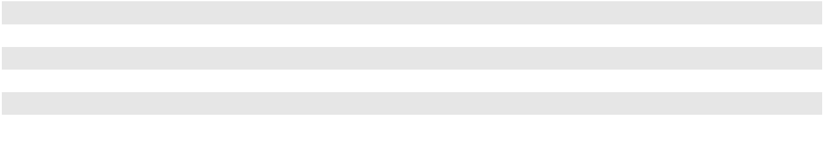

Our incinerators offer a wide range of technological capabilities to customers through this network. In the United States, we provide incineration through one fluidized bed thermal oxidation unit and three solids and liquids-capable incinerator facilities and we operate one active hazardous waste liquid injection incinerator in Canada.

We are currently constructing a second incinerator at our Kimball Nebraska facility that will increase our permitted capacity by approximately 70,000 tons. This incinerator will be the sister site to our El Dorado, Arkansas facility housing a solids and liquids-capable incinerator and is set to open in late 2024.

Commercial and Non-Commercial Landfills. In the United States and Canada, we operate seven commercial landfills with approximately 27.2 million cubic yards of remaining highly probable airspace. Six of our commercial landfills are designed and permitted for the disposal of hazardous waste and one landfill is operated for non-hazardous industrial waste disposal and, to a lesser extent, municipal solid waste. In addition to our commercial landfills, we also own and operate one non-commercial landfill that only accepts waste from our on-site incinerator. Additionally, we are in the process of closing two commercial landfills, Altair and Westmorland, which began closure procedures in 2020, and one on-site non-commercial landfill that reached capacity in early 2023. The three landfills that are already in closure, are excluded from the landfill counts above. See "Landfill Accounting" within Note 2, "Significant Accounting Policies," to our consolidated financial statements included in Item 8 of this report for additional information on our commercial and non-commercial landfills.

Wastewater Treatment Facilities. We operate a total of ten facilities, of which eight are owned and two are leased, that offer a range of wastewater treatment technologies and services. Wastewater treatment consists primarily of three types of services: hazardous wastewater treatment, sludge dewatering or drying and non-hazardous wastewater treatment.

26

Treatment, Storage and Disposal Facilities. We operate 32 TSDFs in the United States and Canada, of which 29 are owned and three are leased. Our TSDFs facilitate the movement of materials among our network of service centers and treatment and disposal facilities. Transportation may be accomplished by truck, rail, barge or a combination of modes, with our own assets or in conjunction with third-party transporters. Specially designed containment systems, vehicles and other equipment permitted for waste transport, together with drivers trained in transportation and waste handling procedures, provide for the movement of customer waste streams.

Other Hazardous Waste Management Properties. We also own eight facilities specializing in solvent recovery, and two autoclave facilities specifically designed to treat medical waste.

Oil Processing, Blending and Packaging Facilities

Oil Terminals. We operate a total of 78 oil terminals, of which 52 are owned and 26 are leased, which collect or process used oil prior to delivery to our re-refineries or distribution as recycled fuel oil.

Oil Recycling and Re-refining Facilities. We own eight oil re-refineries, seven in the United States and one in Canada. With nearly 234.9 million gallons of used oil collected this year, we were able to return 221 million gallons of new re-refined oil, lubricants and byproducts back into the marketplace in 2023.

Oil Packaging and Blending Facilities. We operate a total of four oil packaging and blending facilities, of which three are owned and one is leased.

ITEM 3. LEGAL PROCEEDINGS

See Note 18, "Commitments and Contingencies," to our consolidated financial statements included in Item 8 of this report for a description of legal proceedings.

ITEM 4. MINE SAFETY DISCLOSURES

Not applicable.

27

PART II

ITEM 5. MARKET FOR REGISTRANT'S COMMON EQUITY, RELATED STOCKHOLDER MATTERS AND ISSUER PURCHASES OF EQUITY SECURITIES

Common Stock

Our common stock trades on the New York Stock Exchange ("NYSE") under the symbol CLH. On February 14, 2024, there were 244 stockholders of record of our common stock, excluding stockholders whose shares were held in nominee, or "street name" accounts through brokers or banks. On our last record date, approximately 90,000 additional stockholders beneficially held shares in street name accounts.

We have never declared nor paid any cash dividends on our common stock, and we do not intend to pay any dividends on our common stock in the foreseeable future. We intend to retain our future earnings, if any, for use in the operation and expansion of our business, payment of our outstanding debt and our stock repurchase program. In addition, our current revolving credit agreement and the indentures and loan agreement governing our other outstanding debt limit the amount we could pay as cash dividends on or for repurchase of our common stock. For additional information surrounding our stock repurchase program, see Note 15, "Stockholders' Equity," to our consolidated financial statements included in Item 8 of this report.

Securities Authorized For Issuance Under Equity Compensation Plans

See Item 12, "Security Ownership of Certain Beneficial Owners and Management and Related Stockholder Matters," for a description of the securities which are authorized for issuance under our equity compensation plans.

Issuer Purchases of Equity Securities

 |  |  |  | Total Number of |  | Approximate Dollar
 |  |  |  | Shares Purchased |  | Approximate Dollar
 | Total Number | Average Price |  | as Part of | Value of Shares that May
 | Total Number |  |  | Publicly | Yet Be Purchased Under
Period | of Shares |  | Paid Per | Announced Plans | the Plans or Programs ⁽³⁾
Period | Purchased ⁽¹⁾ |  | Share ⁽²⁾ | or Programs |  | (in thousands)
October 1, 2023 through October 31, 2023 | 30,678 | $ | 153.29 | 29,994 | $ | 82,677
November 1, 2023 through November 30, 2023 | 184,126 |  | 157.92 | 180,724 |  | 54,101
December 1, 2023 through December 31, 2023 | 13,385 |  | 174.58 | — |  | 554,101
Total | 228,189 | $ | 158.27 | 210,718
_____________________
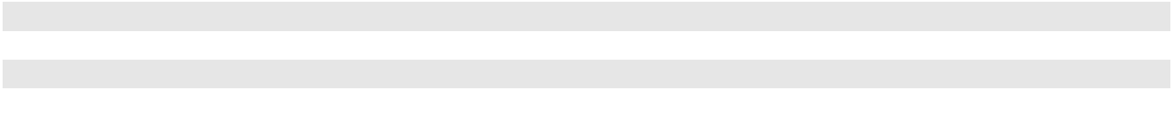
- Includes 17,471 shares withheld by us from employees to satisfy employee tax obligations upon vesting of restricted shares granted under our long-term equity incentive programs.
- The average price paid per share of common stock repurchased under our stock repurchase program includes commissions paid to the brokers.
- On December 5, 2023, our Board of Directors authorized a $500.0 million expansion of the Company’s current share repurchase program. As of December 31, 2023, the amount available for repurchase under the expanded plan is $554.1 million. We have funded and intend to fund repurchases through available cash resources. The stock repurchase program authorizes us to purchase our common stock on the open market or in privately negotiated transactions periodically in a manner that complies with applicable U.S. securities laws. The number of shares purchased and the timing of the purchases has depended and will depend on several factors, including share price, cash required for business plans, trading volume and other conditions. We maintain a repurchase plan in accordance with Rule 10b5-1 promulgated under the Securities Exchange Act of 1934, as amended. During the three months ended December 31, 2023, 54,574 shares were repurchased under the Rule 10b5-1 plan. Future repurchases may be made as open market or privately negotiated transactions as described above. We have no obligation to repurchase stock under this program and may suspend or terminate the repurchase program at any time.

28

COMPARISON OF 5-YEAR CUMULATIVE TOTAL RETURN

AMONG CLEAN HARBORS, INC.,

NYSE COMPOSITE INDEX, S&P MIDCAP 400 INDEX AND A CUSTOM PEER GROUP

Performance Graph

The following graph compares the five-year return from investing $100 in each of our common stock, the NYSE Composite Index, the S&P Midcap 400 Index and a custom peer group. We established a custom peer group that closely aligns with the breadth and size of our business. This peer group is comprised of ABM Industries Incorporated, Advanced Drainage Systems, Inc., Chemed Corporation, Emcor Group, Inc., Enviri Corporation, GFL Environmental, Inc., Healthcare Services Group, Inc., Huntsman Corporation, Iron Mountain Incorporated, KBR, Inc, Quanta Services, Inc., Republic Services, Inc., Rollins, Inc., Stanley Black & Decker, Inc., Stericycle, Inc., Tetra Tech, Inc., Waste Connections, Inc., and Waste Management, Inc. In 2022, we reassessed our peers to maintain a group that closely aligns with the breath and size of our current operations. Further, Heritage-Crystal Clean, Inc. had previously been in the Peer Group but is no longer listed since being acquired by a private company in 2023.

The values illustrated assume reinvestment of dividends on the ex-dividend date and compares relative performance since a particular starting date. In this instance, the starting date was December 31, 2018, when our common stock closed at $49.35 per share. The graph is presented pursuant to SEC rules and is not meant to be an indication of our future performance.

NOTE: Index Data: Copyright Standard and Poor’s, Inc. Used with permission. All rights reserved.
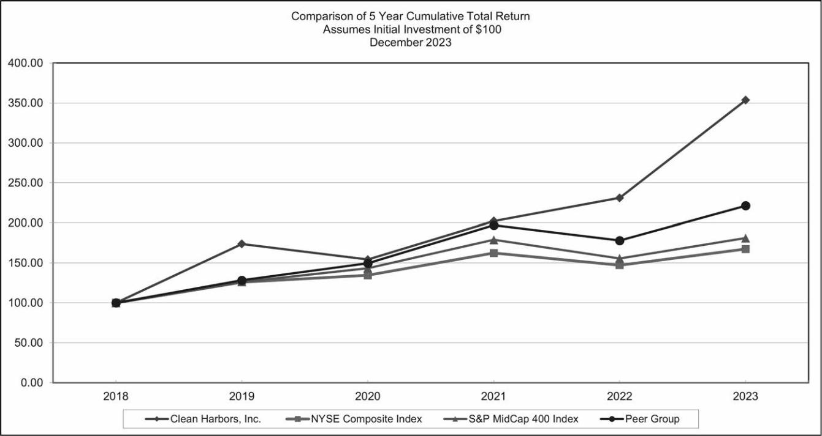

ITEM 6. RESERVED

29

ITEM 7. MANAGEMENT'S DISCUSSION AND ANALYSIS OF FINANCIAL CONDITION AND RESULTS OF OPERATIONS

Overview

We are North America’s leading provider of environmental and industrial services supporting our customers in finding environmentally responsible solutions to further their sustainability goals in today's world. Everywhere industry meets the environment, we strive to provide eco-friendly products and services that protect and restore North America's natural environment. We believe we operate, in the aggregate, the largest number of hazardous waste incinerators, landfills and treatment, storage and disposal facilities ("TSDFs") in North America. We serve over 300,000 customers, including the majority of Fortune 500 companies, across various markets including chemical and manufacturing, as well as numerous government agencies. These customers rely on us to safely deliver a broad range of services including but not limited to end-to-end hazardous waste management, emergency response, industrial cleaning and maintenance and recycling services. We are also a leading provider of parts cleaning and related environmental services to general manufacturing, automotive and commercial customers in North America and largest re-refiner and recycler of used oil in North America.

Performance of our segments is evaluated on several factors of which the primary financial measure is Adjusted EBITDA, as reconciled to our net income and described more fully below. The following is a discussion of how management evaluates its segments in regards to other factors including key performance indicators that management uses to assess the segments’ results, as well as certain macroeconomic trends and influences that impact each reportable segment:

- Environmental Services - Environmental Services segment results are predicated upon the demand by our customers for our wide variety of services, waste volumes managed by delivering such services and project work for which responsible waste handling and/or disposal is required. Environmental Services results are also impacted by the demand for planned and unplanned industrial related cleaning and maintenance services at customer sites, environmental cleanup services on a scheduled or emergency basis, including response to large scale events such as major chemical spills, natural disasters, or other instances where immediate and specialized services are required. The Environmental Services segment results include the Safety-Kleen branches' core environmental service offerings of containerized waste disposal, parts washer and vacuum services. These results are driven by the volumes of waste collected from these customers, the overall number of parts washers placed at customer sites and the demand for and frequency of other offered services. In managing the business and evaluating performance, management tracks the volumes and mix of waste handled and disposed of or recycled, generally through our incinerators, TSDFs and landfills, the utilization rates of our incinerators, equipment and workforce, including billable hours, and the number of parts washer services performed and pricing realized by our business and peer companies as well as other key metrics. Levels of activity and ultimate performance associated with this segment can be impacted by several factors including overall U.S. GDP, U.S. industrial production, economic conditions in the general manufacturing, chemical and automotive markets, including efforts and economic incentives to increase domestic operations, available capacity at waste disposal outlets, weather conditions, efficiency of our operations, technology, changing regulations, competition, market pricing of our services, costs incurred to deliver our services and the management of our related operating costs.

- Safety-Kleen Sustainability Solutions - Safety-Kleen Sustainability Solutions ("SKSS") segment results are impacted by our customers' demand for high-quality, environmentally responsible recycled oil products and their demand for our related service and product offerings. SKSS offers high quality recycled base and blended oil products and other automotive and industrial lubricants to end users including fleet customers, distributors, manufacturers of oil products and industrial plants. Segment results are impacted by market pricing, overall demand and the mix of our oil products sales. Segment results are also predicated on the demand for other SKSS product and service offerings including collection services for used oil, used oil filters and other automotive fluids. The used oil collected is used as feedstock in our oil re-refining to produce our base and blended oil products and other hydraulic oils, lubricants and recycled fuel oil or are integrated into the Clean Harbors' recycling and disposal network. In operating the business and evaluating performance, management tracks the volumes and relative percentages of base and blended oil sales along with various pricing metrics associated with the commodity driven margin between product pricing and the overall costs associated with the collection of used oil. Levels of activity and ultimate performance associated with this segment can be impacted by economic conditions in the manufacturing and automotive services markets, efficiency of our operations, technology, weather conditions, changing regulations, competition and the management of our related operating costs. Costs incurred in connection with the collection of used oil and other raw materials associated with the segment’s oil related products can also be volatile and can be impacted by global events and their relative impact on commodity products and pricing. The overall market price of oil and regulations that change the possible usage of used oil or burning of used oil as a fuel, impact the premium the segment can charge for used oil collections.

30

Highlights

Total direct revenues for 2023 increased 4.7% or $242.5 million to $5,409.2 million, compared with $5,166.6 million in 2022. Our Environmental Services segment direct revenues increased $339.7 million or 8.1% in 2023 compared with 2022 driven by continued growth across all our service offerings, most predominately in our Safety-Kleen branches' core environmental services offerings and our industrial service offerings, including the incremental revenues from the acquisition of Thompson Industrial on March 31, 2023. Direct revenues recorded by our SKSS Segment decreased $97.1 million in 2023 compared to 2022 primarily due lower market-based pricing on our base oil product sales despite higher volumes sold. The SKSS Segment increased the pricing on our collection of used oil services, which partially offset the impact of the lower base oil pricing on direct revenues. Foreign currency translation of our Canadian operations negatively impacted our consolidated direct revenues by $23.3 million in 2023 as compared to 2022.

Income from operations in 2023 was $612.4 million as compared with $634.7 million in 2022. We reported net income in 2023 and 2022 of $377.9 million and $411.7 million, respectively. Adjusted EBITDA, which is the primary financial measure by which we evaluate our segments was $1,012.6 million in 2023 and $1,022.1 million in 2022, a decrease driven by the results of the SKSS Segment, which was largely offset by continued growth in our Environmental Services segment. Additional information regarding Adjusted EBITDA, which is a non-GAAP measure, including a reconciliation of Adjusted EBITDA to net income, appears below under "Adjusted EBITDA."

Net cash from operating activities for 2023 was $734.6 million, an increase of $108.3 million from 2022. Adjusted free cash flow, which management uses to measure our financial strength and ability to generate cash, was $321.9 million in 2023, which represented a $32.0 million increase over 2022. This increase is due to incremental net cash generated by operating activities, partially offset by higher spend on property plant and equipment, net of proceeds from the sale and disposal of fixed assets. Additional information regarding adjusted free cash flow, which is a non-GAAP measure, including a reconciliation of adjusted free cash flow to net cash from operating activities, appears below under "Adjusted Free Cash Flow."

31

Segment Performance

The primary financial measure by which we evaluate the performance of our segments is Adjusted EBITDA. The following table sets forth certain financial information associated with our results of operations for the years ended December 31, 2023, 2022 and 2021 (in thousands, except percentages):

 |  |  |  |  | Summary of Operations
 | For the years ended December 31, |  |  |  |  |  |  | 2023 over 2022 |  |  |  | 2022 over 2021
 | 2023 | 2022 |  | 2021 |  |  |  | Change | % |  |  | Change | %
 | 2023 |  |  |  |  |  |  | Change |  | Change |  | Change |  | Change
Direct Revenues⁽¹⁾:
Environmental Services | $4,511,442 | $4,171,706 |  | $3,032,454 |  | $ |  | 339,736 | 8.1% |  | $1,139,252 |  | 37.6%
Safety-Kleen Sustainability Solutions | 897,263 | 994,392 |  | 772,813 |  |  |  | (97,129) | (9.8) |  | 221,579 |  | 28.7
Corporate Items | 447 |  | 507 |  | 299 |  |  | (60) |  | N/M |  | 208 |  | N/M
Total | 5,409,152 | 5,166,605 |  | 3,805,566 |  |  |  | 242,547 | 4.7 |  | 1,361,039 |  | 35.8
Cost of Revenues⁽²⁾:
Environmental Services | 3,063,043 | 2,902,979 |  | 2,106,790 |  |  |  | 160,064 | 5.5 |  | 796,189 |  | 37.8
Safety-Kleen Sustainability Solutions | 646,301 | 615,303 |  | 484,662 |  |  |  | 30,998 | 5.0 |  | 130,641 |  | 27.0
Corporate Items | 36,780 |  | 25,648 |  | 18,385 |  |  | 11,132 |  | N/M |  | 7,263 |  | N/M
Total | 3,746,124 |  | 3,543,930 |  | 2,609,837 |  |  | 202,194 | 5.7 |  |  | 934,093 | 35.8
Selling, General and Administrative Expenses:
Environmental Services | 346,791 | 315,674 |  | 265,946 |  |  |  | 31,117 | 9.9 |  | 49,728 |  | 18.7
Safety-Kleen Sustainability Solutions | 78,089 | 72,762 |  | 60,797 |  |  |  | 5,327 | 7.3 |  | 11,965 |  | 19.7
Corporate Items | 246,281 |  | 238,955 |  | 211,219 |  |  | 7,326 | 3.1 |  |  | 27,736 | 13.1
Total | 671,161 | 627,391 |  | 537,962 |  |  |  | 43,770 | 7.0 |  | 89,429 |  | 16.6
Adjusted EBITDA:
Environmental Services | 1,101,608 | 953,053 |  | 659,718 |  |  |  | 148,555 | 15.6 |  | 293,335 |  | 44.5
Safety-Kleen Sustainability Solutions | 172,873 | 306,327 |  | 227,354 |  |  |  | (133,454) | (43.6) |  | 78,973 |  | 34.7
Corporate Items | (261,911) |  | (237,252) |  | (210,466) |  |  | (24,659) | (10.4) |  |  | (26,786) | (12.7)
Total | $1,012,570 |  | $1,022,128 |  | $ 676,606 |  | $ | (9,558) | (0.9)% |  |  | $ 345,522 | 51.1%
Adjusted EBITDA as a % of Direct Revenues:
Environmental Services⁽³⁾ | 24.4 % | 22.8 % |  | 21.8 % |  |  |  | 1.6 % |  |  | 1.0 %
Safety-Kleen Sustainability Solutions⁽³⁾ | 19.3 % | 30.8 % |  | 29.4 % |  |  |  | (11.5) % |  |  | 1.4 %
Corporate Items⁽⁴⁾ | (4.8) % | (4.6) % |  | (5.5) % |  |  |  | (0.2) % |  |  | 0.9 %
Total | 18.7 % | 19.8 % |  | 17.8 % |  |  |  | (1.1)% |  |  | 2.0 %
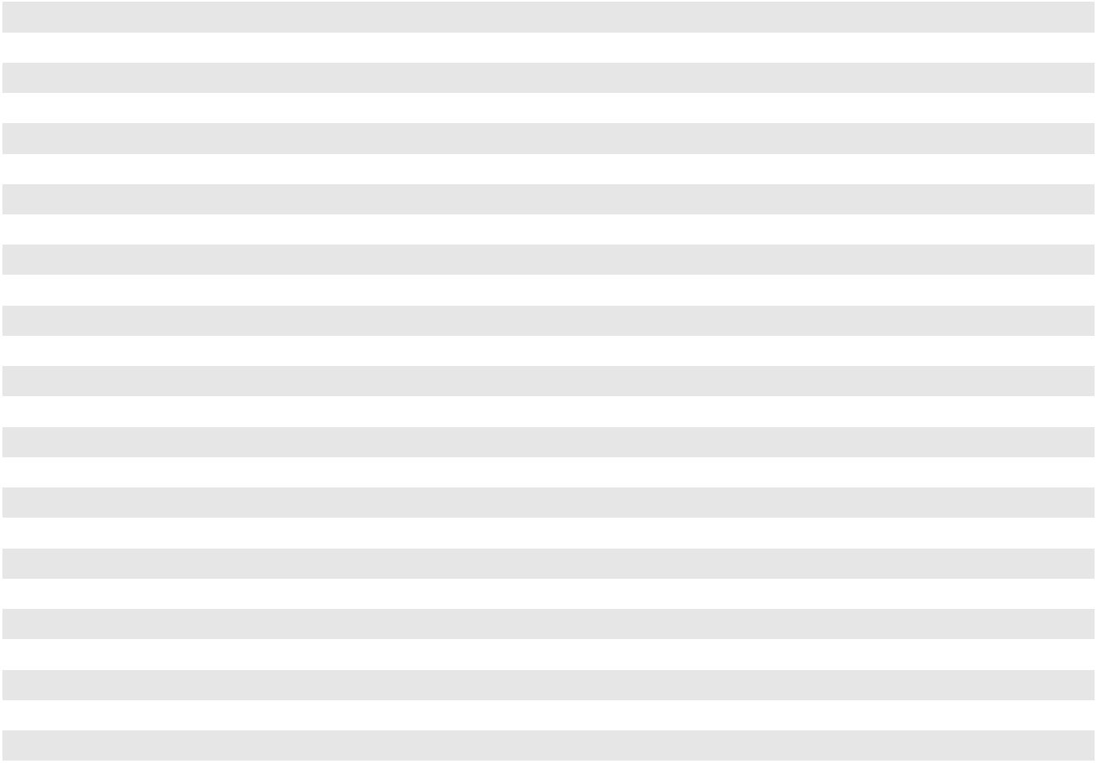

___________________________________

N/M = not meaningful

- Direct revenue is revenue allocated to the segment performing the provided service.

- Cost of revenue is shown exclusive of items presented separately on the consolidated statements of operations, which consist of (i) accretion of environmental liabilities and (ii) depreciation and amortization.
- Calculated as a percentage of individual segment direct revenue.

- Calculated as a percentage of total Company revenue.

32

Direct Revenues

There are many factors which can impact our revenues including, but not limited to: overall levels of industrial activity and economic growth in North America, competitive industry pricing, overall market incineration capacity including captive incineration closures, impacts of acquisitions and divestitures, the level of emergency response services, government infrastructure investment, existence or non-existence of large scale environmental waste and remediation projects, weather related events, the number of parts washers placed at customer sites, miles driven and related lubricant demand, base and blended oil pricing, market supply for base oil products, market changes relative to the collection of used oil, our ability to manage the spread between oil product prices, and prices for the collection of used oil and foreign currency translation. In addition, customer efforts to minimize hazardous waste and changes in regulation can impact our revenues.

Environmental Services

 |  | For the years ended December 31, |  |  |  |  |  | 2023 over 2022 |  |  |  | 2022 over 2021
(in thousands, except percentages) |  | 2023 |  | 2022 |  | 2021 |  | Change | % |  |  | Change | %
 |  |  |  |  |  |  |  | Change |  | Change |  | Change |  | Change
Direct revenues |  | $4,511,442 | $4,171,706 |  | $3,032,454 |  | $ 339,736 |  | 8.1 % |  | $1,139,252 |  | 37.6 %

Environmental Services direct revenues for the year ended December 31, 2023 increased $339.7 million from the comparable period in 2022 due to growth across our service offerings. Revenue from our Safety-Kleen branches' core service offerings increased $113.9 million as both demand and pricing increased for our containerized waste, parts washer and vacuum services. Revenue from our industrial services operations grew $107.9 million due to contributions from the acquisition of Thompson Industrial on March 31, 2023 coupled with growth of the legacy industrial service offerings. Technical services revenue increased $68.6 million with contributions across our portfolio of waste disposal services more than offsetting slightly lower utilization at our incinerators. Landfill volumes and pricing both increased in 2023 and pricing for our incineration benefitted 2023 as well. Utilization at our incinerators for 2023 was 84% as compared to 86% in the prior year due to unplanned outages for required maintenance and significant weather events earlier in 2023. Field and emergency response service revenues increased $34.6 million from 2022. The Canadian operations of the Environmental Services segment were negatively impacted by $18.5 million due to foreign currency translation.

Environmental Services direct revenues for the year ended December 31, 2022 increased $1,139.3 million from the comparable period in 2021, split almost equally between growth of the legacy operations and incremental revenues from the HydroChemPSC operations acquired on October 8, 2021. More specifically, direct revenues of our industrial service offerings increased $605.1 million, most predominately in revenue streams associated with the HydroChemPSC operations. Technical services and Safety-Kleen Environmental services revenues, which were not impacted by the acquisition of HydroChemPSC, grew by 23.6% and 18.5%, respectively. Technical services revenues increased $285.6 million with revenue growth across our portfolio of waste disposal facilities driven by higher throughput, higher value waste streams at our incinerators and broad based pricing initiatives, including fuel surcharges. In 2022, utilization at our incinerators was 86% as compared to 85% in 2021, largely due to increased volumes and throughput efficiencies offsetting an increase in down days due to weather related events, most notably in the fourth quarter of 2022. We also saw a 29% increase in landfill volumes in 2022 when compared with 2021. Direct revenues for the Safety-Kleen core service offerings increased $119.4 million from the comparable period in 2021 due to improved pricing and greater demand for our containerized waste, vacuum services and parts washer services. Field and emergency response services revenues increased $108.9 million largely due to contributions from the HydroChemPSC operations and as legacy base business returned to pre-pandemic levels despite a $39.3 million decrease in decontamination services. The Canadian operations of the Environmental Services segment were negatively impacted by $19.4 million due to foreign currency translation.

Safety-Kleen Sustainability Solutions

 |  | For the years ended December 31, |  |  |  |  |  | 2023 over 2022 |  |  |  | 2022 over 2021
(in thousands, except percentages) |  | 2023 |  | 2022 |  | 2021 |  | Change | % |  |  | Change | %
 |  |  |  |  |  |  |  | Change |  | Change |  | Change |  | Change
Direct revenues |  | $ 897,263 | $ 994,392 |  | $ 772,813 |  | $ (97,129) |  | (9.8)% |  | $ 221,579 |  | 28.7 %

SKSS direct revenues for the year ended December 31, 2023 decreased $97.1 million from the comparable period in 2022. Base oil sales revenues decreased $97.6 million due to lower pricing despite an 8% increase in the volume sold during 2023. Revenues from contract packaging also decreased $18.0 million and revenues from recycled fuel oil and refinery byproducts decreased $12.2 million. Blended oil sales revenues increased $19.5 million, a 23% increase in gallons sold, which offset the lower pricing of these products. Revenues from the collection of used oil increased $14.1 million driven by higher pricing for these services. The Canadian operations of the SKSS segment were negatively impacted by $4.8 million in 2023 due to foreign currency translation.

33

SKSS direct revenues for the year ended December 31, 2022 increased $221.6 million from the comparable period in 2021. The overall growth was largely driven by a $154.1 million increase in base oil revenue predominately due to higher pricing across slightly lower volumes sold. Revenues from recycled fuel oil and refinery byproducts increased $53.1 million and revenues from blended oil sales increased $30.0 million due to higher pricing which more than offset a 22% decrease of gallons sold. During 2022, the volume of used oil collected increased in line with the expansion of our network through two acquisitions, (see Note 4, "Business Combinations," to our consolidated financial statements included in Item 8 of this report), however, revenue from the collection of used oil decreased $10.0 million. The Canadian operations of the SKSS segment were negatively impacted by $6.7 million in 2022 due to foreign currency translation.

Cost of Revenues

We believe that management of operating costs is vital to our ability to remain price competitive. We continue to experience the current macroeconomic inflationary pressures across several cost categories, but most notably related to internal and external labor, transportation, general supplies and energy related costs. We aim to manage these increases through constant cost monitoring and a focus on cost saving areas, including lowering employee turnover, as well as our overall customer pricing strategies designed to offset the negative inflationary impacts on our margins.

We continue to upgrade the quality and efficiency of our services through the development of new technology and continued modifications and expansion at our facilities. We invest in new business opportunities and aggressively implement strategic sourcing and logistics solutions in the face of inflationary pressures, while also continuing to optimize our management and operating structure in an effort to manage our operating margins.

Environmental Services

 |  | For the years ended December 31, |  |  |  |  |  | 2023 over 2022 |  |  |  | 2022 over 2021
(in thousands, except percentages) |  | 2023 |  | 2022 |  | 2021 |  | Change | % |  |  | Change | %
 |  |  |  |  |  |  |  | Change |  | Change |  | Change |  | Change
Cost of revenues |  | $3,063,043 | $2,902,979 |  | $2,106,790 |  | $160,064 |  | 5.5 % |  | $796,189 |  | 37.8 %
As a % of Direct revenues |  | 67.9 % | 69.6 % |  | 69.5 % |  | (1.7)% |  |  |  | 0.1 %

Environmental Services cost of revenues for the year ended December 31, 2023 increased $160.1 million from the comparable period in 2022, but as a percentage of revenues, these costs improved 1.7%. Overall, labor and benefit related costs increased $126.1 million, equipment and supply costs increased $23.4 million and external transportation, vehicle and fuel related costs increased $6.8 million. These cost increases were generally commensurate with the revenue growth in the business, however better leverage of our costs drove the cost improvement as a percentage of revenues.

Environmental Services cost of revenues for the year ended December 31, 2022 increased $796.2 million from the comparable period in 2021 primarily due to the increase in direct revenues noted above, including additional costs from the HydroChemPSC operations. Cost of revenues as a percentage of direct revenues remained relatively consistent with 2021 despite lower decontamination services and the growth of our industrial services offerings which typically operate at a lower margin than our waste disposal focused offerings. Overall, labor and benefit related costs, including travel, increased $386.4 million, equipment and supply costs increased $199.7 million and external transportation, vehicle and fuel costs increased $132.8 million. These increases were driven by a combination of overall business growth, including the addition of HydroChemPSC, and inflationary pressures.

Safety-Kleen Sustainability Solutions

 |  | For the years ended December 31, |  |  |  |  |  | 2023 over 2022 |  |  |  | 2022 over 2021
(in thousands, except percentages) |  | 2023 |  | 2022 |  | 2021 |  | Change | % |  |  | Change | %
 |  |  |  |  |  |  |  | Change |  | Change |  | Change |  | Change
Cost of revenues |  | $646,301 | $615,303 |  | $484,662 |  | $ 30,998 |  | 5.0 % |  | $130,641 |  | 27.0 %
As a % of Direct revenues |  | 72.0 % | 61.9 % |  | 62.7 % |  | 10.1 % |  |  |  | (0.8)%

SKSS cost of revenues for the year ended December 31, 2023 increased $31.0 million from 2022 and as a percentage of revenues, these costs increased 10.1%, mainly driven by the reduced revenue discussed above. Overall, external transportation, rail, vehicle and fuel costs increased $23.5 million, labor and benefit related costs increased $11.8 million and equipment and supply costs increased $5.5 million. Cost of materials, including oil additives and other raw materials decreased by $16.2 million mainly driven by a lower cost of obtaining used oil though our oil collection services. The remaining cost spread across various cost categories.

SKSS cost of revenues for the year ended December 31, 2022 increased $130.6 million from the comparable period in

2021 and as a percentage of revenue continued to improve. The cost of raw materials used in production of our oil products

34

increased $74.5 million, more than half of which was due to increased costs to obtain used oil through our used oil collection services. The increase in base oil pricing resulted in a correlating increase in the cost we paid for used oil feedstock. Other primary costs that contributed to the overall increase include external transportation, vehicle and fuel costs which increased $25.3 million, labor and benefit related costs, including travel, which increased $9.7 million and equipment and supply costs which increased $2.8 million.

Selling, General and Administrative Expenses

We strive to manage our selling, general and administrative ("SG&A") expenses commensurate with the overall performance of our segments and corresponding revenue levels. We believe our ability to properly align these costs with business performance is reflective of our strong management of the businesses and further promotes our ability to remain competitive in the marketplace.

Environmental Services

 |  | For the years ended December 31, |  |  |  |  |  | 2023 over 2022 |  |  |  | 2022 over 2021
(in thousands, except percentages) |  | 2023 |  | 2022 |  | 2021 |  | Change | % |  |  | Change | %
 |  |  |  |  |  |  |  | Change |  | Change |  | Change |  | Change
SG&A expenses |  | $346,791 | $315,674 |  | $265,946 |  | $ 31,117 |  | 9.9 % |  | $ 49,728 |  | 18.7 %
As a % of Direct revenues |  | 7.7 % | 7.6 % |  | 8.8 % |  | 0.1 % |  |  |  | (1.2)%

Environmental Services SG&A expenses for the year ended December 31, 2023 increased $31.1 million from the comparable period in 2022, but remained relatively consistent as a percentage of revenues by maintaining leverage of our SG&A base in the midst of the revenue growth discussed above. Overall, labor and benefit related costs, including travel, increased $32.0 million primarily driven by incremental headcount, including the acquisitions occurring during the periods, and higher incentive compensation.

Environmental Services SG&A expenses for the year ended December 31, 2022 increased $49.7 million from the comparable period in 2021, but improved 1.2% as a percentage of revenues driven by leveraging our SG&A base in the midst of the revenue growth discussed above. Increased labor and benefits related cost, including travel, of $35.4 million was the largest contributor to the overall cost increase, predominantly due to the addition of the HydroChemPSC business operations, investments in our employees and higher incentive compensation. The remaining increases were spread across various other cost categories.

Safety-Kleen Sustainability Solutions

 |  | For the years ended December 31, |  |  |  |  |  | 2023 over 2022 |  |  |  |  | 2022 over 2021
(in thousands, except percentages) |  | 2023 |  | 2022 |  | 2021 |  | Change | % |  |  |  | Change | %
 |  |  |  |  |  |  |  | Change |  | Change |  |  | Change |  | Change
SG&A expenses |  | $ 78,089 | $ 72,762 |  | $ 60,797 |  | $ 5,327 |  | 7.3 % $ |  |  |  | 11,965 | 19.7 %
As a % of Direct revenues |  | 8.7 % | 7.3 % |  | 7.9 % |  | 1.4 % |  |  |  |  |  | (0.6)%

SKSS SG&A expenses for the year ended December 31, 2023 increased $5.3 million from the comparable period in 2022 and as a percentage of revenues these costs increased mainly due to the revenue reductions discussed above. Higher labor and benefit costs of $3.5 million and a $1.1 million increase in a remedial liability estimate in 2023 drove the overall cost increase. The higher labor and benefit costs were primarily driven by the expanded sales team established in late 2022 which remained relatively consistent through 2023.

SKSS SG&A expenses for the year ended December 31, 2022 increased $12.0 million from the comparable period in

2021 primarily due to a $9.9 million increase in labor and benefit costs, including travel, as we expanded our sales team for the segment and made other incremental workforce investments to support its growth. The remaining increases were spread across various cost categories. As a percentage of revenue, these costs improved slightly when compared to the same period in the prior year.

35

Corporate Items

 |  | For the years ended December 31, |  |  |  |  |  | 2023 over 2022 |  |  |  | 2022 over 2021
(in thousands, except percentages) |  | 2023 |  | 2022 |  | 2021 |  | Change | % |  |  | Change | %
 |  |  |  |  |  |  |  | Change |  | Change |  | Change |  | Change
SG&A expenses |  | $246,281 | $238,955 |  | $211,219 |  | $7,326 |  | 3.1 % |  | $27,736 |  | 13.1 %
As a % of Total Company Direct revenues |  | 4.6 % | 4.6 % |  | 5.6 % |  |  | — % |  |  | (1.0)%

We manage our Corporate SG&A expenses commensurate with the overall total Company performance and direct revenue levels. As a percentage of revenue these costs remained relatively consistent in 2023 after a decrease from 2021 to 2022.

In total, Corporate Items SG&A expenses increased by $7.3 million in 2023; however, as noted above, these costs remained relatively consistent as a percentage of revenues. In general, the overall cost increase was driven by higher labor and benefit related expenses, professional fees and cybersecurity/ information technology costs of $5.6 million, $3.9 million and $3.2 million, respectively, partially offset by lower stock-based compensation expense of $6.1 million.

Corporate Items SG&A expenses for the year ended December 31, 2022 increased by $27.7 million in 2021. Overall cost increases included a $23.3 million increase in labor, benefits and travel related expenses, including incentive compensation, driven by investments in our workforce, and an $8.0 million increase from higher stock-based compensation costs. The increase in stock-based compensation expense was driven by the timing of grants issued in 2022 and higher expense associated with the achievement of performance metrics. Overall grants for 2022 were slightly lower than for 2021. Additional drivers of the overall increase in Corporate Items SG&A included a $6.7 million increase in cybersecurity information technology related costs and a $2.2 million closure reserve estimate increase for an inactive non-landfill site. Partially offsetting these cost increases were a reduction in professional fees of $6.8 million and a reduction in severance costs of $6.0 million, both related to costs from the acquisition of HydroChemPSC in 2021 which did not recur in 2022. Additionally, in 2022 we recognized a $3.0 million breakup fee received for the termination of the proposed asset acquisition from Vertex Energy, Inc.

Adjusted EBITDA

Management considers Adjusted EBITDA to be a measurement of performance which provides useful information to both management and investors. Adjusted EBITDA should not be considered an alternative to net income or other measurements under generally accepted accounting principles ("GAAP"). Adjusted EBITDA is not calculated identically by all companies, and therefore our measurements of Adjusted EBITDA, while defined consistently and in accordance with our existing credit agreement, may not be comparable to similarly titled measures reported by other companies.

We use Adjusted EBITDA to enhance our understanding of our operating performance, which represents our views concerning our performance in the ordinary, ongoing and customary course of our operations. We historically have found it helpful, and believe that investors have found it helpful, to consider an operating measure that excludes certain expenses relating to transactions not reflective of our core operations.

The information about our operating performance provided by Adjusted EBITDA is used by our management for a variety of purposes. We regularly communicate Adjusted EBITDA results to our lenders since our loan covenants are based upon levels of Adjusted EBITDA achieved and to our board of directors and we discuss with the board our interpretation of such results. We also compare our Adjusted EBITDA performance against internal targets as a key factor in determining cash and equity bonus compensation for executives and other employees, largely because we believe that this measure is indicative of how the fundamental business is performing and being managed.

We also provide information relating to our Adjusted EBITDA so that analysts, investors and other interested persons have the same data that we use to assess our core operating performance. We believe that Adjusted EBITDA should be viewed only as a supplement to the GAAP financial information. We also believe, however, that providing this information in addition to, and together with, GAAP financial information provides a better understanding of our core operating performance and how management evaluates and measures our performance.

36

The following is a reconciliation of net income to Adjusted EBITDA for the following years (in thousands, except percentages):

 |  |  |  |  |  |  |  |  |  |  |  |  |  |  | For the years ended December 31,
Net income |  |  |  |  |  |  |  |  |  |  | 2023 |  |  |  |  |  |  |  |  | 2022 |  |  |  |  |  |  | 2021
 |  |  |  |  |  |  |  |  |  | $ | 377,856 |  |  |  |  |  |  | $ |  | 411,744 |  |  |  |  |  | $ | 203,247
Accretion of environmental liabilities |  |  |  |  |  |  |  |  |  |  |  | 13,667 |  |  |  |  |  |  |  | 12,943 |  |  |  |  |  |  | 11,745
Stock-based compensation |  |  |  |  |  |  |  |  |  |  |  | 20,703 |  |  |  |  |  |  |  | 26,844 |  |  |  |  |  |  | 18,839
Depreciation and amortization |  |  |  |  |  |  |  |  |  |  | 365,761 |  |  |  |  |  |  |  |  | 347,594 |  |  |  |  |  |  | 298,135
Other (income) expense, net |  |  |  |  |  |  |  |  |  |  |  | (2,315) |  |  |  |  |  |  |  | (2,472) |  |  |  |  |  |  | 515
Loss on early extinguishment of debt |  |  |  |  |  |  |  |  |  |  |  | 2,880 |  |  |  |  |  |  |  | 422 |  |  |  |  |  |  |  | —
Gain on sale of business |  |  |  |  |  |  |  |  |  |  |  |  |  |  | — |  |  |  |  | (8,864) |  |  |  |  |  |  |  | —
Interest expense, net of interest income |  |  |  |  |  |  |  |  |  |  | 108,595 |  |  |  |  |  |  |  |  | 107,663 |  |  |  |  |  |  | 77,657
Provision for income taxes |  |  |  |  |  |  |  |  |  |  | 125,423 |  |  |  |  |  |  |  |  | 126,254 |  |  |  |  |  |  | 66,468
Adjusted EBITDA
 |  |  |  |  |  |  |  |  |  | $ | 1,012,570 |  |  |  |  |  |  | $ |  | 1,022,128 |  |  |  |  |  | $ | 676,606
As a % of Direct revenues |  |  |  |  |  |  |  |  |  |  |  | 18.7 % |  |  |  |  |  |  |  | 19.8 % |  |  |  |  |  |  | 17.8 %
Depreciation and Amortization
 |  |  |  | For the years ended December 31, |  |  |  |  |  |  |  |  |  |  | 2023 over 2022 |  |  |  |  |  |  |  |  |  |  | 2022 over 2021
(in thousands, except percentages) |  |  |  | 2023 |  |  | 2022 |  |  | 2021 |  |  |  |  | Change |  |  |  |  | % |  |  |  | Change |  |  | %
(in thousands, except percentages) |  |  |  | 2023 |  |  | 2022 |  |  | 2021 |  |  |  |  |  |  |  |  |  | Change |  |  |  |  |  |  |  | Change
Depreciation of fixed assets and
amortization of landfills and |  |  | $ | 315,499 | $ |  | 297,357 | $ |  | 263,387 |  | $ |  |  | 18,142 |  |  |  |  | 6.1 % |  |  | $ | 33,970 |  |  | 12.9 %
finance leases |  |  |  |  |  |  |  |  |  |  |  |  |  |  |  |  |  |  |  | 6.1 % |  |  | $
Permits and other intangibles |  |  |  | 50,262 |  |  | 50,237 |  |  | 34,748 |  |  |  |  | 25 |  |  |  |  | — |  |  |  | 15,489 |  |  | 44.6
amortization |  |  |  | 50,262 |  |  | 50,237
Total depreciation and |  |  | $ | 365,761 | $ |  | 347,594 | $ |  | 298,135 |  | $ |  |  | 18,167 |  |  |  |  | 5.2 % |  |  | $ | 49,459 |  |  | 16.6 %
amortization |  |  |  |  |  |  |  |  |  |  |  |  |  |  |  |  |  |  |  | 5.2 % |  |  | $
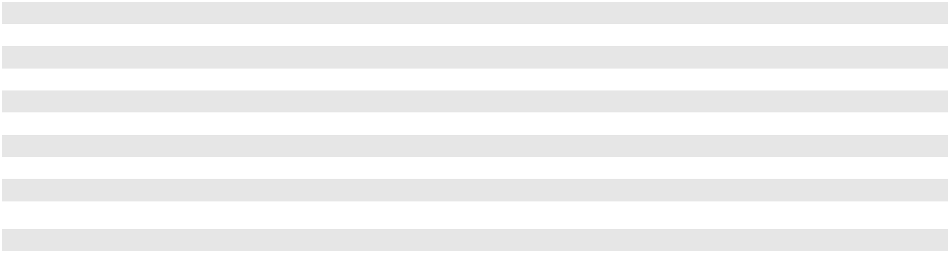
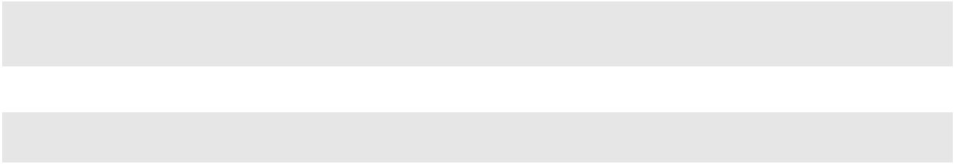

Depreciation and amortization for the year ended December 31, 2023 increased $18.2 million from the comparable period in 2022 due to incremental depreciation and amortization associated with the Thompson Industrial assets acquired on March 31, 2023 and increased finance lease and landfill amortization in the period. For additional information regarding the acquired balances, see Note 4, "Business Combinations," to our consolidated financial statements included in Item 8 of this report.

Depreciation and amortization for the year ended December 31, 2022 increased $49.5 million from the comparable period in 2021 predominately due to the depreciation and amortization of the HydroChemPSC tangible and intangible assets as well as increased depreciation and amortization associated with the acquisition completed in the second quarter of 2022.

Other Income (Expense), net

 |  | For the years ended December 31, |  |  |  |  |  |  |  |  | 2023 over 2022 |  |  |  |  | 2022 over 2021
(in thousands, except percentages) |  | 2023 |  |  | 2022 |  |  | 2021 |  |  | Change | % |  |  |  | Change | %
(in thousands, except percentages) |  | 2023 |  |  | 2022 |  |  | 2021 |  |  | Change |  | Change |  |  | Change |  | Change
Other income (expense), net |  | $ 2,315 | $ |  | 2,472 | $ |  | (515) | $ |  | (157) | (6.4)% $ |  |  |  | 2,987 | (580.0)%

For the year ended December 31, 2023, other income (expense), net remained relatively consistent with the comparable period in 2022. For the year ended December 31, 2022, other income (expense), net increased $3.0 million primarily due to gains recognized on the sale of fixed assets in 2022.

Loss on Early Extinguishment of Debt

 |  | For the years ended December 31, |  |  |  |  |  |  |  | 2023 over 2022 |  |  |  |  | 2022 over 2021
(in thousands, except percentages) |  | 2023 |  |  | 2022 |  |  | 2021 |  | Change | % |  |  |  | Change | %
(in thousands, except percentages) |  | 2023 |  |  | 2022 |  |  | 2021 |  | Change |  | Change |  |  | Change |  | Change
Loss on early extinguishment of debt |  | $ (2,880) | $ |  | (422) | $ |  | — | $ (2,458) |  | 582.5 % $ |  |  |  | (422) | 100.0 %

For the year ended December 31, 2023, loss on early extinguishment of debt increased $2.5 million from the comparable period in 2022 due to losses recognized for the repayment of Term Loans due in 2024 and repricing of the Term Loans due in 2028. For additional information regarding our current portfolio of long-term debt and related significant activity, see Note 12, "Financing Arrangements," to our consolidated financial statements included in Item 8 of this report.

37

Gain on Sale of Business

 |  | For the years ended December 31, |  |  |  |  |  |  |  |  | 2023 over 2022 |  |  |  |  | 2022 over 2021
(in thousands, except percentages) |  | 2023 |  |  |  | 2022 |  |  | 2021 |  | Change | % |  |  |  | Change | %
 |  | 2023 |  |  |  | 2022 |  |  | 2021 |  | Change |  | Change |  |  | Change |  | Change
Gain on sale of business |  | $ | — |  | $ | 8,864 |  | $ | — |  | $ (8,864) |  | 100.0 % |  | $ | 8,864 |  | 100.0 %

During the year ended December 31, 2022, we recognized an $8.9 million gain on the sale of a non-core line of business within our Environmental Services segment. For additional information regarding the gain on sale of business in 2022, see Note 5, "Disposition of Business," to our consolidated financial statements included in Item 8 of this report.

Interest Expense, Net of Interest Income

 |  | For the years ended December 31, |  |  |  |  |  |  | 2023 over 2022 |  |  |  | 2022 over 2021
(in thousands, except percentages) |  | 2023 |  | 2022 |  | 2021 |  |  | Change | % |  |  | Change | %
 |  |  |  |  |  |  |  |  | Change |  | Change |  | Change |  | Change
Interest expense, net of interest |  | $ 108,595 | $ 107,663 |  | $ 77,657 |  | $ |  | 932 | 0.9 % |  | $ 30,006 |  | 38.6 %
income

Interest expense, net of interest income for the year ended December 31, 2023 remained relatively consistent with the comparable period in 2022 as higher interest rates on our portfolio of debt obligations were partially offset by recognizing an $8.3 million benefit from settling certain interest rate swaps in January 2023 and higher interest income realized, generally on our cash investments. The effective interest rates on our long-term debt for the years ended December 31, 2023 and December 31, 2022 were 5.19% and 4.05%, respectively.

Interest expense, net of interest income, increased $30.0 million in 2022 when compared to 2021. This increase was primarily due to the incremental interest associated with the $1.0 billion of secured senior term loans issued in October 2021 in connection with the acquisition of HydroChemPSC. Increases in the variable rates on our existing debt during the period was offset by increased interest income and capitalized interest.

As we exit 2023, the effective rate on our debt is approximately 5.34% given the current interest rate environment and our portfolio of long-term debt and related interest rate swaps. For additional information regarding our current portfolio of long-term debt, see Note 12, "Financing Arrangements," to our consolidated financial statements included in Item 8 of this report.

Provision for Income Taxes

 |  | For the years ended December 31, |  |  |  |  |  | 2023 over 2022 |  |  |  | 2022 over 2021
(in thousands, except percentages) |  | 2023 |  | 2022 |  | 2021 |  | Change | % |  |  | Change | %
 |  |  |  |  |  |  |  | Change |  | Change |  | Change |  | Change
Provision for income taxes |  | $125,423 | $126,254 |  | $66,468 |  | $ (831) |  | (0.7)% |  | $59,786 |  | 89.9%
Effective tax rate |  | 24.9 % | 23.5 % |  | 24.6 % |  | 1.4 % |  |  |  | (1.1)%

For the year ended December 31, 2023, the provision for income taxes was relatively consistent with the comparable period in 2022 despite a decrease in pre-tax earnings. The effective tax rate for 2023 was 24.9% which is higher than the 2022 effective tax rate of 23.5% primarily due to the utilization of unbenefited losses in 2022, which reduced the effective tax rate in that period.

For the year ended December 31, 2022, provision for income taxes increased $59.8 million from the comparable period in 2021, largely due to the increase in pre-tax earnings. The effective tax rate for 2022 was 23.5% which is relatively consistent with the 2021 effective tax rate of 24.6%.

The 2022 and 2021 effective tax rates benefited from the utilization of previously unbenefited losses in certain of our Canadian entities for which we had previously recognized valuation allowances. These entities had historically generated operating losses but began to generate profits due to discrete events, including government subsidies and the gain on sale of a business, but more recently due to operational profits. As of December 31, 2022, these net operating losses were fully utilized and any remaining valuation allowance, which was nominal, was released.

Liquidity and Capital Resources

We assess our liquidity in terms of our ability to generate cash to fund our operating, investing and financing activities. Our primary ongoing cash requirements will be to fund operations, capital expenditures, interest payments and investments in line with our business strategy. We believe our future operating cash flows will be sufficient to meet our future operating and internal investing cash needs. We monitor our actual needs and forecasted cash flows, our liquidity and our capital resources, enabling us to plan our present needs and fund items that may arise during the year as a result of changing business conditions

38

or opportunities. Furthermore, our existing cash balance and the availability of additional borrowings under our revolving credit facility provide additional potential sources of liquidity should they be required.

Summary of Cash Flow Activity

 |  |  | For the years ended December 31,
(in thousands) |  |  | 2023 |  |  | 2022 |  |  | 2021
Net cash from operating activities |  | $ | 734,552 | $ |  | 626,214 | $ |  | 545,997
Net cash used in investing activities |  |  | (575,050) |  |  | (388,944) |  |  | (1,507,602)
Net cash (used in) from financing activities |  |  | (208,891) |  |  | (187,315) |  |  | 898,249

Net cash from operating activities

Net cash from operating activities for the year ended December 31, 2023 was $734.6 million as compared to $626.2 million for year ended December 31, 2022. This $108.3 million increase in operating cash flows was attributable to improvement in working capital balances, partially offset by higher cash paid for income taxes, environmental expenditures and interest.

Net cash from operating activities for the year ended December 31, 2022 was $626.2 million, an increase of $80.2 million compared to the year ended December 31, 2021. The operating cash flows were most notably impacted by greater levels of operating income partially offset by an increase in working capital caused by the recent significant growth in the business, strategic inventory management and higher payments for interest, income taxes and incentive compensation. With approximately 30% of our debt being subject to variable interest rates during 2022, the LIBOR rate increases during the year, as well as a full year of interest payments for the incremental debt issued in October of 2021, resulted in the increase in interest payments when compared to the prior year. The increased tax payments were attributable to increased profits.

Net cash used in investing activities

Net cash used in investing activities for the year ended December 31, 2023 was $575.1 million, an increase of $186.1

million compared to the year ended December 31, 2022. Amounts spent on additions to property, plant and equipment, net of

proceeds from the sale and disposal of fixed assets increased $76.4 million, primarily driven by incremental spend on the new

incinerator being built in Kimball, Nebraska. Total spending in 2023 related to the construction of the new incinerator was

$82.6 million compared to $44.9 million spent on the project in 2022. Also contributing to the overall increase in cash used in

investing activities was a $40.9 million cash outflow from the net purchase of marketable securities in 2023 compared to a

$18.8 million cash inflow from the net sale of marketable securities in 2022. Cash paid for acquisitions, net of cash acquired

reflected an increase of $33.3 million due to the acquisition of Thompson Industrial in 2023 for $110.9 million compared to

$86.3 million paid for acquisitions in 2022. The cash flows in 2022 also include $16.8 million of proceeds from the sale of a

business which didn't recur in 2023.

Net cash used in investing activities for the year ended December 31, 2022 was $388.9 million, a decrease of $1,118.7 million compared to the year ended December 31, 2021. Cash paid for acquisitions, net reflected a decrease of $1,167.0 million due to the acquisition of HydroChemPSC in 2021 for $1.23 billion compared to $86.3 million paid for acquisitions in 2022. Also contributing to the overall decrease was an $18.8 million cash inflow from the net sale of marketable securities compared to a $30.8 million cash outflow from the net purchase of marketable securities in 2021. This change in cash flows is largely due to timing. In 2022 we received $16.8 million for the sale of a business which decreased the net cash used in investing activities for 2022. Amounts spent on additions to property, plant and equipment, net of proceeds from the sale and disposal of fixed assets increased $116.6 million which partially offset these decreases. The higher spending on property, plant and equipment was driven by incremental spend on the new incinerator being built in Kimball, Nebraska as well as for the HydroChemPSC operations. Total spend in 2022 related to the construction of the new incinerator in Kimball, Nebraska was $44.9 million.

Net cash (used in) from financing activities

Net cash used in financing activities for the year ended December 31, 2023 was $208.9 million as compared to $187.3 million for the year ended December 31, 2022. The total increase of $21.6 million during 2023 is due to $8.3 million of incremental debt repayments, $6.3 million of incremental deferred financing costs paid and a $5.0 million increase in withholdings paid for taxes on vested restricted stock. For more information on the debt transactions during the year, refer to Note 12, "Financing Arrangements" to our consolidated financial statements included in Item 8 of this report. The increase in the withholdings paid on vested restricted stock is due to the higher share prices at vesting during 2023.

Net cash from financing activities for the year ended December 31, 2022 was $187.3 million, as compared to net cash from financing activities of $898.2 million for the year ended December 31, 2021. The primary drivers of this change were the

39

$995.0 million of cash received in 2021 from the issuance of debt, net of discount, which did not recur in 2022, and the $108.1 million of higher principal payments of long term debt in 2022. In addition to $10.0 million of incremental principal payments required for the aforementioned debt, in November 2022 we also repaid $100.0 million of long term debt due in 2024. Partially offsetting these were higher deferred financing costs paid in 2021 associated with the debt issuance.

Adjusted Free Cash Flow

Management considers adjusted free cash flow to be a measure of liquidity which provides useful information to both management, creditors and investors about our financial strength and our ability to generate cash. Additionally, adjusted free cash flow is a metric on which a portion of management incentive compensation is based. We define adjusted free cash flow as net cash from operating activities excluding cash impacts of items derived from non-operating activities, less additions to property, plant and equipment plus proceeds from sales or disposals of fixed assets. Adjusted free cash flow should not be considered an alternative to net cash from operating activities or other measurements under GAAP. Adjusted free cash flow is not calculated identically by all companies, and therefore our measurements of adjusted free cash flow may not be comparable to similarly titled measures reported by other companies.

The following is a reconciliation from net cash from operating activities to adjusted free cash flow for the following periods (in thousands):

 |  | For the years ended December 31,
 |  | 2023 |  |  | 2022 |  |  | 2021
Net cash from operating activities | $ | 734,552 | $ |  | 626,214 | $ |  | 545,997
Additions to property, plant and equipment |  | (422,300) |  |  | (345,056) |  |  | (241,856)
Proceeds from sale and disposal of fixed assets |  | 9,650 |  |  | 8,779 |  |  | 22,156
Adjusted free cash flow | $ | 321,902 | $ |  | 289,937 | $ |  | 326,297
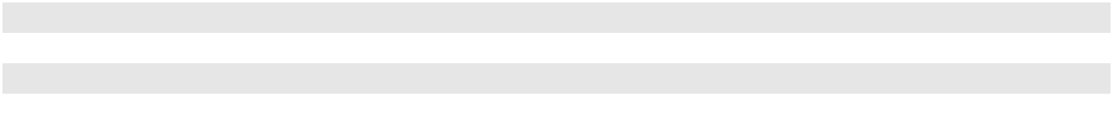

Summary of Capital Resources

At December 31, 2023, cash and cash equivalents and marketable securities totaled $550.8 million, compared to $554.6 million at December 31, 2022. At December 31, 2023, cash and cash equivalents held by our Canadian subsidiaries totaled $75.9 million. The cash and cash equivalents and marketable securities balance for our U.S. operations was $368.8 million at December 31, 2023. Our U.S. operations had net operating cash inflows of $657.1 million for the year ended December 31, 2023.

We also maintain a $400.0 million revolving credit facility, of which, as of December 31, 2023, approximately $265.7 million was available to borrow under the facility, with letters of credit of $134.3 million outstanding.

Material Capital Requirements

Capital Expenditures

In 2023, our capital expenditures were $412.7 million. We anticipate that 2024 capital spending, net of disposals, will be in the range of $395.0 million to $415.0 million. This projected amount is inclusive of capital expenditures of approximately $65.0 million to finish the Kimball, Nebraska incinerator project and $15.0 million to $20.0 million for a strategic project in Baltimore, Maryland.

We anticipate that the capital spending will be funded by cash from our operations. Unanticipated changes in environmental regulations could require us to make significant capital expenditures for our facilities and adversely affect our results of operations and cash flow.

In 2023, capital spending on the construction of our new incinerator at our Kimball, Nebraska facility was approximately $82.6 million. Total spending on the project through December 31, 2023, was $134.7 million. We expect the remaining spending for this project to be approximately $65.0 million and we anticipate it will be complete in late 2024. We have increased the total expected spend on the project to incorporate enhancements including more direct burn bays and specialized lines designed to process incremental high hazard waste.

Acquisitions

On February 2, 2024, the Company signed an agreement with Gryphon Investors, Inc. to acquire HEPACO, a leading provider of specialized environmental and emergency response services in the Eastern United States, for $400.0 million in cash, subject to working capital and other adjustments. The Company intends to fund the acquisition with a combination of available cash and incremental borrowings under our term loan facility.

40

Financing Arrangements

As of December 31, 2023, our financing arrangements included (i) $545.0 million of 4.875% unsecured senior notes due 2027, (ii) $980.0 million of secured senior term loans due 2028, (iii) $300.0 million of 5.125% unsecured senior notes due 2029 and (iv) $500.0 million of 6.375% unsecured senior notes due 2031. As noted above, we also maintain our $400.0 million revolving credit facility with no amounts owed as of December 31, 2023.

The material terms of these arrangements are discussed further in Note 12, “Financing Arrangements,” to our consolidated financial statements included in Item 8 of this report. In 2024, we expect to pay $10.0 million in principal payments on the secured senior term loans and approximately $120 million interest payments on the entire portfolio of financing arrangements, assuming the variable rate remains consistent throughout 2024. We expect that future payments of interest will continue to be funded through cash flows from operations and any principal payments will either be funded through available cash from operations or through available financing alternatives. We will continue to monitor our debt instruments and evaluate opportunities where it may be beneficial to refinance or reallocate the portfolio.

As of December 31, 2023, we were in compliance with the covenants of all of our debt agreements, and we believe we will continue to meet such covenants.

Environmental Liabilities

 |  |  | As of December 31, |  |  |  |  |  | 2023 over 2022
(in thousands) |  |  | 2023 |  |  | 2022 |  |  | Change |  | % Change
Closure and post-closure liabilities |  | $ | 118,600 | $ |  | 118,801 | $ |  | (201) | (0.2)%
Remedial liabilities |  |  | 111,243 |  |  | 116,290 |  |  | (5,047) | (4.3)%
Total environmental liabilities |  | $ | 229,843 | $ |  | 235,091 | $ |  | (5,248) | (2.2)%

Total environmental liabilities as of December 31, 2023 were $229.8 million, a decrease of $5.2 million compared to December 31, 2022. This decrease was primarily due to expenditures of $29.0 million made during 2023 and decreases in environmental liability estimates recorded to the consolidated balance sheet of $2.1 million. These decreases were partially offset by annual accretion of $13.7 million, changes in environmental liability estimates resulting in charges to the consolidated statement of operations of $4.8 million and new liabilities, including those recognized as a result of recent acquisitions of $6.7 million.

We anticipate our environmental liabilities, substantially all of which we assumed in connection with our acquisitions, will be payable over many years and that cash flow from operations will generally be sufficient to fund the payment of such liabilities when required. We have included a schedule of our expected payments as of December 31, 2023, in Note 10, “Closure and Post-closure Liabilities" and Note 11, "Remedial Liabilities,” to our consolidated financial statements included in Item 8 of this report.

Events not anticipated (such as future changes in environmental laws and regulations) could require that payments to satisfy our environmental liabilities be made earlier or in greater amounts than currently anticipated, which could adversely affect our results of operations, cash flow and financial condition. Conversely, the development of new treatment technologies or other circumstances may arise in the future which may reduce amounts ultimately paid.

Letters of Credit

We obtain standby letters of credit as security for financial assurances we have been required to provide to regulatory bodies for our hazardous waste facilities and which would be called only in the event that we fail to satisfy closure, post-closure and other obligations under the permits issued by those regulatory bodies for such licensed facilities. As of December 31, 2023, there were $134.3 million outstanding letters of credit. See Note 12, "Financing Arrangements," to the accompanying financial statements included in Item 8 of this report for further discussion of our standby letters of credit and other financing arrangements.

Critical Accounting Estimates

Our consolidated financial statements are based on the application of GAAP, which requires us to make estimates and judgments that affect the reported amounts of our assets, liabilities, revenues and expenses and related disclosures of contingent liabilities. These estimates and judgements cannot be determined with certainty. Actual results could differ from those estimates, and any such differences may be material to our consolidated financial statements. We believe the estimates set forth below may involve a higher degree of judgment and complexity in their application than our other accounting estimates and represent the critical accounting estimates used in the preparation of our consolidated financial statements. Our accounting

41

policies related to these estimates are discussed in Note 2, "Significant Accounting Policies," to our consolidated financial statements included in Item 8 of this report.

We believe our judgments related to these accounting estimates are appropriate. However, if different assumptions or conditions were to prevail, the results could be materially different from the amounts recorded. Our management reviews critical accounting estimates with the Audit Committee of our Board of Directors on an ongoing basis and as needed prior to the release of our annual financial statements.

Landfill Accounting. We amortize landfill improvements and certain landfill-related permits over their estimated useful lives. The units-of-consumption method is used to amortize land, landfill cell construction, asset retirement costs and remaining landfill cells and sites. We also utilize the units-of-consumption method to record closure and post-closure obligations for landfill cells and sites. Under the units-of-consumption method, we include future estimated construction and asset retirement costs, as well as costs incurred to date, in the amortization base of the landfill assets. Additionally, where appropriate, as discussed below, we include probable expansion airspace yet to be permitted in the calculation of the total remaining useful life of the landfill. If we determine that expansion capacity should no longer be considered in calculating the recoverability of a landfill asset, we may be required to recognize an asset impairment or incur significantly higher amortization expense. If at any time we decide to abandon the expansion effort, the capitalized costs related to the expansion effort are expensed immediately.

Landfill Assets. Landfill assets include the costs of landfill site acquisition, permits and cell construction incurred to date. These amounts are amortized under the units-of-consumption method such that the asset is completely amortized when the landfill ceases accepting waste. Changes in the determination of when the landfill will cease accepting waste, either through a business decision by management, determination that expansion capacity should no longer be considered probable or changes in estimates on annual airspace consumption, will impact the amortization expense of the landfill assets.

Landfill Capacity. Landfill capacity, which is the basis for the amortization of landfill assets and for the accrual of final closure and post-closure obligations, represents total permitted airspace plus unpermitted airspace that management believes is probable of ultimately being permitted based on established criteria. As of December 31, 2023, there were no unpermitted expansions included in management's landfill calculation. If actual expansion airspace is significantly different from management's estimate of expansion airspace, the amortization rates used for the units-of-consumption method would change, therefore impacting our profitability. If we determine that there is less actual expansion airspace at a landfill, this would increase amortization expense recorded and decrease profitability, while if we determine a landfill has more actual expansion airspace, amortization expense would decrease and profitability would increase.

Landfill Final Closure and Post-Closure Liabilities. Landfill final closure and post-closure liabilities recorded at December 31, 2023 and 2022 were $59.4 million and $62.3 million, respectively. We have material financial commitments for the costs associated with requirements of the EPA and the comparable regulatory agency in Canada for landfill final closure and post-closure activities. In the United States, the landfill final closure and post-closure requirements are established under the standards of the EPA, and are implemented and applied on a state-by-state basis. We develop estimates for the cost of these activities based on our evaluation of site-specific facts and circumstances, such as the existence of structures and other landfill improvements that would need to be dismantled, the amount of groundwater monitoring and leachate management expected to be performed and the length of the post-closure period as determined by the applicable regulatory agency. Included in our cost estimates are our interpretation of current regulatory requirements and proposed regulatory changes. These cost estimates may change in the future due to various circumstances including, but not limited to, permit modifications, changes in legislation or regulations, technological changes and results of environmental studies. We perform zero-based reviews of these estimated liabilities based upon a planned schedule, typically every five years or sooner if the occurrence of a significant event is likely to change the timing or amount of the currently estimated expenditures. We consider a significant event to be a new regulation or an amendment to an existing regulation, a new permit or modification to an existing permit or a change in the market price of a significant cost item. Our cost estimates are calculated using internal sources as well as input from third-party experts. These costs are measured at estimated fair value using present value techniques, and therefore changes in the estimated timing of closure and post-closure activities would affect the liability, the value of the related asset and our results of operations.

Final closure costs are the costs incurred after the site ceases to accept waste, but before the landfill is certified as closed by the applicable state or provincial regulatory agency. These costs generally include the costs required for capping the final cell of the landfill (if not included in cell closure), dismantling certain structures for landfills and other landfill improvements and regulation-mandated groundwater monitoring and leachate management. Post-closure costs involve the maintenance and monitoring of a landfill site that has been certified closed by the applicable regulatory agency, generally including groundwater monitoring and leachate management. Regulatory post-closure periods are generally 30 years after landfill closure. Final closure and post-closure obligations are accrued on a units-of-consumption basis, such that the present value of the final closure and post-closure obligations are fully accrued at the date the landfill ceases accepting waste. Changes in the determination of when the landfill will cease accepting waste, either through a business decision by management, determination that expansion

42

capacity should no longer be considered probable or changes in estimates on annual airspace consumption, will accelerate accrual of these costs.

Non-Landfill Closure and Post-Closure Liabilities. Non-landfill closure and post-closure liabilities recorded at December 31, 2023 and 2022 were $59.2 million and $56.6 million, respectively. We base estimates for non-landfill closure and post-closure liabilities on our interpretations of existing permit and regulatory requirements for closure and post-closure maintenance and monitoring. Our cost estimates are calculated using internal sources as well as input from third-party experts. We estimate when future operations will cease and inflate the current cost of closing the non-landfill facility using the appropriate inflation rate and then discounting the future value to arrive at an estimated present value of closure and post-closure costs. The estimates for non-landfill closure and post-closure liabilities are inherently uncertain due to the possibility that permit and regulatory requirements will change in the future, impacting the estimation of total costs and the timing of the expenditures. We review non-landfill closure and post-closure liabilities for changes to key assumptions that would impact the amount of the recorded liabilities. Changes that would prompt us to revise a liability estimate include changes in legal requirements that impact our expected closure plan or scope of work, in the market price of a significant cost item, in estimates as to when future operations may cease or in the expected timing of the cost expenditures. Changes in estimates for non-landfill closure and post-closure events immediately impact the required liability and the value of the corresponding asset. If a change is made to a fully-amortized asset, the adjustment is charged immediately to expense. When a change in estimate relates to an asset that has not been fully amortized, the adjustment to the asset is recognized in income prospectively as a component of amortization. Historically, material changes to non-landfill closure and post-closure estimates have been infrequent. See Note 10, "Closure and Post-Closure Liabilities," to our consolidated financial statements included in Item 8 of this report for the changes to these Landfill and Non-Landfill Closure and Post-Closure liabilities during the years ended December 31, 2023 and 2022.

Remedial Liabilities. Remedial liabilities recorded at December 31, 2023 and 2022 were $111.2 million and $116.3 million, respectively. Remedial liabilities are obligations to investigate, alleviate and/or eliminate the effects of a release (or threat of a release) of hazardous substances into the environment and may also include corrective action under RCRA or the corresponding Canadian regulations. Our remediation obligations can be further characterized as legal, Superfund, long-term maintenance and one-time projects. Legal liabilities are typically comprised of litigation matters that involve potential liability for certain aspects of environmental cleanup and can include third-party claims for property damage or bodily injury allegedly arising from or caused by exposure to hazardous substances originating from our activities or operations or, in certain cases, from the action or inaction of other persons or companies. Superfund liabilities are typically claims alleging that we are a potentially responsible party ("PRP") and/or are potentially liable for environmental response, removal, remediation and cleanup costs at/or from either a facility we own or a site owned by a third-party. Long-term maintenance liabilities include the costs of groundwater monitoring, treatment system operations, permit fees and facility maintenance for inactive operations. One-time projects liabilities include the costs necessary to comply with regulatory requirements for the removal or treatment of contaminated materials.

Amounts recorded related to the costs required to remediate a location are determined by internal engineers and operational personnel and incorporate input from external third parties. The estimates consider such factors as the nature and extent of environmental contamination (if any); the terms of applicable permits and agreements with regulatory authorities as to cleanup procedures and whether modifications to such permits and agreements will likely need to be negotiated; the cost of performing anticipated cleanup activities based upon current technology; and in the case of Superfund and other sites where other parties will also be responsible for a portion of the cleanup costs, the likely allocation of such costs and the ability of such other parties to pay their share. Each quarter, our management discusses if any events have occurred or milestones have been met that would warrant the creation of a new remedial liability or the revision of an existing remedial liability. Such events or milestones include identification and verification as a PRP, receipt of a unilateral administrative order under Superfund or requirement for RCRA interim corrective measures, completion of the feasibility study under Superfund or the corrective measures study under RCRA, new or modifications to existing permits, changes in property use or a change in the market price of a significant cost item. Remedial liabilities are inherently difficult to estimate and there is a risk that the actual quantities of contaminants could differ from the results of the site investigation, which could materially impact the amount of our liability. It is also possible that chosen methods of remedial solutions will not be successful and funds will be required for alternative solutions.

Remedial liabilities are discounted when the timing of the payments is estimable and the amounts are determinable, with the exception of remedial liabilities assumed as part of an acquisition that are measured at fair value at the acquisition date.

We establish reserves for estimated environmental liabilities based on acceptable technologies when we determine the liability is appropriate. Introductions of new technologies are subject to successful demonstration of the effectiveness of the alternative technology and regulatory approval. We routinely review and evaluate the sites for which we have established estimated environmental liabilities reserves to determine if there should be changes in the established reserves. The changes in

43

estimates are reflected as adjustments in the ordinary course of business in the period when we determine that an adjustment is appropriate as new information becomes available. Upon demonstration of the effectiveness of the alternative technology and applicable regulatory approval, we update our estimated cost of remediating the affected sites. See Note 11, "Remedial Liabilities," to our consolidated financial statements included in Item 8 of this report for the changes to the remedial liabilities during the years ended December 31, 2023 and 2022. The changes in our estimates have not been material.

Acquisitions. In accordance with the acquisition method of accounting, the purchase price paid for an acquisition is allocated to the assets and liabilities acquired based upon their estimated fair values as of the acquisition date, with the excess of the purchase price over the net assets acquired recorded as goodwill. Intangible assets acquired in a business combination may consist of patents, trademarks and tradenames, developed technology, customer relationships and other intangibles. The fair value for acquired customer relationship intangibles is determined as of the acquisition date based on estimates and judgments regarding expectations for the future after-tax cash flows arising from the follow-on revenue from customer relationships that existed on the acquisition date over their estimated lives, including the probability of expected future revenue from these customers, less a contributory assets charge, all of which is discounted to present value. The fair value of the trademark and tradename intangible assets as well as the developed technology intangible assets are determined utilizing the relief from royalty method which is a form of the income approach. Under this method, a royalty rate based on observed market royalties is applied to projected revenue supporting the tradename or technology and discounted to present value using an appropriate discount rate. Tangible assets acquired in a business combination include real estate and personal property. When determining the fair value of tangible personal property acquired, we must estimate the cost to replace the asset with a new asset taking into consideration such factors as age, condition and the economic useful life of the asset. Valuations are performed by management or third-party valuation specialists under management's supervision, where appropriate.

Goodwill and Other Long-Lived Assets. We have a significant amount of goodwill associated with previous acquisitions. We conducted our annual impairment test of goodwill as of December 31, 2023 in which we assessed the recoverability of the goodwill associated with our reporting units.

For each reporting unit, we compared the reporting unit's fair value to its respective carrying value and determined that no adjustments to the carrying value of goodwill were necessary. In all cases, the estimated fair value of each reporting unit significantly exceeded its carrying value. We measure fair value for all of our reporting units using an income approach (a discounted cash flow analysis) which incorporates several estimates and assumptions with varying degrees of uncertainty, including estimated revenue growth and operational performance. Such assumptions are subject to variability from year to year and are directly impacted by, among other things, macroeconomic conditions. The discounted cash flow analyses include estimated cash flows for a discrete period and for a terminal period thereafter. We corroborate our estimates of fair values by also considering other factors such as the fair value of comparable companies to businesses contained in our reporting units, as well as performing a reconciliation of the total estimated fair value of all reporting units to our market capitalization.

Indefinite-lived intangible assets are not amortized but are reviewed for impairment annually as of December 31, or when events or changes in the business environment indicate that the carrying value may be impaired. This review is performed by comparing the fair value of an indefinite lived intangible asset to its carrying value. We measure fair value for our indefinite lived intangible assets using an income approach (a discounted cash flow analysis) which incorporates several estimates and assumptions with varying degrees of uncertainty, including estimates of future cash flows associated with the intangible assets. If the fair value is less than the carrying value, the impairment loss is measured as the excess of the carrying value of the asset over its fair value. The estimated fair values of our indefinite-lived intangibles exceeded their carrying values at December 31, 2023.

Our long-lived assets are carried on our financial statements based on their cost less accumulated depreciation or amortization. Long-lived assets with finite lives are reviewed for impairment whenever events or changes in circumstances indicate that their carrying value may not be entirely recoverable. When such factors and circumstances exist, our management compares the estimated undiscounted future cash flows associated with the related asset or group of assets to the respective carrying amounts. The cash flows used in this analysis include assumptions and estimates with varying degrees of uncertainty, including estimated revenue growth and operational performance. An impairment loss, if any, would be measured as the excess of the carrying amount over the fair value of the asset and recorded in the period in which the determination is made. Any resulting impairment losses recorded by us would have an adverse impact on our results of operations.

Our future cash flow assumptions and conclusions with respect to goodwill and asset impairments could be impacted by changes arising from (i) a sustained period of economic and industrial slowdowns, (ii) continued reduced demand for base and blended oil products and an inability to price our oil related products and services to maintain profitability, (iii) inability to scale our operations and implement cost reduction efforts in light of reduced demand or (iv) a significant decline in our share price for a sustained period of time. These factors, among others, could significantly impact the impairment analysis and may result in future goodwill or asset impairment charges that, if incurred, could have a material adverse effect on our financial condition and results of operations.

44

Legal Matters. As described in Note 18, "Commitments and Contingencies," to our consolidated financial statements included in Item 8 of this report, we are subject to legal proceedings which relate to our past acquisitions or which have arisen in the ordinary course of business. We accrue for liabilities associated with these matters when it is probable that a liability has been incurred and the amount can be reasonably estimated. The most likely cost to be incurred is accrued based on an evaluation of then currently available facts with respect to each matter. When no amount within a range of estimates is more likely, the minimum is accrued. As of December 31, 2023, we had reserves of $32.4 million consisting of (i) $25.0 million related to pending legal or administrative proceedings, including Superfund liabilities, which were included in remedial liabilities on the consolidated balance sheets and (ii) $7.4 million primarily related to legal claims as well as federal, state and provincial enforcement actions, which were included in accrued expenses on the consolidated balance sheets. The inherent uncertainty related to the outcome of these matters can result in amounts materially different from any provisions made with respect to their resolution. In management's opinion, it is not reasonably possible that the potential liability in excess of what is recorded, if any, that may result from these actions, either individually or collectively, will have a material effect on our financial position, results of operations or cash flows.

45

ITEM 7A. QUANTITATIVE AND QUALITATIVE DISCLOSURES ABOUT MARKET RISK

In the normal course of business, we are exposed to market risks, including changes in interest rates and certain foreign currency rates, primarily relating to the Canadian dollar.

Interest Rate Risk

Our philosophy in managing interest rate risk is to maintain a debt portfolio inclusive of both variable and fixed-rate debt so as to limit our exposure to interest rate volatility. As of December 31, 2023, before taking into account any interest rate swap agreements then in place, we held $980.0 million of variable rate debt under our secured senior term loans due 2028. The secured senior term loans due 2028 ("2028 Term Loans") pay interest at the Term SOFR rate plus the Term SOFR adjustment (as defined by the Term Loan Agreement) of 0.11448% plus a margin of 1.75% (reduced from 2.00% in December 2023).

To hedge interest rate exposure on a portion of this outstanding variable debt, we entered into interest rate swap agreements. Under the terms of the interest rate swaps entered into in 2022 ("2022 Swaps"), which hedge the interest rate exposure on the 2028 Term Loans, we receive interest based on the variable rates on the 2028 Term Loans and we pay a fixed amount of interest. For more information on the structure of the 2028 Term Loans or 2022 Swaps, see Note 12, "Financing Arrangements," to our consolidated financial statements included in Item 8 of this report. As of December 31, 2023, under the terms of the 2022 Swaps, the Company received interest based on the one-month Term SOFR index and paid interest at the fixed rate of 1.9645% on a notional amount of $600.0 million. When combined with the 1.75% interest rate margin for Term SOFR borrowings and the Term SOFR adjustment of 0.11448% under the 2028 Term Loans, the effective annual interest rate on such $600.0 million aggregate principal amount of the 2028 Term Loans was approximately 3.83%. The remaining balance of the 2028 Term Loans subject to interest rate risk as of December 31, 2023 was $380.0 million.

We designated our interest rate swap instruments as effective cash flow hedges at inception, and therefore the change in fair value is recorded in stockholders' equity as a component of accumulated other comprehensive loss and included in interest expense at the same time as interest expense is affected by the hedged transactions. Differences paid or received over the life of the agreements are recorded as additions to or reductions of interest expense on the underlying debt.

The following table provides information regarding our total borrowings at December 31, 2023 (in thousands):

Scheduled Maturity Dates | 2024 |  |  | 2025 |  |  | 2026 |  |  | 2027 |  | 2028 |  | Thereafter |  |  |  | Total
Secured senior term loans due 2028 | $ 10,000 | $ |  | 10,000 | $ |  | 10,000 | $ |  | 10,000 | $ 940,000 |  | $ |  | — | $ |  | 980,000
Unsecured senior notes due 2027 | — |  |  | — |  |  | — |  |  | 545,000 |  | — |  |  | — |  |  | 545,000
Unsecured senior notes due 2029 | — |  |  | — |  |  | — |  |  | — |  | — |  |  | 300,000 |  |  | 300,000
Unsecured senior notes due 2031 | — |  |  | — |  |  | — |  |  | — |  | — |  |  | 500,000 |  |  | 500,000
Long term debt, at par | $ 10,000 | $ |  | 10,000 | $ |  | 10,000 | $ |  | 555,000 | $ 940,000 |  | $ |  | 800,000 | $ |  | 2,325,000
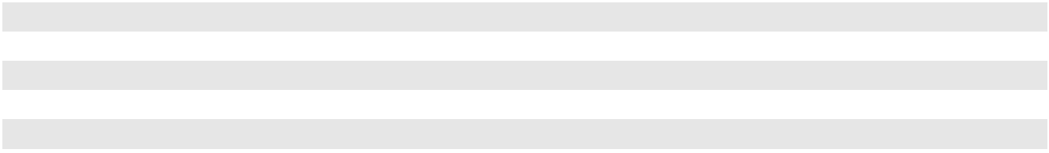

The interest rate on the $545.0 million unsecured senior notes due July 15, 2027 is fixed at 4.875%. Interest payments on this debt are due semiannually on January 15 and July 15 in the amount of $13.3 million upon each date. The interest rate on the $300.0 million unsecured senior notes due July 15, 2029 is fixed at 5.125%. Interest payments on these $300.0 million unsecured senior notes are also due semiannually on January 15 and July 15 in the amount of $7.7 million upon each date.

In January 2023, we issued $500.0 million principal amount of 6.375% unsecured senior notes due February 1, 2031. Interest payments on this debt are due semiannually on February 1 and August 1 in the amount of $15.9 million upon each date, and the payments commenced on August 1, 2023.

As of December 31, 2023, interest payments on the $600.0 million of our secured senior term loan, that is effectively fixed by the 2022 Swaps, are approximately $1.9 million per month, inclusive of the margin, Term SOFR Adjustment and fixed swap rate, discussed above. We continue to have variable interest rate risk relative to the portion of our secured senior term loans which exceeds the $600.0 million of principal which is subject to the 2022 Swaps. Should the average interest rate on the remaining variable portion of our long-term debt change by 100 basis points, we estimate that our annual interest expense would change by up to approximately $4.8 million.

In addition to the fixed and variable borrowings described above, we have a revolving credit agreement with a maximum borrowing of up to $400.0 million. As of December 31, 2023, the Company had no borrowings outstanding under the facility, letters of credit of $134.3 million issued under the facility and $265.7 million available to borrow. Borrowings under this facility would be subject to interest rate variability.

46

Foreign Currency Risk

We view our investment in our foreign subsidiaries as long-term; thus, we have not entered into any hedging transactions between any two foreign currencies or between any of the foreign currencies in which we transact business and the U.S. Dollar. Given our significant investment in Canada and operations in India and the fluctuations that have and can occur between the U.S. Dollar and Canadian Dollar or Indian Rupee exchange rates, significant movements in cumulative translation adjustment amounts recorded as a component of other comprehensive loss can occur in any given period.

During 2023, our Canadian subsidiaries transacted a portion of their business in U.S. Dollars and at any period end had cash on deposit in U.S. Dollars and outstanding U.S. Dollar accounts receivable and payable balances related to their operations. Those U.S. denominated balances are subject to foreign currency gains or losses. Exchange rate movements also affect the translation of Canadian generated profits and losses into U.S. Dollars. Had the Canadian Dollar been 10.0% stronger or weaker against the U.S. Dollar, we would have reported increased or decreased net income of $11.9 million for the year ended December 31, 2023.

47

ITEM 8. FINANCIAL STATEMENTS AND SUPPLEMENTARY DATA

INDEX TO FINANCIAL STATEMENTS AND SUPPLEMENTARY DATA

Report of Independent Registered Public Accounting Firm (PCAOB ID No. 34)

Consolidated Balance Sheets

Consolidated Statements of Operations

Consolidated Statements of Comprehensive Income

Consolidated Statements of Cash Flows

Consolidated Statements of Stockholders' Equity

Notes to Consolidated Financial Statements

- Operations

- Significant Accounting Policies

- Revenues

- Business Combinations

- Disposition of Business

- Inventories and Supplies

- Property, Plant and Equipment

- Goodwill and Other Intangible Assets

- Accrued Expenses

- Closure and Post-Closure Liabilities

- Remedial Liabilities

- Financing Arrangements

- Income Taxes

- Earnings Per Share

- Stockholders' Equity

- Accumulated Other Comprehensive Loss

- Stock Based Compensation

- Commitments and Contingencies

- Leases

- Segment Reporting

Page

No

49

51

52

53

54

55

56

56

56

64

67

71

71

71

72

73

74

75

77

80

80

82

83

83

85

87

88

48

REPORT OF INDEPENDENT REGISTERED PUBLIC ACCOUNTING FIRM To the stockholders and the Board of Directors of Clean Harbors, Inc. Opinion on the Financial Statements

We have audited the accompanying consolidated balance sheets of Clean Harbors, Inc. and subsidiaries (the "Company") as of December 31, 2023 and 2022, the related consolidated statements of operations, comprehensive income, cash flows, and stockholders’ equity, for each of the three years in the period ended December 31, 2023, and the related notes (collectively referred to as the "financial statements"). In our opinion, the financial statements present fairly, in all material respects, the financial position of the Company as of December 31, 2023 and 2022, and the results of its operations and its cash flows for each of the three years in the period ended December 31, 2023, in conformity with accounting principles generally accepted in the United States of America.

We have also audited, in accordance with the standards of the Public Company Accounting Oversight Board (United States) (PCAOB), the Company's internal control over financial reporting as of December 31, 2023, based on criteria established in Internal Control - Integrated Framework (2013) issued by the Committee of Sponsoring Organizations of the Treadway Commission and our report dated February 21, 2024, expressed an unqualified opinion on the Company's internal control over financial reporting.

Basis for Opinion

These financial statements are the responsibility of the Company's management. Our responsibility is to express an opinion on the Company's financial statements based on our audits. We are a public accounting firm registered with the PCAOB and are required to be independent with respect to the Company in accordance with the U.S. federal securities laws and the applicable rules and regulations of the Securities and Exchange Commission and the PCAOB.

We conducted our audits in accordance with the standards of the PCAOB. Those standards require that we plan and perform the audit to obtain reasonable assurance about whether the financial statements are free of material misstatement, whether due to error or fraud. Our audits included performing procedures to assess the risks of material misstatement of the financial statements, whether due to error or fraud, and performing procedures that respond to those risks. Such procedures included examining, on a test basis, evidence regarding the amounts and disclosures in the financial statements. Our audits also included evaluating the accounting principles used and significant estimates made by management, as well as evaluating the overall presentation of the financial statements. We believe that our audits provide a reasonable basis for our opinion.

Critical Audit Matter

The critical audit matter communicated below is a matter arising from the current-period audit of the financial statements that was communicated or required to be communicated to the audit committee and that (1) relates to accounts or disclosures that are material to the financial statements and (2) involved our especially challenging, subjective, or complex judgments. The communication of the critical audit matter does not alter in any way our opinion on the financial statements, taken as a whole, and we are not, by communicating the critical audit matter below, providing a separate opinion on the critical audit matter or on the accounts or disclosures to which it relates.

Remedial Liabilities - Refer to Note 2, "Significant Accounting Policies", and Note 11, "Remedial Liabilities", to the financial statements

Critical Audit Matter Description

Remedial liabilities include the costs of removal or containment of contaminated material, the treatment of potentially contaminated groundwater and maintenance and monitoring costs necessary to comply with regulatory requirements. The estimate of remedial liabilities involves an analysis of numerous factors that are inherently difficult to estimate and involve a significant amount of judgment. The Company routinely reviews and evaluates the sites for which remedial liabilities have been recognized to determine if there should be changes in the cost estimates. As a result, the valuation of liabilities is subject to material changes as additional information becomes available, particularly as it relates to changes in technologies and changes in laws and regulations that govern the remediation efforts.

Total remedial liabilities recorded as of December 31, 2023 were $111.2 million.

Given the subjectivity and judgment involved in measuring remedial liabilities, auditing remedial liabilities involved especially subjective judgment and an increased extent of effort, including the need to involve our specialists who have expertise in environmental remediation.

49

How the Critical Audit Matter Was Addressed in the Audit

Our audit procedures related to remedial liabilities included the following, among others:

- We tested the effectiveness of controls related to the recognition and measurement of remedial liabilities, including those controls over changes in estimates.

- We evaluated the methods and assumptions used by management to estimate the remedial liabilities by confirming specific facts and circumstances related to a selection of sites with project managers and other Company personnel responsible for monitoring these sites, including legal counsel.

- With the assistance of auditor specialists who have expertise in environmental matters and specialized skills and training, we evaluated the reasonableness of the Company’s estimates by:

– Searching for information in the public domain for completeness of sites identified for remediation.

– Assessing the completeness of the Company’s cost estimates for a selection of sites, specifically, comparing the cost estimates to relevant regulatory guidelines and specifications.

– Testing the accuracy of the amounts recorded for a selection of sites, specifically, verifying the mathematical accuracy of the calculation, agreeing cost components to supporting documents, and/or developing an independent range of cost estimates.

/s/ Deloitte & Touche LLP

Boston, Massachusetts

February 21, 2024

We have served as the Company's auditor since 2005.

50

CLEAN HARBORS, INC. AND SUBSIDIARIES

CONSOLIDATED BALANCE SHEETS

(dollars in thousands)

 |  | As of December 31,
ASSETS |  | 2023 |  |  | 2022
Current assets:
Cash and cash equivalents | $ | 444,698 | $ |  | 492,603
Short-term marketable securities |  | 106,101 |  |  | 62,033
Accounts receivable, net of allowances aggregating $42,209 and $45,253, respectively |  | 983,111 |  |  | 964,603
Unbilled accounts receivable |  | 107,859 |  |  | 107,010
Inventories and supplies |  | 327,511 |  |  | 324,994
Prepaid expenses and other current assets |  | 82,939 |  |  | 82,518
Total current assets |  | 2,052,219 |  |  | 2,033,761
Property, plant and equipment, net |  | 2,193,318 |  |  | 1,980,302
Other assets:
Operating lease right-of-use assets |  | 187,060 |  |  | 166,181
Goodwill |  | 1,287,736 |  |  | 1,246,878
Permits and other intangibles, net |  | 602,797 |  |  | 620,782
Other long-term assets |  | 59,739 |  |  | 81,803
Total other assets |  | 2,137,332 |  |  | 2,115,644
Total assets | $ | 6,382,869 |  | $ | 6,129,707
LIABILITIES AND STOCKHOLDERS' EQUITY
Current liabilities:
Current portion of long-term debt | $ | 10,000 | $ |  | 10,000
Accounts payable |  | 451,806 |  |  | 446,629
Deferred revenue |  | 95,230 |  |  | 94,094
Accrued expenses and other current liabilities |  | 397,157 |  |  | 396,716
Current portion of closure, post-closure and remedial liabilities |  | 26,914 |  |  | 23,123
Current portion of operating lease liabilities |  | 56,430 |  |  | 49,532
Total current liabilities |  | 1,037,537 |  |  | 1,020,094
Other liabilities:
Closure and post-closure liabilities, less current portion of $13,556 and $13,205, respectively |  | 105,044 |  |  | 105,596
Remedial liabilities, less current portion of $13,358 and $9,918, respectively |  | 97,885 |  |  | 106,372
Long-term debt, less current portion |  | 2,291,717 |  |  | 2,414,828
Operating lease liabilities, less current portion |  | 131,743 |  |  | 119,259
Deferred tax liabilities |  | 353,107 |  |  | 350,389
Other long-term liabilities |  | 118,330 |  |  | 90,847
Total other liabilities |  | 3,097,826 |  |  | 3,187,291
Commitments and contingent liabilities (See Note 18)
Stockholders' equity:
Common stock, $0.01 par value:
Authorized 80,000,000 shares; issued and outstanding 53,929,703 and 54,064,797 shares, |  | 539 |  |  | 541
respectively |  | 539 |  |  | 541
Additional paid-in capital |  | 459,728 |  |  | 504,240
Accumulated other comprehensive loss |  | (175,339) |  |  | (167,181)
Retained earnings |  | 1,962,578 |  |  | 1,584,722
Total stockholders' equity |  | 2,247,506 |  |  | 1,922,322
Total liabilities and stockholders' equity | $ | 6,382,869 |  | $ | 6,129,707
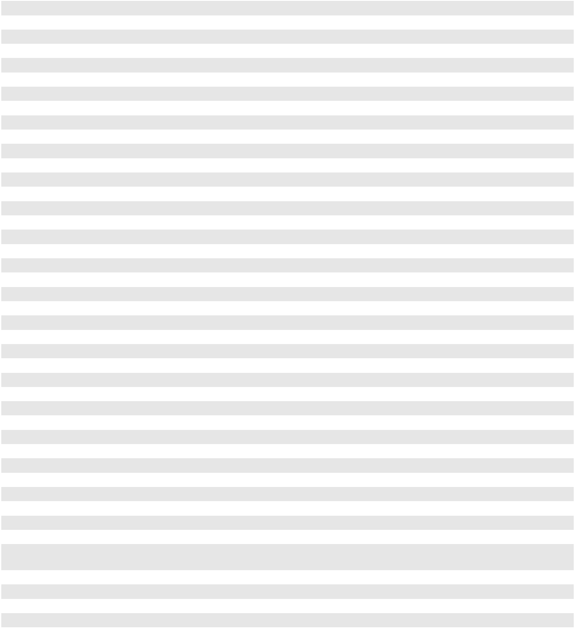
The accompanying notes are an integral part of these consolidated financial statements.

51

CLEAN HARBORS, INC. AND SUBSIDIARIES

CONSOLIDATED STATEMENTS OF OPERATIONS

(in thousands except per share amounts)

 |  | For the years ended December 31,
 |  | 2023 |  |  | 2022 |  |  | 2021
Revenues:
Service revenues | $ | 4,449,542 | $ |  | 4,133,184 | $ |  | 3,048,019
Product revenues |  | 959,610 |  |  | 1,033,421 |  |  | 757,547
Total revenues |  | 5,409,152 |  |  | 5,166,605 |  |  | 3,805,566
Cost of revenues: (exclusive of items shown separately below)
Service revenues |  | 3,054,594 |  |  | 2,892,726 |  |  | 2,105,043
Product revenues |  | 691,530 |  |  | 651,204 |  |  | 504,794
Total cost of revenues |  | 3,746,124 |  |  | 3,543,930 |  |  | 2,609,837
Selling, general and administrative expenses |  | 671,161 |  |  | 627,391 |  |  | 537,962
Accretion of environmental liabilities |  | 13,667 |  |  | 12,943 |  |  | 11,745
Depreciation and amortization |  | 365,761 |  |  | 347,594 |  |  | 298,135
Income from operations |  | 612,439 |  |  | 634,747 |  |  | 347,887
Other income (expense), net |  | 2,315 |  |  | 2,472 |  |  | (515)
Loss on early extinguishment of debt |  | (2,880) |  |  | (422) |  |  | —
Gain on sale of business |  | — |  |  | 8,864 |  |  | —
Interest expense, net of interest income of $11,930, $4,607 and $2,218, |  | (108,595) |  |  | (107,663) |  |  | (77,657)
respectively |  | (108,595) |  |  | (107,663) |  |  | (77,657)
Income before provision for income taxes |  | 503,279 |  |  | 537,998 |  |  | 269,715
Provision for income taxes |  | 125,423 |  |  | 126,254 |  |  | 66,468
Net income | $ | 377,856 | $ |  | 411,744 | $ |  | 203,247
Earnings per share:
Basic | $ | 6.99 |  | $ | 7.59 |  | $ | 3.73
Diluted
Diluted | $ | 6.95 |  | $ | 7.56 |  | $ | 3.71
Shares used to compute earnings per share — Basic
Shares used to compute earnings per share — Basic |  | 54,071 |  |  | 54,223 |  |  | 54,514
Shares used to compute earnings per share — Diluted
Shares used to compute earnings per share — Diluted |  | 54,382 |  |  | 54,487 |  |  | 54,761
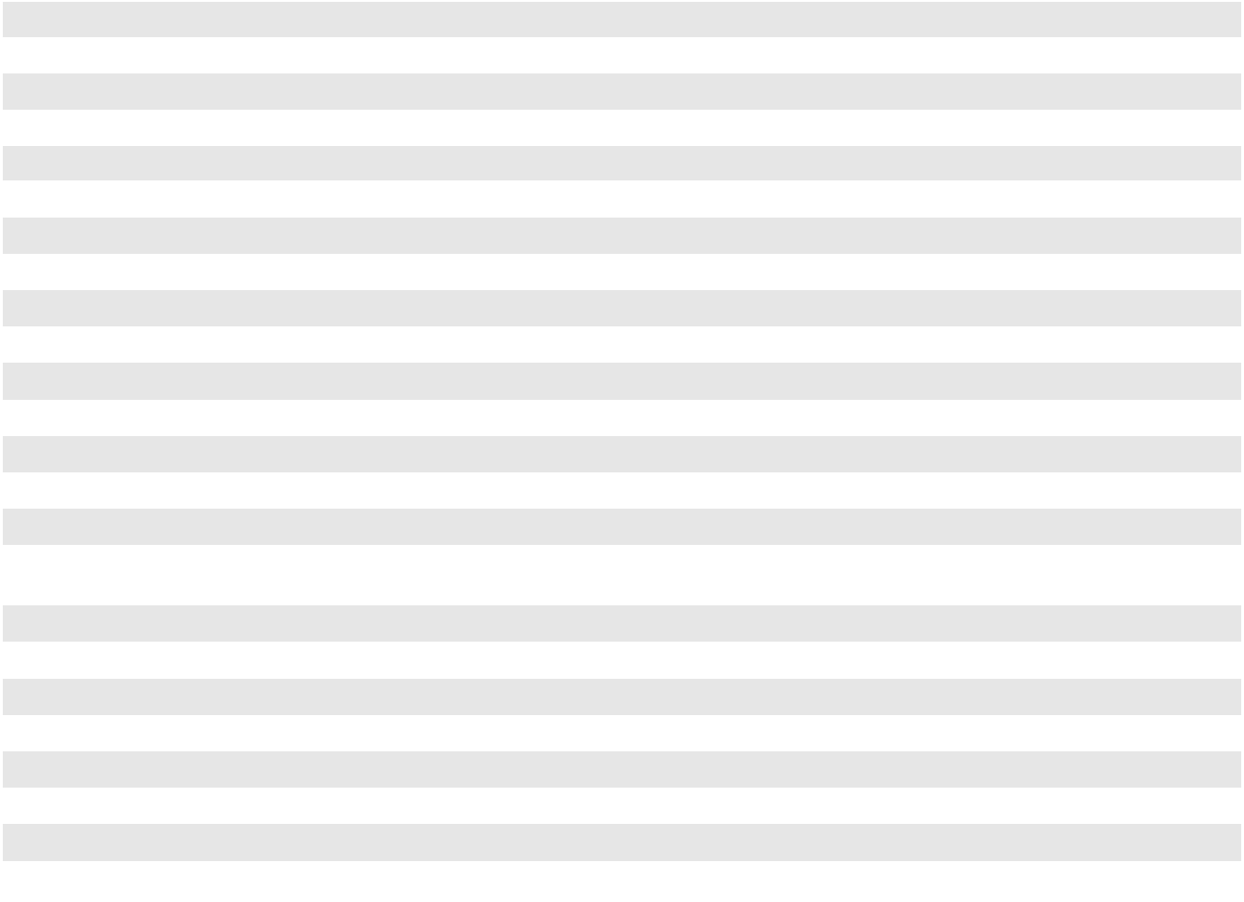

The accompanying notes are an integral part of these consolidated financial statements.

52

CLEAN HARBORS, INC. AND SUBSIDIARIES

CONSOLIDATED STATEMENTS OF COMPREHENSIVE INCOME

(in thousands)

 |  | For the years ended December 31,
 |  | 2023 |  |  | 2022 |  |  | 2021
Net income | $ | 377,856 | $ |  | 411,744 | $ |  | 203,247
Other comprehensive (loss) income, net of tax:
Unrealized gain (loss) on available-for-sale securities |  | 559 |  |  | (413) |  |  | (285)
Unrealized gain on fair value of interest rate hedges |  | 5,163 |  |  | 61,124 |  |  | 6,235
Reclassification adjustment for interest rate hedge amounts realized in net |  | (16,425) |  |  | (683) |  |  | 10,011
income |  | (16,425) |  |  | (683) |  |  | 10,011
Reclassification adjustment for settlement of interest rate hedges |  | (5,905) |  |  | — |  |  | —
Pension adjustments |  | (550) |  |  | 318 |  |  | 1,094
Foreign currency translation adjustments |  | 9,000 |  |  | (31,515) |  |  | (1,590)
Other comprehensive (loss) income, net of tax |  | (8,158) |  |  | 28,831 |  |  | 15,465
Comprehensive income | $ | 369,698 | $ |  | 440,575 | $ |  | 218,712
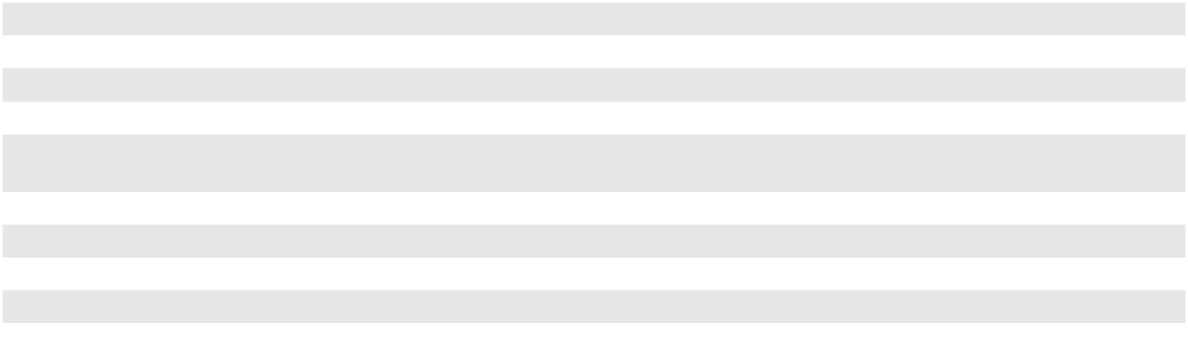

The accompanying notes are an integral part of these consolidated financial statements.

53

CLEAN HARBORS, INC. AND SUBSIDIARIES

CONSOLIDATED STATEMENTS OF CASH FLOWS

(in thousands)

 |  | For the years ended December 31,
 |  | 2023 |  |  | 2022 |  |  | 2021
Cash flows from operating activities: | $ | 377,856 | $ |  | 411,744 | $ |  | 203,247
Net income
Adjustments to reconcile net income to net cash from operating activities: |  | 365,761 |  |  | 347,594 |  |  | 298,135
Depreciation and amortization |  | 365,761 |  |  | 347,594 |  |  | 298,135
Allowance for doubtful accounts |  | 5,956 |  |  | 7,783 |  |  | 8,018
Amortization of deferred financing costs and debt discount |  | 5,309 |  |  | 6,301 |  |  | 4,245
Accretion of environmental liabilities |  | 13,667 |  |  | 12,943 |  |  | 11,745
Changes in environmental liability estimates |  | 4,828 |  |  | 8,272 |  |  | 2,979
Deferred income taxes |  | 12,685 |  |  | 17,549 |  |  | 1,482
Other (income) expense, net |  | (2,315) |  |  | (2,472) |  |  | 515
Stock-based compensation |  | 20,703 |  |  | 26,844 |  |  | 18,839
Loss on early extinguishment of debt |  | 2,880 |  |  | 422 |  |  | —
Gain on sale of business |  | — |  |  | (8,864) |  |  | —
Environmental expenditures |  | (28,960) |  |  | (13,946) |  |  | (15,506)
Changes in assets and liabilities, net of acquisitions: |  | 2,453 |  |  | (201,087) |  |  | (96,551)
Accounts receivable and unbilled accounts receivable |  | 2,453 |  |  | (201,087) |  |  | (96,551)
Inventories and supplies |  | (4,312) |  |  | (74,547) |  |  | (31,689)
Other current and non-current assets |  | (22,645) |  |  | (17,303) |  |  | 9,268
Accounts payable |  | (27,425) |  |  | 74,460 |  |  | 108,398
Other current and long-term liabilities |  | 8,111 |  |  | 30,521 |  |  | 22,872
Net cash from operating activities |  | 734,552 |  |  | 626,214 |  |  | 545,997
Cash flows used in investing activities: |  | (422,300) |  |  | (345,056) |  |  | (241,856)
Additions to property, plant and equipment |  | (422,300) |  |  | (345,056) |  |  | (241,856)
Proceeds from sale and disposal of fixed assets |  | 9,650 |  |  | 8,779 |  |  | 22,156
Acquisitions, net of cash acquired |  | (119,596) |  |  | (86,278) |  |  | (1,253,232)
Proceeds from sale of business, net of transaction costs |  | 750 |  |  | 16,811 |  |  | —
Additions to intangible assets including costs to obtain or renew permits |  | (2,649) |  |  | (1,966) |  |  | (3,848)
Purchases of available-for-sale securities |  | (158,264) |  |  | (49,845) |  |  | (129,234)
Proceeds from sale of available-for-sale securities |  | 117,359 |  |  | 68,611 |  |  | 98,412
Net cash used in investing activities |  | (575,050) |  |  | (388,944) |  |  | (1,507,602)
Cash flows (used in) from financing activities: |  | 2,759 |  |  | 552 |  |  | (1,806)
Change in uncashed checks |  | 2,759 |  |  | 552 |  |  | (1,806)
Tax payments related to withholdings on vested restricted stock |  | (13,838) |  |  | (8,801) |  |  | (10,805)
Repurchases of common stock |  | (51,164) |  |  | (50,183) |  |  | (54,410)
Deferred financing costs paid |  | (6,736) |  |  | (410) |  |  | (13,737)
Payments on finance leases |  | (15,937) |  |  | (12,821) |  |  | (8,458)
Principal payments on debt |  | (623,975) |  |  | (115,652) |  |  | (7,535)
Proceeds from issuance of debt, net of discount |  | 500,000 |  |  | — |  |  | 995,000
Borrowing from revolving credit facility |  | 114,000 |  |  | — |  |  | —
Payment on revolving credit facility |  | (114,000) |  |  | — |  |  | —
Net cash (used in) from financing activities |  | (208,891) |  |  | (187,315) |  |  | 898,249
Effect of exchange rate change on cash |  | 1,484 |  |  | (9,927) |  |  | (3,170)
(Decrease) increase in cash and cash equivalents |  | (47,905) |  |  | 40,028 |  |  | (66,526)
Cash and cash equivalents, beginning of year |  | 492,603 |  |  | 452,575 |  |  | 519,101
Cash and cash equivalents, end of year | $ | 444,698 |  | $ | 492,603 |  | $ | 452,575
Supplemental information:
Cash payments for interest and income taxes: | $ | 114,560 | $ |  | 105,643 | $ |  | 73,440
Interest paid
Income taxes paid, net of refunds |  | 132,314 |  |  | 78,526 |  |  | 65,192
Non-cash investing activities: |  | 52,376 |  |  | 30,950 |  |  | 19,264
Property, plant and equipment accrued |  | 52,376 |  |  | 30,950 |  |  | 19,264
Remedial liability assumed in acquisition of property, plant and equipment |  | — |  |  | 8,092 |  |  | —


The accompanying notes are an integral part of these consolidated financial statements.

54

CLEAN HARBORS, INC. AND SUBSIDIARIES
CONSOLIDATED STATEMENTS OF STOCKHOLDERS' EQUITY
 |  |  |  | (in thousands)
 | Common Stock |  |  |  |  |  |  |  |  | Accumulated
 | Number | $0.01 |  |  |  | Additional |  |  |  | Other |  |  | Retained |  |  | Total
 | of |  |  | Par |  |  | Paid-in |  | Comprehensive |  |  |  | Retained |  | Stockholders'
 | Shares |  | Value |  |  |  | Capital |  |  | Loss |  |  | Earnings |  |  | Equity
Balance at January 1, 2021 | 54,773 | $ |  | 548 | $ |  | 582,749 | $ |  | (211,477) | $ |  | 969,731 | $ |  | 1,341,551
Net income | — |  |  | — |  |  | — |  |  | — |  |  | 203,247 |  |  | 203,247
Other comprehensive income | — |  |  | — |  |  | — |  |  | 15,465 |  |  | — |  |  | 15,465
Stock-based compensation | — |  |  | — |  |  | 18,839 |  |  | — |  |  | — |  |  | 18,839
Issuance of common stock for restricted
share vesting, net of employee tax | 235 |  |  | 2 |  |  | (10,807) |  |  | — |  |  | — |  |  | (10,805)
withholdings | 235 |  |  | 2 |  |  | (10,807) |  |  | — |  |  | — |  |  | (10,805)
Repurchases of common stock | (589) |  |  | (6) |  |  | (54,404) |  |  | — |  |  | — |  |  | (54,410)
Balance at December 31, 2021 | 54,419 |  |  | 544 |  |  | 536,377 |  |  | (196,012) |  |  | 1,172,978 |  |  | 1,513,887
Net income | — |  |  | — |  |  | — |  |  | — |  |  | 411,744 |  |  | 411,744
Other comprehensive income | — |  |  | — |  |  | — |  |  | 28,831 |  |  | — |  |  | 28,831
Stock-based compensation | — |  |  | — |  |  | 26,844 |  |  | — |  |  | — |  |  | 26,844
Issuance of common stock for restricted
share vesting, net of employee tax | 183 |  |  | 2 |  |  | (8,803) |  |  | — |  |  | — |  |  | (8,801)
withholdings | 183 |  |  | 2 |  |  | (8,803) |  |  | — |  |  | — |  |  | (8,801)
Repurchases of common stock | (537) |  |  | (5) |  |  | (50,178) |  |  | — |  |  | — |  |  | (50,183)
Balance at December 31, 2022 | 54,065 |  |  | 541 |  |  | 504,240 |  |  | (167,181) |  |  | 1,584,722 |  |  | 1,922,322
Net income | — |  |  | — |  |  | — |  |  | — |  |  | 377,856 |  |  | 377,856
Other comprehensive loss | — |  |  | — |  |  | — |  |  | (8,158) |  |  | — |  |  | (8,158)
Stock-based compensation | — |  |  | — |  |  | 20,703 |  |  | — |  |  | — |  |  | 20,703
Issuance of common stock for restricted
share vesting, net of employee tax | 193 |  |  | 1 |  |  | (13,839) |  |  | — |  |  | — |  |  | (13,838)
withholdings | 193 |  |  | 1 |  |  | (13,839) |  |  | — |  |  | — |  |  | (13,838)
Repurchases of common stock | (328) |  |  | (3) |  |  | (51,376) |  |  | — |  |  | — |  |  | (51,379)
Balance at December 31, 2023 | 53,930 | $ |  | 539 | $ |  | 459,728 | $ |  | (175,339) | $ |  | 1,962,578 | $ |  | 2,247,506
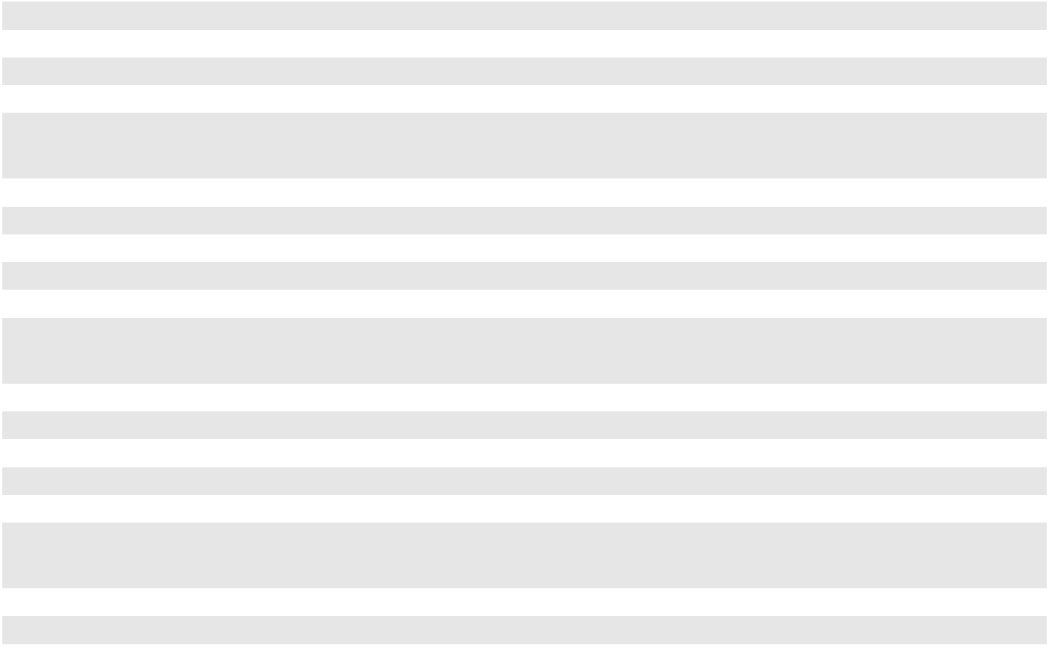

The accompanying notes are an integral part of these consolidated financial statements.

55

CLEAN HARBORS, INC. AND SUBSIDIARIES

NOTES TO CONSOLIDATED FINANCIAL STATEMENTS

(1) OPERATIONS

Clean Harbors, Inc., through its subsidiaries (collectively, the "Company"), is a leading provider of sustainable environmental and industrial services throughout North America. The Company is also the largest re-refiner and recycler of used oil and the premier provider of parts cleaning and related environmental services to commercial, industrial and automotive customers in North America.

(2) SIGNIFICANT ACCOUNTING POLICIES

The accompanying consolidated financial statements of the Company reflect the application of certain significant accounting policies as described below:

Principles of Consolidation

The accompanying consolidated financial statements include the accounts of Clean Harbors, Inc. and its majority-owned subsidiaries. All intercompany accounts and transactions have been eliminated in consolidation.

Use of Estimates

The preparation of consolidated financial statements in conformity with U.S. Generally Accepted Accounting Principles (GAAP), requires management to make estimates and assumptions about future events that affect the amounts reported in the consolidated financial statements and the accompanying notes. Management bases its estimates on historical experience and other assumptions that it believes to be reasonable at the time. Actual results could differ from those estimates, and any such differences may be material to the consolidated financial statements. Estimates and assumptions are reviewed periodically and the effects of changes, if any, are reflected in our consolidated financial statements in the period they are determined.

Cash, Cash Equivalents, Marketable Securities and Uncashed Checks

Cash consists primarily of cash on deposit and money market accounts. The Company, through its wholly-owned captive insurance subsidiary, invests in marketable securities. Marketable securities with maturities of three months or less from the date of purchase are classified as cash equivalents. As of December 31, 2023 and 2022, the Company had total marketable securities as follows (in thousands):

 | December 31, 2023 |  |  | December 31, 2022
Commercial paper | $ | 27,542 | $ |  | 5,035
U.S. Treasury securities |  | — |  |  | 28,973
Total cash equivalents |  | 27,542 |  |  | 34,008
Municipal bonds |  | — |  |  | 1,930
Commercial paper |  | 56,172 |  |  | 24,075
Corporate notes and bonds |  | 49,929 |  |  | 36,028
Total marketable securities |  | 106,101 |  |  | 62,033
Total | $ | 133,643 | $ |  | 96,041
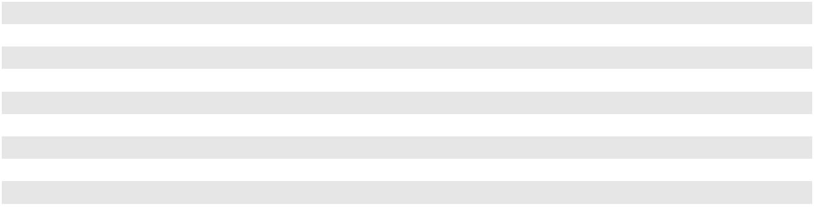

Realized gains and losses on sales of available-for-sale marketable securities in the years presented were immaterial. The majority of the marketable securities have a remaining maturity of less than one year and fair value approximates cost.

The Company's cash management program with its revolving credit lender allows the Company to maintain a zero balance in the U.S. bank disbursement accounts that are used to issue vendor and payroll checks. When checks are presented to the bank for payment, cash deposits in amounts sufficient to fund the checks are made, at the Company's discretion, either from funds provided by other accounts or under the terms of the Company's revolving credit facility. Checks that have been written to vendors or employees but have not yet been presented for payment at the Company's bank are classified as uncashed checks in accounts payable and changes in the balance are reported as a financing activity in the consolidated statements of cash flows.

56

CLEAN HARBORS, INC. AND SUBSIDIARIES

NOTES TO CONSOLIDATED FINANCIAL STATEMENTS (Continued)

Allowance for Doubtful Accounts and Revenue Allowance

On a regular basis, the Company evaluates its accounts receivable and establishes the allowance for doubtful accounts based on an evaluation of certain criteria and evidence of collection uncertainty including historical collection trends, reasonable expectations of future collections, current economic trends and changes in customer payment patterns. Past-due receivable balances are written off when the Company's collection efforts have been deemed unsuccessful in collecting the outstanding balance due.

Due to the nature of the Company's businesses and the invoices that result from the services provided, customers may withhold payments and attempt to renegotiate amounts invoiced. In addition, for some of the services provided, the Company's invoices are based on quotes that, in limited instances, can result in adjustments to revenue subsequent to billing. Based on industry knowledge and historical trends, the Company records a revenue allowance in anticipation of these expected adjustments. This practice causes the volume of activity flowing through the revenue allowance during the year to be higher than the balance at the end of the year. The revenue allowance is intended to cover the net amount of revenue adjustments that may need to be credited to customers' accounts in future periods. Management determines the appropriate total revenue allowance by evaluating the following factors on an invoice-by-invoice basis as well as on a consolidated level: trends in adjustments to previously billed amounts, existing economic conditions, communications with customers and other information as deemed applicable. Revenue allowance estimates can differ from the actual adjustments, but historically the revenue allowance has been sufficient to cover the net amount of the reserve adjustments issued in subsequent reporting periods.

The following table reflects the activity in the allowance for doubtful accounts and revenue allowance (in thousands):

 |  | Allowance for Doubtful Accounts |  |  |  |  |  |  |  |  |  | Revenue Allowance
 |  | 2023 |  |  | 2022 |  |  | 2021 |  |  | 2023 |  |  |  | 2022 |  |  | 2021
Balance at January 1, | $ | 24,659 | $ |  | 24,136 | $ |  | 24,634 | $ |  | 20,594 | $ |  |  | 16,004 | $ |  | 20,115
Additions charged to earnings |  | 5,956 |  |  | 7,783 |  |  | 8,018 |  |  | 46,467 |  |  |  | 54,836 |  |  | 34,319
Deductions from reserves, net of recoveries |  | (8,047) |  |  | (7,260) |  |  | (8,516) |  |  | (47,420) |  |  |  | (50,246) |  |  | (38,430)
Balance at December 31, | $ | 22,568 | $ |  | 24,659 | $ |  | 24,136 | $ |  | 19,641 | $ |  |  | 20,594 | $ |  | 16,004
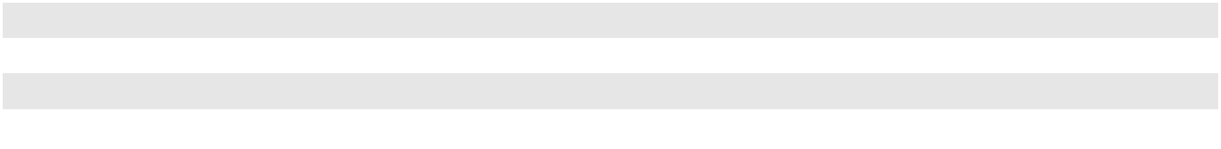

Credit Concentration

Concentration of credit risks in accounts receivable is limited due to the large number of customers comprising the Company's customer base throughout North America. The Company maintains policies over credit extension that include credit evaluations, credit limits and collection monitoring procedures on a customer-by-customer basis. However, the Company generally does not require collateral before services are performed. No individual customer accounted for more than 10% of accounts receivable or more than 10% of total third-party revenues in the periods presented.

Inventories and Supplies

Inventories are stated at the lower of cost or market. The cost of oil and oil products as well as the cost of supplies and drums, solvent and solution and other inventories is principally determined on a first-in, first-out ("FIFO") basis. The Company continually reviews its inventories for obsolete or unsalable items and adjusts its carrying value to reflect estimated realizable values.

Property, Plant and Equipment, net (excluding landfill assets and finance lease right-of-use assets)

Property, plant and equipment, net is stated at cost less accumulated depreciation. Expenditures for major renewals and improvements which extend the life or usefulness of the asset are capitalized. Items of an ordinary repair or maintenance nature are charged directly to operating expense as incurred. During the construction and development period of an asset, the costs incurred, including interest expense, are classified as construction-in-progress. When the asset is ready for its intended use, the asset is reclassified to an appropriate asset classification and depreciation or amortization commences.

57

CLEAN HARBORS, INC. AND SUBSIDIARIES

NOTES TO CONSOLIDATED FINANCIAL STATEMENTS (Continued)

The Company depreciates and amortizes the capitalized cost of these assets, using the straight-line method as follows:

Asset Classification |  | Estimated Useful Life
Buildings and building improvements
Buildings |  | 20-42 years
Leasehold and building improvements |  | 2-45 years
Vehicles |  | 2-15 years
Equipment
Capitalized software and computer equipment |  | 3-5 years
Containers and railcars |  | 8-16 years
All other equipment |  | 4-30 years
Furniture and fixtures |  | 5-8 years
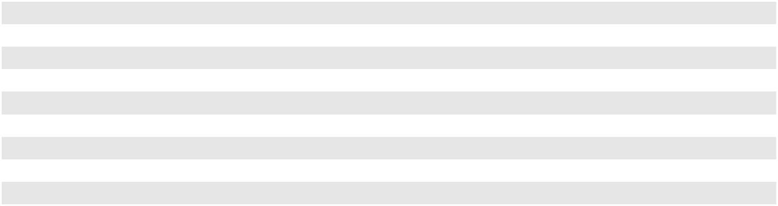

Gains and losses on the sale of property, plant and equipment are included in Other income (expense), net. Fully depreciated assets are retained in property, plant and equipment and accumulated depreciation until they are removed from service.

The Company tests asset groups for impairment whenever events or changes in circumstances indicate that the carrying value may not be recoverable. An impairment in the carrying value of long-lived assets is recognized if the expected future undiscounted cash flows derived from the assets, or group of assets, are less than their carrying value. The Company did not record any impairment charges related to long-lived assets in the periods presented.

Business Combinations

In accordance with the acquisition method of accounting, the purchase price paid for an acquisition is allocated to the assets and liabilities acquired based upon their estimated fair values as of the acquisition date, with the excess of the purchase price over the net assets acquired recorded as goodwill. As required, a preliminary fair value is determined once a business is acquired, with the final determination of the fair value being completed no later than one year from the date of acquisition.

Goodwill

Goodwill is comprised of the purchase price of business acquisitions in excess of the fair value of the net assets acquired. Goodwill is reviewed for impairment annually as of December 31 or when events or changes in the business environment indicate the carrying value of a reporting unit may exceed its fair value. This review is performed by comparing the fair value of each reporting unit to its carrying value, including goodwill. If the fair value is less than the carrying amount, a loss is recorded for the excess of the carrying value over the fair value up to the carrying amount of goodwill.

The Company determines its reporting units by identifying the components of each operating segment. As of

December 31, 2023, the Company had four reporting units consisting of, Environmental Sales and Service, Industrial Services,

Environmental Facilities and Safety-Kleen Sustainability Solutions ("SKSS"). See Note 8, "Goodwill and Other Intangible

Assets," for additional information related to the Company's goodwill impairment tests.

Permits and Other Intangibles

Costs related to acquiring licenses, permits and intangible assets, such as legal fees, site surveys, engineering costs and other expenditures are capitalized. Other intangible assets consist primarily of customer and supplier relationships, trademarks and trade names and developed technology.

Permits relating to landfills are amortized on a units-of-consumption basis. All other permits are amortized over periods ranging from five to 30 years on a straight-line basis. Finite-lived other intangible assets are amortized on a straight-line basis over their respective useful lives, which range from two to 25 years.

All finite-lived intangible assets are reviewed for impairment whenever events or changes in circumstances indicate that the carrying value may not be recoverable. When such factors and circumstances exist, management compares the projected undiscounted future cash flows associated with the related asset or group of assets to the carrying amount. The impairment loss, if any, is measured as the excess of the carrying amount over the fair value of the asset or group of assets.

58

CLEAN HARBORS, INC. AND SUBSIDIARIES

NOTES TO CONSOLIDATED FINANCIAL STATEMENTS (Continued)

Indefinite-lived intangible assets are not amortized but are reviewed for impairment annually as of December 31, or when events or changes in the business environment indicate that the carrying value may be impaired. If the fair value of the asset is less than the carrying amount, the impairment loss is measured as the excess of the carrying value of the asset over its fair value.

Landfill Accounting

The Company amortizes landfill improvements and certain landfill-related permits over the estimated useful lives. The units-of-consumption method is used to amortize land, landfill cell construction, asset retirement costs and remaining landfill cells and sites. The Company also utilizes the units-of-consumption method to record closure and post-closure obligations for landfill cells and sites. Under the units-of-consumption method, the Company includes future estimated construction and asset retirement costs, as well as costs incurred to date, in the amortization base of the landfill assets. Additionally, where appropriate, as described below, the Company includes probable expansion airspace that has yet to be permitted in the calculation of the total remaining useful life of the landfill. If it is determined that expansion capacity should no longer be considered in calculating the recoverability of a landfill asset, the Company may be required to recognize an asset impairment or incur significantly higher amortization expense. If at any time the Company makes the decision to abandon the expansion effort, the capitalized costs related to the expansion effort are expensed immediately.

Landfill assets—Landfill assets include the costs of landfill site acquisition, permits and cell construction incurred to date. These amounts are recorded at cost, which includes capitalized interest as applicable. Landfill assets, net of amortization, are combined with management's estimate of the costs required to complete construction of the landfill to determine the amount to be amortized over the remaining estimated useful economic life of a site. Amortization of landfill assets is recorded on a units-of-consumption basis, such that the landfill assets should be completely amortized at the date the landfill ceases accepting waste. Amortization totaled $18.6 million, $16.2 million and $13.7 million for the years ended December 31, 2023, 2022 and 2021, respectively. Changes in the determination of when the landfill will cease accepting waste, either through a business decision by the Company, determination that expansion capacity should no longer be considered probable or changes in estimates on annual airspace consumption, will impact the amortization expense of the landfill assets. Changes in estimated costs to complete construction are applied prospectively to the amortization rate.

Landfill capacity—Landfill capacity, which is the basis for the amortization of landfill assets and for the accrual of final closure and post-closure obligations, represents total permitted airspace plus unpermitted airspace that management believes is highly probable of ultimately being permitted. As of December 31, 2023, there were no unpermitted expansions included in the Company's landfill accounting model. If actual expansion airspace is significantly different from management's estimate of expansion airspace, the amortization rates used for the units-of-consumption method would change, therefore impacting the Company's profitability.

As of December 31, 2023, the Company had eight active landfill sites (including the Company's non-commercial landfill), which have estimated remaining lives (based on anticipated waste volumes and the remaining highly probable airspace) as follows:

 |  |  |  | Remaining |  | Permitted Remaining Highly
Facility Name |  | Location |  | Lives |  | Probable Airspace
Facility Name |  | Location |  | (Years) |  | (cubic yards) (in thousands)
Buttonwillow |  | California | 20 |  | 4,999
Deer Trail |  | Colorado | 21 |  | 1,420
Grassy Mountain |  | Utah | 34 |  | 4,320
Kimball |  | Nebraska | 23 |  | 547
Lambton |  | Ontario, Canada | 46 |  | 4,350
Lone Mountain |  | Oklahoma | 16 |  | 3,165
Ryley |  | Alberta, Canada | 30 |  | 5,692
Sawyer |  | North Dakota | 65 |  |  | 3,260
 |  |  |  |  | 27,753
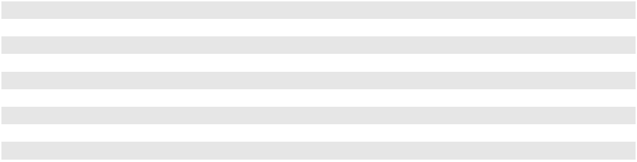
In 2023, as expected, the Company's non-commercial landfill at Deer Park, Texas reached permitted capacity and is in the process of closing. This landfill has been excluded from the table above.

At December 31, 2023 and 2022, the Company had no cubic yards of permitted, but not highly probable, airspace.

59

CLEAN HARBORS, INC. AND SUBSIDIARIES

NOTES TO CONSOLIDATED FINANCIAL STATEMENTS (Continued)

The following table presents the remaining highly probable airspace from January 1, 2022 through December 31, 2023 (in thousands of cubic yards):

 | 2023 |  | 2022
Remaining capacity, beginning of year | 28,270 | 23,784
Changes in highly probable airspace, net | 464 | 5,579
Consumed | (981) |  | (1,093)
Remaining capacity, end of year | 27,753 | 28,270
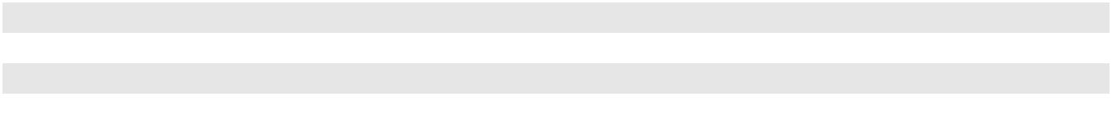

In the year ended December 31, 2023 the Company received a permit for expansion of its Kimball, Nebraska landfill. In the year ended December 31, 2022, the Company received a permit for the expansion of its Ryley landfill in Alberta, Canada.

Amortization of cell construction costs and accrual of cell closure obligations—Landfills are typically comprised of a number of cells, which are constructed within a defined acreage (or footprint). The cells are typically discrete units, which require both separate construction and separate capping and closure procedures. Cell construction costs are the costs required to excavate and construct the landfill cell. These costs are typically amortized on a units-of-consumption basis, such that they are completely amortized when the specific cell ceases accepting waste. In some instances, the Company has landfills that are engineered and constructed as "progressive trenches." In progressive trench landfills, a number of contiguous cells form a progressive trench. In those instances, the Company amortizes cell construction costs over the airspace within the entire trench, such that the cell construction costs will be fully amortized at the end of the trench useful life.

The design and construction of a landfill does not create a landfill asset retirement obligation. Rather, the asset retirement obligation for cell closure (the cost associated with capping each cell) is incurred in relatively small increments as waste is placed in the landfill. Therefore, the cost required to construct the cell cap is capitalized as an asset retirement cost and a liability of an equal amount is established, based on the discounted cash flow associated with each capping event, as airspace is consumed. Spending for cell capping is reflected as environmental expenditures within operating activities in the consolidated statements of cash flows.

Landfill final closure and post-closure liabilities —The balance of landfill final closure and post-closure liabilities at December 31, 2023 and 2022 was $59.4 million and $62.3 million, respectively. The Company has material financial commitments for the costs associated with requirements of the Environmental Protection Agency ("EPA") and the comparable regulatory agency in Canada for landfill final closure and post-closure activities. The Company develops estimates for the cost of these activities based on an evaluation of site-specific facts and circumstances, including the Company's interpretation of current regulatory requirements and proposed regulatory changes. Such estimates may change in the future due to various circumstances including, but not limited to, permit modifications, changes in legislation or regulations, technological changes and results of environmental studies.

Final closure costs are the costs incurred after the site ceases to accept waste, but before the landfill is certified as closed by the applicable state regulatory agency. These costs generally include the costs required to cap the final cell of the landfill (if not included in cell closure), the costs required to dismantle certain structures for landfills and other landfill improvements, and regulation-mandated groundwater monitoring and leachate management. Post-closure costs involve the maintenance and monitoring of a landfill site that has been certified closed by the applicable regulatory agency. These costs generally include groundwater monitoring and leachate management. Regulatory post-closure periods are generally 30 years after landfill closure. Final closure and post-closure obligations are accrued on a units-of-consumption basis, such that the present value of the final closure and post-closure obligations are fully accrued at the date the landfill ceases accepting waste.

Cell closure, final closure and post-closure costs (also referred to as "asset retirement obligations") are calculated by estimating the total obligation in current dollars, adjusted for future inflation estimates and discounted at the Company's credit-adjusted risk-free interest rate (6.51% and 5.37% during 2023 and 2022, respectively).

Non-Landfill Closure and Post-Closure Liabilities

The balance of non-landfill closure and post-closure liabilities at December 31, 2023 and 2022 was $59.2 million and

$56.6 million, respectively. Non-landfill closure and post-closure obligations arise when the Company commences non-landfill

facility operations and include costs required to dismantle and decontaminate certain structures and other costs incurred during

the closure process. Post-closure costs, if required, include associated maintenance and monitoring costs as required by the

closure permit. Post-closure periods are performance-based and are not typically specified in terms of years in the closure

permit, but generally range from 10 to 30 years or more.

60

CLEAN HARBORS, INC. AND SUBSIDIARIES

NOTES TO CONSOLIDATED FINANCIAL STATEMENTS (Continued)

The Company records its non-landfill closure and post-closure liability by: (i) estimating the current cost of closing a non-landfill facility and the post-closure care of that facility, if required, based upon the closure plan that the Company is required to follow under its operating permit, or in the event the facility operates with a permit that does not contain a closure plan, based upon legally enforceable closure commitments made by the Company to various government agencies;

- estimates as to when future operations may cease; (iii) cost estimates of closing the non-landfill facility using the inflation rate to the time of closing; and (iv) discounting the future value back to the present using the credit-adjusted risk-free interest rate.

The estimates for non-landfill closure and post-closure liabilities are inherently uncertain due to the possibility that permit and regulatory requirements will change in the future, impacting the estimation of total costs and the timing of the expenditures. Management reviews non-landfill closure and post-closure liabilities for changes to key assumptions that would impact the amount of the recorded liabilities. Changes that would prompt management to revise a liability estimate include changes in legal requirements that impact the Company's expected closure plan or scope of work, in the market price of a significant cost item, in the estimate as to when future operations at a location might cease or in the expected timing of the costs. Changes in estimates for non-landfill closure and post-closure events immediately impact the liability and the value of the corresponding asset. If a change is made to a fully-amortized asset, the adjustment is charged immediately to expense. When a change in estimate relates to an asset that has not been fully amortized, the adjustment to the asset is recognized in income prospectively as a component of amortization. Historically, changes to non-landfill closure and post-closure estimates have not been material.

Remedial Liabilities

The balance of remedial liabilities at December 31, 2023 and 2022 was $111.2 million and $116.3 million, respectively. Remedial liabilities, including Superfund liabilities, include the costs of removal or containment of contaminated material, treatment of potentially contaminated groundwater and maintenance and monitoring costs necessary to comply with regulatory requirements. Most of the Company's remedial liabilities relate to the active and inactive hazardous waste treatment and disposal facilities which the Company acquired and Superfund sites owned by third-parties for which the Company, or the prior owners of certain of the Company's facilities for which the Company may have certain indemnification obligations, have been identified as potentially responsible parties ("PRPs") or potential PRPs. The Company's estimate of remedial liabilities involves an analysis of such factors as: (i) the nature and extent of environmental contamination (if any); (ii) the terms of applicable permits and agreements with regulatory authorities as to cleanup procedures and whether modifications to such permits and agreements will likely need to be negotiated; (iii) the cost of performing anticipated cleanup activities based upon current technology; and (iv) in the case of Superfund and other sites where other parties will also be responsible for a portion of the cleanup costs, the likely allocation of such costs and the ability of such other parties to pay their share. The measurement of remedial liabilities is reviewed at least quarterly and changes in estimates are recognized in the consolidated statements of operations when identified.

Where the Company concludes that it is probable that a liability has been incurred and an amount can be estimated, a liability is recognized. Remedial liabilities are inherently difficult to estimate. Estimating remedial liabilities requires that the existing environmental contamination be understood. There are risks that the actual quantities of contaminants differ from the results of the site investigation, and that contaminants exist that have not been previously identified. In addition, the value of the remedial liabilities is dependent on the remedial method selected. There is a risk that funds will be expended on a remedial solution that is not successful, which could result in the Company incurring the incremental costs of an alternative solution. Such estimates, which are subject to change, are subsequently revised if and when additional or new information becomes available.

Remedial liabilities are discounted when the timing of the payments is determinable and the amounts are estimable. In the case of remedial liabilities assumed in connection with acquisitions, acquired liabilities are recorded at fair value as of the dates of the acquisitions calculated by inflating costs in current dollars using an estimate of future inflation rates as of the respective acquisition dates until the expected time of payment, and then discounting the amount of the payments to their present value using a risk-free discount rate as of the acquisition dates. Discount rates used in the present value determination of the Company's remedial liabilities range from 1.37% to 4.90%.

Self-Insurance Liabilities

The Company self-insures a significant portion of expected losses related to workers' compensation, employee medical, comprehensive general liability and vehicle liability. Liabilities associated with these losses are recorded based on the Company's estimates of the ultimate cost to settle incurred claims. These recorded liabilities are estimated based on independent

61

CLEAN HARBORS, INC. AND SUBSIDIARIES

NOTES TO CONSOLIDATED FINANCIAL STATEMENTS (Continued)

actuarial estimates and judgments which consider the frequency and settlement amount of historical claims data and are discounted to present value using a risk-free interest rate.

Revenue Recognition

The Company recognizes revenue when control of the promised goods or services is transferred to the Company's customers, in an amount that reflects the consideration the Company expects to be entitled to in exchange for those goods or services. The majority of the Company’s revenues are for services, which are recognized based on time and materials incurred at contractually agreed-upon rates. Product revenues are recognized when the products are delivered and control transfers to the customer. The Company’s payment terms vary by the type of customers and the products or services offered. The periods between invoicing and when payments are due are not significant. Amounts billed to customers related to shipping and handling are classified as revenue, and the Company's shipping and handling costs are included in costs of revenues. In the course of operations, the Company collects sales tax and other excise taxes from its customers and recognizes a current liability, which is then relieved when the taxes are remitted to the appropriate government authorities. The Company excludes sales and other excise taxes that it collects from customers from its revenues.

Foreign Currency

The Company has international operations in Canada and administrative support services located in India. The functional currencies of foreign operations are the local currency and therefore assets and liabilities of those foreign operations are translated to U.S. Dollars at the exchange rate in effect at the balance sheet date and revenue and expenses at the average exchange rate for the period. Gains and losses from the translation of the consolidated financial statements of foreign subsidiaries into U.S. Dollars are included in stockholders' equity as a component of accumulated other comprehensive loss. Gains and losses from transactions not denominated in the functional currency of an entity are recognized in the consolidated statements of operations. Recorded balances that are denominated in a currency other than the functional currency are remeasured to the functional currency using the exchange rate at the balance sheet date and gains or losses are recorded in the consolidated statements of operations.

Defined Contribution Plan

The Company has defined contribution plans under which eligible employees may contribute up to the maximum amount as provided by law. The Company matches a portion of these employee contributions and contributed $28.8 million, $25.3 million and $20.5 million in 2023, 2022 and 2021 respectively.

Advertising Expense

Advertising costs are expensed as incurred. Advertising expense was $10.9 million in 2023, $9.4 million in 2022 and $6.0 million in 2021.

Stock-Based Compensation

Stock-based compensation cost is measured at the grant date based on the fair value of the award and is recognized as expense over the requisite service period, which generally represents the vesting period. In addition, the Company issues awards with performance targets established prior to or at the grant date. The expense for these awards is recognized over the requisite service period when management believes it is probable those performance targets will be achieved. The fair value of the Company's grants are based on the closing price of the Company's common stock on the respective dates of grant. Forfeitures are recognized as they occur. Stock-based compensation is recognized in selling, general and administrative expense.

Interest Rate Derivatives

The Company enters into interest rate derivative agreements as part of the overall strategy to hedge against fluctuations in variable interest rates. These interest rate derivatives swap a variable interest rate for a fixed interest rate and have been designated as cash flow hedges. The Company assesses the hedge’s effectiveness at the inception of the hedge and at regular intervals throughout the life of the derivative. To the extent that the interest rate swap is highly effective, changes in fair value are recorded in stockholders’ equity as a component of accumulated other comprehensive loss. Amounts are reclassified from accumulated other comprehensive loss into interest expense on the consolidated statement of operations in the same period or periods during which the hedged transactions affect earnings. Although it was determined that the interest rate swaps will be a highly effective hedge, any portion of the interest rate swaps subsequently determined to be ineffective will be recognized in

62

CLEAN HARBORS, INC. AND SUBSIDIARIES

NOTES TO CONSOLIDATED FINANCIAL STATEMENTS (Continued)

earnings. Further, if it becomes probable that a forecasted transaction designated as the hedged item will not occur, any gain or loss deferred is recognized in interest expense at that time.

The fair value of the interest rate swaps is calculated using discounted cash flow valuation methodologies based upon the one-month variable rate yield curves that are observable at commonly quoted intervals for the full term of the interest rate swaps and as such is considered a Level 2 measure according to the fair value hierarchy. The Company recognizes the fair value of the derivative instruments by counterparty as either a net asset, included in Other long-term assets, or net liability, included in Accrued expenses and other current liabilities, on the consolidated balance sheets.

Income Taxes

Current income tax expense approximates cash to be paid or refunded for taxes for the applicable period. Deferred tax expense or benefit is the result of changes between deferred tax assets and liabilities. Deferred tax assets and liabilities are determined based upon the temporary differences between the financial statement basis and tax basis of assets and liabilities as well as from net operating loss and tax credit carryforwards as measured by the enacted tax rates which will be in effect when these differences reverse. The effect of a change in tax rates on deferred tax assets and liabilities is generally recognized in income in the period that includes the enactment date. The Company evaluates the recoverability of future tax deductions and credits and a valuation allowance is established by tax jurisdiction when, based on an evaluation of both positive and negative objective verifiable evidence, it is more likely than not that some portion or all of deferred tax assets will not be realized.

The Company recognizes and measures a tax benefit from uncertain tax positions when it is more likely than not that the tax position will be sustained upon examination by the taxing authorities, based on the technical merits of the position. The Company recognizes a liability for unrecognized tax benefits resulting from uncertain tax positions taken or expected to be taken in a tax return. The Company adjusts these liabilities when its judgment changes as a result of the evaluation of new information not previously available. Due to the complexity of some of these uncertainties, the ultimate resolution may result in a payment that is materially different from the current estimate or future recognition of an unrecognized benefit. These differences will be reflected as increases or decreases to income tax expense in the period in which they are determined. Liabilities for unrecognized tax benefits are included within other long-term liabilities in the consolidated balance sheets.

The Company recognizes interest and penalties related to unrecognized tax benefits within the provision for income taxes line in the consolidated statements of operations. Accrued interest and penalties are included within the other long-term liabilities line in the consolidated balance sheets.

Earnings per Share ("EPS")

Basic EPS is calculated by dividing net income by the weighted average number of common shares outstanding during the period. Diluted EPS gives effect to all potentially dilutive common shares that were outstanding during the period.

Leases

The Company’s leases predominately relate to real estate, equipment, such as vehicles and industrial equipment utilized in operations, and rail cars utilized in connection with the Company’s transportation needs. Contracts are reviewed at inception to determine if the arrangement is a lease and, if so, whether it is an operating or finance lease. For all of its leases, the Company has elected not to separate lease and nonlease components, such as common area maintenance.

The Company generally enters into long-term real estate leases with two to ten-year terms and long-term non-real estate leases with three to eight-year terms. In the normal course of business, the Company also enters into short-term leases having terms of one year or less. These leases are generally equipment leases entered into for short periods of time (e.g. daily, weekly or monthly) to satisfy immediate and/or short-term operational needs of the business which can arise based upon the nature of particular services performed. The Company has elected not to recognize right-of-use ("ROU") assets and lease liabilities for these short-term leases. Operating and finance leases with terms exceeding one year are recognized as ROU assets and lease liabilities and measured at commencement date based on the present value of the future lease payments over the lease term.

Certain of the Company's real estate leases contain escalating future lease payments. Escalating lease payments that are based upon explicit amounts contained in the lease or an index (e.g., consumer price index) are included in the Company's determination of future lease payments to determine the ROU asset and lease liability recognized at the commencement date. Any differences in the future lease payments from initial recognition are not anticipated to be material and will be recorded as variable lease cost in the period incurred. The variable lease cost will also include the Company’s portion of property tax, utilities and common area maintenance. A significant portion of the Company’s real estate lease agreements include renewal periods at the Company’s option. The Company includes these renewal periods in the lease term only when renewal is

63

CLEAN HARBORS, INC. AND SUBSIDIARIES

NOTES TO CONSOLIDATED FINANCIAL STATEMENTS (Continued)

reasonably certain based upon facts and circumstances specific to the lease and known by the Company. Certain of the equipment and rail car leases transfer ownership upon the conclusion of the lease term and as such, are classified as finance leases. Leases containing purchase options are classified as finance leases only when it is reasonably certain that the Company will execute such options.

The Company uses its incremental borrowing rate on collateralized debt based on the information available at the lease commencement date in determining the present value of future lease payments as the implicit rate is typically not readily determinable.

For operating leases, lease cost is recognized on a straight-line basis over the lease term and is included in cost of revenues or selling, general and administrative expenses depending on the use of the asset. For finance leases, ROU assets are amortized on a straight-line basis and interest expense is recognized based on the incremental borrowing rate. Finance lease amortization is recognized in depreciation and amortization and finance lease related interest expense is recognized in interest expense, net of interest income.

Accounting Pronouncements Not Yet Adopted

In November 2023, the Financial Accounting Standards Board ("FASB") issued ASU No. 2023-07, Segment Reporting (Topic 280): Improvements to Reportable Segment Disclosures, which requires an enhanced disclosure of significant segment expenses on an annual and interim basis. This guidance will be effective for the annual periods beginning the year ended December 31, 2024, and for interim periods beginning January 1, 2025. Early adoption is permitted. Upon adoption, the guidance should be applied retrospectively to all prior periods presented in the financial statements. The Company is currently evaluating the impact of adopting this new pronouncement on its consolidated financial statements disclosures.

In December 2023, the FASB issued ASU No. 2023-09, Income Taxes (Topic 740): Improvements to Income Tax Disclosures, which enhances income tax disclosures related to the tax rate reconciliation and income taxes paid. This guidance will be effective for the annual periods beginning the year ended December 31, 2025. Early adoption is permitted. Upon adoption, the guidance can be applied prospectively or retrospectively. The Company is currently evaluating the impact of adopting this new pronouncement on its consolidated financial statements disclosures.

(3) REVENUES

The Company generates revenues through the following operating segments: Environmental Services and Safety-Kleen Sustainability Solutions ("SKSS"). The Company's Environmental Services operating segment generally has four sources of revenue and the SKSS operating segment has two sources of revenue. The Company disaggregates third-party revenues by geographic location and source of revenue as management believes these categories depict how revenue and cash flows are affected by economic factors. The Company's significant sources of revenue include:

Technical Services—Technical Services contribute to the revenues of the Environmental Services operating segment. Revenues for these services are generated from fees charged for waste material management and disposal services including onsite environmental management services, collection and transportation, packaging, recycling, treatment and disposal of waste and remediation projects. These services handle hazardous and/or non-hazardous waste, including per- and polyfluoroalkyl substances ("PFAS"). Revenue is primarily generated by short-term projects, most of which are governed by master service agreements that are long-term in nature. These master service agreements are typically entered into with the Company's larger customers and outline the pricing and legal frameworks for such arrangements. Services are provided based on purchase orders or agreements with the customer and include prices based upon units of volume of waste, material and personnel costs as well as transportation and other fees. Collection and transportation revenues are recognized over time, as the customer receives and consumes the benefits of the services as they are being performed and the Company has a right to payment for performance completed to date. The Company uses the input method to recognize revenue over time, based on time and materials incurred as a basis for measuring the satisfaction of the performance obligation. Revenues for treatment and disposal of waste are recognized upon completion of treatment, final disposition in a landfill or incinerator, or when the waste is shipped to a third-party for processing and disposal. The Company periodically enters into bundled arrangements for the collection and transportation and disposal of waste. For such arrangements, transportation and disposal are considered distinct performance obligations and the Company allocates revenue to each based on the relative standalone selling price (i.e., the estimated price that a customer would pay for the services on a standalone basis). Revenues and the related costs from waste that is not yet completely processed and disposed of are deferred. The deferred revenues and costs are recognized when the services are completed. The period between collection and transportation and the final processing and disposal ranges depending on the location of the customer, but generally is measured in days.

64

CLEAN HARBORS, INC. AND SUBSIDIARIES

NOTES TO CONSOLIDATED FINANCIAL STATEMENTS (Continued)

Industrial Services—Industrial Services contribute to the revenues of the Environmental Services operating segment. These revenues are primarily generated from industrial and specialty services provided to refineries, chemical plants, manufacturing facilities, power generation companies and other industrial customers throughout North America. Services include in-plant cleaning and maintenance services, plant outage and turnaround services, specialty cleaning services including chemical cleaning, pigging and high and ultra-high pressure water cleaning, leak detection and repair, daylighting, production services and upstream energy services. Services are provided based on purchase orders or agreements with the customer and include prices based upon daily, hourly or job rates for equipment, materials and personnel. The Company recognizes revenue for these services over time, as the customer receives and consumes the benefits of the services as they are being performed and the Company has a right to payment for performance completed to date. The Company uses the input method to recognize revenue over time, based on time and materials incurred.

Field and Emergency Response Services—Field and Emergency Response Services contribute to the revenues of the Environmental Services operating segment. Field Services revenues are generated from cleanup services at customer sites, including those managed by municipalities and utility providers, or other locations on a scheduled or emergency response basis. Services include confined space entry for tank cleaning, site decontamination, remediation, railcar cleaning, manhole/vault clean outs, product recovery and transfer and vacuum services. Additional services include filtration and water treatment services. Response services for environmental emergencies of any scale range from man-made disasters such as oil spills to natural disasters like hurricanes. Emergency response services also include spill cleanup on land and water, as well as contagion disinfection, decontamination and disposal services. Field and emergency response services are provided based on purchase orders or agreements with customers and include prices generally based upon daily, hourly or job rates for equipment, materials and personnel. The Company recognizes revenue for these services over time, as the customer receives and consumes the benefits of the services as they are being performed and the Company has a right to payment for performance completed to date. The Company uses the input method to recognize revenue over time, based on time and materials incurred. The duration of such services can be over a number of hours, several days or even months for larger scale projects.

Safety-Kleen Environmental Services—Safety-Kleen Environmental Services revenues contribute both to the Environmental Services operating segment and the SKSS operating segment depending upon the nature of such revenues and operating responsibilities relative to executing the revenue contracts. Revenues from providing containerized waste handling and disposal services, parts washer services and vacuum services, referred to collectively as the Safety-Kleen branches' core service offerings, contribute to the revenues of the Environmental Services operating segment. In addition, sales of packaged blended oil products and other complementary product sales contribute to the revenues of the Environmental Services operating segment. Revenues generated from waste oil, anti-freeze and oil filter collection services, sales of bulk blended oil products and sales of bulk automotive fluids contribute to the SKSS operating segment.

Generally, the revenue from services is recognized over time, as the customer receives and consumes the benefits of the services as they are being performed and the Company has a right to payment for performance completed to date. The duration of such services can be over a number of hours or several days. The Company uses the input method to recognize revenue over time, based on time and materials incurred. Product revenue is recognized upon the transfer of control whereby control transfers when the products are delivered to the customer. Containerized waste services consist of profiling, collecting, transporting and recycling or disposing of a wide variety of waste. Related collection and transportation revenues are recognized over time, as the customer receives and consumes the benefits of the services as they are being performed and the Company has a right to payment for performance completed to date. Parts washer services include customer use of the Company's parts washer equipment, cleaning and maintenance of the parts washer equipment and removal and replacement of used cleaning fluids. Parts washer services are considered a single performance obligation due to the highly integrated and interdependent nature of the arrangement. Revenue from parts washer services is recognized over the service interval as the customer receives the benefit of the services.

Safety-Kleen Oil—Safety-Kleen Oil related sales contribute to the revenues of the SKSS segment. These revenues are generated from sales of high-quality base and blended lubricating oils to third-party distributors, government agencies, fleets, railroads and industrial customers. The business also sells recycled fuel oil to asphalt plants, industrial plants and pulp and paper companies. The used oil is also processed into vacuum gas oil which can be further re-refined into lubricant base oils or sold directly into the marine diesel oil fuel market. Revenue for oil products is recognized at a point in time, upon the transfer of control. Control transfers when the products are delivered to the customer.

65

CLEAN HARBORS, INC. AND SUBSIDIARIES

NOTES TO CONSOLIDATED FINANCIAL STATEMENTS (Continued)

The following tables present the Company's third-party revenue disaggregated by source of revenue and geography (in thousands):

 |  |  |  |  |  |  | For the year ended December 31, 2023
 |  |  |  | Environmental |  |  | Safety-Kleen
 |  |  |  | Environmental |  |  | Sustainability |  |  | Corporate |  |  | Total
Primary Geographical Markets |  |  |  | Services |  |  | Solutions |  |  | Corporate |  |  | Total
United States |  |  | $ | 4,022,394 | $ |  | 846,339 | $ |  | 447 | $ |  | 4,869,180
Canada |  |  |  | 447,515 |  |  | 92,457 |  |  | — |  |  | 539,972
Total third-party revenues |  |  | $ | 4,469,909 |  | $ | 938,796 |  | $ | 447 |  | $ | 5,409,152
Sources of Revenue
Technical Services |  |  | $ | 1,563,847 | $ |  | — | $ |  | — | $ |  | 1,563,847
Industrial Services and Other |  |  |  | 1,418,938 |  |  | — |  |  | 447 |  |  | 1,419,385
Field and Emergency Response Services |  |  |  | 609,913 |  |  | — |  |  | — |  |  | 609,913
Safety-Kleen Environmental Services |  |  |  | 877,211 |  |  | 224,830 |  |  | — |  |  | 1,102,041
Safety-Kleen Oil |  |  |  | — |  |  | 713,966 |  |  | — |  |  | 713,966
Total third-party revenues |  |  | $ | 4,469,909 |  | $ | 938,796 |  | $ | 447 |  | $ | 5,409,152
 |  |  |  |  |  |  | For the year ended December 31, 2022
 |  |  |  | Environmental |  |  | Safety-Kleen
 |  |  |  | Environmental |  |  | Sustainability |  |  | Corporate |  |  | Total
Primary Geographical Markets |  |  |  | Services |  |  | Solutions |  |  | Corporate |  |  | Total
United States |  |  | $ | 3,675,880 | $ |  | 899,780 | $ |  | 507 | $ |  | 4,576,167
Canada |  |  |  | 469,093 |  |  | 121,345 |  |  | — |  |  | 590,438
Total third-party revenues |  |  | $ | 4,144,973 |  | $ | 1,021,125 |  | $ | 507 |  | $ | 5,166,605
Sources of Revenue
Technical Services |  |  | $ | 1,495,264 | $ |  | — | $ |  | — | $ |  | 1,495,264
Industrial Services and Other |  |  |  | 1,311,072 |  |  | — |  |  | 507 |  |  | 1,311,579
Field and Emergency Response Services |  |  |  | 575,300 |  |  | — |  |  | — |  |  | 575,300
Safety-Kleen Environmental Services |  |  |  | 763,337 |  |  | 199,360 |  |  | — |  |  | 962,697
Safety-Kleen Oil |  |  |  | — |  |  | 821,765 |  |  | — |  |  | 821,765
Total third-party revenues |  |  | $ | 4,144,973 |  | $ | 1,021,125 |  | $ | 507 |  | $ | 5,166,605
 |  |  |  |  |  |  | For the year ended December 31, 2021
 |  |  |  | Environmental |  |  | Safety-Kleen
 |  |  |  | Environmental |  |  | Sustainability |  |  | Corporate |  |  | Total
Primary Geographical Markets |  |  |  | Services |  |  | Solutions |  |  | Corporate |  |  | Total
United States |  |  | $ | 2,631,112 | $ |  | 693,542 | $ |  | 299 | $ |  | 3,324,953
Canada |  |  |  | 394,795 |  |  | 85,818 |  |  | — |  |  | 480,613
Total third-party revenues |  |  | $ | 3,025,907 |  | $ | 779,360 |  | $ | 299 |  | $ | 3,805,566
Sources of Revenue
Technical Services |  |  | $ | 1,209,624 | $ |  | — | $ |  | — | $ |  | 1,209,624
Industrial Services and Other |  |  |  | 705,999 |  |  | — |  |  | 299 |  |  | 706,298
Field and Emergency Response Services |  |  |  | 466,380 |  |  | — |  |  | — |  |  | 466,380
Safety-Kleen Environmental Services |  |  |  | 643,904 |  |  | 161,587 |  |  | — |  |  | 805,491
Safety-Kleen Oil |  |  |  | — |  |  | 617,773 |  |  | — |  |  | 617,773
Total third-party revenues |  |  | $ | 3,025,907 |  | $ | 779,360 |  | $ | 299 |  | $ | 3,805,566
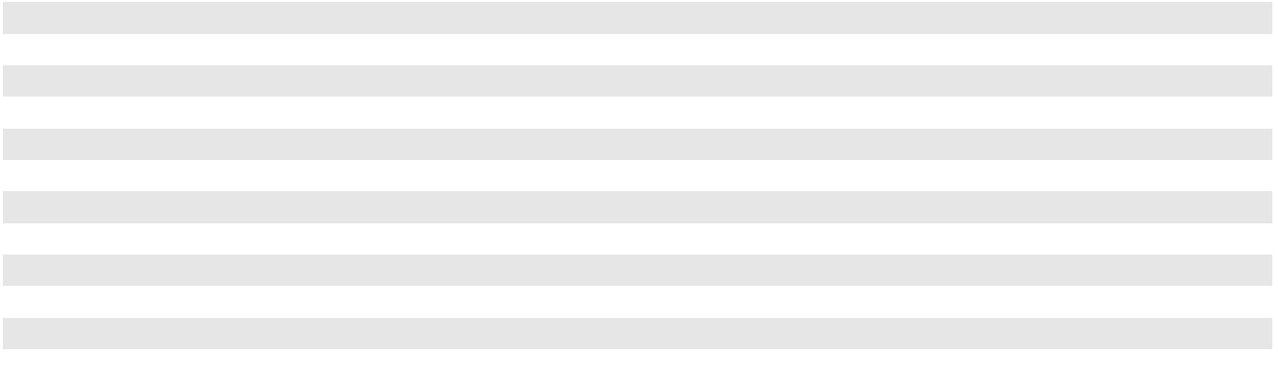

66

CLEAN HARBORS, INC. AND SUBSIDIARIES

NOTES TO CONSOLIDATED FINANCIAL STATEMENTS (Continued)

Contract Balances

(in thousands) |  | December 31, 2023 |  |  | December 31, 2022
Receivables | $ |  | 983,111 | $ |  | 964,603
Contract assets (unbilled receivables) |  |  | 107,859 |  |  | 107,010
Contract liabilities (deferred revenue) |  |  | 95,230 |  |  | 94,094

The timing of revenue recognition, billings and cash collections results in billed accounts receivable, unbilled receivables (contract assets) and customer advances and deposits or deferred revenue (contract liabilities) on the consolidated balance sheet. Generally, billing occurs subsequent to revenue recognition, as a right to payment is not just subject to passage of time, resulting in contract assets, which are generally classified as current. The Company sometimes receives advances or deposits from its customers before revenue is recognized, resulting in contract liabilities. These assets and liabilities are reported on the consolidated balance sheet on a contract-by-contract basis at the end of each reporting period. The contract liability balances at the beginning of each period presented were generally fully recognized in the subsequent three-month period.

Variable Consideration

The nature of the Company's contracts give rise to certain types of variable consideration, including in limited cases volume discounts. Accordingly, management establishes a revenue allowance to cover the estimated amounts of revenue that may need to be credited to customers' accounts in future periods. The Company estimates the amount of variable consideration included in the estimated transaction price based on historical experience, anticipated performance and management's best judgment at the time. The Company includes estimated amounts in the transaction price to the extent it is probable that a significant reversal of cumulative revenue recognized will not occur when the uncertainty associated with the variable consideration is resolved. There have been no material changes in estimates of variable consideration in the periods presented.

Contract Costs

Contract costs include direct and incremental costs to obtain or fulfill a contract. Parts washer costs include costs of solvent, commissions paid relating to revenue generated from parts washer services, and transportation costs associated with transferring the product picked up from the service as it is brought to the Company’s facilities or third-party sites. Costs related to the treatment of waste include costs for waste receiving, drum movement and storage, waste consolidation and transportation between facilities.

The Company’s contract costs that are subject to capitalization are comprised of costs associated with parts washer services and with the treatment and disposal of waste. As of December 31, 2023 and 2022, the Company's deferred contract costs totaled $29.9 million and $29.7 million, respectively. Deferred parts washer costs are recognized over the service interval as the customer receives the benefit of the services, and deferred costs related to treatment and disposal of waste are recognized when the corresponding waste is disposed. Deferred costs are included within total current assets in the Company’s consolidated balance sheets. The deferred contract cost balances at the beginning of each period presented were fully recognized in cost of revenue in the subsequent three-month period.

(4) BUSINESS COMBINATIONS

Proposed 2024 Acquisition

On February 2, 2024, the Company signed a definitive agreement with Gryphon Investors, Inc. to acquire HEPACO, a leading provider of specialized environmental and emergency response services in the Eastern United States, for $400.0 million in cash, subject to working capital and other adjustments. The Company intends to fund the acquisition with a combination of available cash and incremental borrowings under our term loan facility. The acquisition will expand field services operations within the Environmental Services segment and is expected to close in the first half of 2024, subject to regulatory approval and other customary closing conditions.

2023 Acquisition

On March 31, 2023, the Company acquired Thompson Industrial Services, LLC ("Thompson Industrial") for an all-cash purchase price of $110.9 million, net of cash acquired. The operations of Thompson Industrial expand the Environmental Services segment's industrial service operations in the southeastern region of the United States.

67

CLEAN HARBORS, INC. AND SUBSIDIARIES

NOTES TO CONSOLIDATED FINANCIAL STATEMENTS (Continued)

The preliminary allocation of the purchase price is provisional and was based on estimates of the fair value of assets acquired and liabilities assumed as of the acquisition date. The Company continues to obtain information to complete the valuation of these balances and the associated income tax accounting. Measurement period adjustments will reflect new information obtained about facts and circumstances that existed as of the acquisition date. The following table summarizes the preliminary determination and recognition of assets acquired and liabilities assumed (in thousands):

 | At Acquisition Date
 |  | As Reported
Accounts receivable | December 31, 2023
Accounts receivable | $ | 25,233
Inventories and supplies |  | 228
Prepaid expenses and other current assets |  | 1,302
Property, plant and equipment |  | 26,719
Permits and other intangibles |  | 28,900
Operating lease right-of-use assets |  | 4,716
Other long-term assets |  | 72
Current liabilities |  | (10,385)
Current portion of operating lease liabilities |  | (1,653)
Operating lease liabilities, less current portion |  | (3,063)
Other long-term liabilities |  | (560)
Total identifiable net assets |  | 71,509
Goodwill |  | 39,346
Total purchase price | $ | 110,855
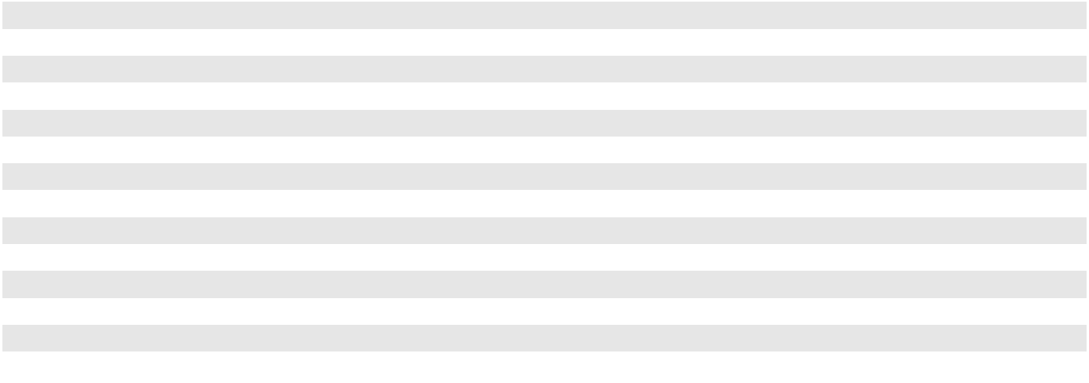

Permits and other intangible assets acquired include customer relationships, trademarks/tradenames and non-compete agreements and are anticipated to have estimated useful lives of between five and 15 years with a weighted average useful life of approximately 13 years. The excess of the total purchase price, which includes the aggregate cash consideration paid in excess of the fair value of the tangible and intangible assets acquired and liabilities assumed, was recorded as goodwill. The goodwill recognized is attributable to the expected operating synergies, assembled workforce and growth potential that the Company expects to realize from the acquisition. Goodwill generated from the acquisition is deductible for tax purposes.

The operations included in the Company's financial statements for the year ended December 31, 2023, and pro forma revenue and earnings amounts on a combined basis as if this acquisition had been completed on January 1, 2022 are immaterial to the consolidated financial statements of the Company.

2022 Acquisitions

On June 17, 2022, the Company acquired a privately-owned company for an all-cash purchase price of approximately $78.9 million, net of cash acquired. The operations of the newly acquired company expand the SKSS segment's waste oil collection capabilities and re-refining business throughout the southeastern region of the United States, including the addition of a re-refinery in Georgia.

68

CLEAN HARBORS, INC. AND SUBSIDIARIES

NOTES TO CONSOLIDATED FINANCIAL STATEMENTS (Continued)

The Company finalized the purchase accounting for this acquisition in the second quarter of 2023. The allocation of the purchase price was based on estimates of the fair value and assets acquired and liabilities assumed as of June 17, 2022. The following table summarizes the final determination and recognition of assets acquired and liabilities assumed (in thousands):

 | Preliminary Allocation |  |  |  |  |  |  | Final Allocation
 |  | As Reported |  | Measurement Period |  |  |  | As Reported
Accounts receivable |  | December 31, 2022 |  |  | Adjustments |  |  | December 31, 2023
Accounts receivable | $ | 1,111 |  | $ | (22) |  | $ | 1,089
Inventories and supplies |  | 5,816 |  |  | (71) |  |  | 5,745
Prepaid expenses and other current assets |  | 144 |  |  | — |  |  | 144
Property, plant and equipment |  | 19,605 |  |  | 2,626 |  |  | 22,231
Permits and other intangibles |  | 23,500 |  |  | — |  |  | 23,500
Operating lease right-of-use assets |  | 585 |  |  | — |  |  | 585
Other long-term assets |  | 13 |  |  | — |  |  | 13
Current liabilities |  | (3,271) |  |  | (104) |  |  | (3,375)
Current portion of operating lease liabilities |  | (186) |  |  | — |  |  | (186)
Operating lease liabilities, less current portion |  | (399) |  |  | — |  |  | (399)
Other long-term liabilities |  | (55) |  |  | (2,626) |  |  | (2,681)
Total identifiable net assets |  | 46,863 |  |  | (197) |  |  | 46,666
Goodwill |  | 32,015 |  |  | 197 |  |  | 32,212
Total purchase price | $ | 78,878 |  | $ | — |  | $ | 78,878

Permits and other intangible assets acquired include supplier relationships, permits, customer relationships and trademarks/ tradenames and are anticipated to have estimated useful lives of between five and 20 years with a weighted average useful life of approximately 18 years. The excess of the total purchase price, which includes the aggregate cash consideration paid in excess of the fair value of the tangible and intangible assets acquired, was recorded as goodwill. The goodwill recognized is attributable to the expected operating synergies, assembled workforce and growth potential that the Company expects to realize from the acquisition. Goodwill generated from the acquisition is deductible for tax purposes.

The operations included in the Company's financial statements for the period ended December 31, 2022 and pro forma revenue and earnings amounts on a combined basis as if this acquisition had been completed on January 1, 2021 were not material in 2022 to the consolidated financial statements of the Company.

On December 9, 2022, the Company acquired a privately-owned business for $12.6 million cash consideration. The acquired company expands the SKSS segment's oil collection operations in the southeastern United States. In connection with this acquisition, goodwill of $2.7 million was recognized. The results of operations for the acquired business were not material in 2022 to the consolidated financial statements of the Company.

HydroChemPSC

On October 8, 2021, the Company completed its acquisition of LJ Energy Services Intermediate Holding Corp. and its subsidiaries (collectively, “HydroChemPSC”), a privately owned company, for an all-cash purchase price of approximately $1.23 billion. HydroChemPSC is a leading U.S. provider of industrial cleaning, specialty maintenance and utilities services. These operations enhance and have been fully integrated into the Company's Environmental Services segment. In the first quarter of 2022, the Company received $5.0 million after finalizing the acquisition date working capital balances, which decreased the overall purchase price.

The Company finalized the purchase accounting for the acquisition of HydroChemPSC in the third quarter of 2022. The allocation of the purchase price was based on estimates of the fair value of assets acquired and liabilities assumed as of October

69

CLEAN HARBORS, INC. AND SUBSIDIARIES

NOTES TO CONSOLIDATED FINANCIAL STATEMENTS (Continued)

8, 2021. The following table summarizes the final determination and recognition of assets acquired and liabilities assumed (in thousands):

 |  |  | Final Allocation
Accounts receivable, including unbilled receivables |  | $ | 131,516
Inventories and supplies |  |  | 3,162
Prepaid expenses and other current assets |  |  | 16,291
Property, plant and equipment |  |  | 314,397
Other intangibles |  |  | 289,000
Operating lease right-of-use assets |  |  | 34,415
Other long-term assets |  |  | 962
Current liabilities |  |  | (118,854)
Current portion of operating lease liabilities |  |  | (11,277)
Operating lease liabilities, less current portion |  |  | (26,344)
Deferred tax liabilities |  |  | (80,386)
Other long-term liabilities |  |  | (4,170)
Total identifiable net assets |  |  | 548,712
Goodwill ^{(i)} |  |  | 676,701
Total purchase price |  | $ | 1,225,413
_____________
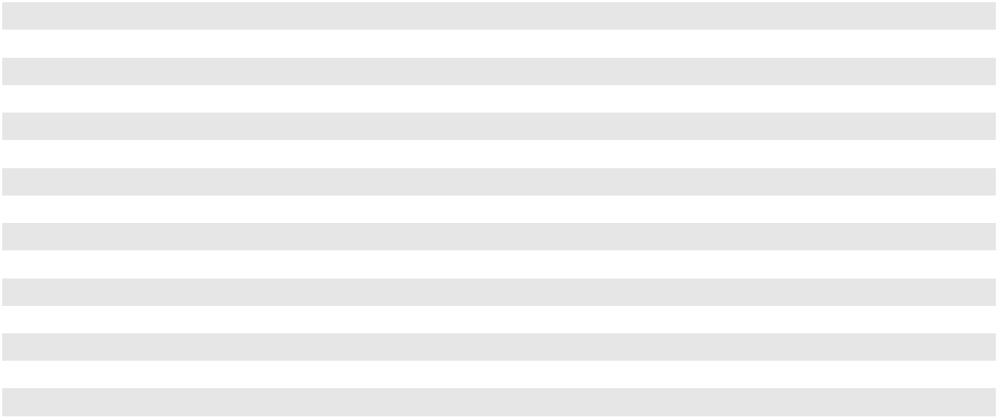
- Goodwill represents the excess of the fair value of the net assets acquired over the purchase price. Goodwill of $676.7 million is attributable to the future economic benefits arising from the acquired operations, synergies and the acquired workforce of HydroChemPSC. None of the goodwill related to this acquisition will be deductible for tax purposes. Final Goodwill was assigned to the Environmental Sales and Service reporting unit, see Note 8, "Goodwill and Other Intangible Assets" for details on reporting unit change as of December 31, 2023.

Unaudited Pro Forma Financial Information

The following table presents unaudited pro forma combined summary financial information for the year ended December 31, 2021, and assumes the acquisition of HydroChemPSC occurred on January 1, 2020 (in thousands):

 |  | 2021
Pro forma combined revenues
Pro forma combined revenues | $ | 4,380,724
Pro forma combined net income |  | 229,807

The pro forma results do not include any costs incurred directly attributable to the acquisition of HydroChemPSC. The pro forma results do reflect impacts resulting from the issuance of $1.0 billion secured senior term loans issued in connection with the acquisition assuming interest rates in effect at the time of the acquisition.

This pro forma financial information is not necessarily indicative of the Company's consolidated operating results that would have been reported had the transactions been completed as described herein, nor is such information necessarily indicative of the Company's consolidated results for any future period. Interest expense used in calculating the pro forma net income in both periods did not contemplate the interest rate swap that the Company put in place in early 2022. See Note 12, "Financing Arrangements."

Other 2021 Acquisition Activity

On March 27, 2021, the Company acquired a privately-owned business for $22.8 million cash consideration. The acquired company increases the SKSS segment's network within the south central United States. In connection with this acquisition, a goodwill amount of $16.3 million was recognized. The results of operations for this acquired business were not material in 2021.

On June 29, 2021, the Company signed a definitive agreement with Vertex Energy, Inc. ("Vertex") to acquire certain assets related to Vertex's used motor oil collection and re-refinery business in an all-cash transaction for $140.0 million, subject

70

CLEAN HARBORS, INC. AND SUBSIDIARIES

NOTES TO CONSOLIDATED FINANCIAL STATEMENTS (Continued)

to working capital and other adjustments. On January 25, 2022, Vertex and the Company mutually agreed to terminate the planned acquisition. Pursuant to the agreement, Vertex paid Clean Harbors a breakup fee of $3.0 million in early 2022 in connection with the termination.

(5) DISPOSITION OF BUSINESS

On June 30, 2022, the Company completed the sale of a line of business as part of its continuous focus on divesting certain non-core operations. The divested line of business was previously included within the Environmental Sales & Service reporting unit of the Environmental Services segment. The Company determined that the disposition did not constitute a strategic shift and that the impact on the Company's overall operations and financial results was not material. Accordingly, the operations associated with the disposal were not reported in discontinued operations. The final purchase price for the line of business was $18.8 million, after settling working capital, of which $1.5 million was held in escrow, half of which was received in 2023, and the remaining amount received in early 2024. The gain on sale of $8.9 million, after accounting for the assets sold, liabilities transferred upon sale and transaction costs, was included in gain on sale of business in the Company's consolidated statement of operations for the year ended December 31, 2022.

(6) INVENTORIES AND SUPPLIES

Inventories and supplies consisted of the following (in thousands):

 |  | December 31, 2023 |  |  | December 31, 2022
Oil and oil related products | $ | 118,600 | $ |  | 151,519
Supplies |  | 177,217 |  |  | 143,743
Solvent and solutions |  | 11,795 |  |  | 11,994
Other |  | 19,899 |  |  | 17,738
Total inventories and supplies | $ | 327,511 | $ |  | 324,994
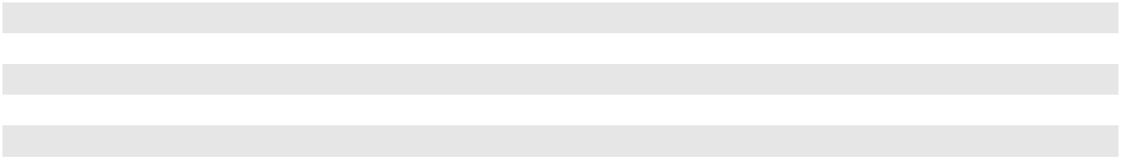

The balance of oil and oil related products has decreased due to lower volumes of base and blended oil on hand at December 31, 2023 when compared with December 31, 2022 and overall price decreases for the oil inventory and additives. Supplies inventories consist primarily of critical spare parts to support the Company's incinerator and re-refinery operations and other general supplies used in our normal day-to-day operations. Other inventories consist primarily of parts washer components, cleaning fluids, absorbents and automotive fluids, such as windshield washer fluid and antifreeze.

(7) PROPERTY, PLANT AND EQUIPMENT

Property, plant and equipment consisted of the following (in thousands):

 |  | December 31, 2023 |  |  | December 31, 2022
Land | $ | 174,891 | $ |  | 172,579
Asset retirement costs (non-landfill) |  | 27,167 |  |  | 22,001
Landfill assets |  | 253,180 |  |  | 232,872
Buildings and improvements ⁽¹⁾ |  | 630,525 |  |  | 591,397
Vehicles ⁽²⁾ |  | 1,276,567 |  |  | 1,112,188
Equipment ⁽³⁾ |  | 2,388,370 |  |  | 2,195,064
Construction in progress |  | 213,601 |  |  | 140,328
 |  | 4,964,301 |  |  | 4,466,429
Less - accumulated depreciation and amortization |  | 2,770,983 |  |  | 2,486,127
Total property, plant and equipment, net | $ | 2,193,318 | $ |  | 1,980,302
___________________________________
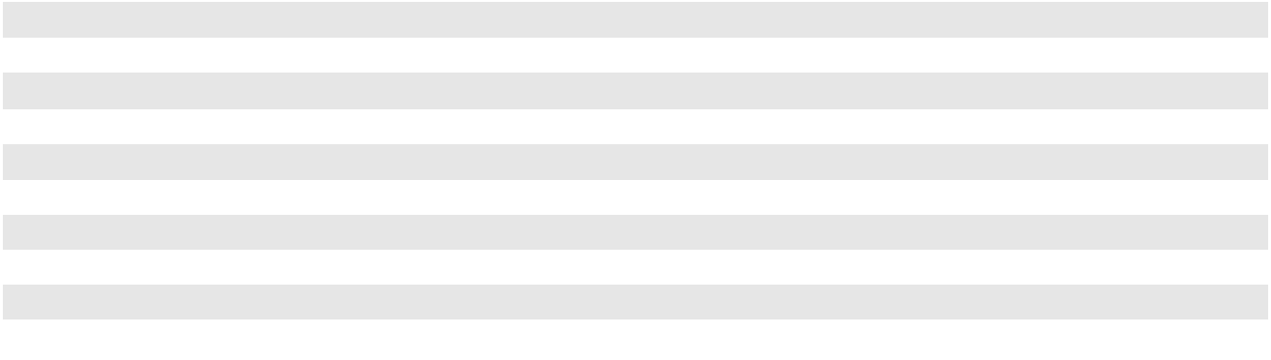
- Balances inclusive of gross ROU assets classified as finance leases of $8.0 million.

- Balances inclusive of gross ROU assets classified as finance leases of $151.7 million and $106.7 million, respectively.

- Balances inclusive of gross ROU assets classified as finance leases of $9.2 million.

Depreciation expense, inclusive of landfill and finance lease amortization was $315.5 million, $297.4 million and $263.4 million for the years ended December 31, 2023, 2022 and 2021, respectively. The Company recorded $6.6 million and $3.4

71

CLEAN HARBORS, INC. AND SUBSIDIARIES

NOTES TO CONSOLIDATED FINANCIAL STATEMENTS (Continued)

million capitalized interest in 2023 and 2022, respectively, mainly due to the construction of a new incinerator in Kimball, Nebraska. Capitalized interest in 2021 was negligible.

(8) GOODWILL AND OTHER INTANGIBLE ASSETS

The changes in goodwill for the years ended December 31, 2023 and 2022 were as follows (in thousands):

 | Environmental |  |  |  | Safety-Kleen
 |  |  |  | Sustainability |  |  | Total
 |  | Services |  |  | Solutions |  | Total
Balance at January 1, 2022 | $ | 1,085,534 | $ |  | 141,508 | $ 1,227,042
Increase from current period acquisitions |  | — |  |  | 34,510 | 34,510
Measurement period adjustments from prior period acquisition |  | (6,762) |  |  | — | (6,762)
Decrease from disposition of business |  | (4,412) |  |  | — | (4,412)
Foreign currency translation |  | (2,514) |  |  | (986) |  | (3,500)
Balance at December 31, 2022 | $ | 1,071,846 | $ |  | 175,032 | $ 1,246,878
Increase from current period acquisition |  | 39,346 |  |  | — | 39,346
Measurement period adjustments from prior period acquisitions |  | — |  |  | 360 | 360
Foreign currency translation |  | 821 |  |  | 331 |  | 1,152
Balance at December 31, 2023 | $ | 1,112,013 | $ |  | 175,723 | $ 1,287,736
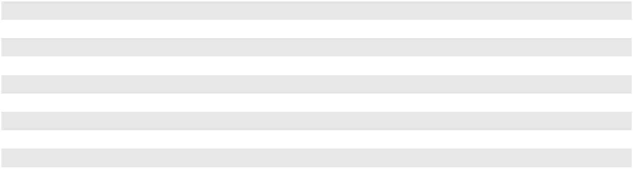

The Company assesses goodwill for impairment on an annual basis as of December 31 or at an interim date when it is more likely than not that events or changes in the business environment (“triggering events”) would reduce the fair value of a reporting unit below its carrying value. The Company did not identify any triggering events in the years presented.

During the fourth quarter of 2023, the Company changed reporting units, separating the historical Environmental Sales and Service reporting unit into two reporting units, Environmental Sales and Service and Industrial Services. This change required goodwill in the Environmental Sales and Services reporting unit to be allocated to the new reporting units based on relative fair value. The Company tested goodwill of the new reporting units for impairment both before and following the change in reporting unit structure, and no impairment was identified.

The Company conducted its annual impairment test of goodwill as of December 31, 2023 and determined that no adjustment to the carrying value of goodwill for any reporting unit was then necessary because the fair values of the reporting units exceeded their respective carrying values. The fair value of all reporting units was determined using an income approach based upon estimates of future discounted cash flows. The resulting estimates of fair value were validated through the consideration of other factors such as the fair value of comparable companies to the reporting units and a reconciliation of the sum of all estimated fair values of the reporting units to the Company’s overall market capitalization. In all cases, the estimated fair values of the reporting units significantly exceeded the respective carrying values.

Significant judgments and unobservable inputs, categorized as Level 3 in the fair value hierarchy, are inherent in the impairment tests performed and include assumptions about the amount and timing of expected future cash flows, growth rates, and the determination of appropriate discount rates. Level 3 inputs are unobservable inputs for the asset or liability in which there is little, if any, market activity for the asset or liability at the measurement date. The Company believes that the assumptions used in its impairment tests are reasonable, but variations in any of the assumptions may result in different measurements of fair values.

The impacts of any adverse business and market conditions which may impact the overall performance of the Company's reporting units will continue to be monitored. If the Company's reporting units do not achieve the financial performance that the Company expects, or if there is a significant prolonged change in demand for the Company's products and services, it is possible that goodwill impairment charges may result. Therefore, there can be no assurance that future events will not result in an impairment of goodwill.

72

CLEAN HARBORS, INC. AND SUBSIDIARIES

NOTES TO CONSOLIDATED FINANCIAL STATEMENTS (Continued)

As of December 31, 2023 and 2022, the Company's intangible assets consisted of the following (in thousands):

 |  |  | December 31, 2023 |  |  |  |  |  |  |  |  |  |  | December 31, 2022
 |  | Cost |  |  | Accumulated |  |  |  |  | Net |  |  | Cost |  |  | Accumulated |  |  |  |  | Net
 |  | Cost |  |  | Amortization |  |  |  |  | Net |  |  | Cost |  |  | Amortization |  |  |  |  | Net
Permits | $ | 191,747 | $ |  |  | 117,556 |  |  | $ | 74,191 | $ |  | 188,373 | $ |  |  | 109,036 |  |  | $ | 79,337
Customer and supplier relationships |  | 604,994 |  |  |  | 258,879 |  |  |  | 346,115 |  |  | 583,709 |  |  |  | 229,368 |  |  |  | 354,341
Other intangible assets |  | 100,068 |  |  |  | 37,862 |  |  |  | 62,206 |  |  | 89,388 |  |  |  | 24,818 |  |  |  | 64,570
Total amortizable permits and other |  | 896,809 |  |  |  | 414,297 |  |  |  | 482,512 |  |  | 861,470 |  |  |  | 363,222 |  |  |  | 498,248
intangible assets |  | 896,809 |  |  |  | 414,297 |  |  |  | 482,512 |  |  | 861,470 |  |  |  | 363,222 |  |  |  | 498,248
Trademarks and trade names |  | 120,285 |  |  |  | — |  |  |  | 120,285 |  |  | 122,534 |  |  |  | — |  |  |  | 122,534
Total permits and other intangible assets | $ | 1,017,094 | $ |  |  | 414,297 |  |  | $ | 602,797 | $ |  | 984,004 | $ |  |  | 363,222 |  |  | $ | 620,782
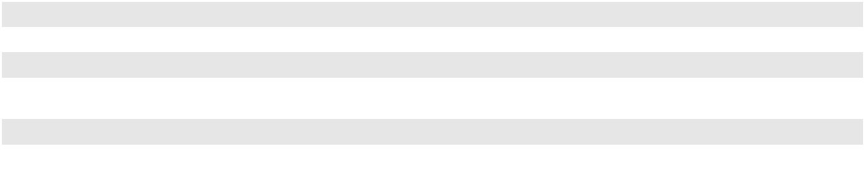

During the periods presented, there were no events or changes in circumstances which would indicate that the carrying values of the Company's asset groups would not be recoverable and thus no impairment charges were recorded. If expectations of future cash flows were to decrease in the future as a result of worse than expected or prolonged periods of depressed activity, future impairments may become evident.

Amortization expense of permits, customer and supplier relationships and other intangible assets for the years ended December 31, 2023, 2022 and 2021 were $50.3 million, $50.2 million and $34.7 million, respectively.

The expected amortization of the net carrying amount of finite-lived intangible assets at December 31, 2023 was as follows (in thousands):

Years ending December 31, |  |  | Expected
 |  |  | Amortization
2024
2024 |  | $ | 46,639
2025 |  |  | 43,231
2026 |  |  | 41,385
2027 |  |  | 39,245
2028 |  |  | 37,975
Thereafter |  |  | 274,037
 |  | $ | 482,512
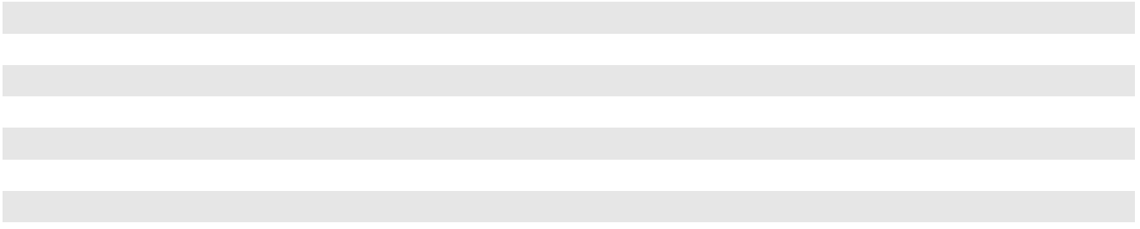

(9) ACCRUED EXPENSES AND OTHER CURRENT LIABILITIES

Accrued expenses and other current liabilities consisted of the following (in thousands):

 |  | December 31, 2023 |  |  | December 31, 2022
Accrued insurance | $ | 107,658 | $ |  | 92,909
Accrued interest |  | 33,857 |  |  | 20,033
Accrued compensation and benefits |  | 113,236 |  |  | 123,226
Accrued income, real estate, sales and other taxes |  | 44,752 |  |  | 61,442
Accrued other |  | 97,654 |  |  | 99,106
 | $ | 397,157 | $ |  | 396,716
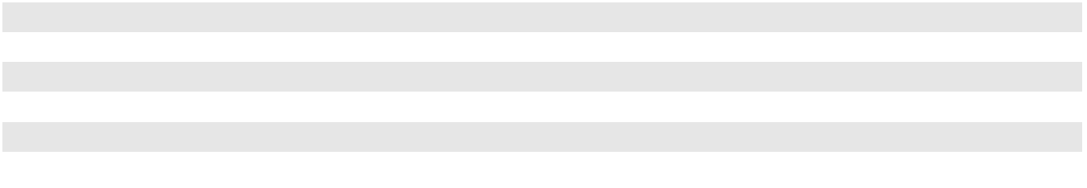

As of December 31, 2023 and 2022, accrued insurance included employee medical insurance costs of $22.8 million and $16.4 million, respectively, and accruals for losses under workers' compensation, comprehensive general liability and vehicle liability self-insurance programs of $82.7 million and $74.9 million, respectively. The increase in accrued interest is due to the timing of interest payments associated with debt issued in 2023. Refer to Note 12, "Financing Arrangements" for more information. The decrease in accrued compensation and benefits is primarily due to a decrease in accrued incentive compensation.

73

CLEAN HARBORS, INC. AND SUBSIDIARIES

NOTES TO CONSOLIDATED FINANCIAL STATEMENTS (Continued)

(10) CLOSURE AND POST-CLOSURE LIABILITIES

The changes to closure and post-closure liabilities (also referred to as "asset retirement obligations") from January 1, 2022 through December 31, 2023 were as follows (in thousands):

 |  | Landfill |  |  | Non-Landfill
 |  | Retirement |  |  | Retirement |  |  | Total
 |  | Liability |  |  | Liability |  |  | Total
Balance at January 1, 2022 | $ | 53,425 | $ |  | 45,678 | $ |  | 99,103
Liabilities assumed in acquisitions |  | — |  |  | 55 |  |  | 55
Measurement period adjustments from prior period acquisitions |  | — |  |  | 1,148 |  |  | 1,148
New asset retirement obligations |  | 3,743 |  |  | — |  |  | 3,743
Accretion |  | 4,605 |  |  | 4,147 |  |  | 8,752
Changes in estimates recorded to consolidated statement of operations |  | 1,063 |  |  | 5,712 |  |  | 6,775
Changes in estimates recorded to consolidated balance sheet |  | 3,219 |  |  | 1,742 |  |  | 4,961
Environmental expenditures |  | (3,373) |  |  | (1,778) |  |  | (5,151)
Currency translation and other |  | (431) |  |  | (154) |  |  | (585)
Balance at December 31, 2022 |  | 62,251 |  |  | 56,550 |  |  | 118,801
Liabilities assumed in acquisitions |  | — |  |  | 574 |  |  | 574
Measurement period adjustments from prior period acquisitions |  | — |  |  | 3,015 |  |  | 3,015
New asset retirement obligations |  | 3,092 |  |  | — |  |  | 3,092
Accretion |  | 4,958 |  |  | 4,519 |  |  | 9,477
Changes in estimates recorded to consolidated statement of operations |  | 1,147 |  |  | 53 |  |  | 1,200
Changes in estimates recorded to consolidated balance sheet |  | (3,706) |  |  | 1,600 |  |  | (2,106)
Environmental expenditures |  | (8,478) |  |  | (7,206) |  |  | (15,684)
Currency translation and other |  | 179 |  |  | 52 |  |  | 231
Balance at December 31, 2023 | $ | 59,443 | $ |  | 59,157 | $ |  | 118,600
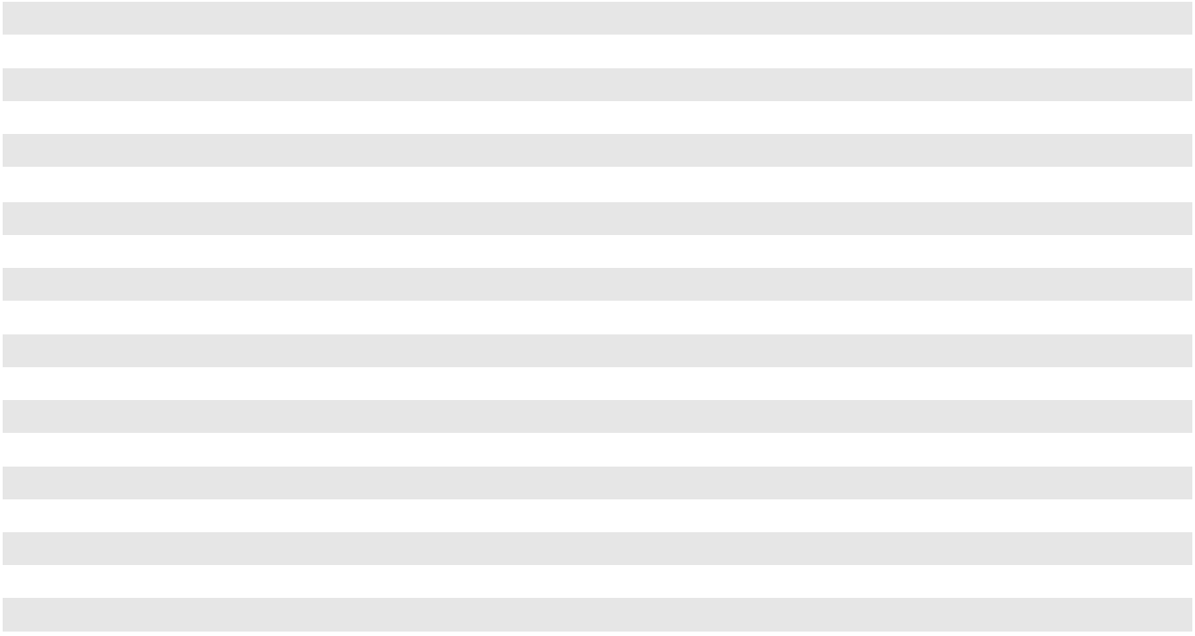

During the first quarter of 2023, the Company's non-commercial landfill at the Deer Park, Texas incineration facility reached its permitted capacity, as expected. The Company has commenced closure activities; however, there have been no changes to the liabilities related to this location. In the year ended December 31, 2023, there were no significant benefits or charges resulting from changes in estimates for closure and post-closure liabilities.

Anticipated payments (based on current estimated costs and anticipated timing of necessary regulatory approvals to commence work on closure and post-closure activities) for each of the next five years and thereafter are as follows (in thousands):

Years ending December 31,
2024 |  | $ | 15,698
2025 |  |  | 16,694
2026 |  |  | 14,750
2027 |  |  | 3,955
2028 |  |  | 13,628
Thereafter |  |  | 252,110
Undiscounted closure and post-closure liabilities |  |  | 316,835
Less: Discount at credit-adjusted risk-free rate |  |  | (114,325)
Less: Undiscounted estimated closure and post-closure liabilities relating to airspace not yet consumed |  |  | (83,910)
Present value of closure and post-closure liabilities |  | $ | 118,600
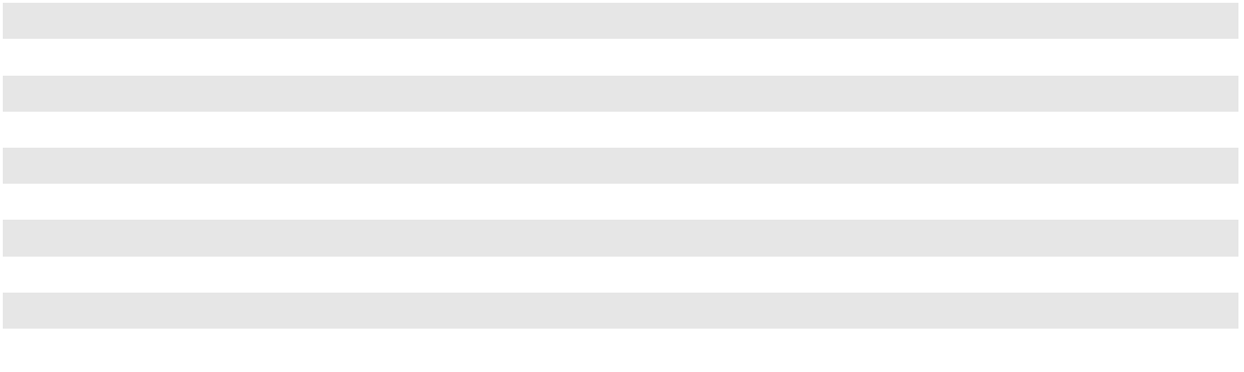

74

CLEAN HARBORS, INC. AND SUBSIDIARIES

NOTES TO CONSOLIDATED FINANCIAL STATEMENTS (Continued)

(11) REMEDIAL LIABILITIES

The changes to remedial liabilities from January 1, 2022 through December 31, 2023 were as follows (in thousands):

 |  |  |  |  |  |  |  | Remedial
 |  |  |  |  |  |  |  | Liabilities
 |  |  |  |  |  |  |  | (Including
 |  | Remedial |  |  | Remedial |  | Superfund)
 |  | Remedial |  |  | Remedial |  |  | for
 | Liabilities for |  |  | Liabilities for |  |  | Non-Landfill |  |  |  | Total
 | Landfill Sites |  |  | Inactive Sites |  |  | Operations |  |  |  | Total
Balance at January 1, 2022 | $ | 1,780 | $ |  | 59,787 | $ |  | 50,306 | $ |  | 111,873
Liabilities assumed in acquisition of real estate |  | — |  |  | — |  |  | 8,092 |  |  | 8,092
Measurement period adjustments from prior period acquisition |  | — |  |  | — |  |  | 338 |  |  | 338
Accretion |  | 86 |  |  | 2,498 |  |  | 1,607 |  |  | 4,191
Changes in estimates recorded to consolidated statement of operations |  | 8 |  |  | 877 |  |  | 612 |  |  | 1,497
Environmental expenditures |  | (50) |  |  | (3,370) |  |  | (5,375) |  |  | (8,795)
Currency translation and other |  | — |  |  | (43) |  |  | (863) |  |  | (906)
Balance at December 31, 2022 |  | 1,824 |  |  | 59,749 |  |  | 54,717 |  |  | 116,290
Accretion |  | 89 |  |  | 2,540 |  |  | 1,561 |  |  | 4,190
Changes in estimates recorded to consolidated statement of operations |  | 19 |  |  | 1,713 |  |  | 1,896 |  |  | 3,628
Expenditures |  | (52) |  |  | (3,840) |  |  | (9,384) |  |  | (13,276)
Currency translation and other |  | — |  |  | 115 |  |  | 296 |  |  | 411
Balance at December 31, 2023 | $ | 1,880 | $ |  | 60,277 | $ |  | 49,086 | $ |  | 111,243
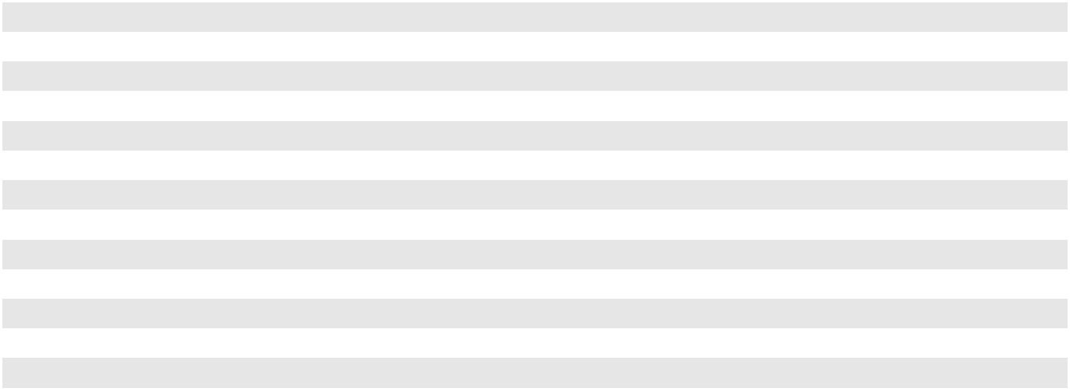

In the year ended December 31, 2023, the Company increased its remedial liabilities for an inactive site and an active site by $1.1 million each due to changes in the estimates of the related liabilities to account for new information obtained regarding the ultimate remediation of these sites. In the year ended December 31, 2022, the $8.1 million liability assumed in acquisition relates to real estate that the Company acquired in 2022. In purchasing the property, the Company assumed a known associated remedial liability, which was contemplated in the purchase price.

Anticipated payments at December 31, 2023 (based on current estimated costs and anticipated timing of necessary regulatory approvals to commence work on remedial activities) for each of the next five years and thereafter were as follows (in thousands):

Years ending December 31,
2024 |  | $ | 13,898
2025 |  |  | 19,253
2026 |  |  | 9,006
2027 |  |  | 7,001
2028 |  |  | 7,767
Thereafter |  |  | 71,737
Undiscounted remedial liabilities |  |  | 128,662
Less: Discount at risk free rates |  |  | (17,419)
Total remedial liabilities |  | $ | 111,243
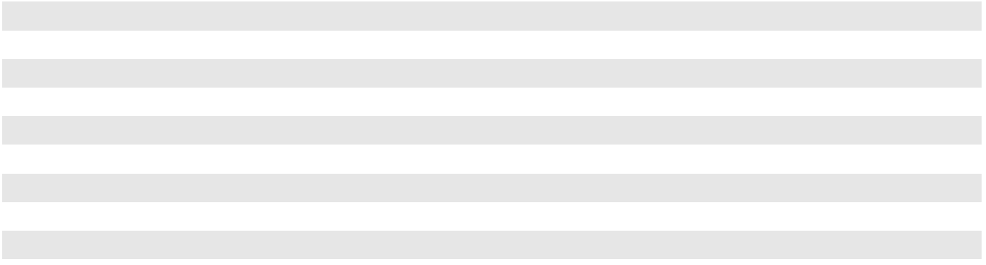

75

CLEAN HARBORS, INC. AND SUBSIDIARIES

NOTES TO CONSOLIDATED FINANCIAL STATEMENTS (Continued)

The following table presents the Company's estimated remedial liabilities and reasonably possible additional liabilities as of December 31, 2023 disaggregated by facility/site type (in thousands, except percentages):

 |  |  |  |  |  | Reasonably
 |  | Remedial |  |  |  |  | Possible
Type of Facility or Site |  | Remedial |  | % of Total |  |  | Additional
Type of Facility or Site |  | Liabilities |  | % of Total |  | Liabilities ⁽¹⁾
Inactive facilities not used in active conduct of the Company's business, most of | $ | 60,277 | 54.2 % |  | $ |  | 11,585
which were assumed through prior period acquisitions (24 facilities)
Facilities now used in active conduct of the Company's business (45 facilities) |  | 43,299 | 38.9 |  |  |  | 9,080
Superfund sites (13 sites) |  | 7,667 |  | 6.9 |  |  | 1,150
Total | $ | 111,243 | 100.0 % |  | $ |  | 21,815
___________________________________
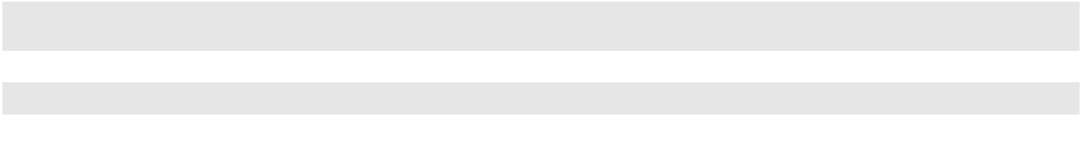
- Amounts represent the high end of the range of management's best estimate of the reasonably possible additional liabilities.

The following table presents the Company's estimated remedial liabilities and reasonably possible additional liabilities as of December 31, 2023 disaggregated by facilities/sites which represent at least 5% of the total and with all other facilities/ sites combined (in thousands, except percentages):

 |  |  |  |  |  |  |  | Reasonably
 |  |  |  | Remedial |  |  |  | Possible
Location |  | Type of Facility or Site |  | Remedial |  | % of Total |  | Additional
Location |  | Type of Facility or Site |  | Liabilities⁽¹⁾ |  | % of Total |  | Liabilities⁽²⁾
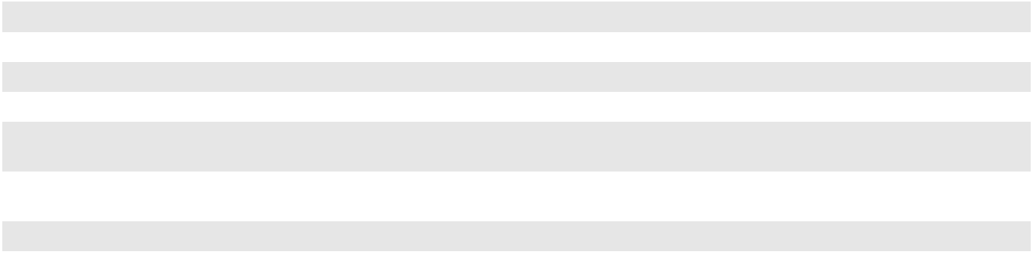

Baton Rouge, LA | Closed incinerator and landfill
Bridgeport, NJ | Closed incinerator
Mercier, Quebec | Idled incinerator
Linden, NJ | Operating solvent recycling center
Various | All other incinerators, landfills, wastewater treatment
Various | facilities and service centers (65 facilities)
Various | Superfund sites (each representing less than 5% of
Various | total liabilities) (13 sites)

Total

_________________________________

$ | 27,883 | 25.1 % |  | $ |  | 4,868
 | 17,472 | 15.7 |  |  |  | 3,288
 | 11,501 | 10.3 |  |  |  | 1,735
 | 9,614 | 8.6 |  |  |  | 2,187
 | 37,106 | 33.4 |  |  |  | 8,587
 | 7,667 |  | 6.9 |  |  | 1,150
$ | 111,243 | 100.0 % |  | $ |  | 21,815

- $25.0 million of the $111.2 million remedial liabilities include estimates related to the legal and administrative proceedings discussed in Note 18, "Commitments and Contingencies."
- Amounts represent the high end of the range of management's best estimate of the reasonably possible additional liabilities.

Revisions to remediation reserve requirements may result in upward or downward adjustments to income from operations in any given period. The Company believes that its extensive experience in the environmental services business, as well as its involvement with a large number of sites, provides a reasonable basis for estimating its aggregate liability. It is possible, however, that future changes in available technology, regulatory or enforcement developments, the results of environmental studies or other factors could necessitate the recording of additional liabilities or the revision of currently recorded liabilities that could be material. Since the Company's satisfaction of the liabilities will occur over many years, the Company cannot reasonably predict the nature or extent of possible future events or the impact that those events, if any, might have on the current estimates of remedial liabilities.

76

CLEAN HARBORS, INC. AND SUBSIDIARIES

NOTES TO CONSOLIDATED FINANCIAL STATEMENTS (Continued)

- FINANCING ARRANGEMENTS Long-term Debt
The following table is a summary of the Company's long-term debt (in thousands):

 |  |  |  | December 31, 2023 |  |  | December 31, 2022
Current Portion of Long-Term Debt:
Secured senior term loans |  |  | $ | 10,000 | $ |  | 10,000
Long-Term Debt:
Secured senior term loans due June 30, 2024 ("2024 Term Loans") |  |  | $ | — | $ |  | 613,975
Secured senior term loans due October 8, 2028 ("2028 Term Loans") |  |  |  | 970,000 |  |  | 980,000
Unsecured senior notes, at 4.875%, due July 15, 2027 ("2027 Notes") |  |  |  | 545,000 |  |  | 545,000
Unsecured senior notes, at 5.125%, due July 15, 2029 ("2029 Notes") |  |  |  | 300,000 |  |  | 300,000
Unsecured senior notes, at 6.375%, due February 1, 2031 ("2031 Notes") |  |  |  | 500,000 |  |  | —
Long-term debt, at par |  |  |  | 2,315,000 |  |  | 2,438,975
Unamortized debt issuance costs and discount, net |  |  |  | (23,283) |  |  | (24,147)
Long-term debt, at carrying value |  |  | $ | 2,291,717 | $ |  | 2,414,828
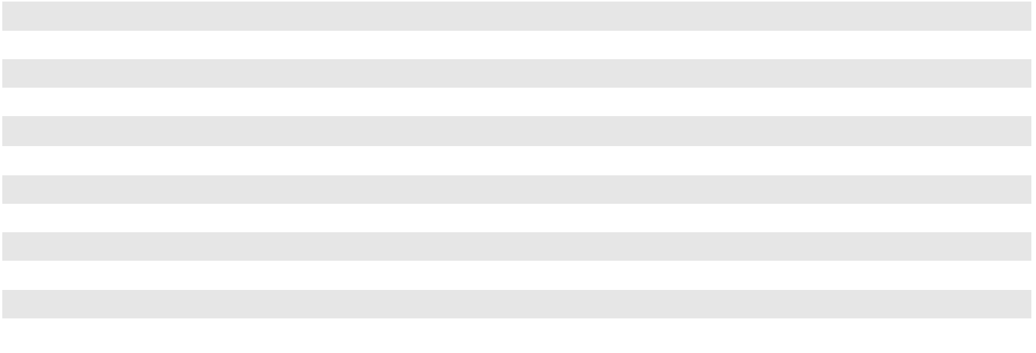

As of December 31, 2023 and 2022, the estimated fair value of the Company’s outstanding long-term debt, including the current portion, was $2.3 billion and $2.4 billion, respectively. The Company’s estimates of fair value of its long-term debt, including the current portion, are based on quoted market prices or other available market data which are considered Level 2 measures according to the fair value hierarchy. Level 2 utilizes quoted market prices in markets that are not active, broker or dealer quotation or alternative pricing sources with reasonable levels of price transparency for similar assets and liabilities.

The sections below will outline the key terms of the outstanding debt, including any changes occurring during the period:

Secured Senior Term Loans

As of December 31, 2023, the 2028 Term Loans had an aggregate principal amount outstanding of $980.0 million under the Fourth Amendment to the Company's existing Credit Agreement dated as of June 30, 2017 (the "Term Loan Agreement").

Interest on the 2028 Term Loans is paid monthly. On December 27, 2023, the Term Loan Agreement was amended to reduce the interest rate margin by 25 basis points. After giving effect to this amendment, the 2028 Term Loan bears interest, at the Company’s election, at either of the following rates: (a) the sum of the Term SOFR Rate (as defined) plus 0.11448% (the one-month Term SOFR adjustment as defined) plus a 1.75% margin, or (b) the sum of the Base Rate (as defined) plus 0.75% margin. The Term SOFR Rate is subject to a floor of 0.00% and the Base Rate is subject to a floor of 1.00%. The Term Loan Agreement provides for Term SOFR adjustments for other interest periods; however, the Company elects one-month Term SOFR for interest payments on that debt resulting in total interest on the 2028 Term Loans of one-month Term SOFR plus 1.86448%.

The 2028 Term Loans are prepayable at any time without premium or penalty, other than customary breakage costs. The 2028 Term Loan amendment in December 2023 reset the six month soft call period for repricing transactions.

On January 24, 2023, the Company repaid the $614.0 million outstanding of 2024 Term Loans using net proceeds from the issuance of $500.0 million of unsecured 2031 Senior Notes, as described below, borrowing $114.0 million under the Company's Revolving Credit Facility, also discussed below, and available cash. During the year, the Company recognized a loss on early extinguishment of debt of $2.9 million due to this transaction and the 2028 Term Loan amendment noted above.

The Company's obligations under the Term Loan Agreement are guaranteed by all of the Company's domestic restricted subsidiaries and secured by the liens on substantially all of the assets of the Company and the guarantors.

Unsecured Senior Notes

On July 2, 2019, the Company completed a private placement of $545.0 million aggregate principal amount of 2027 Notes and $300.0 million aggregate principal amount of 2029 Notes. The 2027 Notes will mature on July 15, 2027 and the 2029 Notes will mature on July 15, 2029. Interest payments on the 2027 and 2029 Notes are paid semiannually on January 15 and July 15.

77

CLEAN HARBORS, INC. AND SUBSIDIARIES

NOTES TO CONSOLIDATED FINANCIAL STATEMENTS (Continued)

On January 24, 2023, the Company completed a private placement of $500.0 million aggregate principal amount of 2031 Notes which will mature on February 1, 2031 (collectively referred to with the 2027 Notes and 2029 Notes as the "Notes"). As noted above, the proceeds from this were used toward the repayment of the 2024 Term Loans. The interest rate on the 2031 Notes is paid semiannually on February 1 and August 1 of each year and commenced on August 1, 2023.

The tables below depict the redemption prices of the Notes if redeemed during the twelve-month period commencing on the dates below, plus accrued and unpaid interest, if any, to but not including the redemption date.

2027 Notes

July 15, 2023

July 15, 2024 and thereafter

2029 Notes

July 15, 2024

July 15, 2025

July 15, 2026 and thereafter

2031 Notes

February 1, 2026

February 1, 2027

February 1, 2028 and thereafter

Percentage

101.219 %

100.000 %

Percentage

102.563 %

101.281 %

100.000 %

Percentage

103.188 %

101.594 %

100.000 %

The Company may also redeem all or any portion of the 2029 Notes prior to July 15, 2024 or the 2031 Notes prior to February 1, 2026, at a redemption price equal to 100% of the principal amount redeemed plus a make whole premium as of the date of redemption including accrued and unpaid interest, if any, up to but not including the date of redemption.

Additionally, subject to certain limitations, prior to February 1, 2026, the Company may use net cash proceeds of one or more equity offerings to redeem up to 40% in aggregate principal of the 2031 Notes at a redemption price equal to 106.375% of the principal amount thereof plus accrued and unpaid interest thereon, if any, up to but not including the date of redemption.

The Notes and the related indentures contain various customary non-financial covenants and are guaranteed by substantially all of the Company’s current and future domestic subsidiaries. The Notes are effectively subordinated to the Company's Term Loans, revolving credit facility and finance lease obligations to the extent of the value of the assets securing such secured indebtedness. The Notes are also effectively subordinated to all indebtedness and other liabilities of the Company's subsidiaries that are not guarantors of the Notes.

Revolving Credit Facility.

On October 28, 2020, the Company and one of the Company's subsidiaries (the "Canadian Borrower") entered into an amended and restated credit agreement for the Company's revolving credit facility with Bank of America, N.A. (“BofA”), as agent for the lenders under the facility (the "Agent"). Under the amended and restated facility, the Company has the right to obtain revolving loans and letters of credit for a combined maximum of up to $350.0 million (with a sub-limit of $250.0 million for letters of credit) and the Canadian Borrower has the right to obtain revolving loans and letters of credit for a combined maximum of up to $50.0 million. Availability under the U.S. line is subject to a borrowing base primarily comprised of 85% of the eligible accounts receivable of the Company and its U.S. subsidiaries plus 100% of cash deposited in a controlled account with the Agent, and availability under the Canadian line is subject to a borrowing base primarily comprised of 85% of the eligible accounts receivable of the Company’s Canadian subsidiaries plus 100% of cash deposited in a controlled account with the Agent’s Canadian affiliate. Subject to certain conditions, the revolving credit facility will expire on October 28, 2025.

On April 28, 2023, the Company entered into an amendment to the credit agreement for the revolving credit facility. As amended, the terms of the agreement are substantially the same as prior to the amendment except for certain updates required to transition the agreement to include a defined LIBOR successor rate. Under the amended agreement, borrowings under the revolving credit facility will bear interest at a rate, at the Company’s option, of either (i) “Term SOFR” (as defined in the amended agreement) plus an applicable margin ranging from 1.50% to 1.75% per annum based primarily on the level of the Company’s average liquidity for the most recent 30 day period or (ii) BofA’s base rate plus an applicable margin ranging from

78

CLEAN HARBORS, INC. AND SUBSIDIARIES

NOTES TO CONSOLIDATED FINANCIAL STATEMENTS (Continued)

0.50% to 0.75% per annum based primarily on such average liquidity. The amended agreement also continues to provide (i) for an unused line fee payable to the lenders, calculated on the then unused portion of the lenders’ $400.0 million maximum commitments, ranging from 0.25% to 0.375% per annum of the unused commitment, and (ii) for outstanding letters of credit, a fee payable to the lenders equal to the then applicable margin for Term SOFR borrowings described above, and to the issuing banks a standard fronting fee and customary fees and charges in connection with all amendments, extensions, draws and other actions with respect to letters of credit.

Letters of credit issued under the revolving credit facility are utilized primarily as security for the Company's insurance program that includes casualty and financial assurance.

The Company’s obligations under the revolving credit facility (including revolving loans and reimbursement obligations for outstanding letters of credit) are guaranteed by substantially all of the Company’s U.S. subsidiaries and secured by a first lien on the Company’s and its U.S. subsidiaries’ accounts receivable. The Canadian Borrower’s obligations under the facility are guaranteed by substantially all of the Company’s Canadian subsidiaries and secured by a first lien on the accounts receivable of the Canadian subsidiaries.

The revolving credit facility had no outstanding loan balances at December 31, 2023 and had availability of $265.7 million and outstanding letters of credit of $134.3 million. The Company also had no outstanding loan balances as of December 31, 2022. As noted above, on January 24, 2023, the Company borrowed $114.0 million under the revolving credit facility. Proceeds from this borrowing were used toward the repayment of the 2024 Term Loans. This borrowing was repaid during the second quarter of 2023.

Cash Flow Hedges

The Company's strategy to hedge against fluctuations in variable interest rates involves entering into interest rate derivative agreements.

The Company effectively fixed the interest rate on $350.0 million principal of the previously outstanding 2024 Term Loans by entering into interest rate swap agreements in 2018 with a notional amount of $350.0 million ("2018 Swaps"). On January 24, 2023, concurrently with the repayment of the 2024 Term Loans, the Company received a settlement payment of $8.3 million from the 2018 Swap counterparties. As a result of the settlement, the Company also reclassified the amounts previously deferred in accumulated other comprehensive loss and recognized a settlement gain of $8.3 million in interest expense in 2023.

In 2022, the Company entered into interest rate swap agreements with a notional amount of $600.0 million ("2022 Swaps") to effectively fix the interest rate on $600.0 million principal of the outstanding 2028 Term Loans. Under the terms of the 2022 Swaps' agreements, the Company receives interest based upon the variable rates on the 2028 Term Loans and pays a fixed amount of interest. The fixed rate on these instruments was 0.931% through June 30, 2023 which, together with the original 2.00% interest rate margin for the 2028 Term Loans, resulted in an effective annual interest rate of approximately 2.931% through June 30, 2023.

The fixed rate on these instruments increased to 1.9645% on July 1, 2023 and the variable rate became linked to Term SOFR to mirror the variable interest payments for the 2028 Term Loans. The 2022 Swaps expire September 30, 2027. Including the 2.00% interest rate margin for borrowings on the 2028 Term Loans and the 0.11448% SOFR adjustment per the 2028 Term Loans, beginning July 1, 2023, the effective annual interest rate of this $600.0 million increased to 4.07898%. With the 2028 Term Loan amendment in December 2023 reducing the margin from 2.00% to 1.75%, discussed in the Term Loans section above, the effective annual interest rate on the swapped portion of 2028 Term Loans outstanding decreased to 3.82898%.

At the inception of these instruments, the Company designated both the 2018 Swaps and the 2022 Swaps (collectively referred to as the “Swaps”) as cash flow hedges. As of December 31, 2023 the Company recorded a derivative asset with a fair value of $35.5 million comprised only of the 2022 Swaps as the 2018 Swaps were settled in early 2023, as noted above. The balance in the derivative asset as of December 31, 2022 was $60.6 million, which included both of the Swaps.

No ineffectiveness has been identified on the Swaps and, therefore the change in fair value is recorded in stockholders' equity as a component of accumulated other comprehensive loss. Amounts are reclassified from accumulated other comprehensive loss into interest expense on the consolidated statement of operations in the same period or periods during which the hedged transactions affect earnings.

79

CLEAN HARBORS, INC. AND SUBSIDIARIES

NOTES TO CONSOLIDATED FINANCIAL STATEMENTS (Continued)

(13) INCOME TAXES

The domestic and foreign components of income before provision for income taxes were as follows (in thousands):

 |  | For the years ended December 31,
 |  | 2023 |  |  | 2022 |  |  | 2021
Domestic | $ | 401,912 | $ |  | 406,206 | $ |  | 223,438
Foreign |  | 101,367 |  |  | 131,792 |  |  | 46,277
Total | $ | 503,279 | $ |  | 537,998 | $ |  | 269,715

The provision for income taxes consisted of the following (in thousands, except percentages):

 |  | For the years ended December 31,
 |  | 2023 |  |  | 2022 |  |  | 2021
Current:
Federal | $ | 64,164 | $ |  | 52,237 | $ |  | 42,480
State |  | 25,496 |  |  | 26,980 |  |  | 18,126
Foreign |  | 23,078 |  |  | 29,488 |  |  | 4,380
 |  | 112,738 |  |  | 108,705 |  |  | 64,986
Deferred
Federal |  | 18,251 |  |  | 32,199 |  |  | 2,275
State |  | (9,049) |  |  | (2,432) |  |  | (4,777)
Foreign |  | 3,483 |  |  | (12,218) |  |  | 3,984
 |  | 12,685 |  |  | 17,549 |  |  | 1,482
Provision for income taxes | $ | 125,423 | $ |  | 126,254 | $ |  | 66,468
Effective tax rate |  | 24.9% |  |  | 23.5% |  |  | 24.6%
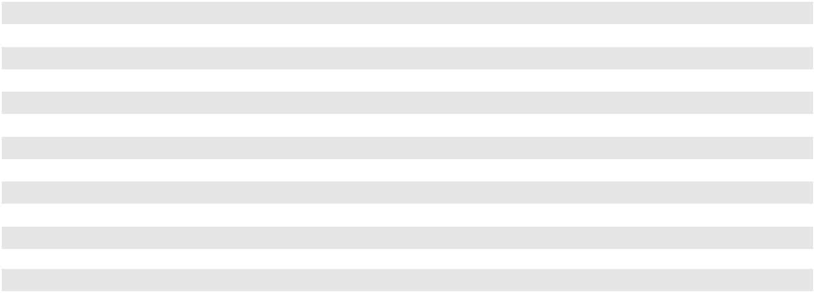

The Company's effective income tax rate varied from the amount computed using the statutory federal income tax rate of 21% as follows (in thousands):

 |  | For the years ended December 31,
 |  | 2023 |  |  | 2022 |  |  | 2021
Tax expense at U.S. statutory rate | $ | 105,689 | $ |  | 112,980 | $ |  | 56,640
State income taxes, net of federal benefit |  | 18,067 |  |  | 19,831 |  |  | 12,101
Foreign rate differential |  | 4,213 |  |  | 6,196 |  |  | 1,922
Valuation allowance |  | (7,699) |  |  | (18,769) |  |  | (9,139)
Uncertain tax position interest and penalties |  | (7) |  |  | (2,454) |  |  | 263
Tax credits expired |  | 1,653 |  |  | 2,768 |  |  | 2,530
Non-deductible compensation |  | 2,898 |  |  | 2,754 |  |  | 2,326
Other |  | 609 |  |  | 2,948 |  |  | (175)
Provision for income taxes | $ | 125,423 | $ |  | 126,254 | $ |  | 66,468
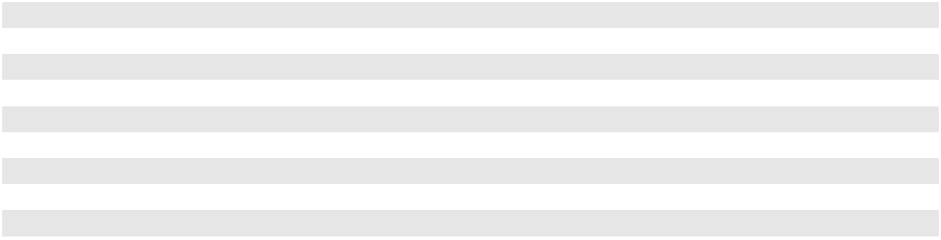

The valuation allowance benefits recognized in 2023 are predominantly the result of cumulative profitable earnings at certain US entities with historic State operating losses. As of December 31, 2023, management determined that there is sufficient positive evidence to conclude that it is more likely than not that additional deferred taxes associated with these State net operating losses are realizable. Therefore, the valuation allowance was reduced accordingly.

The valuation allowance benefits recognized in 2022 were the result of cumulative profitable earnings at certain Canadian entities with historic operating losses. The 2022 earnings were sufficient to utilize substantially all of the net operating losses, and as of December 31, 2022, the Company released any remaining valuation allowances associated with these entities, which were nominal.

The valuation allowance benefits recognized in 2021 were predominately related to taxable earnings in certain Canadian entities that benefited from amounts received under the Canada Emergency Wage Subsidiary. In addition, foreign tax credits

80

CLEAN HARBORS, INC. AND SUBSIDIARIES

NOTES TO CONSOLIDATED FINANCIAL STATEMENTS (Continued)

that expired in the period presented had full valuation allowances which were also written off, contributing to the valuation allowance benefits in the table above. The foreign tax credit expirations and associated valuation allowance write-offs had no net impact to the provision for income taxes in any year.

The components of the total net deferred tax assets and liabilities as of December 31, 2023 and 2022 were as follows (in thousands):

 |  | 2023 |  |  | 2022
Deferred tax assets:
Provision for doubtful accounts | $ | 10,882 | $ |  | 11,544
Closure, post-closure and remedial liabilities |  | 31,944 |  |  | 31,837
Operating lease liabilities |  | 46,784 |  |  | 42,255
Accrued expenses |  | 14,963 |  |  | 19,311
Accrued compensation and benefits |  | 15,058 |  |  | 20,171
Net operating loss carryforwards⁽¹⁾ |  | 39,042 |  |  | 41,585
Tax credit carryforwards⁽²⁾ |  | 6,531 |  |  | 8,903
Stock-based compensation |  | 3,516 |  |  | 3,988
Other |  | 4,843 |  |  | 7,487
Total deferred tax assets |  | 173,563 |  |  | 187,081
Deferred tax liabilities:
Property, plant and equipment |  | (284,997) |  |  | (281,131)
Operating lease right-of-use assets |  | (46,584) |  |  | (41,939)
Interest rate swap asset |  | (9,576) |  |  | (17,587)
Permits and other intangible assets |  | (130,391) |  |  | (132,681)
Prepaid expenses |  | (12,372) |  |  | (12,088)
Total deferred tax liabilities |  | (483,920) |  |  | (485,426)
Total net deferred tax liability before valuation allowance |  | (310,357) |  |  | (298,345)
Less valuation allowance |  | (35,272) |  |  | (42,509)
Net deferred tax liabilities | $ | (345,629) | $ |  | (340,854)
___________________________________
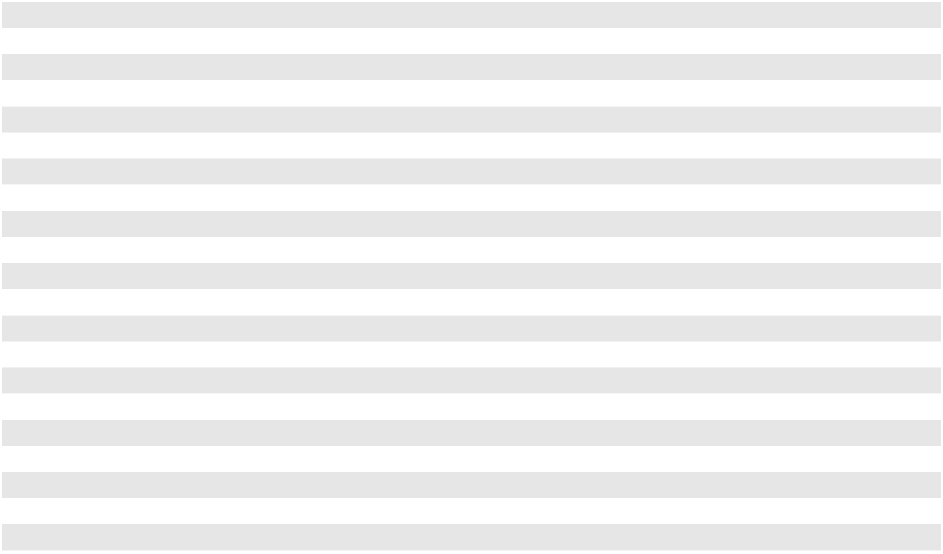
- As of December 31, 2023, the net operating loss carryforwards included (i) state net operating loss carryforwards of $229.9 million which will begin to expire in 2024, (ii) federal net operating loss carryforwards of $26.6 million which will begin to expire in 2024 and (iii) foreign net operating loss carryforwards of $83.2 million which will begin to expire in 2024.

- As of December 31, 2023, the foreign tax credit carryforwards of $4.4 million will begin to expire in 2024.

The Company previously recognized the U.S. federal income taxes related to the operations in Canada and has not accrued for any remaining undistributed foreign earnings. These amounts continue to be indefinitely reinvested. The amount of tax associated with those unrepatriated earnings is not expected to be material.

81

CLEAN HARBORS, INC. AND SUBSIDIARIES

NOTES TO CONSOLIDATED FINANCIAL STATEMENTS (Continued)

A valuation allowance is required to be established when, based on an evaluation of available evidence, it is more likely than not that some portion or all of the deferred tax assets will not be realized. The components of the total valuation allowance as of December 31, 2023 and 2022 were as follows (in thousands):

 | 2023 |  |  |  | 2022
Allowance related to:
Foreign tax credits | $ | 4,422 | $ |  | 7,666
Federal net operating losses |  | 3,783 |  |  | 3,783
State net operating loss carryforwards |  | 4,809 |  |  | 9,928
Foreign net operating loss carryforwards |  | 17,464 |  |  | 15,488
Deferred tax assets of a Canadian subsidiary |  | 4,489 |  |  | 5,339
Realized and unrealized capital losses |  | 305 |  |  | 305
Total valuation allowance | $ | 35,272 | $ |  | 42,509
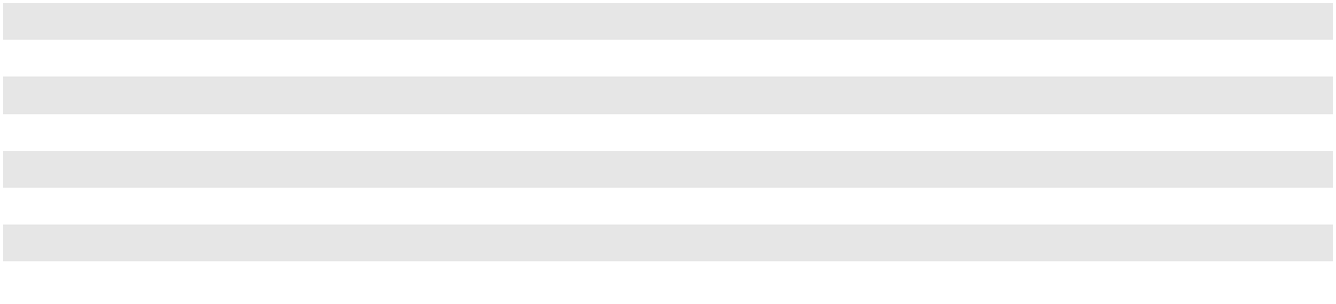

The Company files U.S. federal income tax returns as well as income tax returns in various states and foreign jurisdictions. The Company may be subject to examination by the Internal Revenue Service for calendar years 2018 through 2022. The Company may be subject to examination by Canadian federal and provincial authorities for calendar years 2016 through 2022 and by state and local revenue authorities for calendar years 2017 through 2022. The Company has ongoing U.S., state and local jurisdictional audits, as well as Canadian federal and provincial audits, all of which the Company believes will not result in material liabilities. The Company has not identified any material uncertain tax positions in the periods presented.

(14) EARNINGS PER SHARE

The following are computations of basic and diluted earnings per share (in thousands, except for per share amounts):

For the years ended December 31,

 |  | 2023 |  |  | 2022 |  |  | 2021
Numerator for basic and diluted earnings per share:
Net income | $ | 377,856 | $ |  | 411,744 | $ |  | 203,247
Denominator:
Weighted basic shares outstanding |  | 54,071 |  |  | 54,223 |  |  | 54,514
Dilutive effect of equity-based compensation awards |  | 311 |  |  | 264 |  |  | 247
Weighted dilutive shares outstanding |  | 54,382 |  |  | 54,487 |  |  | 54,761
Basic earnings per share | $ | 6.99 |  | $ | 7.59 |  | $ | 3.73
Diluted earnings per share
Diluted earnings per share | $ | 6.95 |  | $ | 7.56 |  | $ | 3.71

The Company included all outstanding performance awards and restricted stock awards in the calculation of diluted earnings per share except for as shown in the table below:

 | For the years ended December 31,
 | 2023 |  | 2022 |  |  | 2021
Antidilutive restricted stock awards | 12,247 | 10,250 |  |  |  | 67,981
Performance stock awards for which performance criteria was not | 88,876 |  | — |  |  | 14,237
attained at reporting date | 88,876 |  |  |  |  | 14,237

(15) STOCKHOLDERS' EQUITY

On December 5, 2023, the Board of Directors of Clean Harbors authorized a $500.0 million expansion of the Company’s current share repurchase program resulting in $554.1 million available at December 31, 2023. The repurchase program authorizes the Company to purchase the Company's common stock on the open market or in privately negotiated transactions periodically in a manner that complies with applicable U.S. securities laws. The number of shares purchased and the timing of the purchases have depended and will depend on a number of factors including share price, cash required for future business plans, trading volume and other conditions. The Company has no obligation to repurchase stock under this program and may suspend or terminate the repurchase program at any time.

82

CLEAN HARBORS, INC. AND SUBSIDIARIES

NOTES TO CONSOLIDATED FINANCIAL STATEMENTS (Continued)

During the years ended December 31, 2023, 2022 and 2021, the Company repurchased and retired a total of 0.3 million, 0.5 million and 0.6 million shares, respectively, of the Company's common stock for total costs of $51.2 million, $50.2 million and $54.4 million, respectively.

(16) ACCUMULATED OTHER COMPREHENSIVE LOSS

The changes in accumulated other comprehensive loss by component and related tax impacts for the years ended

December 31, 2023, 2022 and 2021 were as follows (in thousands):

 |  |  | Unrealized |  |  | Unrealized
 | Foreign |  | Gain (Loss) |  |  | (Loss) Gain
 | Foreign |  |  | on |  |  | on Fair |  | Unrealized
 | Currency |  |  | Available- |  |  | Value of
 | Translation |  |  | For-Sale |  | Interest Rate |  |  |  | Loss on |  | Total
 | Adjustments |  |  | Securities |  |  | Hedges |  |  | Pension |  | Total
Balance at January 1, 2021 | $ (176,234) | $ |  | 135 | $ |  | (33,629) | $ |  | (1,749) | $ (211,477)
Other comprehensive (loss) income before reclassifications | (1,590) |  |  | (361) |  |  | 6,235 |  |  | 1,411 | 5,695
Amounts reclassified out of accumulated other | — |  |  | — |  |  | 10,011 |  |  | — | 10,011
comprehensive loss | — |  |  | — |  |  | 10,011 |  |  | —
Tax benefit (provision) | — |  |  | 76 |  |  | — |  |  | (317) |  | (241)
Other comprehensive (loss) income | (1,590) |  |  | (285) |  |  | 16,246 |  |  | 1,094 |  | 15,465
Balance at December 31, 2021 | (177,824) |  |  | (150) |  |  | (17,383) |  |  | (655) |  | (196,012)
Other comprehensive (loss) income before reclassifications | (31,515) |  |  | (523) |  |  | 78,711 |  |  | 415 | 47,088
Amounts reclassified out of accumulated other | — |  |  | — |  |  | (683) |  |  | — | (683)
comprehensive loss | — |  |  | — |  |  | (683) |  |  | —
Tax benefit (provision) | — |  |  | 110 |  |  | (17,587) |  |  | (97) |  | (17,574)
Other comprehensive (loss) income | (31,515) |  |  | (413) |  |  | 60,441 |  |  | 318 |  | 28,831
Balance at December 31, 2022 | (209,339) |  |  | (563) |  |  | 43,058 |  |  | (337) |  | (167,181)
Other comprehensive income (loss) before reclassifications | 9,000 |  |  | 708 |  |  | 5,094 |  |  | (741) | 14,061
Amounts reclassified out of accumulated other | — |  |  | — |  |  | (30,273) |  |  | — | (30,273)
comprehensive loss | — |  |  | — |  |  | (30,273) |  |  | —
Tax (provision) benefit | — |  |  | (149) |  |  | 8,012 |  |  | 191 |  | 8,054
Other comprehensive income (loss) | 9,000 |  |  | 559 |  |  | (17,167) |  |  | (550) |  | (8,158)
Balance at December 31, 2023 | $ (200,339) | $ |  | (4) | $ |  | 25,891 | $ |  | (887) | $ (175,339)
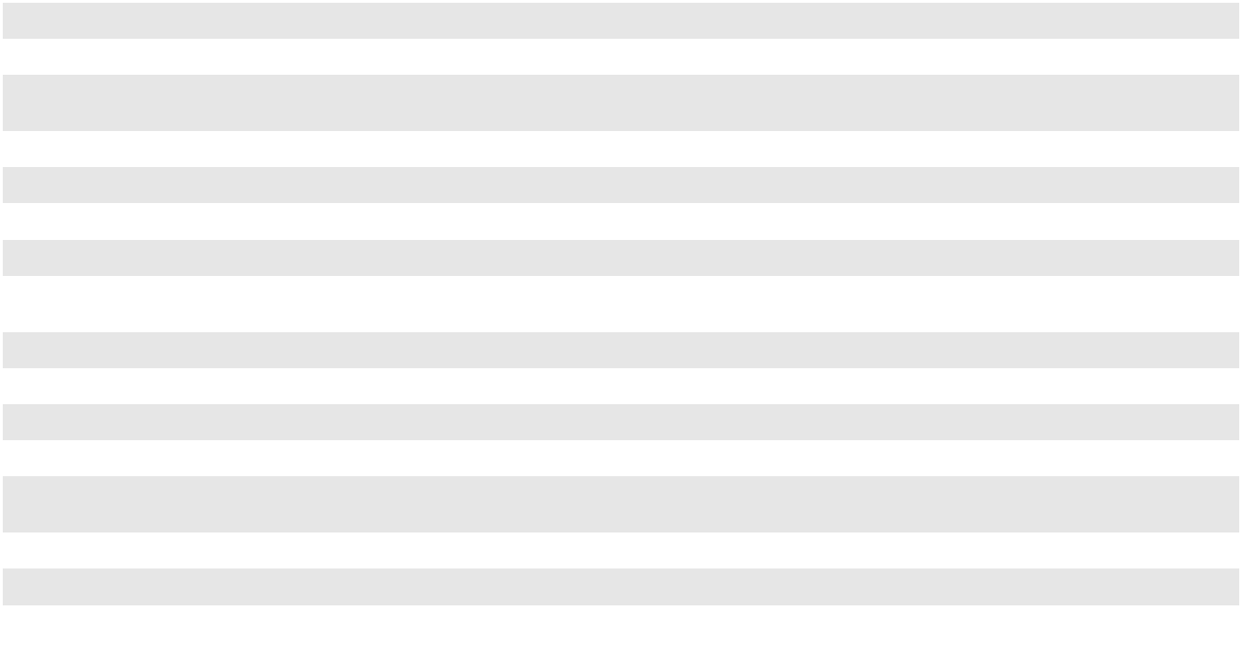

The amounts realized in the consolidated statements of operations during the years ended December 31, 2023, 2022 and 2021 which were reclassified out of accumulated other comprehensive loss were as follows (in thousands):

 |  | For the years ended December 31,
Other Comprehensive Loss Component |  | 2023 |  | 2022 | 2021 |  | Location
Unrealized (Loss) Gain on Fair Value of |  | $ 30,273 | $ | 683 | $ (10,011) |  | Interest expense, net of interest income
Interest Rate Hedges ⁽¹⁾ |  |  |  |  |  |  | Interest expense, net of interest income
___________________________________

  - For the year ended December 31, 2023, the balance is inclusive of an $8.3 million gain realized in connection with the settlement of the 2018 Swaps. For more information on this transaction, see Note 12, "Financing Arrangements."

- STOCK-BASED COMPENSATION

Stock-Based Compensation

In 2020, the Company's shareholders approved the Clean Harbors, Inc. 2020 Stock Incentive Plan (the "2020 Plan"). The

2020 Plan provides for future awards of up to 2.5 million shares of the Company’s common stock (subject to certain anti-dilution adjustments) in the form of stock options, stock appreciation rights, restricted stock, restricted stock units and other stock-based awards. The 2020 Plan is administered by the Compensation and Human Capital Committee of the Company’s Board of Directors.

83

CLEAN HARBORS, INC. AND SUBSIDIARIES

NOTES TO CONSOLIDATED FINANCIAL STATEMENTS (Continued)

The Company grants restricted stock awards and performance stock awards. The restricted stock awards generally vest over three to five years subject to continued employment. The performance stock awards vest depending on the satisfaction of certain performance conditions typically based on revenue, Adjusted EBITDA margin, return on invested capital and a measure of workplace safety. In addition, performance stock awards include continued service conditions subsequent to the attainment of any performance conditions.

Total stock-based compensation cost recognized for the years ended December 31, 2023, 2022 and 2021 was $20.7 million, $26.8 million and $18.8 million, respectively. The total income tax benefit recognized in the consolidated statements of operations from stock-based compensation expense was $3.5 million, $5.0 million and $3.5 million for the years ended December 31, 2023, 2022 and 2021, respectively.

Restricted Stock Awards

The following table summarizes information about restricted stock awards for the year ended December 31, 2023:

 |  | Number of |  |  | Weighted Average
Restricted Stock |  | Number of |  |  | Grant-Date
Restricted Stock |  | Shares |  |  | Fair Value
Balance at January 1, 2023 | 427,142 |  | $ |  | 84.64
Granted | 209,431 |  |  |  | 140.32
Vested | (170,060) |  |  |  | 76.26
Forfeited |  | (51,890) |  |  | 102.11
Balance at December 31, 2023 | 414,623 |  | $ |  | 114.02
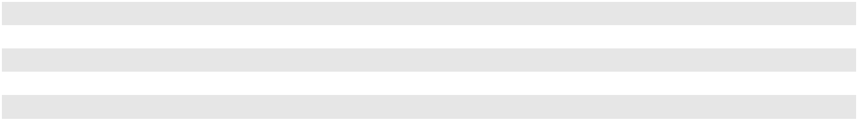

As of December 31, 2023, there was $34.5 million of total unrecognized compensation cost arising from restricted stock awards. This cost is expected to be recognized over a weighted average period of 2.9 years. The total fair value of restricted stock vested during 2023, 2022 and 2021 was $26.5 million, $16.4 million and $17.7 million, respectively.

Performance Stock Awards

Performance stock awards are subject to performance criteria established by the Compensation and Human Capital Committee of the Company's Board of Directors prior to or at the date of grant. The vesting of the performance stock awards is based on achieving targets currently based on revenue, Adjusted EBITDA Margin, Return on Invested Capital and Total Recordable Incident Rate. In addition, performance stock awards include continued service conditions.

The following table summarizes information about performance stock awards for the year ended December 31, 2023:

 |  | Number of |  |  | Weighted Average
Performance Stock |  | Number of |  |  | Grant-Date
Performance Stock |  | Shares |  |  | Fair Value
Balance at January 1, 2023 | 213,679 |  | $ |  | 91.62
Granted | 120,765 |  |  |  | 131.18
Vested | (111,924) |  |  |  | 90.56
Forfeited |  | (41,236) |  |  | 111.50
Balance at December 31, 2023 | 181,284 |  | $ |  | 114.10
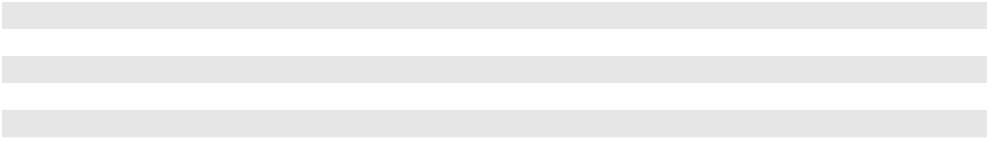

As of December 31, 2023, there was $3.3 million of total unrecognized compensation cost arising from unvested performance stock awards deemed probable of vesting. The total fair value of performance awards vested during 2023, 2022 and 2021 was $17.0 million, $11.1 million and $15.0 million, respectively.

84

CLEAN HARBORS, INC. AND SUBSIDIARIES

NOTES TO CONSOLIDATED FINANCIAL STATEMENTS (Continued)

(18) COMMITMENTS AND CONTINGENCIES

The Company and its subsidiaries are subject to legal proceedings and claims arising in the ordinary course of business. Actions filed against the Company arise from commercial and employment-related claims including alleged class actions related to sales practices and wage and hour claims. The plaintiffs in these actions may be seeking damages or injunctive relief or both. These actions are in various jurisdictions and stages of proceedings, and some are covered in part by insurance. In addition, the Company’s waste management services operations are regulated by federal, state, provincial and local laws enacted to regulate discharge of materials into the environment, remediation of contaminated soil and groundwater or otherwise protect the environment. This ongoing regulation results in the Company frequently becoming a party to legal or administrative proceedings involving all levels of government authorities and other interested parties. The issues involved in such proceedings generally relate to alleged violations of existing permits and licenses or alleged responsibility under federal or state Superfund laws to remediate contamination at properties owned either by the Company or by other parties (“third-party sites”) to which either the Company or the prior owners of certain of the Company’s facilities shipped waste.

At December 31, 2023 and 2022, the Company had recorded reserves of $32.4 million and $37.1 million, respectively, for actual or probable liabilities related to the legal and administrative proceedings in which the Company was then involved, the principal of which are described below. As of December 31, 2023 and 2022, the $32.4 million and $37.1 million, respectively, of reserves consisted of (i) $25.0 million and $24.1 million, respectively, related to pending legal or administrative proceedings, including Superfund liabilities, which were included in remedial liabilities on the consolidated balance sheets, and (ii) $7.4 million and $13.0 million, respectively, primarily related to federal, state and provincial enforcement actions, which were included in accrued expenses on the consolidated balance sheets.

In management's opinion, it is not reasonably possible that the potential liability beyond what has been recorded, if any, that may result from these actions, either individually or collectively, will have a material effect on the Company's financial position, results of operations or cash flows. The Company periodically adjusts the aggregate amount of these reserves when actual or probable liabilities are paid or otherwise discharged, new claims arise, or additional relevant information about existing or probable claims becomes available.

Legal or Administrative Proceedings

As of December 31, 2023, the principal legal and administrative proceedings in which the Company was involved, or which had been terminated during 2023, relate to Safety-Kleen product liability cases and Superfund proceedings.

Safety-Kleen Product Liability Cases: Safety-Kleen, Inc. ("Safety-Kleen"), which is a legal entity acquired by the Company in 2012, has been named as a defendant in certain product liability cases that are currently pending in various courts and jurisdictions throughout the United States. As of December 31, 2023, there were approximately 70 proceedings (excluding cases which have been settled but not formally dismissed) wherein persons claim personal injury resulting from the use of Safety-Kleen's parts cleaning equipment or cleaning products. These proceedings typically involve allegations that the solvent used in Safety-Kleen's parts cleaning equipment contains contaminants and/or that Safety-Kleen's recycling process does not effectively remove the contaminants that become entrained in the solvent during their use. In addition, certain claimants assert that Safety-Kleen failed to warn adequately the product user of potential risks, including a historic failure to warn that solvent contains trace amounts of toxic or hazardous substances such as benzene.

The Company maintains insurance that it believes will provide coverage for these product liability claims (over amounts accrued for self-insured retentions and deductibles in certain limited cases), except for punitive damages to the extent not insurable under state law or excluded from insurance coverage. The Company historically has vigorously defended, and intends to continue to vigorously defend, itself and the safety of its products against all of these claims. Such matters are subject to many uncertainties and outcomes are not predictable with assurance. Consequently, the Company is unable to ascertain the ultimate aggregate amount of monetary liability or financial impact with respect to these matters as of December 31, 2023. From January 1, 2023 to December 31, 2023, 24 product liability claims were settled or dismissed. Due to the nature of these claims and the related insurance, the Company did not incur any expense as insurance provided coverage in full for all such claims. Safety-Kleen may be named in similar, additional lawsuits in the future, including claims for which insurance coverage may not be available.

85

CLEAN HARBORS, INC. AND SUBSIDIARIES

NOTES TO CONSOLIDATED FINANCIAL STATEMENTS (Continued)

Superfund Proceedings: The Company has been notified that either the Company (which, since December 28, 2012, has included Safety-Kleen) or the prior owners of certain of the Company's facilities for which the Company may have certain indemnification obligations have been identified as PRPs or potential PRPs in connection with 131 sites which are subject to or are proposed to become subject to proceedings under federal or state Superfund laws. Of the 131 Superfund related sites, six involve facilities that are now owned or leased by the Company and 125 involve third-party sites to which either the Company or the prior owners of certain of the Company’s facilities shipped waste. Of the 125 third-party sites, 30 are now settled, 13 are currently requiring expenditures on remediation and 82 are not currently requiring expenditures on remediation.

In connection with each site, the Company has estimated the extent, if any, to which it may be subject, either directly or as a result of any indemnification obligations, for cleanup and remediation costs, related legal and consulting costs associated with PRP investigations, settlements and related legal and administrative proceedings. The amount of such actual and potential liability is inherently difficult to estimate because of, among other relevant factors, uncertainties as to the legal liability (if any) of the Company or the prior owners of certain of the Company's facilities to contribute a portion of the cleanup costs, the assumptions that must be made in calculating the estimated cost and timing of remediation, the identification of other PRPs and their respective capability and obligation to contribute to remediation efforts and the existence and legal standing of indemnification agreements (if any) with prior owners, which may either benefit the Company or subject the Company to potential indemnification obligations. The Company believes its potential monetary liability could exceed $1.0 million at three of the 131 Superfund related sites.

Of the 125 third-party sites at which the Company has been notified it is a PRP or potential PRP or may have indemnification obligations, the Company has indemnification agreements at a total of 17 sites. These agreements indemnify the Company (which now includes Safety-Kleen) with respect to any liability at the 17 sites for waste disposed prior to the Company's (or Safety-Kleen's) acquisition of the former subsidiaries of Waste Management and McKesson which had shipped waste to those sites. Accordingly, the indemnifying parties are paying all costs of defending those subsidiaries in those 17 cases, including legal fees and settlement costs. However, there can be no guarantee that the Company's ultimate liabilities for those sites will not exceed the amount recorded or that indemnities applicable to any of these sites will be available to pay all or a portion of related costs. Except for those indemnification agreements discussed, the Company does not have an indemnity agreement with respect to any of the 125 third-party sites discussed above.

Federal, State and Provincial Enforcement Actions

From time to time, the Company pays fines or penalties in regulatory proceedings relating primarily to waste treatment, storage or disposal facilities. As of December 31, 2023, there were no proceedings for which the Company believes it is possible that the sanctions could equal or exceed $1.0 million. The Company believes that the fines or other penalties in this or any of the other regulatory proceedings will, individually or in the aggregate, not have a material effect on its financial condition, results of operations or cash flows.

Self-Insurance Liabilities

Under the Company's insurance programs, coverage is obtained for catastrophic exposures, as well as those risks required to be insured by law or contract. The Company's policy is to retain a significant portion of certain expected losses related to workers' compensation, employee medical, comprehensive general liability and vehicle liability. A portion of these self-insured liabilities are managed through its wholly-owned captive insurance subsidiary.

Provisions for losses expected under these programs are recorded based upon the Company's estimates of the aggregate liability for claims. The current deductible per participant per year for the employee medical insurance policy is $0.9 million. The current deductible per occurrence for workers' compensation is $1.0 million, general liability is $2.0 million and vehicle liability is $2.0 million. The retention per claim for the environmental impairment policy is $1.0 million. At December 31, 2023 and 2022, the Company had accrued $82.7 million and $74.9 million, respectively, for its self-insurance liabilities (exclusive of employee medical insurance) using a risk-free discount rate of 4.86% and 4.36%, respectively.

86

CLEAN HARBORS, INC. AND SUBSIDIARIES

NOTES TO CONSOLIDATED FINANCIAL STATEMENTS (Continued)

Anticipated payments for contingencies related to workers' compensation, comprehensive general liability and vehicle liability related claims at December 31, 2023 for each of the next five years and thereafter were as follows (in thousands):

Years ending December 31,
2024 |  | $ | 33,954
2025 |  |  | 19,675
2026 |  |  | 14,663
2027 |  |  | 9,153
2028 |  |  | 6,275
Thereafter |  |  | 9,650
Undiscounted self-insurance liabilities |  |  | 93,370
Less: Discount |  |  | (10,670)
Total self-insurance liabilities (included in accrued expenses and other current liabilities) |  | $ | 82,700
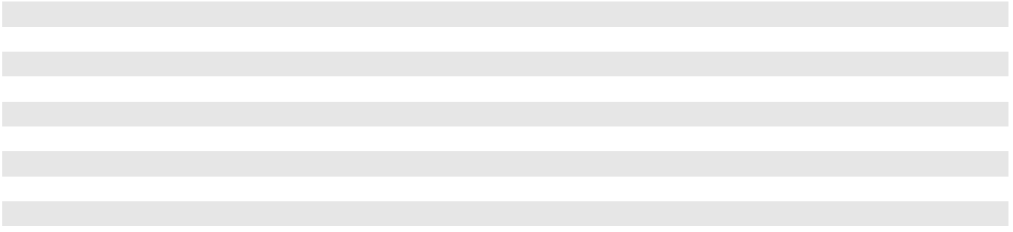

(19) LEASES

The Company’s lease portfolio is predominately operating leases for real estate, vehicles and industrial equipment utilized in operations and rail cars. The Company presents operating lease balances separately on the consolidated balance sheets. The Company's finance leases relate to vehicles, rail cars and certain real estate. The following table presents the Company's finance lease balances and their classification on the consolidated balance sheets (in thousands):

 | Finance Lease Balances (Classification) |  |  |  |  |  |  | December 31, 2023 |  |  |  |  |  |  | December 31, 2022
 | ROU assets (Property, plant and equipment, net) |  |  |  | $ |  |  |  | 126,292 |  |  |  |  | $ |  | 96,207
 | Current portion of lease liabilities (Accrued expenses and other current liabilities) |  |  |  |  |  |  |  | 16,975 |  |  |  |  |  |  | 12,767
 | Long-term portion of lease liabilities (Other long-term liabilities) |  |  |  |  |  |  |  | 113,486 |  |  |  |  |  |  | 86,390
 | The Company’s lease expense was as follows (in thousands):
 |  |  | For the years ended December 31,
 |  |  | 2023 |  |  |  |  |  | 2022 |  |  |  |  |  |  | 2021
 | Operating lease cost | $ | 69,156 |  | $ |  |  |  | 59,041 |  |  |  |  | $ |  | 50,264
 | Finance lease cost:
 | Amortization of ROU assets |  | 17,183 |  |  |  |  |  | 13,239 |  |  |  |  |  |  | 9,504
 | Interest on lease liabilities |  | 4,051 |  |  |  |  |  | 3,011 |  |  |  |  |  |  | 2,544
 | Total finance lease cost |  | 21,234 |  |  |  |  |  | 16,250 |  |  |  |  |  |  | 12,048
 | Short-term lease cost |  | 167,379 |  |  |  |  |  | 158,736 |  |  |  |  |  |  | 102,913
 | Variable lease cost |  | 4,887 |  |  |  |  |  | 4,353 |  |  |  |  |  |  | 3,546
 | Total lease cost | $ | 262,656 |  | $ |  |  |  | 238,380 |  |  |  |  | $ |  | 168,771
 | Other information related to leases was as follows:
 | Weighted Average Remaining Lease Term (years) |  |  |  |  |  |  | December 31, 2023 |  |  |  |  |  |  | December 31, 2022
 | Operating leases |  |  |  |  |  |  |  | 3.8 |  |  |  |  |  |  | 4.2
 | Finance leases |  |  |  |  |  |  |  | 7.1 |  |  |  |  |  |  | 7.5
 | Weighted Average Discount Rate |  |  |  |  |  |  | December 31, 2023 |  |  |  |  |  |  | December 31, 2022
 | Operating leases |  |  |  |  |  |  |  | 4.68 % |  |  |  |  |  |  | 4.08 %
 | Finance leases |  |  |  |  |  |  |  | 3.96 % |  |  |  |  |  |  | 3.53 %
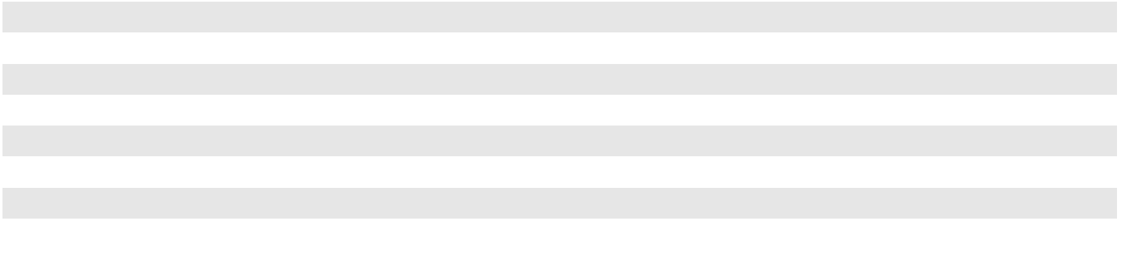

87

CLEAN HARBORS, INC. AND SUBSIDIARIES

NOTES TO CONSOLIDATED FINANCIAL STATEMENTS (Continued)

For the years ended December 31,

Supplemental Cash Flow Related Disclosures (in thousands) |  |  | 2023 |  |  | 2022 |  |  | 2021
Cash paid for amounts related to lease liabilities:
Operating cash flows from operating leases |  | $ | 71,185 | $ |  | 61,014 | $ |  | 50,963
Operating cash flows from finance leases |  |  | 4,051 |  |  | 3,011 |  |  | 2,544
Financing cash flows from finance leases |  |  | 15,937 |  |  | 12,821 |  |  | 8,458
ROU assets obtained in exchange for operating lease liabilities |  |  | 82,392 |  |  | 58,230 |  |  | 55,556
ROU assets obtained in exchange for finance lease liabilities |  |  | 47,238 |  |  | 29,205 |  |  | 30,476
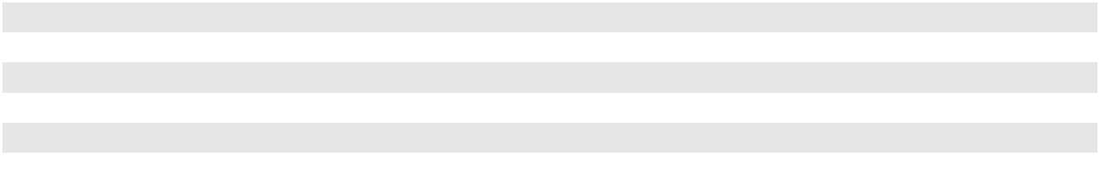

At December 31, 2023, the Company's future lease payments under non-cancelable leases that have lease terms in excess of one year were as follows (in thousands):

 |  |  | December 31, 2023
Years ending December 31, |  |  | Operating Leases |  |  | Finance Leases
2024 |  | $ | 66,372 | $ |  | 23,703
2025 |  |  | 53,215 |  |  | 23,017
2026 |  |  | 38,927 |  |  | 23,029
2027 |  |  | 28,011 |  |  | 23,016
2028 |  |  | 12,925 |  |  | 19,040
Thereafter |  |  | 9,408 |  |  | 41,681
Total future lease payments |  |  | 208,858 |  |  | 153,486
Amount representing interest |  |  | (20,685) |  |  | (23,025)
Total lease liabilities |  | $ | 188,173 | $ |  | 130,461
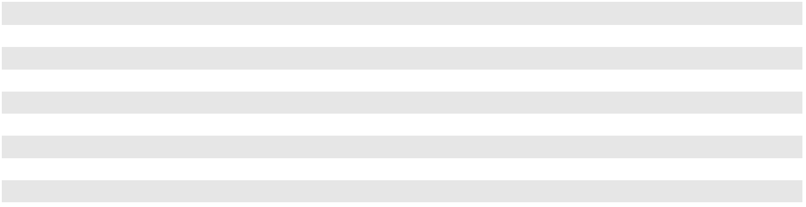

At December 31, 2023, none of the Company's executed leases that had not yet commenced will create significant rights or obligations in the future and sublease transactions are not material. Additionally, the Company does not have any related party leases, and there were no restrictions or covenants imposed by its leases.

(20) SEGMENT REPORTING

Segment reporting is prepared on the same basis that the Company's chief operating decision maker, which is a committee comprised of the Company's Co-Chief Executive Officers, manages the business, makes operating decisions and assesses performance. The Company is managed and reports as two operating segments; (i) the Environmental Services segment and (ii) the Safety-Kleen Sustainability Solutions segment.

Third-party revenue is revenue billed to outside customers by a particular segment. Direct revenues is revenue allocated to the segment providing the product or service. Intersegment revenues represent the sharing of third-party revenues among the segments based on products and services provided by each segment as if the products and services were sold directly to the third-party. The intersegment revenues are shown net. The operations not managed through the Company’s operating segments described above are recorded as “Corporate Items.”

The following tables reconcile third-party revenues to direct revenues for the years ended December 31, 2023, 2022 and 2021 (in thousands):

 |  |  | For the year ended December 31, 2023
 | Environmental |  |  |  | Safety-Kleen |  |  | Corporate
 |  |  |  |  | Sustainability |  |  |  |  |  | Total
 |  | Services |  |  | Solutions |  |  | Items |  |  | Total
Third-party revenues | $ | 4,469,909 | $ |  | 938,796 | $ |  | 447 |  | $ | 5,409,152
Intersegment revenues (expense), net |  | 41,533 |  |  | (41,533) |  |  | — |  |  | —
Direct revenues | $ | 4,511,442 | $ |  | 897,263 | $ |  | 447 |  | $ | 5,409,152

88

CLEAN HARBORS, INC. AND SUBSIDIARIES

NOTES TO CONSOLIDATED FINANCIAL STATEMENTS (Continued)

 |  |  | For the year ended December 31, 2022
 | Environmental |  |  |  | Safety-Kleen |  |  | Corporate
 |  |  |  |  | Sustainability |  |  |  |  |  | Total
 |  | Services |  |  | Solutions |  |  | Items |  |  | Total
Third-party revenues | $ | 4,144,973 | $ |  | 1,021,125 | $ |  | 507 |  | $ | 5,166,605
Intersegment revenues (expense), net |  | 26,733 |  |  | (26,733) |  |  | — |  |  | —
Direct revenues | $ | 4,171,706 |  | $ | 994,392 |  | $ | 507 |  | $ | 5,166,605
 |  |  | For the year ended December 31, 2021
 | Environmental |  |  |  | Safety-Kleen |  |  | Corporate
 |  |  |  |  | Sustainability |  |  |  |  |  | Total
 |  | Services |  |  | Solutions |  |  | Items |  |  | Total
Third-party revenues | $ | 3,025,907 | $ |  | 779,360 | $ |  | 299 |  | $ | 3,805,566
Intersegment revenues (expense), net |  | 6,547 |  |  | (6,547) |  |  | — |  |  | —
Direct revenues | $ | 3,032,454 | $ |  | 772,813 | $ |  | 299 |  | $ | 3,805,566

The primary financial measure by which the Company evaluates the performance of its segments is Adjusted EBITDA, which consists of net income plus accretion of environmental liabilities, stock-based compensation, depreciation and amortization, net interest expense, loss on early extinguishment of debt and provision for income taxes and excludes other gains, losses and non-cash charges not deemed representative of fundamental segment results and other (income) expense, net. Transactions between the segments are accounted for at the Company’s best estimate based on similar transactions with outside customers.

The following table presents Adjusted EBITDA information used by management by reported segment (in thousands):

 |  | For the years ended December 31,
Adjusted EBITDA: |  | 2023 |  |  | 2022 |  |  | 2021
Environmental Services | $ | 1,101,608 | $ |  | 953,053 | $ |  | 659,718
Safety-Kleen Sustainability Solutions |  | 172,873 |  |  | 306,327 |  |  | 227,354
Corporate Items |  | (261,911) |  |  | (237,252) |  |  | (210,466)
Total
Total |  | 1,012,570 |  |  | 1,022,128 |  |  | 676,606
Reconciliation to Consolidated Statements of Operations:
Accretion of environmental liabilities |  | 13,667 |  |  | 12,943 |  |  | 11,745
Stock-based compensation |  | 20,703 |  |  | 26,844 |  |  | 18,839
Depreciation and amortization |  | 365,761 |  |  | 347,594 |  |  | 298,135
Income from operations
Income from operations |  | 612,439 |  |  | 634,747 |  |  | 347,887
Other (income) expense, net |  | (2,315) |  |  | (2,472) |  |  | 515
Loss on early extinguishment of debt |  | 2,880 |  |  | 422 |  |  | —
Gain on sale of business |  | — |  |  | (8,864) |  |  | —
Interest expense, net of interest income |  | 108,595 |  |  | 107,663 |  |  | 77,657
Income from operations before provision for income taxes
Income from operations before provision for income taxes | $ | 503,279 |  | $ | 537,998 |  | $ | 269,715
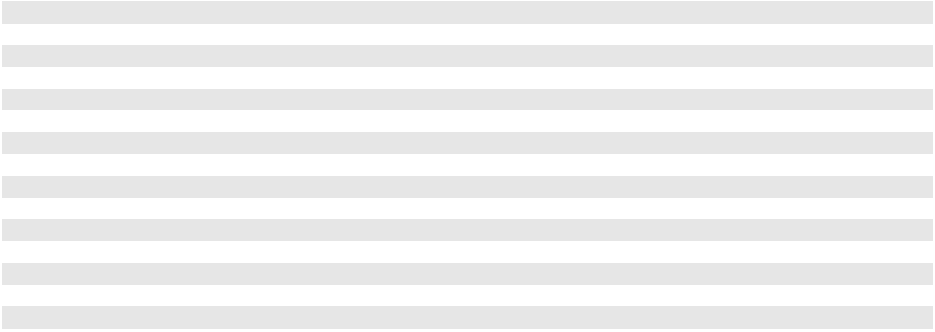

89

CLEAN HARBORS, INC. AND SUBSIDIARIES

NOTES TO CONSOLIDATED FINANCIAL STATEMENTS (Continued)

The following table presents assets by reported segment and in the aggregate (in thousands):

Property, plant and equipment, net | December 31, 2023 |  |  | December 31, 2022
Environmental Services | $ | 1,651,026 | $ |  | 1,467,641
Safety-Kleen Sustainability Solutions |  | 411,415 |  |  | 398,660
Corporate Items |  | 130,877 |  |  | 114,001
Total property, plant and equipment, net
Total property, plant and equipment, net | $ | 2,193,318 |  | $ | 1,980,302
Goodwill and Permits and other intangibles, net
Environmental Services
Goodwill | $ | 1,112,013 | $ |  | 1,071,846
Permits and other intangibles, net |  | 454,919 |  |  | 462,050
Total Environmental Services
Total Environmental Services |  | 1,566,932 |  |  | 1,533,896
Safety-Kleen Sustainability Solutions
Goodwill | $ | 175,723 | $ |  | 175,032
Permits and other intangibles, net |  | 147,878 |  |  | 158,732
Total Safety-Kleen Sustainability Solutions
Total Safety-Kleen Sustainability Solutions |  | 323,601 |  |  | 333,764
Total | $ | 1,890,533 | $ |  | 1,867,660
Geographic Information
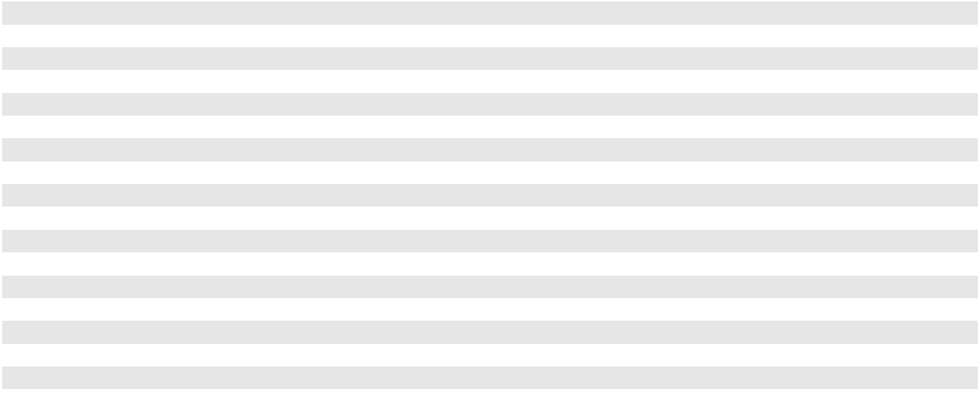

As of December 31, 2023 and 2022, the Company had property, plant and equipment, net of depreciation and amortization and permits and other intangible assets, net of amortization in the following geographic locations (in thousands):

 |  | December 31, 2023 |  |  |  |  |  | December 31, 2022
Property, plant and equipment, net |  | Total |  | % of Total |  |  |  | Total |  |  |  | % of Total
United States | $ | 1,972,221 | 89.9 % |  |  | $ |  | 1,765,291 |  |  | 89.1 %
Canada and other foreign |  | 221,097 | 10.1 |  |  |  |  | 215,011 |  |  | 10.9
Total property, plant and equipment, net
Total property, plant and equipment, net | $ | 2,193,318 |  | 100.0 % |  |  | $ | 1,980,302 |  |  |  | 100.0 %
Permits and other intangibles, net
United States | $ | 570,049 | 94.6 % |  |  | $ |  | 585,887 |  |  | 94.4 %
Canada |  | 32,748 | 5.4 |  |  |  |  | 34,895 |  |  | 5.6
Total permits and other intangibles, net
Total permits and other intangibles, net | $ | 602,797 |  | 100.0 % |  |  | $ | 620,782 |  |  |  | 100.0 %
The following table presents the total assets by geographical area (in thousands):
 |  |  |  |  | December 31, 2023 |  |  |  |  | December 31, 2022
United States |  |  | $ |  |  | 5,786,937 |  |  |  | $ | 5,595,255
Canada and other foreign |  |  |  |  |  | 595,932 |  |  |  |  | 534,452
Total |  |  | $ |  |  | 6,382,869 |  |  |  | $ | 6,129,707
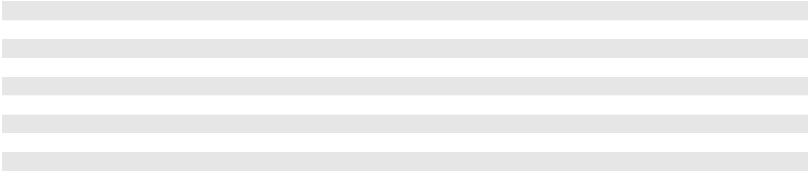

90

ITEM 9. CHANGES IN AND DISAGREEMENTS WITH ACCOUNTANTS ON ACCOUNTING AND FINANCIAL DISCLOSURE

None.

ITEM 9A. CONTROLS AND PROCEDURES

Evaluation of Disclosure Controls and Procedures

Based on an evaluation under the supervision and with the participation of our Co-Chief Executive Officers and Chief Financial Officer, as of the end of the period covered by this Annual Report on Form 10-K, our Co-Chief Executive Officers and Chief Financial Officer have concluded that our disclosure controls and procedures (as defined under Rule 13a-15(e) and 15d-15(e) under the Securities Exchange Act of 1934, as amended (the “Exchange Act”)) were effective as of December 31, 2023 to ensure that information required to be disclosed by us in reports that we file or submit under the Exchange Act is recorded, processed, summarized and reported within the time periods specified in Securities and Exchange Commission rules and forms and is accumulated and communicated to our management, including our Co-Chief Executive Officers and Chief Financial Officer, as appropriate to allow timely decisions regarding required disclosure.

Management's Annual Report on Internal Control Over Financial Reporting

The Company's management is responsible for establishing and maintaining adequate internal control over financial reporting, as that term is defined in Exchange Act Rule 13a-15(f). Under the supervision and with the participation of the Company's management, including the Co-Chief Executive Officers and Chief Financial Officer, the Company conducted an evaluation of its internal control over financial reporting based on the framework in Internal Control—Integrated Framework (2013) issued by the Committee of Sponsoring Organizations of the Treadway Commission.

The Company's management evaluated the effectiveness of Clean Harbors' internal control over financial reporting as of December 31, 2023. Based on their evaluation under the framework in Internal Control—Integrated Framework (2013), the Company's management concluded that the Company maintained effective internal control over financial reporting as of December 31, 2023 based on the criteria in the Internal Control—Integrated Framework (2013).

Deloitte & Touche LLP, the independent registered public accounting firm that audited the Company's consolidated financial statements, has issued an attestation report on the effectiveness of the Company's internal control over financial reporting as of December 31, 2023, which is included below in this Item 9A of this Annual Report on Form 10-K.

Changes in Internal Control over Financial Reporting

There were no changes in the Company's internal control over financial reporting identified in connection with the evaluation required by paragraph (d) of Exchange Act Rules 13a-15 or 15d-15 that was conducted during the quarter ended December 31, 2023 that have materially affected, or are reasonably likely to materially affect, the Company’s internal control over financial reporting.

Limitations on the Effectiveness of Controls

The Company's management, including the Co-Chief Executive Officers and Chief Financial Officer, does not expect that the Company's disclosure controls and procedures or the Company's internal control over financial reporting will prevent all errors and all fraud.

A company's internal control over financial reporting is a process designed to provide reasonable assurance regarding the reliability of financial reporting and the preparation of financial statements for external purposes in accordance with generally accepted accounting principles. A company's internal control over financial reporting includes those policies and procedures that (i) pertain to the maintenance of records that, in reasonable detail, accurately and fairly reflect the transactions and dispositions of the assets of the company; (ii) provide reasonable assurance that transactions are recorded as necessary to permit preparation of financial statements in accordance with generally accepted accounting principles, and that receipts and expenditures of the company are being made only in accordance with authorizations of management and directors of the company; and (iii) provide reasonable assurance regarding prevention or timely detection of unauthorized acquisition, use, or disposition of the company's assets that could have a material effect on the financial statements.

Because of its inherent limitations, internal control over financial reporting may not prevent or detect misstatements. Also, projections of any evaluation of effectiveness to future periods are subject to the risk that controls may become inadequate because of changes in conditions, or that the degree of compliance with the policies or procedures may deteriorate.

Further, the design of disclosure controls and procedures and internal control over financial reporting must reflect the fact that there are resource constraints, and the benefits of controls must be considered relative to their costs. Because of the inherent limitations of controls and procedures and internal control over financial reporting, no evaluation of controls can provide absolute assurance that all control issues and instances of fraud, if any, within the Company have been detected.

91

REPORT OF INDEPENDENT REGISTERED PUBLIC ACCOUNTING FIRM To the stockholders and the Board of Directors of Clean Harbors, Inc. Opinion on Internal Control over Financial Reporting

We have audited the internal control over financial reporting of Clean Harbors, Inc. and subsidiaries (the “Company”) as of December 31, 2023, based on criteria established in Internal Control - Integrated Framework (2013) issued by the Committee of Sponsoring Organizations of the Treadway Commission (COSO). In our opinion, the Company maintained, in all material respects, effective internal control over financial reporting as of December 31, 2023, based on criteria established in Internal Control - Integrated Framework (2013) issued by COSO.

We have also audited, in accordance with the standards of the Public Company Accounting Oversight Board (United States) (PCAOB), the consolidated financial statements as of and for the year ended December 31, 2023, of the Company and our report dated February 21, 2024 expressed an unqualified opinion on those financial statements.

Basis for Opinion

The Company’s management is responsible for maintaining effective internal control over financial reporting and for its assessment of the effectiveness of internal control over financial reporting, included in the accompanying Management’s Annual Report on Internal Control over Financial Reporting. Our responsibility is to express an opinion on the Company’s internal control over financial reporting based on our audit. We are a public accounting firm registered with the PCAOB and are required to be independent with respect to the Company in accordance with the U.S. federal securities laws and the applicable rules and regulations of the Securities and Exchange Commission and the PCAOB.

We conducted our audit in accordance with the standards of the PCAOB. Those standards require that we plan and perform the audit to obtain reasonable assurance about whether effective internal control over financial reporting was maintained in all material respects. Our audit included obtaining an understanding of internal control over financial reporting, assessing the risk that a material weakness exists, testing and evaluating the design and operating effectiveness of internal control based on the assessed risk, and performing such other procedures as we considered necessary in the circumstances. We believe that our audit provides a reasonable basis for our opinion.

Definition and Limitations of Internal Control over Financial Reporting

A company’s internal control over financial reporting is a process designed to provide reasonable assurance regarding the reliability of financial reporting and the preparation of financial statements for external purposes in accordance with generally accepted accounting principles. A company’s internal control over financial reporting includes those policies and procedures that (1) pertain to the maintenance of records that, in reasonable detail, accurately and fairly reflect the transactions and dispositions of the assets of the company; (2) provide reasonable assurance that transactions are recorded as necessary to permit preparation of financial statements in accordance with generally accepted accounting principles, and that receipts and expenditures of the company are being made only in accordance with authorizations of management and directors of the company; and (3) provide reasonable assurance regarding prevention or timely detection of unauthorized acquisition, use, or disposition of the company’s assets that could have a material effect on the financial statements.

Because of its inherent limitations, internal control over financial reporting may not prevent or detect misstatements. Also, projections of any evaluation of effectiveness to future periods are subject to the risk that controls may become inadequate because of changes in conditions, or that the degree of compliance with the policies or procedures may deteriorate.

/s/ Deloitte & Touche LLP

Boston, Massachusetts

February 21, 2024

92

ITEM 9B. OTHER INFORMATION

During the quarter ended December 31, 2023, no director or “officer” (as defined in Rule 16a-1(f)) of Clean Harbors, Inc. adopted or terminated a “Rule 10b5-1 trading arrangement” or “non-Rule 10b5-1 trading arrangement,” as each term is defined in Item 408(a) of Regulation S-K.

ITEM 9C. DISCLOSURE REGARDING FOREIGN JURISDICTIONS THAT PREVENT INSPECTIONS

Not applicable.

PART III

Except for the information set forth below under Item 12 with respect to securities authorized for issuance under the registrant's equity compensation plans, the information called for by Item 10 (Directors, Executive Officers and Corporate Governance), Item 11 (Executive Compensation), Item 12 (Security Ownership of Certain Beneficial Owners and Management and Related Stockholder Matters), Item 13 (Certain Relationships and Related Transactions and Director Independence) and Item 14 (Principal Accountant Fees and Services) is incorporated herein by reference to the registrant's definitive proxy statement for its 2024 annual meeting of shareholders, which definitive proxy statement will be filed with the Securities and Exchange Commission by April 11, 2024.

For the purpose of calculating the aggregate market value of the voting stock of the registrant held by non-affiliates as shown on the cover page of this report, it has been assumed that the directors and executive officers of the registrant, as will be set forth in the Company's definitive proxy statement for its 2024 annual meeting of shareholders, are the only affiliates of the registrant. However, this should not be deemed to constitute an admission that all of such persons are, in fact, affiliates or that there are not other persons who may be deemed affiliates of the registrant.

ITEM 12. SECURITY OWNERSHIP OF CERTAIN BENEFICIAL OWNERS AND MANAGEMENT AND RELATED STOCKHOLDER MATTERS

In addition to the information about the security ownership of certain beneficial owners and management and related stockholder matters which is incorporated herein by reference to the Company's definitive proxy statement for the Company's 2024 annual meeting of shareholders, the following table includes information as of December 31, 2023 regarding shares of common stock authorized for issuance under the Company's equity compensation plan. The Company's shareholders approved the plan in 2020.

 | Number of securities to |  |  | Weighted average |  | Number of securities
 |  |  |  | Weighted average |  | remaining available
 | be issued upon exercise |  |  | exercise |  | for future issuance
Plan Category | of outstanding options |  |  | price of outstanding |  | under equity
Plan Category | and rights |  |  | options and rights |  | compensation plan
Equity compensation plan approved by security holders⁽¹⁾ | — $ |  |  | — | 1,355,049
___________________________________________
- Includes the Company's 2020 Stock Incentive Plan under which there were no outstanding options but 1,355,049 shares were available for grant of stock options, stock appreciation rights, restricted stock, restricted stock units and certain other stock-based awards as of December 31, 2023. See Note 17, "Stock-Based Compensation," to the Company's consolidated financial statements included in Item 8, "Financial Statements and Supplementary Data," in this report.

93

PART IV

ITEM 15. EXHIBITS AND FINANCIAL STATEMENT SCHEDULES

(a) Documents Filed as a Part of this Report

Page

- Financial Statements:

Report of Independent Registered Public Accounting Firm | 49
Consolidated Balance Sheets as of December 31, 2023 and 2022 | 51
Consolidated Statements of Operations for the Three Years Ended December 31, 2023 | 52
Consolidated Statements of Comprehensive Income for the Three Years Ended December 31, 2023 | 53
Consolidated Statements of Cash Flows for the Three Years Ended December 31, 2023 | 54
Consolidated Statements of Stockholders' Equity for the Three Years Ended December 31, 2023 | 55
Notes to Consolidated Financial Statements | 56

All other schedules are omitted because they are not applicable, not required, or because the required information is included in the financial statements or notes thereto.

2. Exhibits:

The list of exhibits filed as part of this annual report on Form 10-K is set forth on the Exhibit Index immediately following the signature page to this report, and such Exhibit Index is incorporated herein by reference.

Exhibits to this annual report on Form 10-K have been included only with the copies of the Form 10-K filed with the Securities and Exchange Commission. Upon request to the Company and payment of a reasonable fee, copies of the individual exhibits will be furnished. The Company undertakes to furnish to the Commission upon request copies of instruments (in addition to the exhibits listed below) relating to the Company's acquisitions and long-term debt.

ITEM 16. FORM 10-K SUMMARY

None

94

SIGNATURES

Pursuant to the requirements of Section 13 or 15(d) of the Securities Exchange Act of 1934, the registrant has duly caused this Form 10-K to be signed on its behalf by the undersigned, thereunto duly authorized on February 21, 2024.

CLEAN HARBORS, INC.

By: | /s/ MICHAEL L. BATTLES | By: | /s/ ERIC W. GERSTENBERG
 | Michael L. Battles |  | Eric W. Gerstenberg
 | Co-Chief Executive Officer and Co-President |  | Co-Chief Executive Officer and Co-President

Pursuant to the requirements of the Securities Exchange Act of 1934, this Form 10-K has been signed below by the following persons on behalf of the registrant and in the capacities and on the dates indicated.

Signature Title Date

/s/ MICHAEL L. BATTLES | Co-Chief Executive Officer and Co-President | February 21, 2024
Michael L. Battles | (Principal Executive Officer)
/s/ ERIC W. GERSTENBERG | Co-Chief Executive Officer and Co-President | February 21, 2024
Eric W. Gerstenberg | (Principal Executive Officer)
/s/ ERIC J. DUGAS | Executive Vice President and Chief Financial Officer | February 21, 2024
Eric J. Dugas | (Principal Financial and Accounting Officer)
* | Founder, Executive Chairman and Chief Technology Officer | February 21, 2024
Alan S. McKim
* | Director | February 21, 2024
Edward G. Galante
* | Director | February 21, 2024
Karyn Polito
* | Director | February 21, 2024
John T. Preston
* | Director | February 21, 2024
Alison Quirk
* | Director | February 21, 2024
Marcy L. Reed
* | Director | February 21, 2024
Andrea Robertson
* | Director | February 21, 2024
Lauren C. States
* | Director | February 21, 2024
Shelley Stewart, Jr.
* | Director | February 21, 2024
John R. Welch
* | Director | February 21, 2024
Robert Willett

*By: | /s/ MICHAEL L. BATTLES | *By: | /s/ ERIC W. GERSTENBERG
 | Michael L. Battles |  | Eric W. Gerstenberg
 | Attorney-in-Fact |  | Attorney-in-Fact

95

EXHIBIT INDEX

Item No. Description

2.6 Agreement and Plan of Merger dated as of October 26, 2012 among Safety-Kleen, Inc., Clean Harbors, Inc., and CH Merger Sub, Inc.

2.7 Stock Purchase Agreement by and among Clean Harbors, Inc., LJ Energy Services Holdings LLC, and LJ Energy Services Intermediate Holding Corp. dated August 3, 2021

3.1A Restated Articles of Organization of Clean Harbors, Inc.

3.1B Articles of Amendment [as filed on May 9, 2011] to Restated Articles of Organization of Clean Harbors, Inc.

3.4D Amended and Restated By-Laws of Clean Harbors, Inc.

3.4E Description of rights of holders of Clean Harbors, Inc. common stock

4.34 Sixth Amended and Restated Credit Agreement dated as of October 28, 2020 among Clean Harbors, Inc., as the U.S. Borrower, Clean Harbors Industrial Services Canada, Inc., as the Canadian Borrower, Bank of America, N.A., as Administrative Agent, and the Lenders party thereto

4.34.1 First Amendment dated April 28, 2023 to Sixth Amended and Restated Credit Agreement dated as of October 28, 2020 among Clean Harbors, Inc., as the U.S. Borrower, Clean Harbors Industrial Services Canada, Inc., as the Canadian Borrower, Bank of America, N.A., as Administrative Agent and the Lenders party thereto

4.34.2 Sixth Amended and Restated Credit Agreement dated as of October 28, 2020, as amended through First Amendment thereto dated April 28, 2023, among Clean Harbors, Inc., as the U.S. Borrower, Clean Harbors Industrial Services Canada, Inc., as the Canadian Borrower, Bank of America, N.A., as Administrative Agent and the Lenders party thereto

4.34B Amended and Restated Security Agreement (Canadian Domiciled Loan Parties) dated as of November 1, 2016 among Clean Harbors Industrial Services Canada, Inc., as the Canadian Borrower and a Grantor, the subsidiaries of Clean Harbors, Inc. listed on Annex A thereto or that thereafter become a party thereto as Grantors, and Bank of America, N.A., as Agent

4.34C Amended and Restated Guarantee (U.S. Domiciled Loan Parties-U.S. Facility Obligations) dated as of November 1, 2016 executed by the U.S. Domiciled Subsidiaries of Clean Harbors, Inc. named therein in favor of Bank of America, N.A., as Agent for itself and the other U.S. Facility Secured Parties

4.34D Amended and Restated Guarantee (Canadian Domiciled Loan Parties-Canadian Facility Obligations) dated as of November 1, 2016 executed by the Canadian Domiciled Subsidiaries of Clean Harbors, Inc. named therein in favor of Bank of America, N.A., as Agent for itself and the other Canadian Facility Secured Parties

4.34E Amended and Restated Guarantee (U.S. Domiciled Loan Parties-Canadian Facility Obligations)
dated as of November 1, 2016 executed by Clean Harbors, Inc. and the U.S. Domiciled Subsidiaries of Clean Harbors, Inc. named therein in favor of Bank of America, N.A., as Agent for itself and the other Canadian Facility Secured Parties

4.34G Second Amended and Restated Security Agreement (U.S. Domiciled Loan Parties) dated as of June 30, 2017, among Clean Harbors, Inc., as the U.S. Borrower and a Grantor, the subsidiaries of Clean Harbors, Inc. listed on Annex A thereto or that thereafter become a party thereto as Grantors, and Bank of America, N.A., as Agent

4.34K Amended and Restated Confirmation and Ratification of Ancillary Loan Documents dated as of October 28, 2020 among Clean Harbors, Inc., as the U.S. Borrower, Clean Harbors Industrial Services Canada, Inc., as the Canadian Borrower, the subsidiaries of Clean Harbors, Inc. listed on Annex A thereto or that thereafter become a party thereto as Grantors, and Bank of America, N.A., as Agent for its own benefit and the benefit of the other Lenders and Credit Parties

4.43 Credit Agreement dated as of June 30, 2017, among the Financial Institutions party thereto, as Lenders, Goldman Sachs Lending Partners LLC, as Administrative Agent and Collateral Agent, Clean Harbors, Inc., as Borrower, and the Loan Guarantors from time to time party thereto

4.43A Security Agreement dated as of June 30, 2017, among Clean Harbors, Inc. and its subsidiaries listed on Annex A thereto or that become a party thereto as the Grantors, and Goldman Sachs Lending Partners LLC, as the Agent

4.43B First Amendment to Credit Agreement dated as of April 17, 2018, among the Financial Institutions party thereto, as Lenders, Goldman Sachs Lending Partners LLC, as Administrative Agent and Collateral Agent, Clean Harbors, Inc., as Borrower, and the Loan Guarantors from time to time party thereto

Location

(1)

(2)

(3)

(4)

(5)

(6)

(7)

(8)

(8)

(9)

(9)

(9)

(9)

(10)

(7)

(10)

(10)

(11)

96

4.43C | Incremental Facility Amendment dated July 19, 2018, to Credit Agreement dated as of June 30,
 | 2017, among the Financial Institutions party thereto, as Lenders, Goldman Sachs Lending
 | Partners LLC, as Administrative Agent and Collateral Agent, Clean Harbors, Inc., as Borrower,
 | and the Loan Guarantors from time to time party thereto
4.43D | Incremental Facility Amendment No. 2 to Credit Agreement, dated as of October 8, 2021, to
 | Credit Agreement dated as of June 30, 2017, as previously amended, among Clean Harbors,
 | Inc., as the Borrower, each of the entities listed as an Incremental Lender on the signature pages
 | thereto, Goldman Sachs Lending Partners LLC, as Administrative Agent and Collateral Agent,
 | and the other Loan Parties as of the date thereof
4.43E | Amendment No. 3 to Credit Agreement, dated June 3, 2023, among Clean Harbors, Inc., as
 | Borrower, and Goldman Sachs Lending Partners LLC, as Administrative Agent and Collateral
 | Agent, to that certain Credit Agreement dated as of June 30, 2017, as previously amended,
 | among the Financial Institutions party thereto, as Lenders, Goldman Sachs Lending Partners
 | LLC, as Administrative Agent and Collateral Agent, Clean Harbors, Inc., as Borrower, and the
 | Loan Guarantors from time to time party thereto
4.43F | Amendment No. 4 to Credit Agreement dated as of December 27, 2023, among the Financial
 | Institutions party thereto, as Lenders, Goldman Sachs Lending Partners LLC, as Administrative
 | Agent and Collateral Agent, Clean Harbors, Inc. as Borrower, and the Loan Guarantors from
 | time to time party thereto.
4.44 | Intercreditor Agreement dated as of June 30, 2017, among Clean Harbors, Inc., and the
 | subsidiaries of Clean Harbors, Inc. listed on the signature pages thereto (together with any
 | subsidiary that becomes a party thereto after the date thereof), Bank of America, N.A., as the
 | Initial ABL Agent, and Goldman Sachs Lending Partners LLC, as agent under the Term Loan
 | Agreement
4.45 | Indenture dated as of July 2, 2019, among Clean Harbors, Inc., as Issuer, the subsidiaries of
 | Clean Harbors, Inc. named therein as Guarantors, and U.S. Bank National Association, as
 | Trustee
4.46 | Indenture dated as of January 24, 2023, among Clean Harbors, Inc., the subsidiaries of Clean
 | Harbors, Inc. named therein as Guarantors, and U.S. Bank Trust Company, National
 | Association, as Trustee
10.43* | Key Employee Retention Plan
10.43A* | Form of Severance Agreement under Key Employee Retention Plan with Confidentiality and
 | Non-Competition Agreement
10.52D* | Clean Harbors, Inc. Amended and Restated Management Incentive Plan
10.58* | Clean Harbors, Inc. 2020 Stock Incentive Plan
10.58A* | Form of Restricted Stock Award Agreement [Non-Employee Director] [for use under 2020
 | Stock Incentive Plan]
10.58B* | Form of Restricted Stock Award Agreement [Employee] [for use under Clean Harbors, Inc.
 | 2020 Stock Incentive Plan]
10.58C* | Form of Performance-Based Restricted Stock Award Agreement [for use under Clean Harbors,
 | Inc. 2020 Stock Incentive Plan]
10.59* | Michael Battles accepted offer letter dated November 1, 2022
10.60* | Severance Agreement dated as of November 1, 2022 between Michael Battles and the
 | Company
10.61* | Eric Gerstenberg accepted offer letter dated November 1, 2022
10.62* | Severance Agreement dated as of November 1, 2022 between Eric Gerstenberg and the
 | Company
10.63* | Alan McKim accepted offer letter dated November 1, 2022
10.64* | Eric J. Dugas accepted offer letter dated February 24, 2023
10.65* | Brian Weber accepted offer letter dated February 24, 2023

- Insider Trading Policy

- Subsidiaries

- Consent of Independent Registered Public Accounting Firm

- Power of Attorney

31.1 Rule 13a-14a/15d-14(a) Certification of the Co-CEO Michael L. Battles

31.2 Rule 13a-14a/15d-14(a) Certification of the Co-CEO Eric W. Gerstenberg

31.3 Rule 13a-14a/15d-14(a) Certification of the CFO Eric J. Dugas

32 Section 1350 Certifications

(12)

(13)

(14)

(15)

(10)

(16)

(17)

(18)

(19)

(20)

(21)

(22)

(22)

(22)

(23)

(23)

(23)

(23)

(23)

(24)

(24)

Filed herewith

Filed herewith

Filed herewith

Filed herewith

Filed herewith

Filed herewith

Filed herewith

Filed herewith

97

97 Clawback Policy

- The following materials from the Company's Annual Report on Form 10-K for the fiscal year ended December 31, 2023, formatted in iXBRL (Inline eXtensible Business Reporting Language): (i) Consolidated Balance Sheets, (ii) Consolidated Statements of Operations, (iii) Consolidated Statements of Comprehensive Income, (iv) Consolidated Statements of Cash Flows, (v) Consolidated Statements of Stockholders' Equity and (vi) Notes to Consolidated Financial Statements, tagged as blocks of text

- Cover page from the Company's Annual Report on Form 10-K for the fiscal year ended December 31, 2023, formatted in iXBRL and contained in Exhibit 101.

Filed herewith

(25)

___________________________________

- A “management contract or compensatory plan or arrangement” filed as an exhibit to this report pursuant to Item 15(a)(3) of Form 10-K.

- Incorporated by reference to the similarly numbered exhibit to the Company's Form 8-K Report filed on October 31, 2012.

- Incorporated by reference to the similarly numbered exhibit to the Company’s Form 8-K Report filed on August 4, 2021.

- Incorporated by reference to the similarly numbered exhibit to the Company's Form 8-K Report filed on May 19, 2005.

- Incorporated by reference to the similarly numbered exhibit to the Company's Form 8-K Report filed on May 12, 2011.

- Incorporated by reference to the similarly numbered exhibit to the Company's Form 8-K Report filed on March 16, 2022.

- Incorporated by reference to prospectus supplement dated November 28, 2012 filed on November 28, 2012 under the Company’s Registration Statement on Form S-3 (File No. 333-185141).

- Incorporated by reference to the similarly numbered exhibit to the Company's Form 8-K Report filed on October 30, 2020.

- Incorporated by reference to the similarly numbered exhibit to the Company’s Form 10-Q Quarterly Report for the Quarterly Period ended March 31, 2023.

- Incorporated by reference to the similarly numbered exhibit to the Company's Form 8-K Report filed on November 2, 2016.

- Incorporated by reference to the similarly numbered exhibit to the Company’s Form 8-K Report filed on June 30, 2017.

- Incorporated by reference to the similarly numbered exhibit to the Company's Form 8-K Report filed on April 17, 2018.

- Incorporated by reference to the similarly numbered exhibit to the Company's Report on Form 8-K filed on July 20, 2018.

- Incorporated by reference to the similarly numbered exhibit to the Company’s Form 8-K Report filed on October 12, 2021.

- Incorporated by reference to the similarly numbered exhibit to the Company’s Form 10-Q Quarterly Report for the Quarterly Period ended June 30, 2023.

- Incorporated by reference to the similarly numbered exhibit to the Company’s Form 8-K Report filed on December 28, 2023.

- Incorporated by reference to the similarly numbered exhibit to the Company's Form 8-K Report filed on July 3, 2019.

- Incorporated by reference to the similarly numbered exhibit to the Company’s Form 8-K Report filed on January 25, 2023.

- Incorporated by reference to the similarly numbered exhibit to the Company's Form 10-Q Quarterly Report for the quarterly period ended March 31, 1999.

98

- Incorporated by reference to the similarly numbered exhibit to the Company's Form 10-K Annual Report for the Year ended December 31, 2010.

- Incorporated by reference to Appendix A to the Company’s definitive proxy statement for its 2021 annual meeting of shareholders filed on April 23, 2021.

- Incorporated by reference to Appendix A to the Company’s definitive proxy statement for its 2020 annual meeting of shareholders filed on April 24, 2020.

- Incorporated by reference to the similarly numbered exhibit to the Company’s Form 8-K Report filed on June 3, 2020.

- Incorporated by reference to the similarly numbered exhibit to the Company’s Form 8-K Report filed on November 2, 2022.

- Incorporated by reference to the similarly numbered exhibit to the Company’s Form 8-K Report filed on March 1, 2023.

- These interactive data files are furnished herewith and deemed not filed or part of a registration statement or prospectus for purposes of Sections 11 or 12 of the Securities Act of 1933, as amended, are deemed not filed for purposes of Section 18 of the Securities Exchange Act of 1934, as amended, and otherwise are not subject to liability under those sections.

99

(This page has been left blank intentionally.)

SHAREHOLDER INFORMATION

COMMON STOCK

Our common stock trades on the New York Stock Exchange (NYSE) under the symbol CLH. On February 14, 2024, there were 244 stockholders of record of our common stock, excluding stockholders whose shares were held in nominee, or “street name” accounts through brokers or banks. On our last record date, approximately 90,000 additional stockholders beneficially held shares in street name accounts.

We have never declared nor paid any cash dividends on our common stock, and we do not intend to pay any dividends on our common stock in the foreseeable future. We intend to retain our future earnings, if any, for use in the operation and expansion of our business, payment of our outstanding debt and for our stock repurchase program. In addition, our current revolving credit agreement and the indentures and loan agreement governing our other outstanding debt limit the amount we could pay as cash dividends on or for repurchase of our common stock.
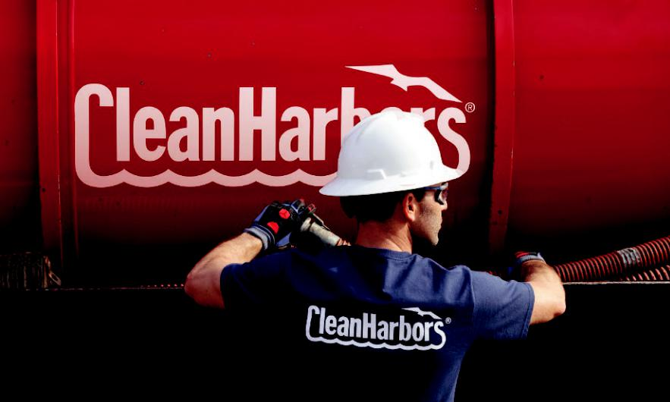

SAFE HARBOR STATEMENT

Any statements contained herein that are not historical facts are forward-looking statements within the meaning of the Private Securities Litigation Reform Act of 1995. These forward-looking statements are generally identifiable by use of the words “believes,” “expects,” “intends,” “anticipates,” “plans to,” “seeks,” “should,” “estimates,” “projects,” “may,” “likely,” or similar expressions. Such statements may include, but are not limited to, statements about future financial and operating results, and other statements that are not historical facts. Such statements are based upon the beliefs and expectations of Clean Harbors’ management as of this date only and are subject to certain risks and uncertainties that could cause actual results to differ materially, including, without limitation, the impact of the HEPACO acquisition and those items identified as “Risk Factors” in Clean Harbors’ most recently filed Form 10-K and Form 10-Q. Forward-looking statements are neither historical facts nor assurances of future performance. Therefore, readers are cautioned not to place undue reliance on these forward-looking statements. Clean Harbors undertakes no obligation to revise or publicly release the results of any revision to these forward-looking statements other than through its filings with the Securities and Exchange Commission, which may be viewed in the “Investors” section of Clean Harbors’ website at www.cleanharbors.com.

Clean Harbors is an equal-opportunity employer. We do not discriminate against applicants due to race, ancestry, color, sex, sexual orientation, gender identity, national origin, religion, age, physical or mental disability, veteran status, or on the basis of any other federal, state/provincial, or local protected class.

Form 10-K

Copies of the Company’s Annual Report on Form 10-K for the year ended December 31, 2023, filed with the Securities and Exchange Commission on February 21, 2024, may be obtained without charge online at www.cleanharbors.com, or by writing to our corporate headquarters:

42 Longwater Drive

P.O. Box 9149

Norwell, MA 02061-9149

Attention: Investor Relations

781.792.5100

Annual Shareholders Meeting Wednesday, May 22, 2024 10:00 a.m. EDT

Clean Harbors Training Facility

101 Philip Drive

Norwell, MA 02061-9149

Auditors

Deloitte & Touche LLP

200 Berkeley Street

Boston, MA 02116

Secretary of the Corporation

Daniel T. Janis, Esq.

Davis, Malm & D’Agostine, P.C.

Corporate Counsel

Davis, Malm & D’Agostine, P.C.

One Boston Place

Boston, MA 02108

Transfer Agent

Equiniti Trust Company, LLC (“EQ”)

48 Wall Street, Floor 23

New York, NY 10005

Corporate Headquarters

42 Longwater Drive

P.O. Box 9149

Norwell, MA 02061-9149

781.792.5000

www.cleanharbors.com

CLEAN HARBORS, INC. | ANNUAL REPORT 2023



